by Dick D. Zigun

Copyright © 1978-2012 by Dick D. Zigun
All Rights Reserved.
C/O CONEY ISLAND, USA, INC.
1208 Surf Avenue
Coney Island, N.Y. 11224
(718) 372-5159
CREDITS

* This play is a theatrical response to the lives of Karen Ann Quinlan, Charles Lindbergh and David "Son of Sam” Berkowitz.

* The playwright prefers that the three acts not be separated. If one act is produced on its own, as has been the case, please run a line similar to the following on the title page of the program: “Lucky Lindy is the second act of a full length play entitled THREE UNNATURAL ACTS.”

* The set design contained herein was created by artist Stephen Pearson, based on an original concept by Dick D. Zigun. Any production making use of this design, or based substantially on this design, should offer appropriate program credit and/or payment to Pearson/Zigun.

* All slides called for in this script are available from the author.

* The song LUCKY LINDY was copyright in 1927, words by L. Wolfe Gilbert, music by Abel Baer. The copyright was renewed in 1955 and 1966 by the publisher, Leo Feist, Inc., New York, N.Y. Renditions of that song on original 78 recordings by Arthur Fields on Bell Records and Vernon Dalhart on Cameo Records are called for in this script. All rights to this material should be secured by the producer.

* For more background on Charles Lindbergh, three books are suggested: Lindbergh, A Biography by Leonard Mosley, 1976; We: His Own Story by Charles A. Lindbergh, 1927; and The Spirit of Saint Louis also by Lindbergh, 1953.

PHOTO CREDITS

PAGES 16, 32, 89, 140, 151
THREE UNNATURAL ACTS, 1978, Yale School of Drama. Directed by David Kaplan with Katlin Clarke, Anneke Gough, Christopher Markle.
Photos by Bruce Siddons.

PAGES 66, 73, 74, 78, 116, 118
LUCKY LINDY, 1979, Mark Taper Forum. Directed by Richard Gershman with Archie Hahn and Noreen Hennessy.
Photos by Jay Thompson.

PAGES 23, 45, 51, 61, 69, 87, 102
THREE UNNATURAL ACTS, 1980, Produced by Coney Island, USA at
Franklin Furnace. Directed by Dick D. Zigun and Rebecca Harrison with Irving Burton, Gretel Cummings and Alison Gordy.
Photos by Justine Woolner.

Inside each program should be a sealed envelope printed with this request to be given out at intermission:

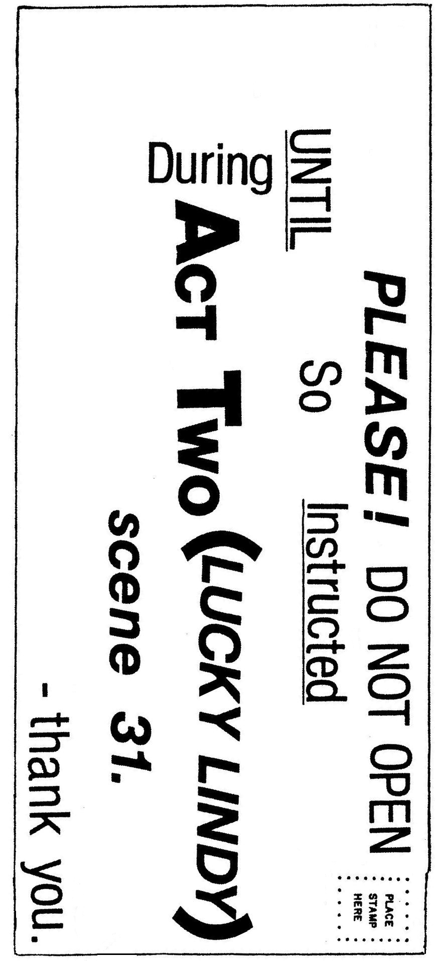

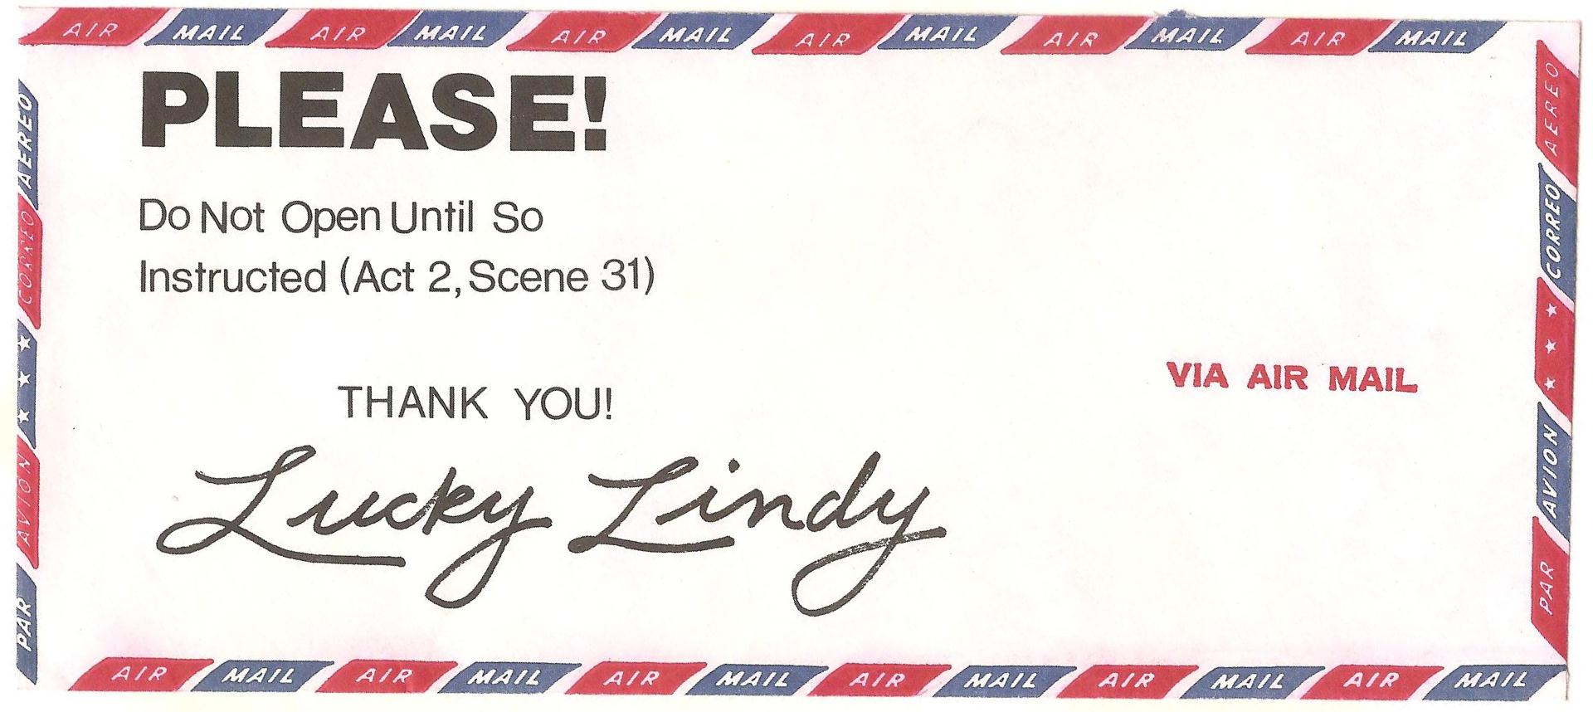

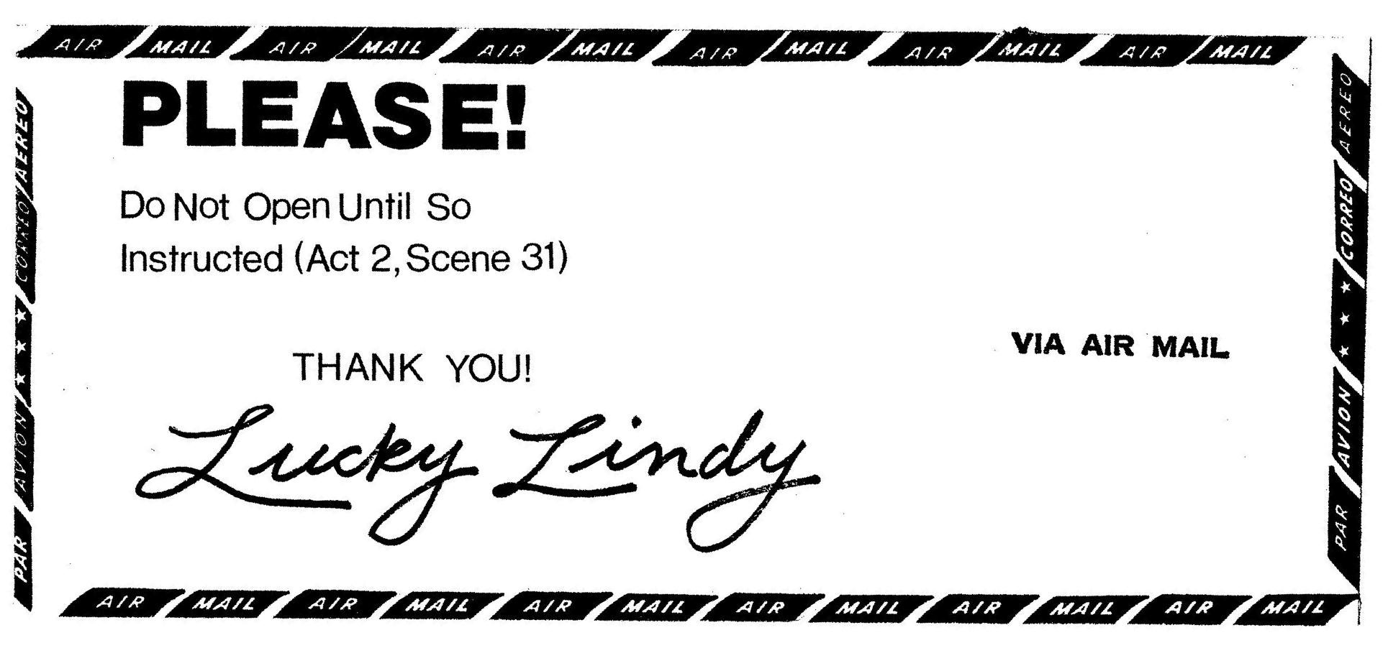

CAST OF CHARACTERS

A WOMAN ................ Educated. Divorced.
A MAN .................. The woman’s part-time lover. Old enough to be her father.
A GIRL ................. The woman’s shy but stage struck daughter or granddaughter. Dyed hair.

PRODUCTION HISTORY

1978
3 UNNATURAL ACTS - Yale School of Drama, Molly Kazan Award
LUCKY LINDY - Portland Conservatory Theatre
GRAND FINALE - Performance Workshop

1979
LUCKY LINDY - Mark Taper Forum, Los Angeles

1981
GRAND FINALE - Tricks & Treats At The Wax Musee

1982
3 UNNATURAL ACTS - New Dramatists (Reading)
3 UNNATURAL ACTS - Playwrights Horizons (Reading), Honorable
Mention, Theater Magazine Contest
LUCKY LINDY - Eureka Theatre, San Francisco
GRAND FINALE - Ensemble Studio Theatre (Reading)

1984
3 UNNATURAL ACTS - Coney Island, USA at Franklin Furnace, NYC
GRAND FINALE - Limbo Lounge
GRAND FINALE - Baca Downtown Gallery

1987 LUCKY LINDY - Repertory Theatre of St. Louis

SET DESIGN

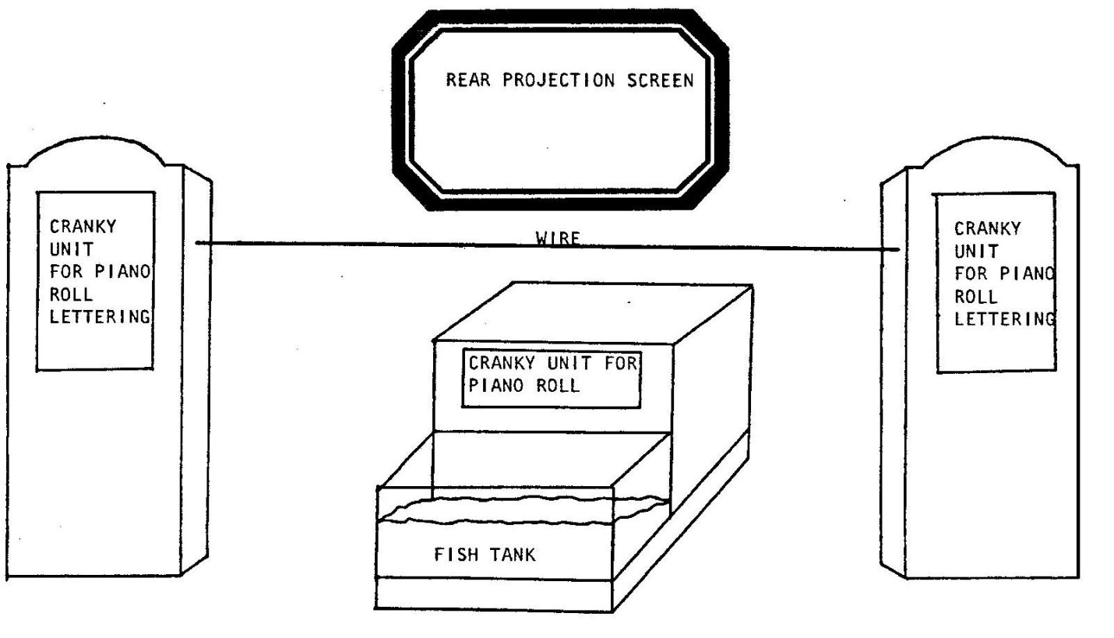

*Act One is performed in front of a curtain hung between the stage right and stage left cranky units. The rear projection screen and centerstage cranky are not seen in Act One.

* Lucky Lindy signs are stenciled onto double-width piano roll paper seamed at the center. Signs crank up on the rolls of piano roll paper.

PLANS FOR CRANKY UNITS
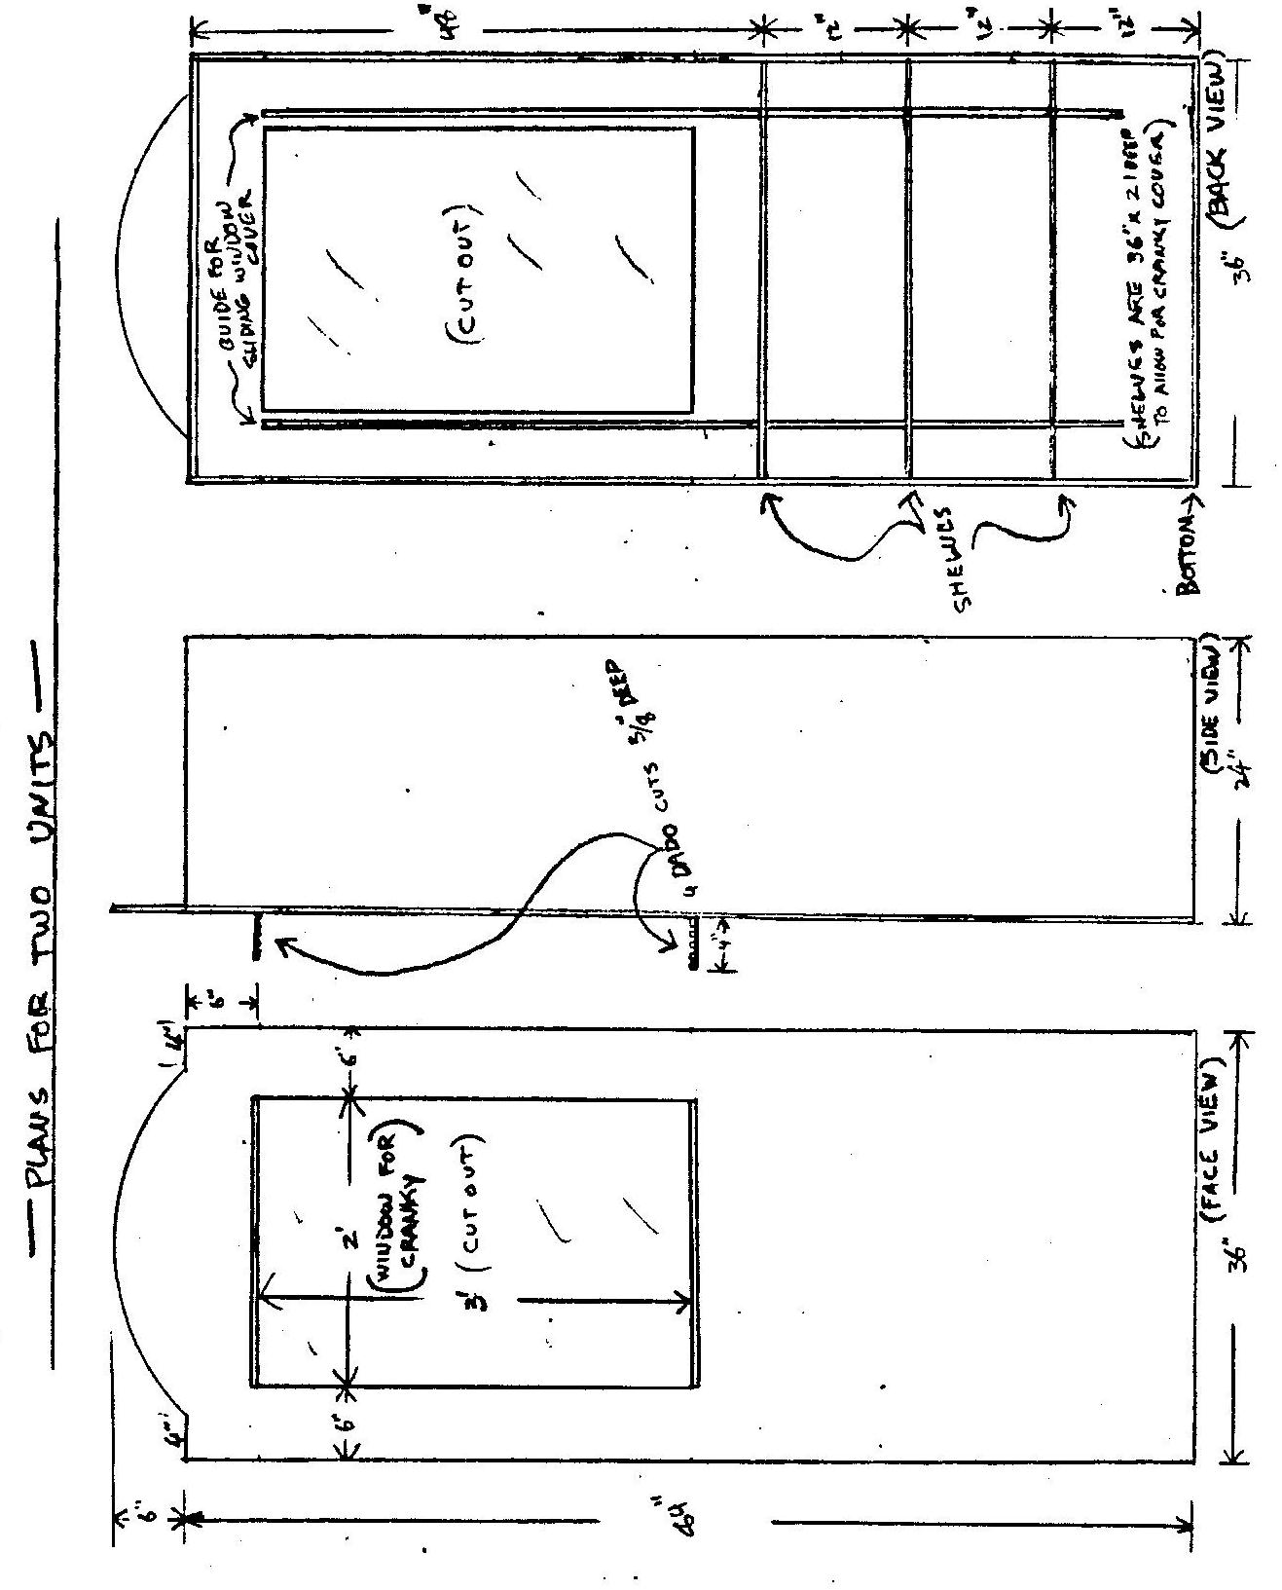

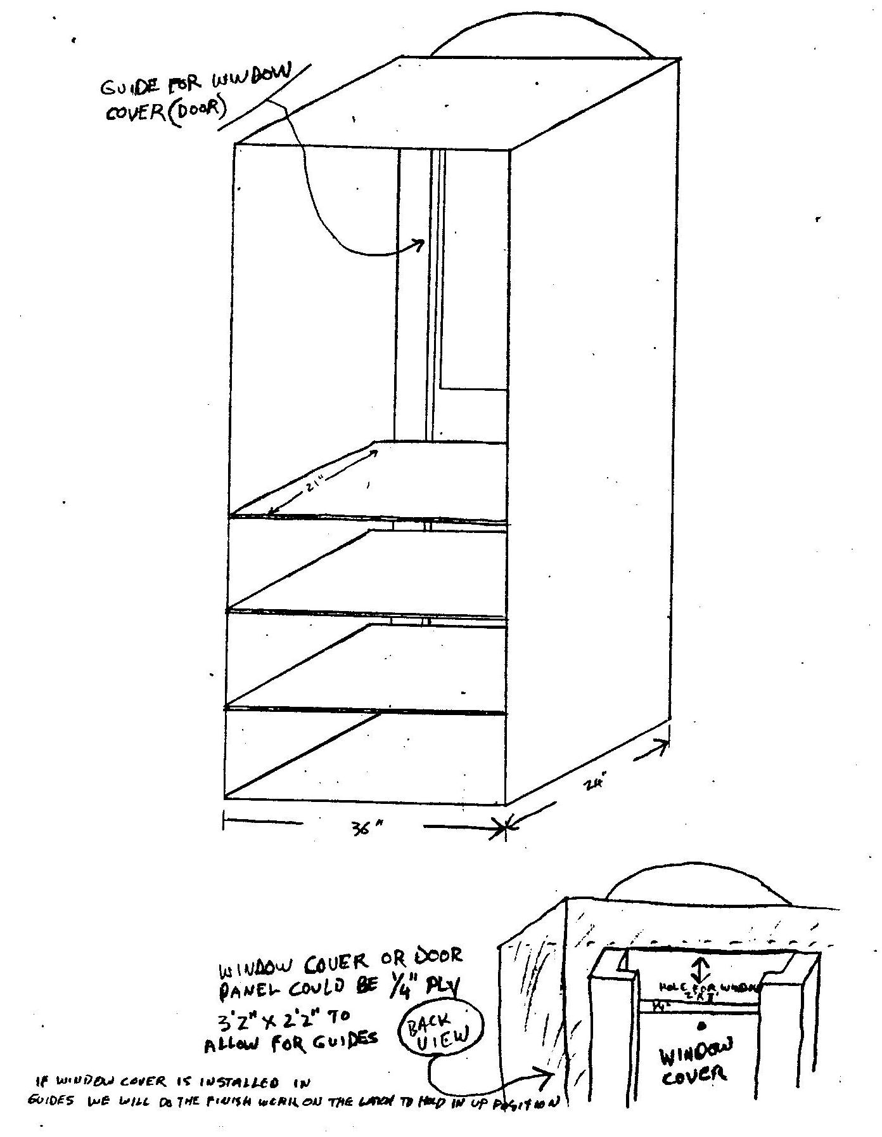

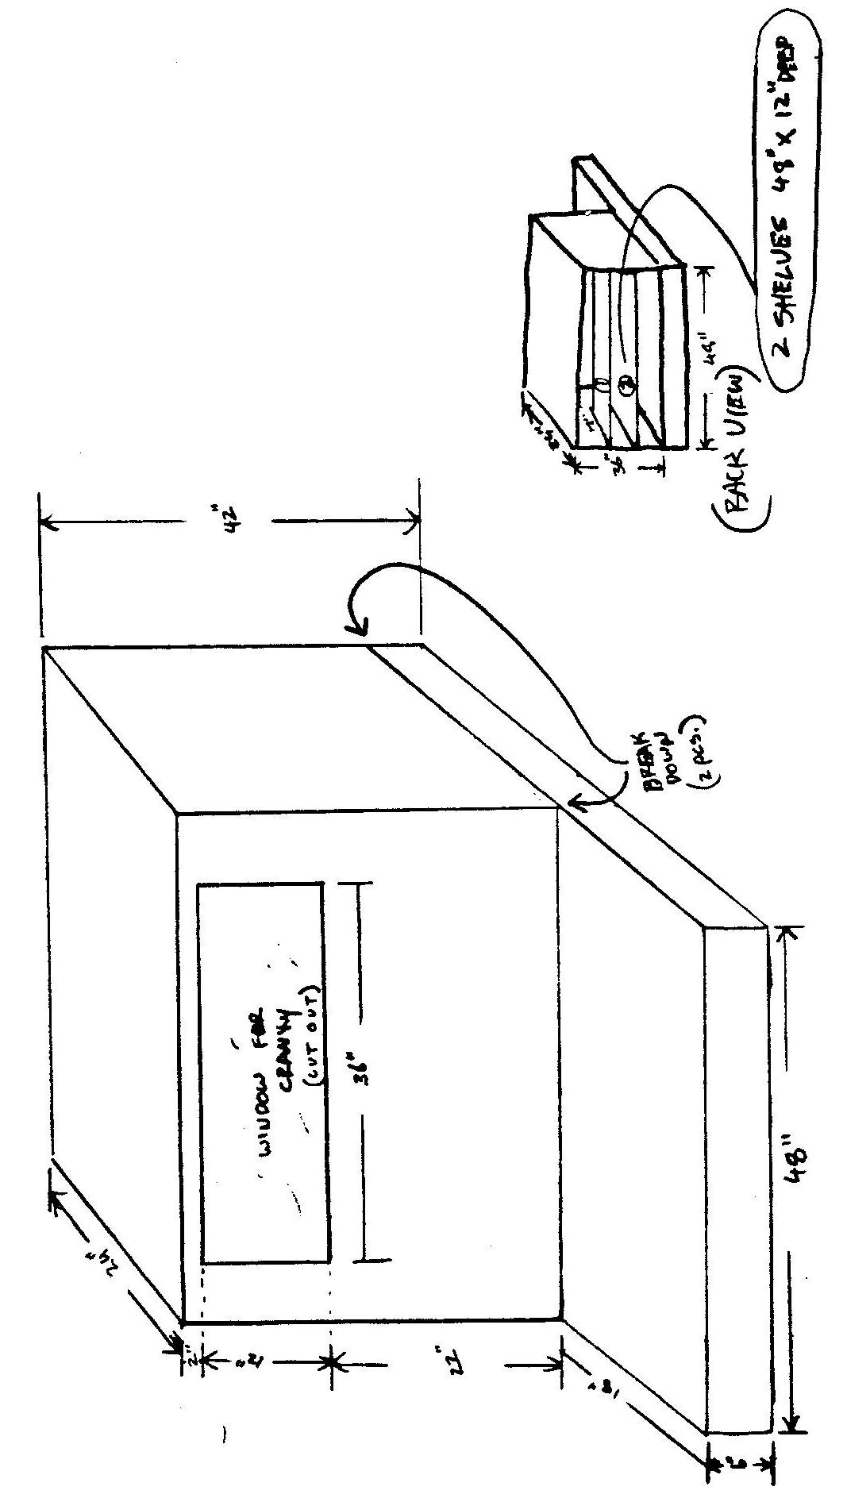

PART ONE

PROLOGUE

[WHEN THE AUDIENCE ENTERS THE THEATRE THE CURTAIN IS CLOSED. THE WINDOW COVERS ARE ALSO CLOSED ON THE STAGE LEFT AND STAGE RIGHT CRANKY UNITS. THE GIRL ENTERS, CUTE AS SHE CAN BE. SHE PLACES HOMEMADE CARDBOARD SIGNS INTOTHE DADO CUT SLOTS IN FRONT OF THE WINDOW COVERS OF THE TWO CRANKY UNITS.]

GIRL
Three Unnatural Acts. Part One. Act One. A Day in the Life of Mimi McMute. The Ventriloquial Adventure.

[SHE PLACES NEW HOMEMADE CARDBOARD SIGNS INTO THE SLOTS IN FRONT OF THE WINDOW COVERS.]

[THE GIRL EXITS. BLACKOUT.]

ACT ONE

A DAY IN THE LIFE OF MIMI McMUTE
-The Ventriloquial Adventure-

SCENE ONE

[LIGHTS UP. THE WOMAN IS SITTING IN A CHAIR TO ONE SIDE OF THE STAGE. THROUGHOUT THE FIRST ACT SHE ONLY SITS THERE, WATCHING. THE GIRL ENTERS CARRYING A CHAIR AND A BOX OF PROPS. SHE PLACES THE CHAIR CENTERSTAGE IN FRONT OF THE CURTAIN. SHE TAKES OBJECTS OUT OF THE BOX AND CAREFULLY LINES UP AN ALARM CLOCK, A TOOTHBRUSH A PLASTIC BATHROOM CUP, A CONTAINER OF DENTAL FLOSS, A WASH BUCKET, A BOX OF MR. BUBBLE, A STICK OF LIPSTICK, A BOX OF KLEENEX, A BOX OF RICE CRISPIES, A SCHOOL BELL, A TOY PLASTIC FLUTE, A PAD AND PENCIL, A COKE AND A STRAW, SOME WIRE AND PLIERS, A HOSTESS SNOWBALL CUPCAKE, A BIRTHDAY CANDLE, TWO PARTY HATS, A PACK OF LUCKY STRIKES, A FIFTH OF JACK DANIELS, A THERMOMETER, A BOTTLE OF ASPIRIN. THE GIRL SITS IN HER CHAIR. SHE RINGS THE ALARM CLOCK. SHE PLACES A NEW HOMEMADE CARDBOARD SIGN INTO THE SLOT IN FRONT OF THE WINDOW COVER OF THE STAGE LEFT CRANKY UNIT. THE SIGNS NOW READ:]

GIRL
Once I am up in the morning, even before watching cartoons, I go and wake up Mimi McMute.

[THE GIRL GOES OFF STAGE ANU RETURNS WITH A CHEAP VENTRILOQUIAL DOLL, MIMI, CRADLED IN HER ARMS. MIMI IS DRESSED IN PAJAMAS WITH HAIR MADE OF YELLOW OR PINK YARN. THE DOLL IS NOT IN THE BEST OF SHAPE.]

…shhhh…

[SHE COVERS MIMI'S EARS.]

Oh, by the way, Mimi can't talk, I think you should know that... but we really don‘t like to mention it much...

[SHE BANGS MIMI’S HEAD ON THE FLOOR. SHE KISSES THE DOLL. SHE BANGS ITS HEAD. SHE KISSES IT. SHE ASSUMES A CHEERFUL LITTLE KID’S VOICE.]

Now rise and shine, Mimi. Rise and shine, little girl.

[MIMI YAWNS.]

You really should cover your mouth when you yawn, shouldn’t you?

[MIMI NODS YES, THEN YAWNS OPENLY AGAIN.]

Well? Must I do everything for you?

[MIMI NODS AND YAWNS YET AGAIN. THE GIRL COVERS MIMI’S MOUTH.]

It seems so.

[SHE TAKES UP THE TOOTHBRUSH.]

Then let us begin your typically typical morning routine. First, we brush your teeth.

[SHE BRUSHES MIMI’S TEETH.]

Up and down, not side to side...that’s it; and don’t forget to massage your gums…good. Fine. Now, let’s take a cup of water and gargle.

[SHE PUTS THE CUP TO MIMI’S LIPS.]

Don’t swallow. Gargle. Like this:

[SHE DEMONSTRATES, THEN GIVES MIMI ANOTHER CHANCE.]

Swish it all around. Spit it out, wipe your mouth and go and find the dental floss.

[SHE FLOSSES MIMI'S MOUTH.]

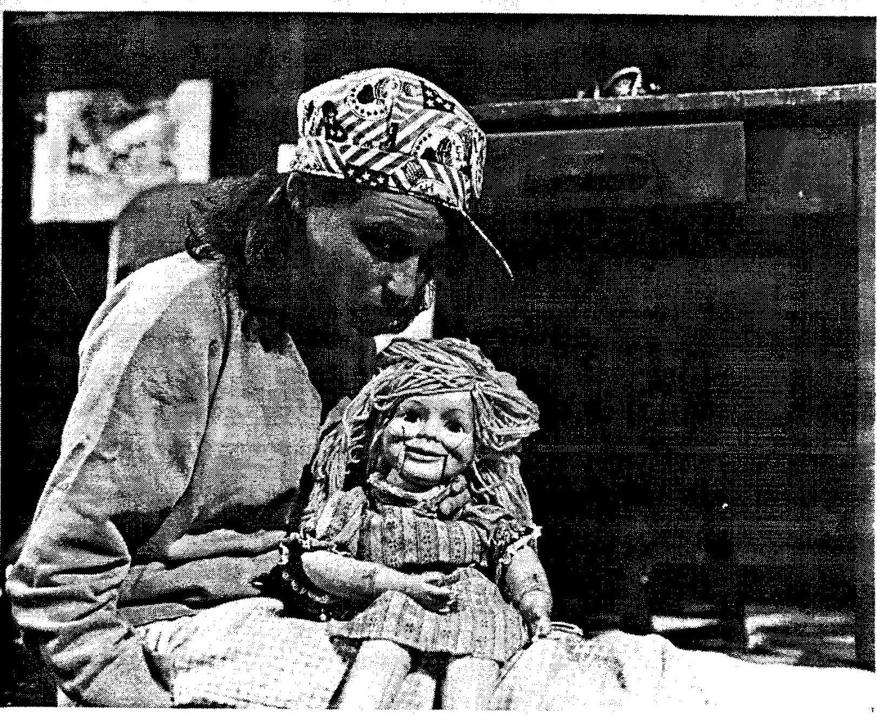

Are you finished flossing? Did you do each tooth? You wouldn’t lie to me, now? Well, if you’re ready then, it's time for your bath.

[SHE SUBMERGES MIMI IN THE EMPTY BUCKET.]

And here come the bubbles!

[SHE ADDS MR. BUBBLE.]

Now how do you feel?

[MIMI GESTURES.]

And what does that mean?

[MIMI GESTURES OBSCENELY.]

One more move like that, young lady, and I'll have to wash your mouth out with soap. Now, it's about time that you got dressed, isn’t it?

[SHE TAKES UP THE LIPSTICK.]

Can’t you pucker your lips so I can put your lipstick on straight?...that’s it, don’t help me out...then I‘ll have to do the best I can without you…brat!

[SHE MAKES UP MIMI.]

Try going like this with a Kleenex and it won’t smear.

[SHE SHOWS MIMI HOW TO BLOT HER LIPSTICK ON A TISSUE.]

Now, let's see how you look...hmmm...not that bad, considering… would you like a little breakfast before we rush off today?

[MIMI NODS YES.]

Snap – Crackle – Pop!

[SHE REACHES FOR THE BOX OF RICE CRISPIES. MIMI KNOCKS THE BOX OVER AND SPILLS IT.]

You should have gotten a bowl first, Mimi! Now look what you’ve done! You’re a mess and you’re late for school on the first day of Junior High!

[THE GIRL RINGS THE SCHOOL BELL. SHE PLAYS THE ROLE OF THE TEACHER.]

Yes, it's roll-call time again, class. Now, I see Bonnie and Billy and Donald D. Deaf —— Horace is here, so says Hyper Mouthed Jeff...but why doesn't Mimi answer when I call her name? Oh, Mimi? Where are you, Mimi-moo? You wouldn't be sitting silent at your desk again, would you be, dear?

[SHE FINDS MIMI.]

Well, I'll be surprised to South Dakota, yes you are! Well, speak-up child, we‘d all like to know; are you absent or present? Cat's got your tongue, swallowed it in fact, we all know that; but aren‘t the little fingers working today, either? Talk to me in sign language.

[MOCK INJUN VOICE:]

No need used forked tongue.

[WITH A SWEEPING GESTURE TOWARDS THE SKY:]

Are

[POINTING TO MIMI WITH BOTH HANDS:]

You

[STOMPING THE GROUND:]

Here?

[SHE TAKES MIMI ASIDE AND TAKES THE DOLL'S HAND:]

You're not cooperating, Miss McMute; and your report does state that you know how to do this. So, let's just review how one‘s feminine little fingers say: "Excuse me, teacher". Show me an "E".

[SHE SLAPS MIMI.]

Do it! "E". It’s like making a fist.

[SHE DEMONSTRATES.]

See? "E".

[SHE PUNCHES MIMI.]

I'll just have to force you. Put your thumb over here and bend these four down to here, bend, BEND! Stiff joints are not an excuse! Arthritis is not an excuse!

[A FINGER SNAPS OFF.]

Don't look at me like that! I did not break anything...it doesn't hurt. Besides, we’re moving on, enough of this. It's time for music class. You've gotten way too much individual attention today, Mimi McMute. So, don‘t be angry with me!

[SHE SHOVES THE FLUTE IN MIMI'S MOUTH.]

Here! Music soothes the savage beast! Blow. Blow!

[SHE RIPS THE INSTRUMENT FROM MIMI’S MOUTH, PUTS IT IN HER OWN AND PLAYS A NOTE. TO MIMI’S: NOTHING. TO HER OWN: A NOTE. TO MIMI’S: NOTHING.]

Unmelodic as well this morning? You don't talk, you don't smile...I‘m surprised you remember how to breathe!

[SHE GIVES THE FLUTE TO MIMI.]

Blow!

[SHE TAKES IT AWAY.]

Mimi McMute, I‘m sending you to the school psychiatrist for testing, RIGHT NOW!

[SHE LAYS MIMI HORIZONTAL AND TAKES UP THE PAD AND PENCIL. THE GIRL PLAYS THE PART OF THE SCHOOL PSYCHIATRIST:]

You've no reason to fear me, Miss McMute. You can relax. Why don't we play a little game in order to break the ice? Now, I'm going to tell you some words and then I'd like you to let me know whatever comes into your mind when you first hear each one. Understand? Good...I think we‘re getting along just fine. We’re ready to start:

[THE GIRL LOOKS TO MIMI FOR A RESPONSE TO EACH OF HER WORDS. MIMI DOES NOTHING, BUT THE GIRL CONTINUES AS IF MIMI WERE COOPERATING FULLY AND TAKES A SERIES OF NOTES:]

Black? ----- Hot? —---— Mother? ----- Father? —-·-- Lips? -—--- Teeth? ----— Tongue? ----- Mouth? -—--- Mouth? -—·—— Mouth? -—--- Mouth? --—--

[BLACKOUT. END OF SCENE ONE.]

SCENE TWO.

[LIGHTS UP. THE WOMAN IS STILL WATCHING. THE GIRL PLACES A NEW HOMEMADE CARDBOARD SIGN INTO THE SLOT IN FRONT OF THE WINDOW COVER OF THE STAGE LEFT CRANKY UNIT. THE SIGNS NOW READ:]

[SHE SITS WITH MIMI IN HER LAP.]

GIRL
Indian Summer. Afternoon. Her friend is gone, the teacher gone, the shrink has gone off, too. Now it’s recess and Mimi sits alone. She spits...at least she tries to spit; you see, the morning has left a bitter taste in her mouth, but her throat is dry, parched. Mimi buys a liquid lunch.

[SHE TAKES UP THE COKE BOTTLE AND STRAW. SHE PUTS THE STRAW IN MIMI'S MOUTH. SHE FANTASIZES A VOICE FOR MIMI:]

"No, I won't use a straw", she thinks...

[SHE TAKES THE STRAW OUT OF MIMI'S MOUTH.]

"...straws mean slow sips at a time and be sure not to slurp... no, I won't be like those puckered people", she thinks, "This Coke goes down the hatch!"

[THE GIRL POURS THE ENTIRE BOTTLE OF COKE DOWN MIMI'S THROAT. THE SODA LEAKS OUT OF THE DUMMY'S BODY.]

“Yes, and I'll piss on the floor, just like Little Linda Blair in The Exorcist; that always shakes them up, I won't use a straw and I‘ll piss and I'll piss until they take notice.”

[SHE HOLDS MIMI HIGH AND LETS HER DRIP.]

Well, Mimi leaks here, Mimi pees there, Mimi stains and drains everywhere; but still, no one takes notice and then Mimi pisses out.

[SHE SITS MIMI DOWN.]

"I think they‘ll never take much notice", she thinks, "for ours is an oral world and I cannot impress them. Ooooo-—Ooooo—Ooooo", she wishes she could cry out, "it‘s all a bad mistake. Somehow, if I might tell my story, oh, I know what I would say.”

[THE GIRL FACES OUT TO THE AUDIENCE, HOLDS MIMI UP SO THAT THE DOLL'S HEAD IS EVEN WITH HERS, THEN FACES MIMI OUT TO THE AUDIENCE AS WELL. SHE MOVES MIMI'S MOUTH TO WORDS FOR THE FIRST TIME, BUT CONTINUES TO MOVE HER OWN LIPS AS WELL. THE GIRL DOES NOT WORK MIMI'S MOUTH BY A HIDDEN STRING THIS SPEECH, BUT OPENLY, WITH A FINGER ON THE DOLL'S CHIN. THE EFFECT IS LESS ONE OF VENTRILOQUISM AND MORE THAT OF A MUTE FIGURE MOUTHING THE WORDS OF A SPOKESWOMAN.]

"Listen up! Once upon a time I was a baby barely born. They slapped me, I did not cry, they slapped me again, and again. I bruised, but I never screamed. I was the ideal infant. I smiled. All were pleased, they loved me. At first my grins were fondly featured; I kept up appearances no matter what was said... but then, smiles were not sufficient and they started making noise: Ga-ga, Ma—ma, Pa—pa, Ca-ca—--No-dice, I couldn’t get it out. None noticed I was otherwise bright and made expressive little pouts. I so wanted to protest, I built a vocabulary of visions; they wanted words. I went back to smiling, they called me autistic. Still, I kept trying to reconceive communication. I smiled at each new acquaintance. The point never got across. The neighborhood kids beat me on both cheeks, I kept on smiling, they took it as a request for more. I gained popularity in the worst of ways. People thought I’d take pleasure in pain since I didn’t yell: Police! That I’d face flames in a burning theatre for not shouting: Fire! Once people learn you don’t balk, they equate silence with masochism, they won’t see your objections. You smile and they interpret you the wrong way. Your teeth might be gritted, your eyes all intense-”

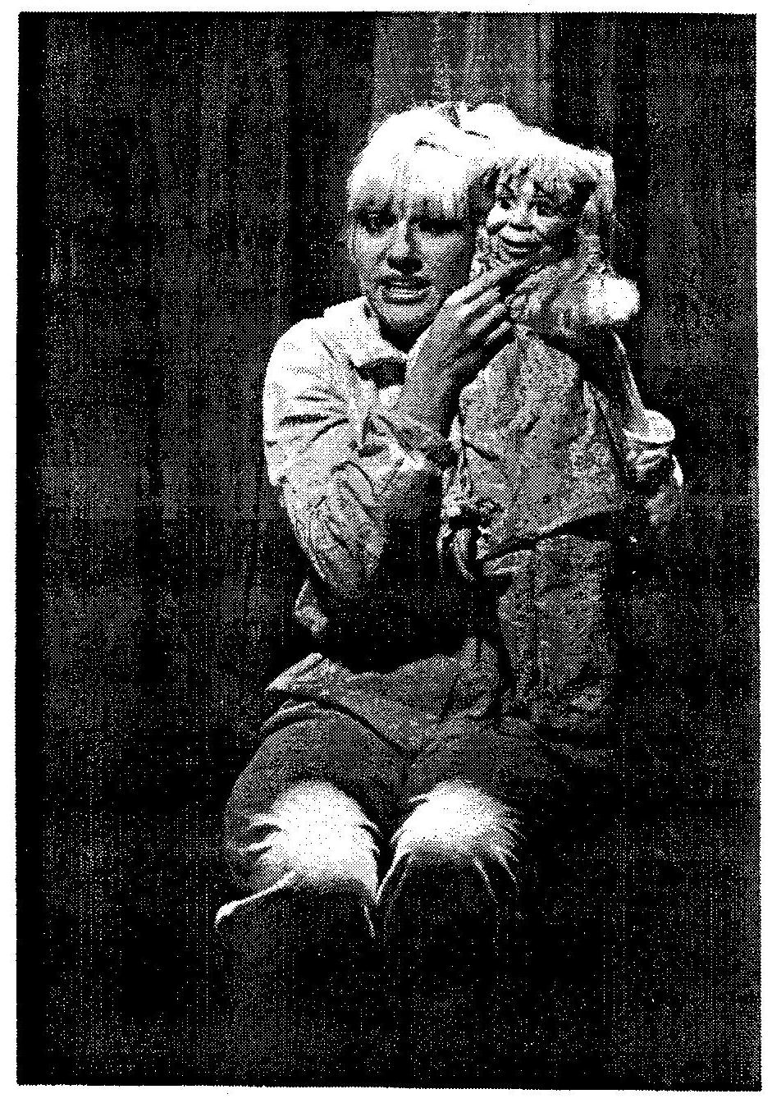

[MIMI'S HEAD HAS SLOWLY TURNED TO FACE THE GIRL.]

"-I want you to stop, no one understands...if only one friend would take one close, thorough, good look."

[MIMI BECOMES TIGHT-LIPPED ONCE AGAIN. THE GIRL ASSUMES HER CHEERFUL LITTLE KID’S VOICE:]

But Mimi McMute knows she will never talk, will never get that story across. She must live in this world on its own terms. Tough terms. Terrible terms. Those terribly tough terms that only mucked up Mimi knows only too well.

[SHE WALKS MIMI ABOUT THE STAGE.]

Yes, this world has all but turned Mimi out, and in turn teenie Mimi can be termed mighty pissed! She wishes she could curse, even under her breath; she'd love to say things like: "Fudge and Shoot, this is bad! Ding—Dang—Damn, I'm in despair! Shit-Fuck-Ass, I can't go on!” Could you or I take it? Mimi doesn't cuss, Mimi can't cuss, Mimi wants to cuss. Mimi springs into action instead!

[SHE PLAYS A HISTRIONIC MOVIE DIRECTOR:]

Mimi cuts loose! Mimi cuts school! Mimi runs off the playground, vandalizes a variety store, robs a pad and pencil and slides into a corner of the downtown public library. What for?

[SHE PUTS THE PENCIL IN MIMI‘S GOOD HAND.]

She plans to write a note. Her plea for peace has changed. She‘s gonna take a chance. She's gonna get extreme. She takes a pad in hand. She writes as best she can. She writes a private plea. She folds it...and she‘s gone.

[MIMI AND THE NOTE ARE HIDDEN.]

Gone where? Scrawled what? What's it say? Who‘s it for? Why's she downtown? She comes to a bridge ----- will she jump with a suicide note in her pocket to leave us all guilty?

[PAUSE.]

She takes a bus! She gets off by a bank ----- will she pass them a note demanding money big enough to finance private research into international non—verbal thought exchange?

[PAUSE.]

She rounds the corner!

[PAUSE.]

She crosses the street! She ducks into a door! The entry to a professional building! Has young Mimi planned a kidnap? If only we could see inside!?!

[THE GIRL SPINS AROUND. THE NOTE IS MAGICALLY IN HER HAND. SHE READS IT TO HERSELF, SHE SCRATCHES HER HEAD. SHE READS THE NOTE ALOUD, ASSUMING A YIDDISH ACCENT:]

"Make my mouth beautiful.” ?

[SHE SCRATCHES HER HEAD.]

Your teeth...maybe, I'm an Orthodontist --- but your whole mouth?...I don't know. "Make my mouth beautiful"...if this is a joke, young lady --- okay...alright, please, don't cry! Just don't fret so much, don't worry. Wire works wonders. Please. Let me see?

[SHE BARES HER OWN TEETH IN EXAMPLE.]

I see what you mean. I can’t.

[PAUSE.]

Alright, don't cry! I'll try!

[SHE PICKS UP THE WIRE AND PLIERS AND GOES AND FINDS MIMI. SHE RETURNS WITH HER HAND PLACED OVER THE DOLL'S MOUTH. SHE PLAYS THE DIRECTOR AGAIN:]

Mimi heads home, tentatively embarrassed, her lips tightly pressed together, unsure of what the reaction will be. She spends ten minutes pacing up and down the street in front of her house before summoning the courage to go in before dark. She stumbles each step. She fumbles the lock. She opens the door and scurries to the mirror in her room. She turns on the light --- the girl, her best friend, is there, waiting.

[THE GIRL SPEAKS WITH HER NORMAL VOICE. SHE HOLDS MIMI WITH THE DOLL'S BACK TO THE AUDIENCE.]

Hi, Mimi! What's up? Where ya been? Come on, friend, flash that famous smile!

[SHE MAKES FACES AT MIMI BUT GETS NO RESPONSE, PLAYFUL OR OTHERWISE. SHE FINALLY PULLS MIMI’S HAND AWAY FROM HER MOUTH. NOTHING HAS CHANGED.]

Hey! Hey-hey! That's some new mouth you got there, Mimi! Never noticed it before. Geez, I could go far with looks like that. Don't get me wrong, it looks good on you, but, well...a mute’s a mute. Now come on, let's play, it's almost supper time and while you were out I thought up a new game. We both just sit here not talking. I'll look at you. You'll look at me. I won't talk. You won't talk. Good game, huh? It's called: Helen Keller gets a dummy doll.

[PAUSE.]

Go!

[THEY BOTH JUST SIT THERE NOT TALKING. BLACKOUT. END OF SCENE TWO.]

SCENE THREE

[LIGHTS UP. THE WOMAN IS STILL WATCHING. THE GIRL PLACES A NEW HOMEMADE CARDBOARD SIGN INTO THE SLOT IN FRONT OF THE WINDOW COVER OF THE STAGE LEFT CRANKY UNIT. THE SIGNS NOW READ:]

[MIMI IS OFF IN A CORNER. THE GIRL SPEAKS TO THE AUDIENCE IN THE ROLE OF THE OLDER FRIEND:]

GIRL
Boy, do I have BIG things planned for this evening! She hasn't caught on yet, but I purposely lied to Mimi before. Wow, what a difference! What a beauty! What a makeover! If you haven't heard yet, she's the talk of the town. I wanted to fool her, because, coincidentally, believe it or not, today is Mimi's thirteenth birthday and I don't think she knows. In the past we ignored it so as not to hurt her feelings; but since the duckling‘s turned to swan today, well, EVERYBODY'S here!

[SHE PUTS THE CANDLE ON THE CUPCAKE. A PARTY HAT GOES ON HER HEAD. SHE LIGHTS THE CANDLE AND CARRIES THE CUPCAKE OVER TO MIMI HIDDEN BEHIND HER BACK.]

Surprise! Happy Birthday, Mimi. You're beautiful at last!

[SHE PUTS THE OTHER PARTY HAT ON MIMI’S HEAD.]

We’re so happy for you! Now you'll get to learn all those things that happy people do. How does that feel? Terrific, I bet! Now, this is called a birthday candle on cake. You should blow out the first, then take a bite of the second.

[MIMI BENDS OVER, CLOSE TO THE FLAME. SHE TRIES TO BLOW OUT THE CANDLE, BUT SMEARS CAKE ON HER FACE INSTEAD.]

Oops, you’ll get the hang of it in time. Oops...oops...

[PAUSE. SHE WHISPERS. SHE GETS NASTY:]

I guess you‘re right, this all seems too childish, doesn't it? Let’s go into that dark corner where the adults can't watch us.

[SHE LIGHTS A LUCKY STRIKE.]

Wanna learn how to smoke?

[SHE PUTS THE CIGARETTE IN MIMI'S MOUTH AND LIGHTS ANOTHER FOR HERSELF. SHE BLOWS SMOKE IN MIMI'S FACE.]

Want to learn to blow smoke rings? Exhale through your nostrils? Loosen up, Mimi. We’ll let down our hair. Here, have another cig.

[SHE PUTS THE SECOND IN MIMI‘S MOUTH.]

Aren‘t we mature? Hmmmm?

[THE GIRL COUGHS.]

You know, Mimi, I think maybe it‘s cooler not to smoke these days; you have to keep up to date, read the magazines.

[SHE OPENS THE BOTTLE OF JACK DANIELS.]

We'll drink this to wash the cancer out.

[SHE TAKES A BIG SWIG.]

Go on...give it a taste, everyone'll think you‘re real tough.

[MIMI TURNS AWAY.]

Then just hold your nose and just gulp ——

[SHE DEMONSTRATES.]

---it won't taste nearly so bad. Go on...

[SHE SEES THAT SHE HAS EMPTIED THE BOTTLE.]

Whataya know, bottle's empty...it's no good anymore...wait a minute, don't throw it out yet, it‘s still good for something:

[SHE PUTS IT ON THE FLOOR AND SPINS IT.]

The bottle spins
And twirls about
And I kiss ---

[IT STOPS.]

--— MIMI!
On the mouth!

[SHE DOES.]

Did you like that?...it was my best French kiss! I'm learning how from Tony. I wasn‘t practicing on you, it's a game; for us big kids; it's lots of fun! It's your turn...and you'll have to kiss whomever it points to; and no favorites...

[MIMI WILL NOT KISS.]

...don’t be so anti—social...what do you mean, you feel sick?

[THE GIRL BELCHES.]

I hope you’re not lying.

[SHE STICKS THE THERMOMETER IN MIMI'S MOUTH, OPENS THE BOTTLE OF ASPIRIN, TAKES TWO HERSELF, READS THE THERMOMETER AND THEN POURS A HANDFUL OF THE TABLETS DOWN MIMI’S THROAT. SHE PLAYS THE ROLE OF THE YOUNGER SIBLING:]

Those should make you feel good. Better now? Okay, let's get back to the party!

[THE GIRL CROSSES TO CENTERSTAGE. SHE LOOKS BACK AT MIMI IN THE CORNER. SHE EXTENDS HER HAND.]

Come on...

[SHE GOES BACK.]

...everything's gonna be alright.

[SHE SWITCHES TO THE VOICE OF THE MOTHER:]

No one's expecting you to talk...you should at least make an appearance.

[SHE CROSSES TO CENTERSTAGE. SHE LOOKS BACK. SHE RETURNS TO MIMI.]

Not yet? Alright, but don't delay too long, Mimi; you'll miss your golden opportunity. I think that the best looking boy in town is waiting to dance with you. You‘re a hit. They all love you...see him over there? Come on...

[SHE PLAYS THE OLDER FRIEND:]

Don’t be shy, Mimi! He‘d be a good catch. You only have to meet him for now; if you're nervous, we can double date. I'd like that...

[SHE EXTENDS HER HAND. VARIOUS NEW AND OLD VOICES DRIFT IN AND OUT OF THE NEXT FEW LINES:]

I won't let you do this to yourself, Mimi McMute! You've got no more reasons to hide. Now, come on...

[PAUSE.]

Come on...

[PAUSE.]

Come ON!

[SHE CROSSES AND PICKS UP THE DOLL. SHE BANGS MIMI’S HEAD ON THE FLOOR. SHE KISSES THE DOLL. SHE BANGS ITS HEAD. SHE KISSES IT. SHE CARRIES MIMI TO CENTERSTAGE.]

...maybe we should lie down for a while and take a short rest.

[SHE LIES DOWN WITH MIMI IN HER ARMS AND PASSES OUT. HER EYES ARE CLOSED, SHE BURPS, MIMI FALLS TO THE FLOOR. THE GIRLS SITS UP, SITS MIMI UP AND LETS GO OF THE DOLL. MIMI FALLS OVER. SHE SITS MIMI UP — MIMI FALLS AGAIN. THE GIRL SPEAKS WITH HER OWN VOICE:]

Mimi? Mimi, wake up. It’s late.

[SHE SHAKES MIMI.]

Wake up!

[SHE PUTS MIMI'S MOUTH TO HER EAR.]

I can still hear your breathing, Mimi, so you can stop playing...

[SHE SLAPS HER.]

MIMI McMUTE!

[NO RESPONSE. SHE CRADLES THE DOLL.]

I think you’re in a coma, Mimi. I guess I’ll have to tuck you into bed. Always doing things for you; but that’s okay; it’s been a busy day. What else are friend for?

[SHE KISSES MIMI ON THE FOREHEAD.]

Goodnight.

[THE WOMAN STANDS AND TURNS OFF THE LIGHTS. BLACKOUT. THE WOMAN TURNS ON THE LIGHTS AND LETS THE GIRL, DANGLING MIMI BY THE ARM, TAKE A BOW. END OF SCENE THREE. END OF ACT ONE.]

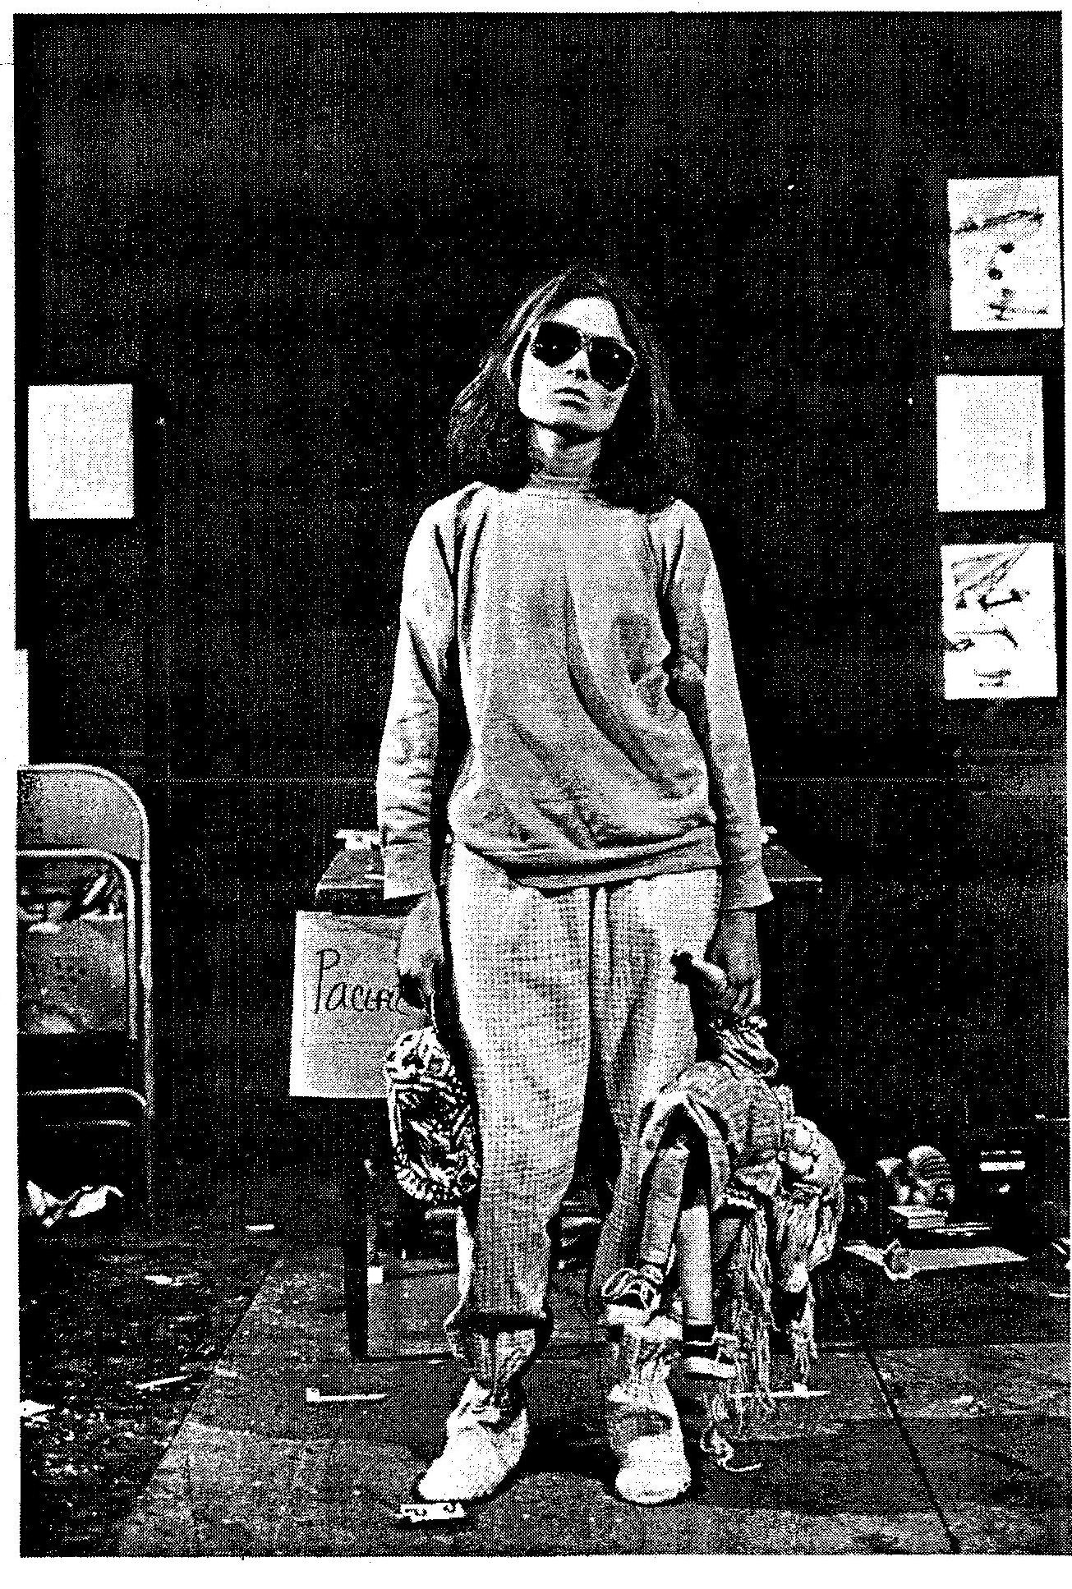

ACT TWO

A LIFE IN A DAY: LUCKY LINDY
-The Limiting Lecture-

PROLOGUE.

[LIGHTS UP. THE CURTAIN IS CLOSED BETWEEN THE TWO CRANKY UNITS. THE WINDOW COVERS CONCEAL THE PIANO ROLL SIGNS. THE WOMAN ENTERS. SHE WEARS SUNGLASSES. SHE CARRIES A TAPE RECORDER PLAYING DAVE BRUBECK’S “TAKE FIVE.”]

WOMAN
Act Two. A Life in a Day: Lucky Lindy. A tabletop theatre. Prologue.

[SHE OPENS THE WINDOW COVER ON THE STAGE RIGHT CRANKY UNIT. SHE OPENS THE WINDOW COVER ON THE STAGE LEFT CRANKY UNIT. TWO SIGNS ARE REVEALED STENCILLED ONTO PIANO ROLL PAPER ILLUMINATED WITH BACKLIGHT:]

Two fixed points...

[SHE WALKS THE STAGE BETWEEN THE TWO UNITS.]

A gap in between.

[PAUSE.]

Spanning the distance:

[SHE OPENS THE CURTAIN. A TAUNT LINE IS STRETCHED BETWEEN THE TWO UNITS. THE REAR PROJECTION SCREEN SHOWS A PHOTO OF LINDBERGH. THE CENTER CRANKY UNIT IS COVERED WITH A SHEET.]

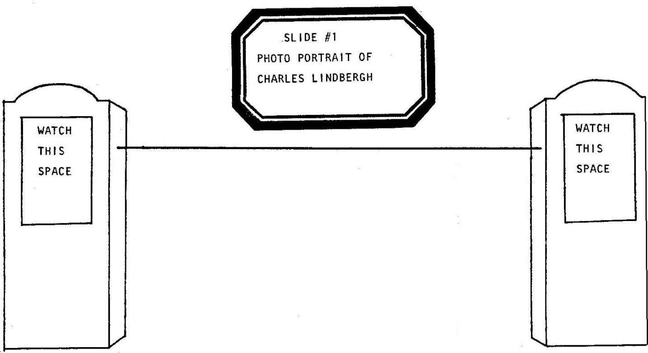

A line...

[SHE DEMONSTRATES THE LINE'S ELASTICITY.]

straight or curved.

[SHE LABELS CONCEPTS:]

A beginning. The end. Middle.
Departure. Destination. A nice little journey.
“A" leads to "Z", just like a Rube Goldberg.

The New Math?

[SHE SHRUGS.]

Linear Logic?

[SHE SHRUGS.]

Structuralist Symbolism?

[SHE REJECTS THEM ALL AND THEN PUTS A FINGER UP INTO THE AIR.]

Discussion within confines. Yes!

[SHE GESTURES A COMPRESSION/SQUEEZE MOTION.]

An everyday occurrence.

[SHE POINTS TO SOMEONE IN THE AUDIENCE:]

How do we run meetings?

[THE COMPRESSION GESTURE.]

Robert's Rules of Order. Sipping your soup? Old Amy‘s etiquette. Suing your doctor? The book of malpractice law. When they're playing your song:

[SHE SNAPS HER FINGERS TO THE MUSIC.]

Are they sharp or in key?

[THE COMPRESSION GESTURE.]

So, how do we approach a discussion of—

[SHE POINTS TO THE SLIDE.]

Charles Lindbergh?

[SHE HOLDS UP A BLACKBOARD SLATE AND READS WHAT HAS BEEN PRINTED ON IT IN YELLOW LETTERS:]

"Rules of Lindbergh”.

[SHE CRANKS THE STAGE RIGHT SIGN. SHE CRANKS THE STAGE LEFT SIGN:]

Two fixed points...

[PAUSE.]

Spanning the gap?

[A SILVER COLORED TOY AIRPLANE, BEARING SOME RESEMBLANCE TO THE SPIRIT OF ST. LOUIS, FLIES OUT TO CENTERSTAGE ATTACHED TO THE LINE.]

An airplane above.

THE MAN ENTERS IN DIVING MASK AND SNORKEL AND PULLS THE SHEET OFF THE CENTER CRANKY UNIT. THE CENTER UNIT HOLDS A LARGE GLASS AQUARIUM, HALF FULL OF WATER, BENEATH THE PLANE ON THE LINE. A SIGN IS REVEALED STENCILLED ONTO THE PIANO ROLL PAPER ILLUMINATED WITH BACKLIGHT:

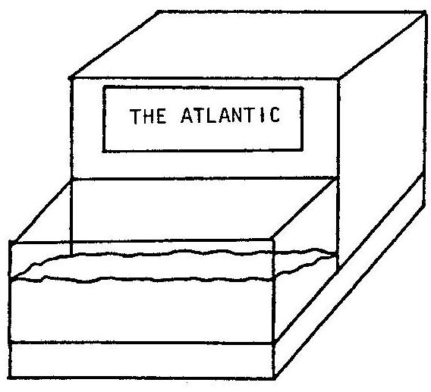

An ocean below.

[SHE ASKS THE MAN:]

The distance between?

[HE REVEALS A TAPE MEASURE AND MEASURES THE DISTANCE FROM ONE SIGN, OVER THE OCEAN, TO THE OTHER CRANKY.]

MAN
I think it’s about three thousand, six-hundred and ten miles.

[SHE SHAKES HER HEAD ‘NO,’ GOES AND PUSHES THE PLANE BACK AND FORTH ON THE LINE AND THEN TURNS OVER HER BLACKBOARD SLATE WHICH IS PRINTED WITH THE RIGHT ANSWER:]

WOMAN
No—no—no! The right answer is: "33 1/2 Hours"!

MAN & WOMAN
Rules of Lindbergh!

[HIS TAPE MEASURE GOES WILD. SHE GESTURES TOWARDS THE MAN:]

WOMAN
My assistant this evening —

[HE BOWS.]

- is a visiting actor from Rhode Island who naturally understands...small things.
[HE REVEALS A PLASTIC FISH AND PLACES IT INTO THE TANK. SHE CLAPS HER HANDS.]

Mister Manipulator, if you so please!

[HE EXITS TO FINDS PRDPS. THE WOMAN SHUTS OFF HER TAPE RECORDER AND HANDS IT TO THE GIRL, STILL IN HER PAJAMAS, STILL CLUTCHING MIMI, SITTING IN A CORNER ON SOME PILLOWS WITH THE REMOTE CONTROL TO THE SLIDE PROJECTORS. THE WOMAN ADDRESSES THE AUDIENCE:]

A Life In A Day: Lucky Lindy. A Tabletop Theatre. In 33 1/2 scenes...

SCENE ONE.

WOMAN
...Scene One.

[THE MAN CRANKS THE STAGE RIGHT SIGN. THE WOMAN CRANKS THE STAGE LEFT SIGN.]

Ma and Pa Lindbergh lived in a farmhouse off in Minnesota on the Mississippi banks.

[THE MAN CRANKS THE CENTERSTAGE SIGN AS THE GIRL USES HER REMOTE CONTROL TO CUT TO SLIDE #2 AND ALSO PLAY A TAPE RECORDING OF TURKEY IN THE STRAW.]

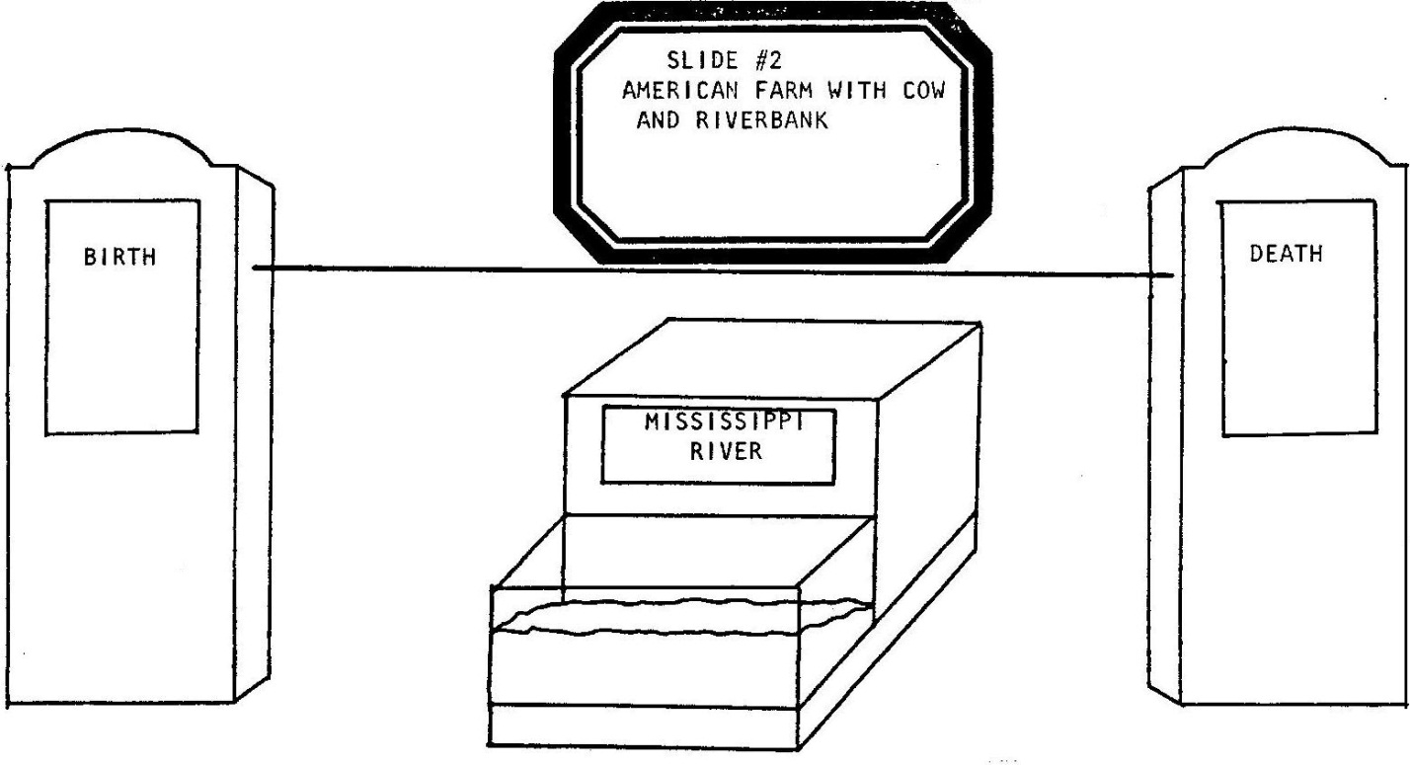

This was 1902 and the plane was not invented yet...

[THE PLANE FLIES OFF—STAGE ON THE LINE.]

...so a stork must have brought them their gift from the sky.

[THE MAN PLAYS PA LINDBERGH. HE SITS AND READS A NEWSPAPER. THE WOMAN PLAYS THE EXPECTANT MA LINDBERGH. SHE KNITS AND SITS. HIDDEN BY HIS NEWSPAPER, THE MAN IMITATES BIRD CALLS. THE WOMAN WAVES OUT A WINDOW. A WHITE GLOVED HAND DESCENDS FROM ABOVE ON A WIRE. THE GLOVED HAND HOLDS A GIFT WRAPPED PACKAGE WHICH DESCENDS INTO THE WOMAN’S LAP. THE HAND WITHDRAWS. THE WOMAN UNWRAPS THE PACKAGE AND FINDS THE PLANE INSIDE, NOW WRAPPED IN A BABY DIAPER. THE MAN CONTINUES TO READ HIS NEWSPAPER. THE WOMAN CUDDLES THE DIAPERED PLANE AS IF A REAL BABY.

MA
Coochie-coochie-coochie—coochie-coochie-coochie—coo.

PA
What’s that you got now?

MA
We‘ve a baby...Pa!

[TO PLANE:]

Coochie-coochie-coochie—coochie-coochie-coochie—coo.

PA
You stopped talkin’ human?

MA
Likes me this way.

[PA PEEKS AT THE PLANE/BABY:]

PA
Not much livelier ‘an a houseplant.

[SHE TRIES TO GIVE HIM THE PLANE/BABY:]

I don't want no weird runt baby!

[HE TAKES THE PLANE/BABY, HOLDS IT ON HIS LAP, MAKES A FACE AND PASSES IT BACK. HE REVEALS A WET GREASE SPOT ON HIS NEWSPAPER.]

Let it age a few years.

MA
Oh, Pa...looks just like you...don‘t it?

PA
No resemblance...them hands...never seen a day’s work...still, hope it‘s a boy...best be, ha, with a mug like that.

[HE TOSSES THE PLANE/BABY UP INTO THE AIR AND CATCHES IT.]

Doesn't cry.

[TOSS AND CATCH.]

Yup, it‘s a boy.

[TOSS AND CATCH.]

Takes after me!

[TOSS AND CATCH.]

Free as an eagle in the sky! Want me to show you the world, son?

[HE TOSSES THE PLANE/BABY BUT ON ITS WAY DOWN MA INTERCEPTS THE BUNDLE.]

MA
Not so fast, please. Back to yer work a while...Pa. Let me watch the birdie.

[ASIDE:]

...“Eagle”, huh?...

PA
I do somethin’ wrong...Ma?

MA
You just think it up a good inspiring name.

PA
[ASIDE:]

“Birdie”, huh?

[HE PACES, MUTTERS, AND REJECTS SEVERAL SISSY BIRD NAMES: ROBIN, DOVE, SWAN, SPARROW, JAY, WOODY PECKER, CHICK. HE IS SUDDENLY INSPIRED:]

Name’s: Lucky Lindy!

MA
Who’s that?

PA
That’s him.
MA
That’s a name???
PA
Yup! LUCKY LINDY!
MA
What for?
PA
Get him out of the house…

MA & PA
…he’ll want to earn it someday!

[THEY EXIT.]

SCENE TWO.

WOMAN
Scene Two.

[THE MAN CRANKS THE STAGE RIGHT SIGN. THE WOMAN CRANKS THE STAGE LEFT SIGN. THE MAN CRANKS THE CENTERSTAGE SIGN. THE GIRL ADVANGES TO SLIDE #3 AND ALSO PLAYS A TAPE RECORDING OF “ROCK-A-BYE, BABY.”]

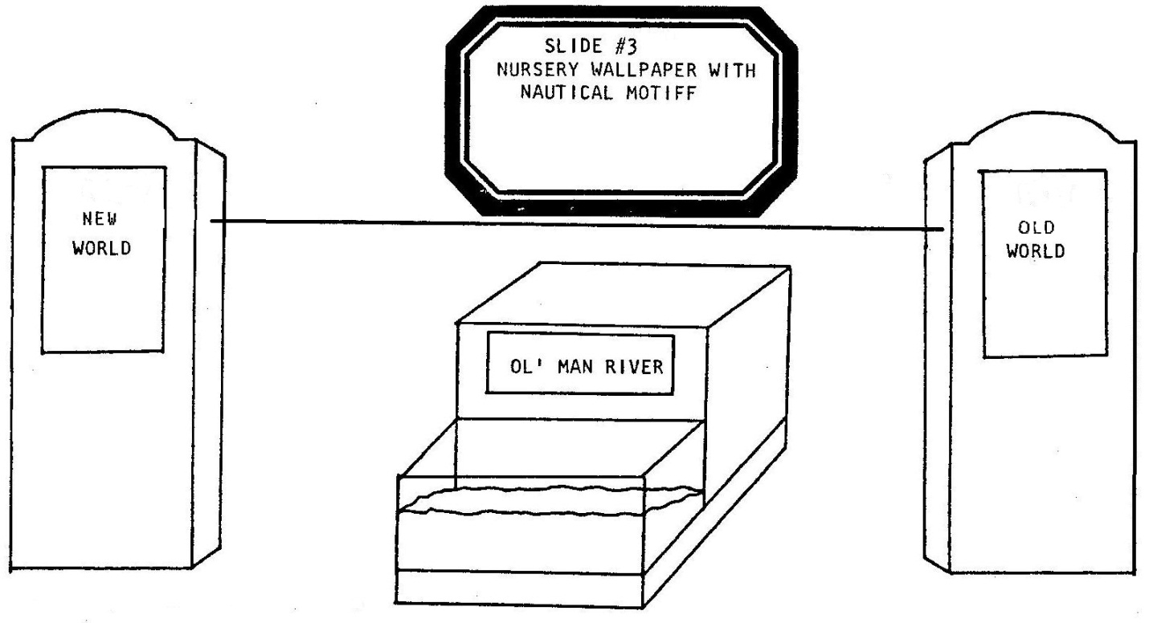

[THE WOMAN UNBUTTONS HER BLOUSE AND BREASTFEEDS THE PLANE/BABY. THE MAN PROVIDES APPROPRIATE SUCKLING SOUND EFFECTS. THE PLANE/BABY BURPS. THE MAN EXITS.]

MA
You're growing up so cute!

[SHE TWIRLS THE PLANE‘S PROPELLER.]

Say: "Ma"...it's not such a hard word. Try and say: "Ma", Lit— tle—-Luc--ky—-Lin--dy...

[SHE THROWS A DIRTY LOOK OFF—STAGE.]

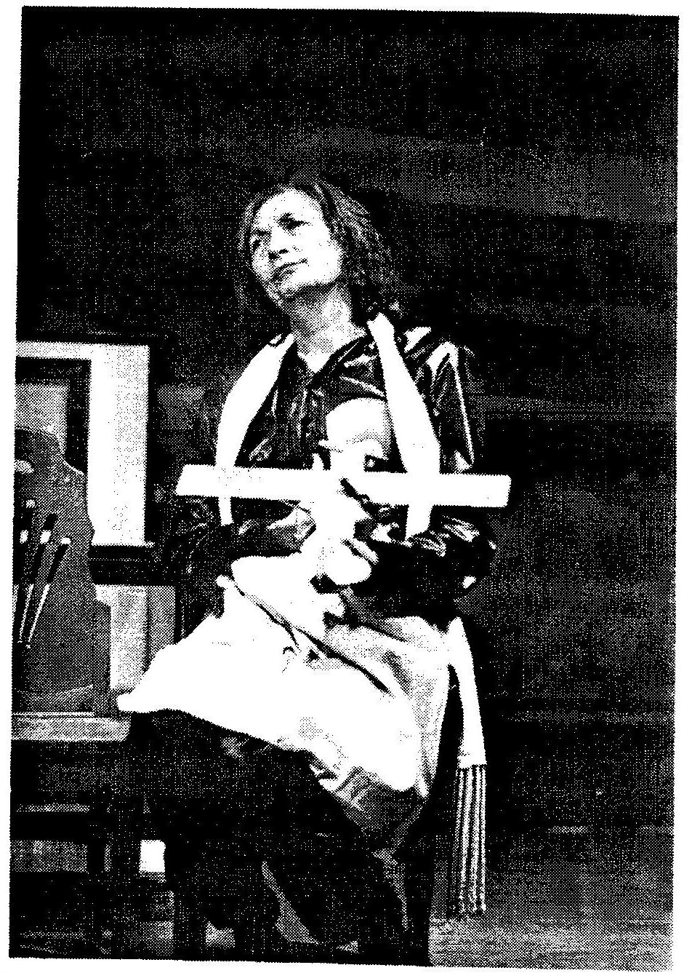

Your Pa's away from the farm a lot ‘cause he’s now a United States Congressman. But in place of his full-time paternal presence, he left you a unique name to live up to. I said: That name’s gonna help the kid amount to somethin’? He said that he wants you to be better than him. I say: Being a Congressman ain’t doin’ too bad! He just says: inspire the boy to look up at the stars...he tosses you in the air a few times and then he’s off to make democracy again. What should I tell ya?...better 'an him...lucky name...look at the stars...I don't know; maybe he wants you to be a navigator...or something...Ow!

SHE PUTS THE PLANE/BABY IN HER LAP AND BUTTONS HER BLOUSE. SHE ROCKS AND HUMS IT A SNATCH OF SEA CHANTY.

Once upon a time, it was summer of the year one thousand —

[SHE TAKES UP AN APPLE.]

- and Leif Ericson -

[SHE PULLS A LEAF OFF THE APPLE.]

- and his father, Eric The Red —

[SHE HAS THE APPLE IN ONE HAND, THE LEAF IN ANOTHER.]

- were sitting and talking things over at the kitchen table:

[SHE TURNS THE APPLE AND LEAF INTO PUPPETS WITH NORDIC VOICES:]

- How ya doing, Dad?
- Oh, can’t complain, Leif. But you look a little bored.
- Fidgety, Old Red. You know.
— Well, what seems to be on your mind, son?
- You think maybe I can borrow the boat tonight?

[AS MA ONCE AGAIN:]

But though Leif was brave and found the New World, listen carefully now, he was unfortunately also simple minded and called it Vinland instead of America, and nobody else was curious to visit.

[SHE TOSSES THE LEAF AND TAKES A BITE OF THE APPLE.]

His relatives forgot him, his life was a waste and we were lost again. Epic explorers, if you MUST be one someday, have to be very clever or else they sacrifice years and years and years of their lives away from their friends, and favorite ethnic foods, and families -

[SHE THROWS A DIRTY LOOK OFF—STAGE.]

- when they go off to make history. You‘ve got to make sure and get it the first time, because opportunity doesn't give out rainchecks. These things are often run as a race. It’s best to go real fast, do it first, win your fame and then come right home. Here's a happier epic example for instance:

[SHE SPOON FEEDS THE PLANE.]

In fourteen hundred and ninety two
Columbus sailed the ocean blue
He sailed and sailed and sailed and sailed and sailed…
And did his stuff, like you'll do too!

[THE PLANE/BABY SPEAKS COURTESY OF THE MAN OFF-STAGE:]

PLANE
"Goo-goo—me-too?"

MA
You talked!

[THE MAN ENTERS.]

PA
I'm home!

[HE TAKES AND TOSSES THE PLANE INTO THE AIR.]

MA
I wish you wouldn't do that.

PA
He likes it. He was born to look at the stars. I want him to invent the airplane!

MA
what are you talking about? It's been done.

PA
Oh.

[HE TOSSES THE PLANE AWAY - MA CATCHES IT IN THE NICK OF TIME.]

You sure?

MA
I don’t know what you know in Washington, but it made the Minnesota papers. Last December, The Wright Brothers did it; Orville and Wilbur.

PA
Orville and Wilbur…Orville and Wilbur? What kind of names are those?

MA
Inventor names -

PA
Orville and Wilbur?!?

MA
- you did him wrong!

PA
Then…He’ll be a flier!

MA
I told him to be a sailor!

PA
Why?!?

MA
To look up at the stars -

[SHE THROWS HIM A DIRTY LOOK.]

- navigation!

PA
That’s sissy stuff!

MA
He likes it!

[AS THE MAN PULLS THE DIAPER OFF THE PLANE:]

PA
You spoil this kid rotten!

SCENE THREE.

[THE MAN CRANKS THE STAGE RIGHT SIGN. THE WOMAN CRANRS THE STAGE LEFT SIGN. THE WOMAN CRANKS THE CENTERSTAGE SIGN. THE GIRL ADVANCES TO SLIDE #4 AND ALSO PLAYS A TAPE RECORDING OF “THE CHARLESTON.”]

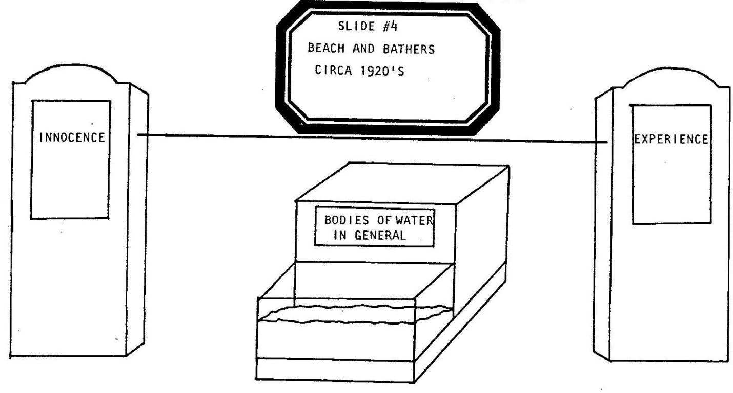

[THE ACTION SWITCHES TO THE LITTLE STAGE OVER THE AQUARIUM AND CENTERSTAGE CRANKY UNIT. THE WOMAN PUTS SUNGLASSES ON THE PLANE'S NOSE AND RUBS ITS WINGS WITH SUNTAN LOTION. SHE RESTS THE PLANE ON A SMALL HAND TOWEL NEXT TO AN OPEN BOOK.]

WOMAN
Now he's older, confused, all alone, talking to himself.

[SHE SPEAKS FOR THE PLANE, LINDY, NOT WITH VENTRILOQUISM BUT AS A PUPPETEER WHO IS SEEN AS AN EXTENSION OF THE FIGURE. SHE DOES EVERYTHING SHE CAN TO PERSONIFY THE PLANE ITSELF.]

LINDY/WOMAN
This isn’t the real me, Joe College; spread out on the beach, checking out the girls.

[SHE WAVES TO THE PLANE.]

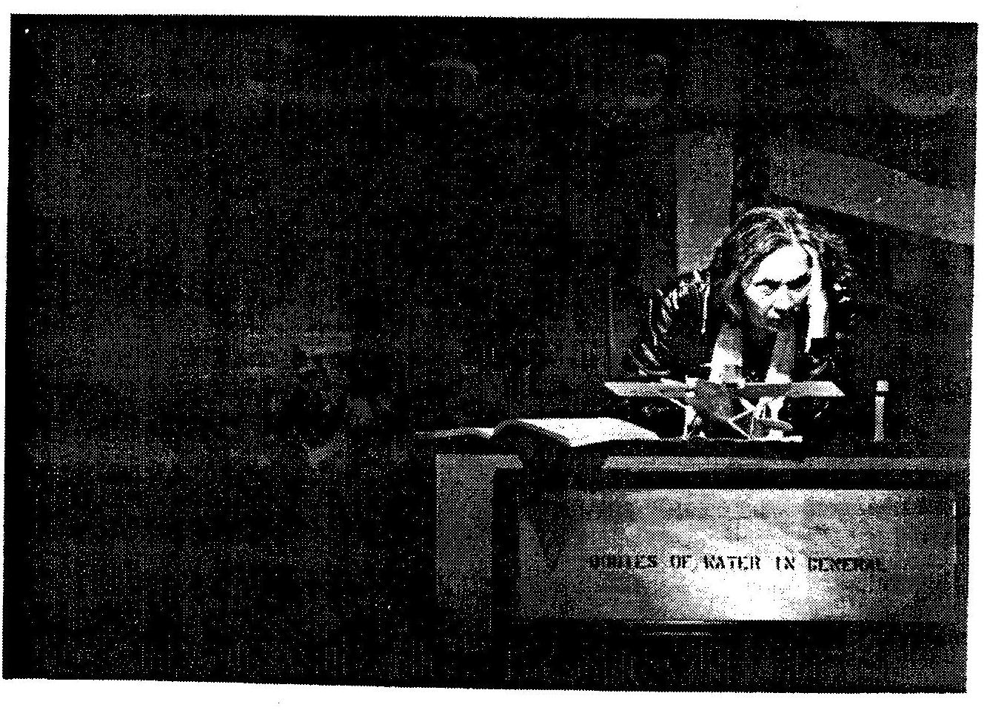

No, admit it, L.L., you want to be a sailor, maybe even a pirate...but you I don't even know how to swim! Who's fault is that?

[THE PLANE THROWS A DIRTY LOOK OFF-STAGE.]

Twenty years old and SOMEBODY never taught me how to swim! Some Captain I’ll make...L.L .... Land-Lubber! How embarrassing. Damn name! What SHOULD I do? I can‘t go home again, Ma stopped talking years ago. Pa was winning all the fights. I remember her last words:

[THE WOMAN MOMENTARILY RESUMES THE ROLE OF MA FOR A FLASHBACK:]

Let him at least learn a trade!?! So help me if you don’t!

[WE SEE MA STOP TALKING. THE WOMAN RETURNS TO PERSONIFICATION OF THE PLANE.]

LINDY/WOMAN
...maybe this IS my last chance! Better give school a try, swallow my pride. Forget about becoming a sailor. Back to the books! I’ll be the BEST hot and cold water plumber there ever was-For Ma!

[SHE PULLS THE PLUMBING TEXTBOOK OVER AND HELPS THE PLANE READ. THE MAN, AS PA, STROLLS IN, SEARCHING THE BEACH FOR HIS SON. HE WALKS A SLINKY DOG ON A LEASH. HE EYES THE PLANE.]

PA
Hi, son.

[THE PLANE IGNORES HIM.]

Remember me?

LINDY/WOMAN
What do you want?

PA
Brought you a surprise!

LINDY/WOMAN
Waterwings?

PA

Guess again.
LINDY/WOMAN
I don’t want it.

PA
A cute puppy-dog!

[HE GIVES THE DOG TO THE PLANE.]

LINDY/WOMAN
I don’t want it.

PA
An American boy should have a dog.

LINDY/WOMAN
An American boy should know how to swim.

PA
You know how I feel about that.

LINDY/WOMAN
I’ll stop talking!

PA
Not you too -

LINDY/WOMAN
Apologize for not fulfilling your fatherly duty.

PA
Got you a dog -

LINDY/WOMAN
You teach me to swim!

PA
Son, let’s have a heart to heart talk, discuss this logically, man to man —

[HE PICKS UP THE PLANE. THE WOMAN HOLDS HER BREATH.]

Now, just stop holding your breath!...damn kid...never learned to listen...

[HE WAITS. THE WOMAN TURNS RED IN THE FACE. PA LOSES.]

...ALRIGHT!

[HE RESTS THE PLANE, UPSIDE DOWN, ON THE RIM OF THE AQUARIUM. THE PLANE‘S WINGS STRADDLE THE EDGES OF THE TANK.]

That’s it, you’ve mastered the Dead Man‘s Float...now, when I let go, I want you to liven up. Kick your feet, turn your arms, okay? I’ll count to three: One. Two. Three: Go!

[HE DROPS THE PLANE INTO THE WATER. THE WOMAN GAGS. HE PULLS THE PLANE OUT OF THE WATER.]

What happened?

LINDY/WOMAN
Give me another chance, please!?!

PA
Then listen to your old man for once. When I say go, you kick and stroke, kick and stroke, like this:

[HE DEMONSTRATES.]

LINDY/WOMAN
Kick and stroke, kick and stroke. I got it, okay.

PA
Okay. Ready? One…Two…Three: GO!

[HE DROPS THE PLANE INTO THE WATER. IT SINKS. THE WOMAN BOBS IT UP AND BLOWS DOWN INTO THE TANK.]

LINDY/WOMAN
Help! Help! I’m drowning! Glub…glub…HELP!

PA
Not from me kid, no more. I’ve done my part. You’ve had your way, now sink or swim in it!

LINDY/WOMAN
I’m drowning!

PA
That’s right. You’re all washed up sailor!

LINDY/WOMAN
Help…HELP!

PA
You want my help? First drop out of college and become a great aviator!

[HE EXITS. THE WOMAN LEAVES THE PLANE UNDERWATER AND RUNS FOR HELP, AS HERSELF, TO THE DOG LEFT BEHIND.]

WOMAN
Well, don’t just sit there, DO SOMETHING, Dog!

[THE DOG DOES NOT DO MUCH, BUT IT DOES MANAGE TO BARK AROUND AND FIND A ROLL OF CANDY LIFESAVERS. THE WOMAN HOLDS THEM UP. AN ASIDE:]

Lifesavers!

[SHE THROWS THE ROLL OF LIFESAVERS INTO THE WATER. THE PLANE SWIMS TO THE CANDY AND SHE TAKES THE DRIPPING WET LINDY FROM THE WATER AND PLACES THE PLANE ON ITS BACK ON THE LITTLE STAGE. SHE PULLS OVER THE SLINKY DOG, PLACES ITS FRONT PAWS ON THE PLANE‘S UNDERBELLY, AND RESUSCITATES THE PLANE. RIGHTSIDE-UP AND BREATHING, THE PLANE HUGS THE DOG.]

LINDY/WOMAN
Thanks –

[THE WOMAN, HERSELF, NARRATES:]

WOMAN
-the lad said to his dog, once his lungs had filled with air again instead of water —

LINDY/WOMAN
—I think I've learned my lesson. Dad was right about you...and school...and swimming...and maybe he‘s even right about some other things, too. From now on I’ll hate the water and set my sights on becoming a pilot. And as for you, false friend-

[THE PLANE SPITS INTO THE AQUARIUM.]

-I vow someday I‘ll get my revenge!
SCENES FOUR - ELEVEN.

[THE MAN CRANKS THE STAGE RIGHT SIGN. THE WOMAN GRANKS THE STAGE LEFT SIGN. THE MAN CRANKS THE CENTERSTAGE SIGN. THE GIRL ADVANCES TO SLIDE #5.]

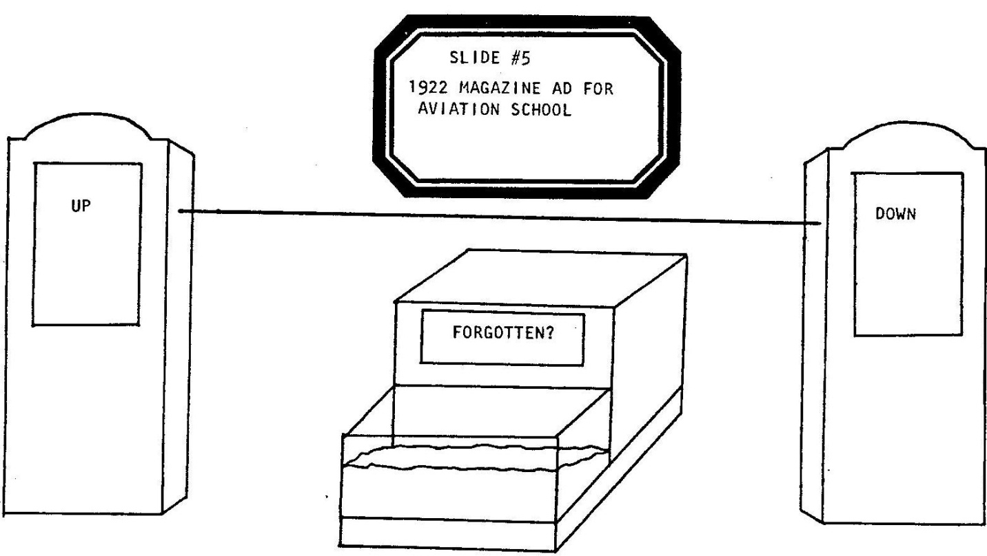

WOMAN
Scenes Four through Eleven:

[THE DOG IS PUT AWAY. THE WOMAN CALLS THE FIRST MINI-SCENE:]

Four!

MAN
1922. Lindy, the Lucky still unearned, makes for a cheap flying school in Lincoln, Nebraska and takes his very first plane ride from the fast side of town.

[THE WOMAN PLAYS A MAE WEST-LIKE CHARACTER COMBINING ALL OF LINDY'S FLYING TEACHER INTO ONE CHARACTER OF A PROSTITUTE WITH A FIRST-TIME CUSTOMER. SHE CARRIES A BOTTLE OF BOOZE.]

PROSTITUTE
Ready or not, here we go, Momma's boy!

[THE MAN NOW TALKS FOR THE PLANE.]

LINDY/MAN
Flap and fly; flap and fly. I think I‘ve got it...okay! Contact!

PROSTITUTE

[ASIDE:]

He's never done this before, ain’t that slim? Hey, I'm gonna nickname him: “Slim".

[SHE TALKS TO THE PLANE:]

Oh, yeah...and that’s cash...in full...in advance-—Slim.

[MONEY IS EXCHANGED. SHE PUTS IT IN HER QUITER]

Then let's see to your trip-let’s go for a ride-after you:

[SHE POINTS THE WAY, HE POSITIONS HIMSELF IN FRONT OF HER, SHE PUTS OUT HER LEG.]

LINDY/MAN
Contact?

PROSTITUTE
Contact!

[SHE PUSHES HIM OVER HER LEG INTO A TRIP. THE GIRL ADVANCES TO SLIDE #6.]

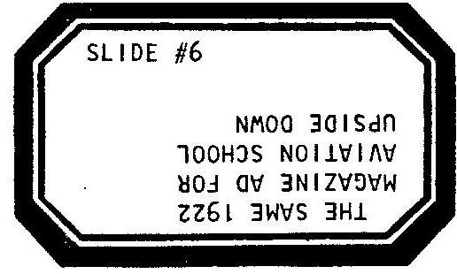

[THE MAN NARRATES.]

MAN
The flying school folded before "Slim" finished the course.

WOMAN
Five!

[THE GIRL ADVANCES TO SLIDE #7.]

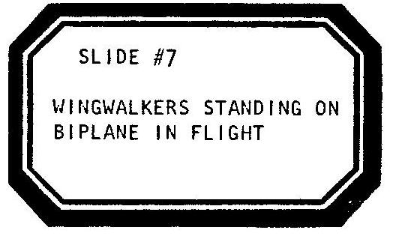

MAN
So suckered Slim knocked and knocked on the door of a stunt pilot and begged for a job — any job:

[HE ASSISTS THE PLANE’S WING IN KNOCKING ON AN IMAGINARY DOOR. THE WOMAN, WITH BOTTLE, ANSWERS. THE PLANE GRABS HER BOTTLE AND POURS OUT THE BOOZE INTO THE AQUARIUM. THE WOMAN REVEALS ANOTHER BOTTLE.]

PROSTITUTE

[ASIDE:]

Dares to tell ME he'd do ANYTHING for a break and a buck! Ain’t that the devil! Hey, suppose I nickname him: "Daredevil”?

[SHE LAUGHS AND ADDRESSES THE PLANE:]

Better buy some shoes and insurance, "Daredevil", I‘m gonna let you walk out on my wings...

[THE MAN, WITH THE PLANE, WALKS TWO TIGHTROPE STEPS. THE GIRL ADVANCES TO SLIDE #8.]

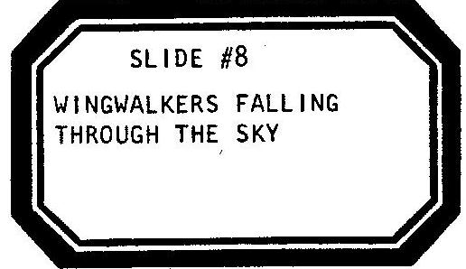

WOMAN
Six!

MAN
And then "Slim"..."Daredevil"...whomever...starts to save and get smart, leaves his betters behind and jumps out on his own.

[HE CLIMBS A CHAIR WITH THE PLANE. THE GIRL ADVANCES TO SLIDE #9.]

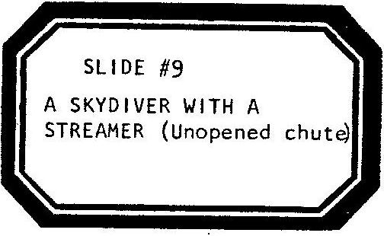

PROSTITUTE
Ain’t gonna hear me calling him: Geronimo...

[THE MAN JUMPS AND FLOATS THE PLANE TO THE STAGE. THE PROSTITUTE FOLLOWS THE MOCK-PARACHUTE JUMP WITH TWO BOTTLES AS BINOCULARS. SHE IS IN LOVE WITH HIM:]

Oh..."Geronimo!"...Geronimo...Geronimo...

[JUST BEFORE THE PLANE CRASHES TO THE STAGE, THE GIRL ADVANCES TO SLIDE #10.]

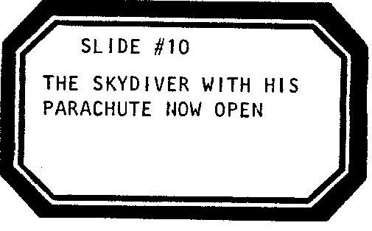

WOMAN
Seven!

[THE GIRL ADVANCES TO SLIDE #11.]

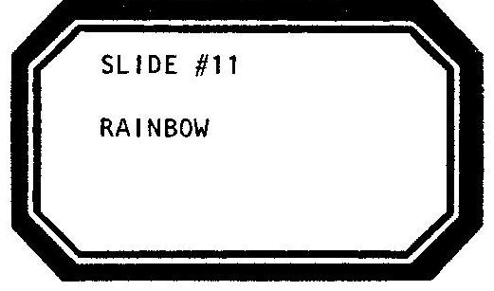

MAN
1923: He's finally twenty one.

[HE PICKS THE PLANE UP OFF THE STAGE AND ATTACHES IT TO THE LINE AS IT WAS LAST SEEN SUSPENDED IN THE PROLOGUE. HE LETS GO. THE PLANE FLOATS IN THE AIR.]

He buys his very own plane and takes his first solo flight. It’s a broken down jalopy, a war surplus Jenny, but it takes him up all alone in the air... and nobody calls him nothin’.

[FOR A MOMENT HE DOES NOTHING BUT GRIN AND PUSH THE PLANE BACK AND FORTH ON THE LINE IN FRONT OF THE RAINBOW SLIDE.]

WOMAN
Eight!

[THE GIRL ADVANCES TO SLIDE #12.]

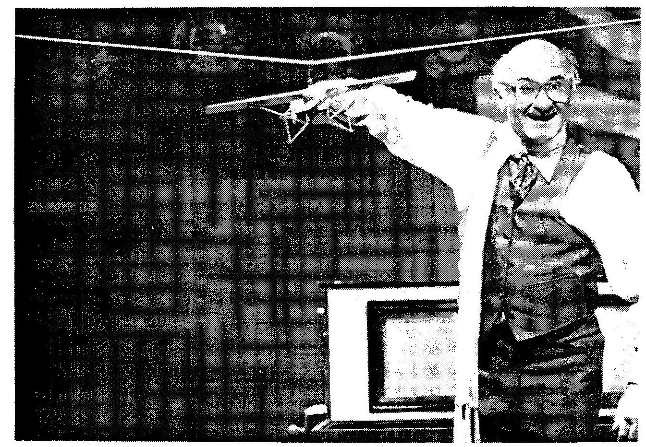

MAN
He’s tried it. He likes it. He barnstorms all over the South and Midwest.

[HE BOUNCES THE PLANE ALONG THE LINE. STUNTS AND DIVES]

LINDY/MAN
I like it. I like it. I'm a natural at something, it's like I was born to be here...wheee! Am I...Lucky? I feel like a different man! I wonder if my own mother would even recognize me?

WOMAN
Nine!

THE GIRL ADVANCES TO SLIDE #13.

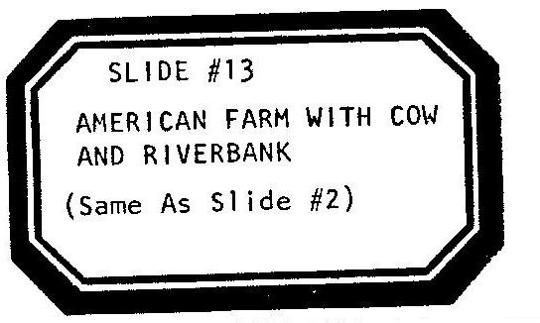

[THE GIRL ALSO PLAYS THE TAPE RECORDING OF TURKEY IN THE STRAW FROM SCENE ONE. THE MAN AND THE WOMAN AGAIN PLAY MA AND PA — WE NOW SEE THEM YEARS LATER. THEY POSE TIGHT LIPPED, LIKE THE PAINTING AMERICAN GOTHIC, BETWEEN THE SLIDE OF THE FARMHOUSE AND THE LINE. MA SEES THE PLANE ON THE LINE AND IS ABOUT TO TELL PA, BUT THEN REMEMBERS THAT THEY ARE NOT TALKING TO EACH OTHER. MA TAKES OUT A PAD AND A CARPENTER‘S PENCIL AND WRITES A NOTE TO PA. THE FOLLOWING DIALOGUE BETWEEN MA AND PA IS ENTIRELY CARRIED OUT BY THE USE OF SUCH SIGNS.]

MA WRITES
"Lookee There!”

PA WRITES
"I See!"

MA WRITES
“You Gonna Talk?”
PA WRITES
“You Talkin’ First?”

MA WRITES
“You Gonna Fly???”
PA WRITES
“In THAT Sissy Old Plane?”

MA WRITES
“…but…but…He Likes It!”
PA WRITES
“…HARUMPH!...”

MA WRITES
“Hi, Son!”

[THE MAN ENTERS, BUT NOW TO SPEAK FOR LINDY. PA, AS IT WERE, REMAINS IN THE HOUSE.]

LINDY/MAN
Come on, Ma! Ladies first!

[THEY DIP AND “FLY” TOGETHER.]

What do you think of your boy now?

MA WRITES
“…Nice…”

[THEY LAND.]

LINDY/MAN
Aw, Ma! You just go into the house and write Pa a note that his son’s come home and it’s his turn now.

[SHE EXITS AND THEN BACKS RIGHT OUT ONTO THE STAGE.]

MA
…Pa…

LINDY/MAN
You talked!

MA
…Pa’s dead.

[SHE LAUGHS HYSTERICALLY.]

LINDY/MAN
Dead?

[SHE STILL LAUGHS.]

MA
I hated his guts!

[HE SLAPS HER ACROSS THE FACE. SHE FREEZES.]

LINDY/MAN
Pa have…heart trouble?

MA
Died of shame.

LINDY/MAN
But I’m a pilot!

MA
Not one up with the stars…

[HE FLIES OFF. SHE SUDDENLY FEELS THE PAIN FROM THE SLAP ACROSS HER FACE.]

MA WRITES
“Ow.”

[SHE HOLDS THE SIGN UP AS LINDY’S PLANE FLIES OFF. SHE BACKS OFF THE STAGE, WAVING HER SIGN AS THE PLANE GETS FARTHER AND FARTHER AWAY. HE FLIES THE PLANE SIX INCHES OFF OF THE GROUND]

LINDY/MAN
I guess Pa, as always, was right to the end. I’m not my father’s son…Lucky Lindy, ha! I’m just a seamy sided pilot dwelling in the lowly, unepic portions of the sky!

[HE NARRATES.]

MAN
His sense of place, all the joy he had felt, was suddenly gone-and then he faced the facts:

LINDY/MAN
I think it’s time I learned what it’s like to be a real man!

WOMAN
Scene Ten – Hup!

[THE GIRL ADVANCES TO SLIDE #14.]

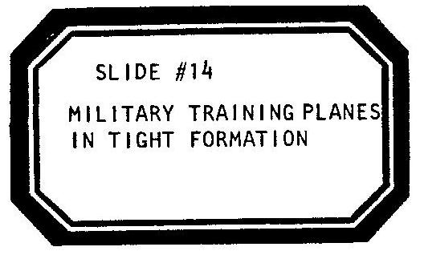

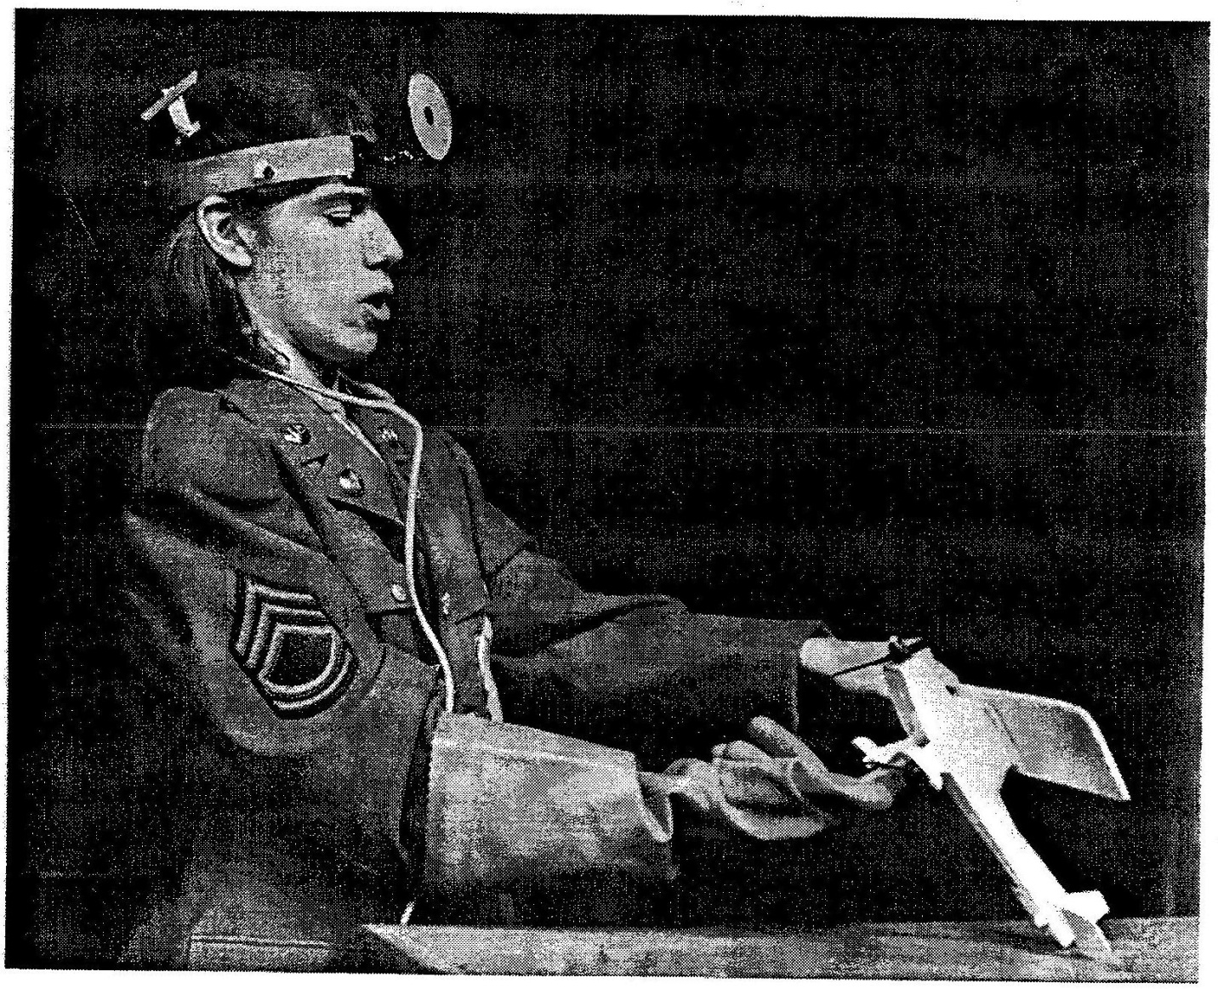

MAN
1924: Entering the United States Army Flying School for a two year stint of: DISCIPLINE!

WOMAN OFF-STAGE
-and that's American to me. Next!

[THE MAN HOLDS THE PLANE ON THE STAGE OVER THE AQUARIUM. THE WOMAN ENTERS AS AN INDUCTION DOCTOR. SHE WEARS A JANITOR’S RUBBER GLOVE THAT COMES UP TO HER ELBOW.]

DOCTOR
Don’t mind me too much, boy. I won’t hurt ya. Drop your drawers.

[PLANE STANDS ERECT.]

At ease, flyer…I’m only maintenance here.

[PLANE TILTS DOWN AND BACKS OFF. SHE POKES A GLOVED FINGER BETWEEN ITS WHEELS.]

DOCTOR
Cough...cough...good. You get injured in training...say: Ahh... I’ll patch up the worst scratches...breathe deeply...then check to see if your locker looks neat. If it's messy, you’re sick, that’s the best clue for me...under the tongue…

[SHE PLACES AN AIR PRESSURE TIRE GAUGE UNDER THE PLANE'S PROPELLER. SHE SHAKES DOWN THE AIR GAUGE AND CHECKS IT LIKE A THERMOMETER.]

Now, I want you staying in shape, fit for a challenge. You just ain’t born an American. You got to watch for your chance. Just try and look good when your turn comes, this country wants heroes. Make the grade on your day, and that’s American to me!

[SHE SALUTES THE PLANE.]

...see ya...NEXT!

[SHE EXITS.]

MAN
Two years later, Lucky Lindy graduated, you guessed it, first in his class, was made a Second Lieutenant; but in 1926, even properly trained, perhaps too overqualified for work, he could find no other job except as an airmail pilot flying the route between–

[HE CLOTHESPINS TWO ENVELOPES TO THE PLANE’S WINGS. THEY ARE ADDRESSED:]

-Chicago and St. Louis.

WOMAN
Eleven!

[THE GIRL ADVANCES TO SLIDE #l5.]

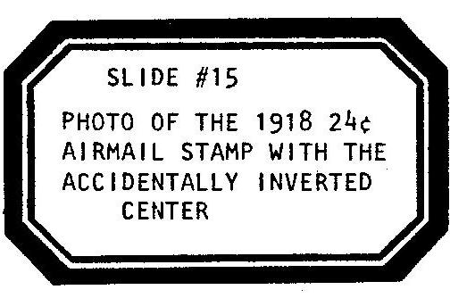

[THE MAN SLIDES THE PLANE WITH LETTERS BACK AND FORTH ON THE LINE LIKE A PINBALL AND DELIVERS THE MAIL.]

LINDY/MAN
What dumps! What a life! I'm gnawing at the pits again. Where's the challenge? Not rain nor sleet nor snow can stop the mail... from getting me down. I wish there was a war I could get shot at in; I haven't felt fulfilled a single day in my life. Maybe my old dog, my only true friend who once saved my life, can cheer me if I take him up for a spin.

THE MAN SETS THE SLINKY DOG ON THE STAGE OVER THE AQUARIUM AND ATTACHES ITS LEASH TO THE PLANE NOW SUSPENDED FROM THE LINE. THE PLANE BEGINS TO SLOWLY FLY OFF STAGE - THE DOG IS DRAGGED ACROSS THE SMALL PLATFORM, AND THEN FALLS OFF. IT DANGLES, SUSPENDED
FROM ITS LEASH. THE PLANE EXITS WITH THE DOG IN TOW.

MAN
"ARGGH", said the dog, whatever its name was, as it strangled, dangling on its leash. But bad-cursed Lucky Lindy of St. Louis, Missouri did not hear the yelp; as his mind was preoccupied with his own failures, tenfold!

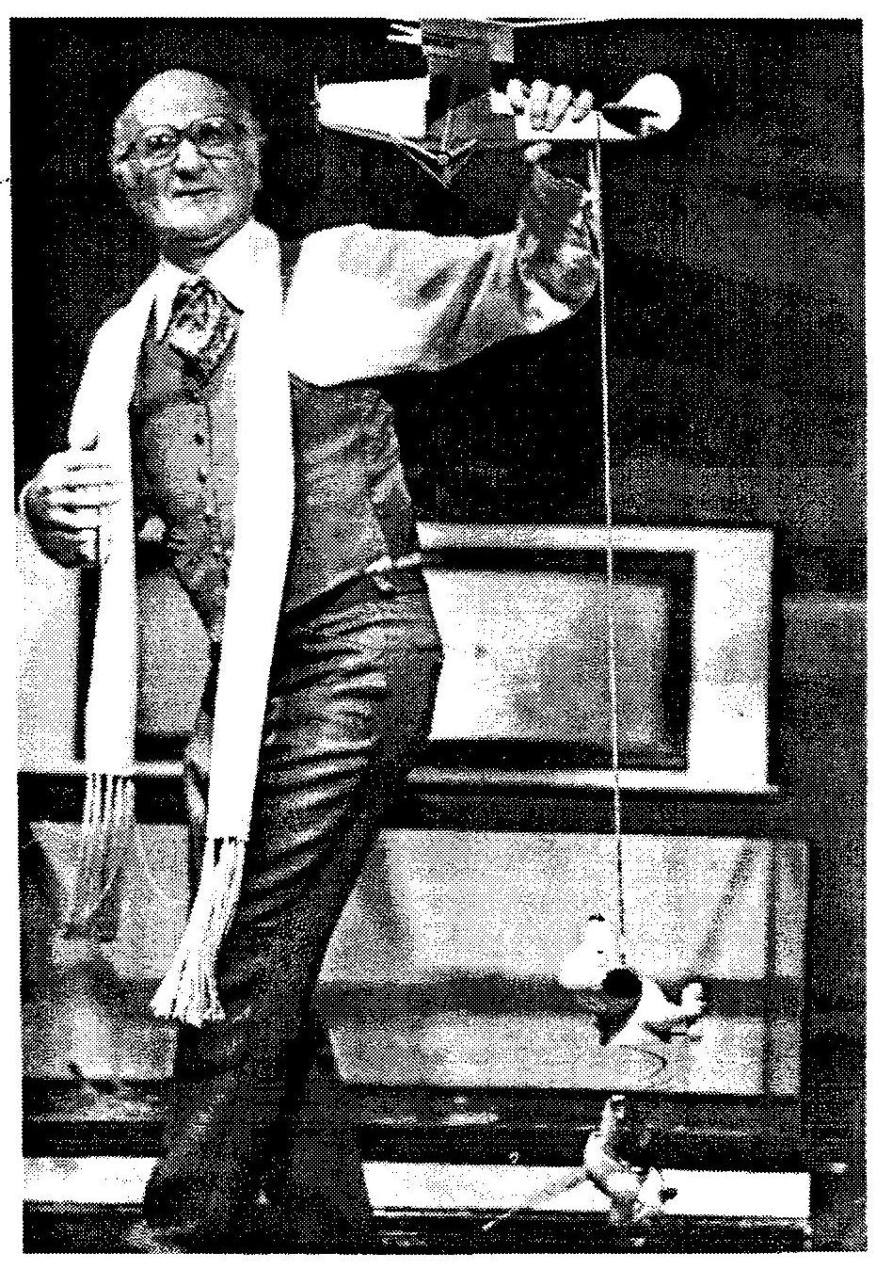

SCENE TWELVE.

WOMAN
Meanwhile:

[THE GIRL ADVANCES TO SLIDE #16.]

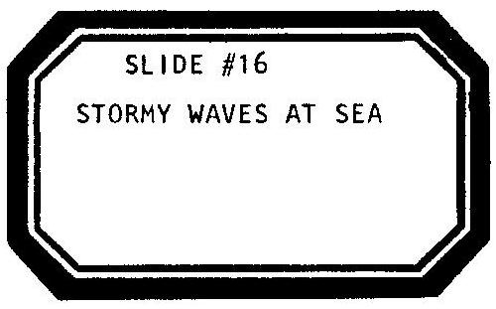

Scene Twelve!

[THE WOMAN DONS A BERET AND STUFFS HER POCKETS WITH PAPER MONEY.]

A fat little Frenchman-

[THE WOMAN CRANKS THE STAGE LEFT SIGN.]

—who was named Raymond Orteig made a whole lot of money off two hotels in New York—

[THE WOMAN CRANKS THE STAGE RIGHT SIGN.]

Ray liked it when people crossed the sea-

[THE WOMAN CRANKS THE CENTERSTAGE SIGN AND POURS SALT IN THE WATER.]

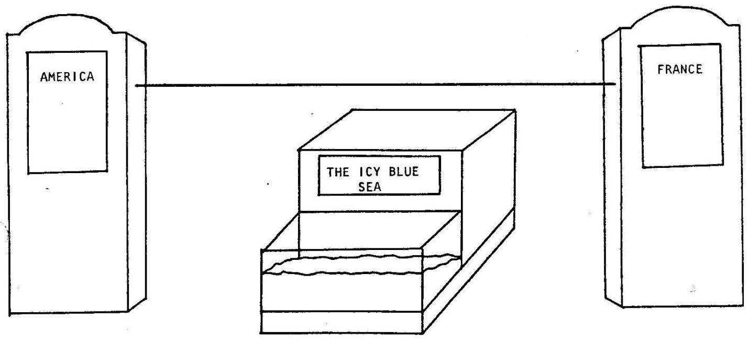

-from one continent to another. When his countrymen stayed in America, his hotels were full; and when Americans went to Paris, Raymond's brother did well too.

[THE MAN APPEARS WEARING A BERET AND A FAKE MUSTACHE-JUST LIKE ALL THE OTHER FRENCHMEN IN THIS PLAY. HE WAVES TO THE WOMAN FROM ACROSS THE WATER.]

As far as the fat little Frenchman was concerned, people could not cross the Atlantic fast enough; especially since his younger brother, who only owned one hotel and wasn't nearly as rich as Ray, kept on sending telegrams that read:

[THE MAN, PIERRE ORTEIG, CLOTHESPINS A TELEGRAM TO THE LINE AND SENDS IT ACROSS TO HIS BROTHER. HE SPEAKS WITH A PHONY FRENCH ACCENT:]

PIERRE
Don’t send advice—send TOURISTS!

WOMAN
So, one sunny day, when his brother's birthday was almost near, Monsieur Orteig thought:

[SHE TOO PUTS ON A MUSTACHE AND A PHONY FRENCH ACCENT TO BECOME RAYMOND ORTEIG.]

RAYMOND
Because I love my brother, I have invested a whole lot of money, in a new luxury liner-

[SHE REVEALS A TOY LUXURY LINER NOT UNLIKE THE TITANIC.]

-That will become ze fastest,
And ze safest,
And ze biggest, boat on ze sea.
And so it can get there,
In time for Pierre,
I will fill it with extravagant New Yorkers-

[THE MAN ENTERS IN A NEW COSTUME: AN EXTRAVAGANT l920‘S NEW YORKER. HE NURSES AN ICED DRINK IN A HUGE BRANDY SNIFTER.]

And launch ze ship, Just now. Excusez—moi.

[SHE FLOATS THE BOAT IN THE AQUARIUM. THE MAN AND WOMAN AND GIRL CELEBRATE A BON VOYAGE PARTY. THE WOMAN CHRISTENS THE BOAT WITH A CHAMPAGNE POPPER. THE GIRL PLAYS A TAPE RECORDING OF CROWD AND BOAT WHISTLE SOUND EFFECTS. THE WOMAN AND GIRL WAVE AND BACK OFF-STAGE, THE BOAT AND THE MAN ARE AT SEA. HE NURSES HIS DRINK. THERE IS A THUD. HE SUDDENLY BEGINS TO IMITATE A MORSE CODE S-O-S AND ANNOUNCES IN THE STYLE OF WALTER WINCHELL:]

MAN
Good evening, Mister and Misses North America and all the ships at sea. The Titanic struck an iceberg-

[HE DUMPS HIS DRINK INTO THE AQUARIUM. THE ICE CUBES SINK THE TOY BOAT. THE LUXURY LINER SINKS TO THE BOTTOM OF THE TANK AND REMAINS THERE FOR THE REST OF THE PLAY.]

Fifteen-hundred died in style!

[THE GIRL ADVANCES TO SLIDE #17.]

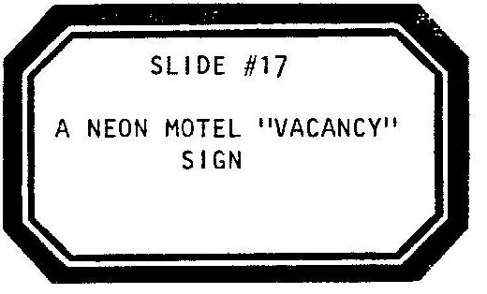

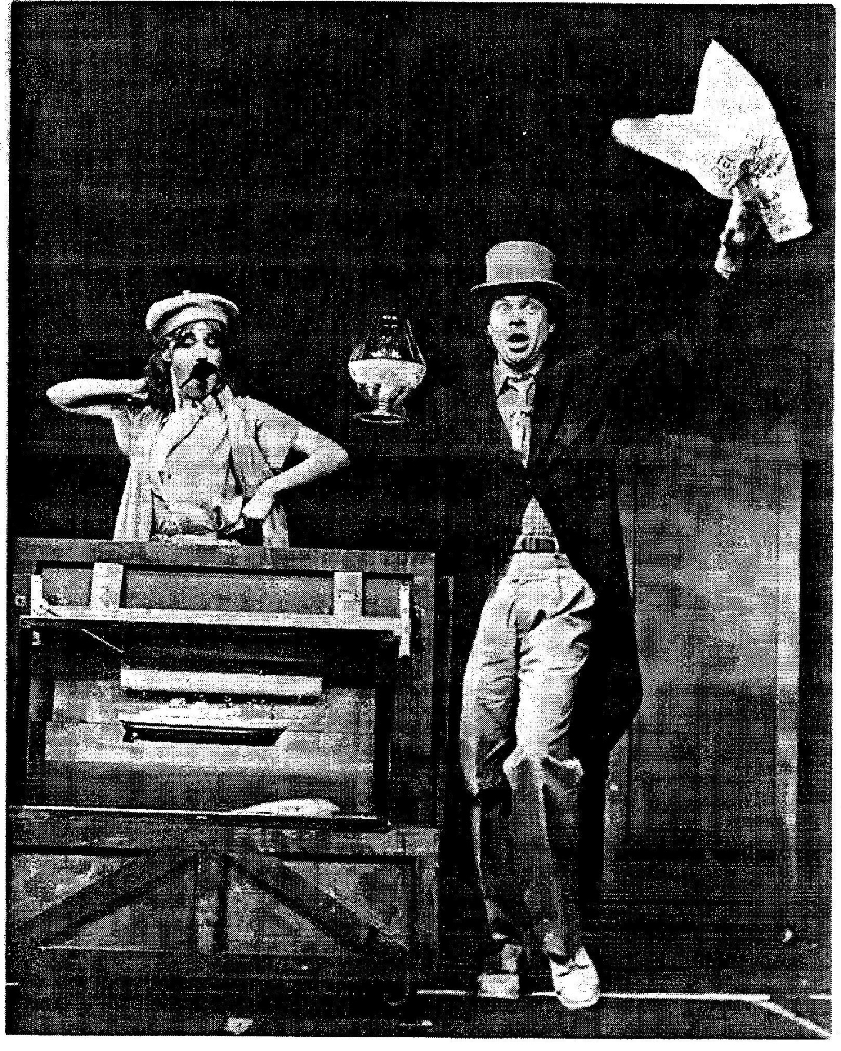

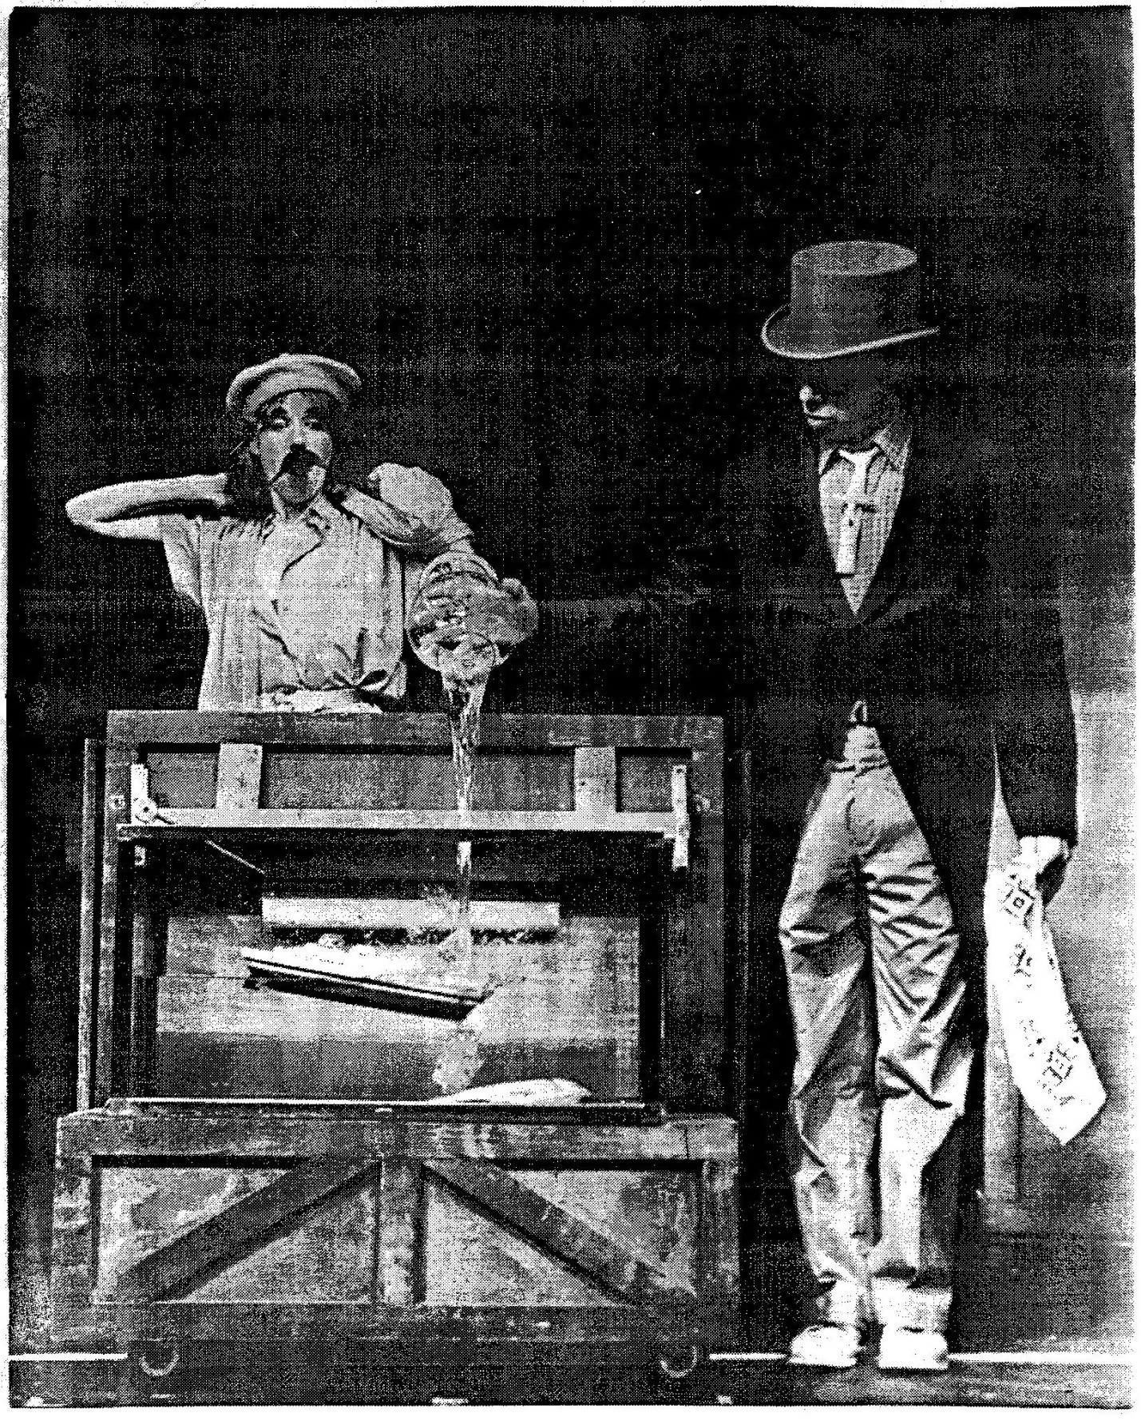

SCENE THIRTEEN.

WOMAN
Scene Thirteen:

[THE WOMAN CRANKS THE STAGE RIGHT SIGN. THE MAN CRANKS THE STAGE LEFT SIGN. THE MAN CRANKS THE CENTERSTAGE SIGN.]

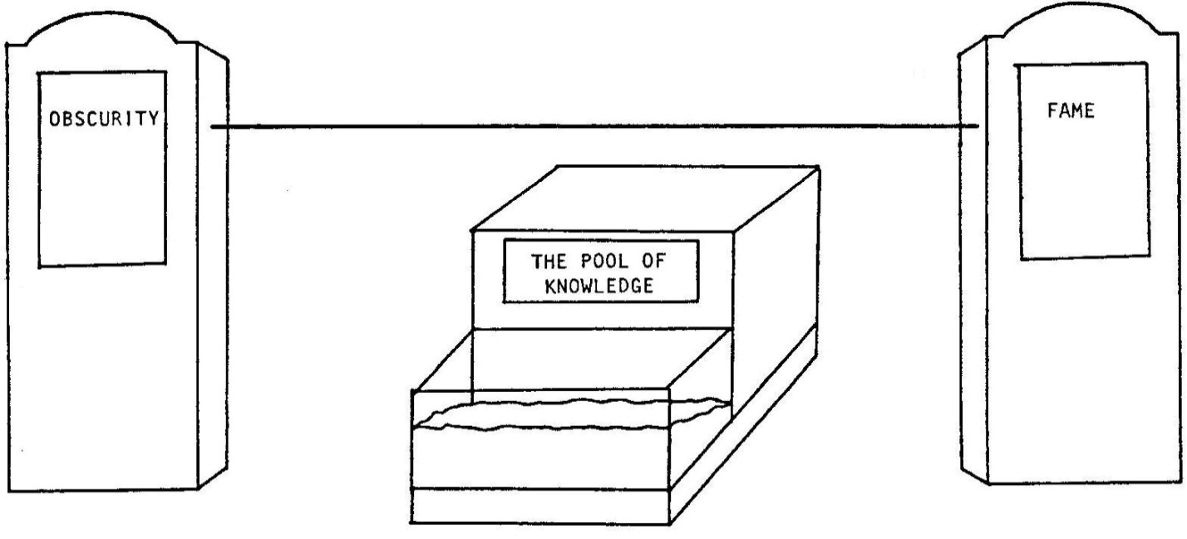

[SHE CLOTHESPINS A TIN CAN TELEPHONE ONTO THE LINE NEAR THE “OBSCURITY" END OF THE STRING.]

RAYMOND
Who is it can solve zis problem? Master zis ocean? Who can fill zis void? Leap zis expanse? Hop zis distance? I have been on ze phone all day long. I have talked to too, too many people. One architect sez he has invented ze world's longest floating bridge. One scientist has a waterproof transmutation machine. Should I listen to them? I think they are all, how do you say...
but then, what do I know? I have another one on ze phone right now: Oui? Oui? Oui? Oh, oh,...oh, oh, oh, no!

[SHE PUTS DOWN THE PHONE.]

And that was ze last caller. Now who can zis little rich French fatty turn to? I have an idea-

[SHE PICKS UP THE PHONE.]

Operator?

[OFF-STAGE THE MAN PINCHES HIS NOSE AND ANSWERS:]

MAN
Yes?

RAYMOND
Get me ze brightest of all you Americans!

MAN
One moment please.

[THE MAN ENTERS SMOKING A PIPE AND HOLDING A LIGHTBULB. HE CLOTHESPINS ANOTHER TIN CAN TELEPHONE ONTO THE LINE AT THE “FAME” END OF THE STAGE. HE TINKERS WITH THE BULB AS HE TALKS.]

RAYMOND
Iz that you, Thomas Edison?

EDISON
Now, Ray, I’m busy-

RAYMOND
But you do not know me!

[EDISON CHUCKLES.]

Sacre bleu! Ze man, he knows everything!

EDISON
-so just let me tell you what you need to know about crossing the water, okay?

RAYMOND
Whatever you say.

[ASIDE:]

Ze man is too much!

EDISON
Don’t need no gizmos for the Atlantic. Just planes.

RAYMOND
But planes, they cannot fly so far!

EDISON
That’s what you and planes think.

RAYMOND
Perhaps with an extraordinary…brave pilot…maybe…

EDISON
This is the new world speaking, Frenchie, we don’t need that kinda stuff anymore. Forget the driver. You turn this thing into a business proposition, put up some money, make it worth a company’s while-

[THE TRICK LIGHTBULB FINALLY LIGHTS-WHEN STICKING OUT OF THE BOWL OF HIS PIPE. EDISON LOOKS AT THE BULB. HE LOOKS AT THE PIPE…]

-Listen…I gotta go!

[HE IS GONE. THE PHONES ARE PULLED OFF.]

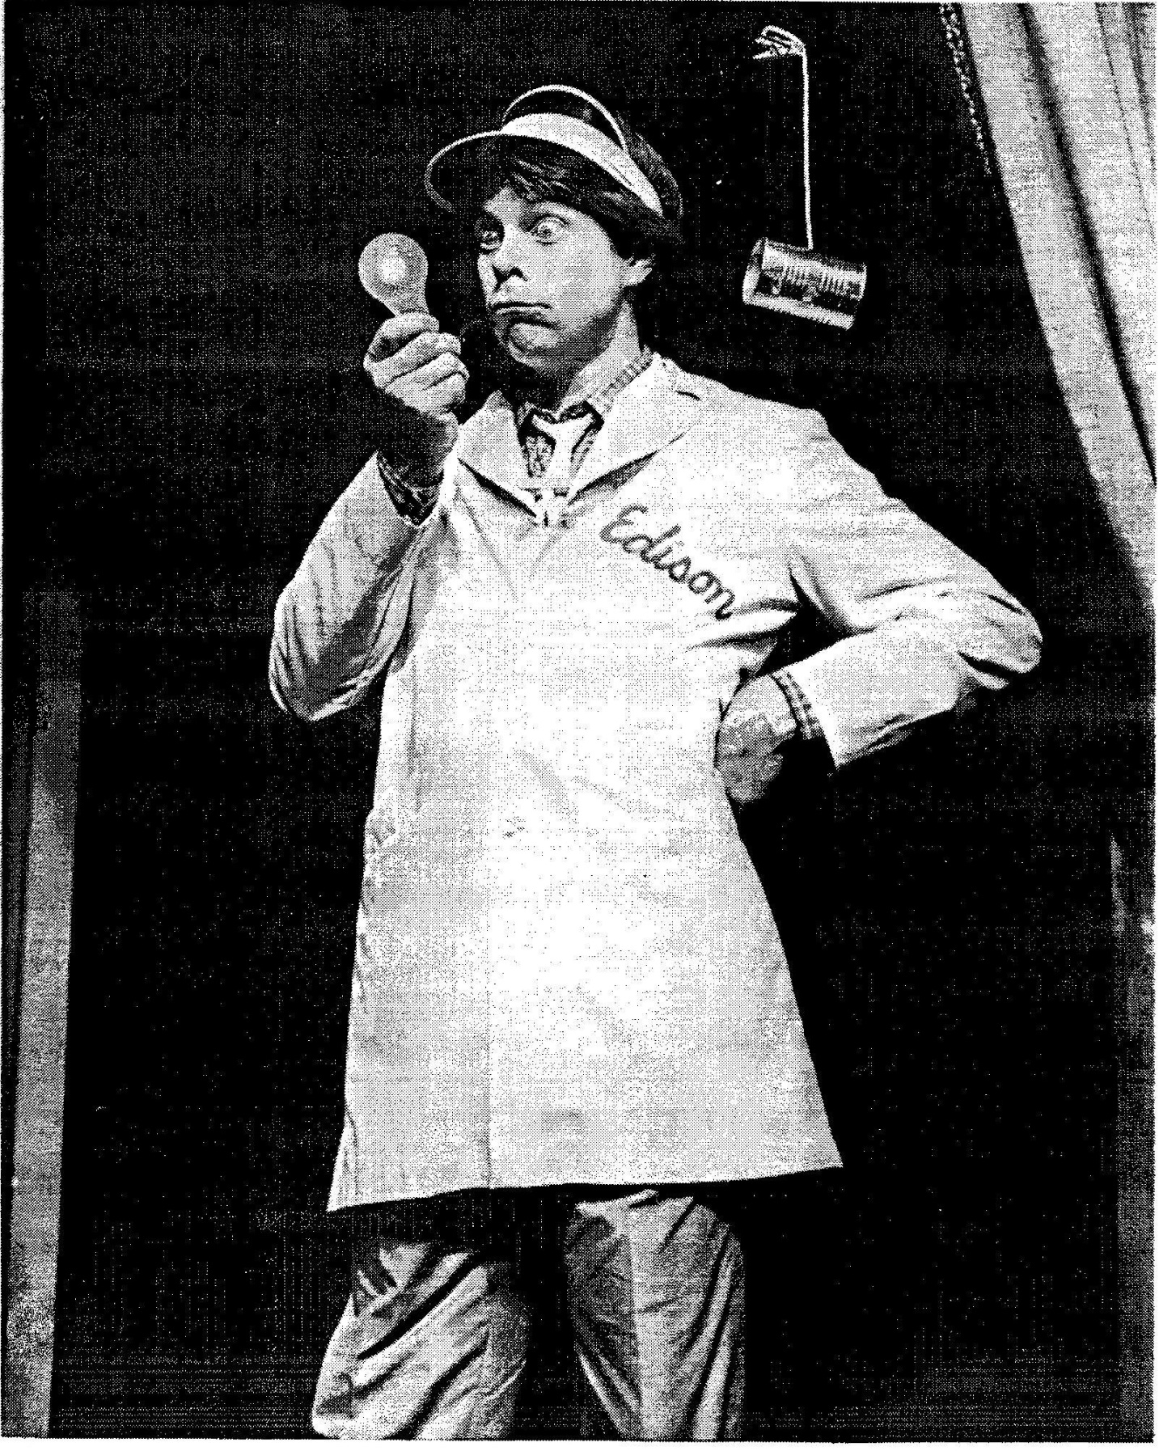

SCENE FOURTEEN.

WOMAN
Scene Fourteen: 1926.

[THE WOMAN CRANKS THE STAGE RIGHT SIGN. THE WOMAN CRANKS THE STAGE LEFT SIGN. PREGNANT PAUSE. THE WOMAN CRANKS THE CENTERSTAGE SIGN.]

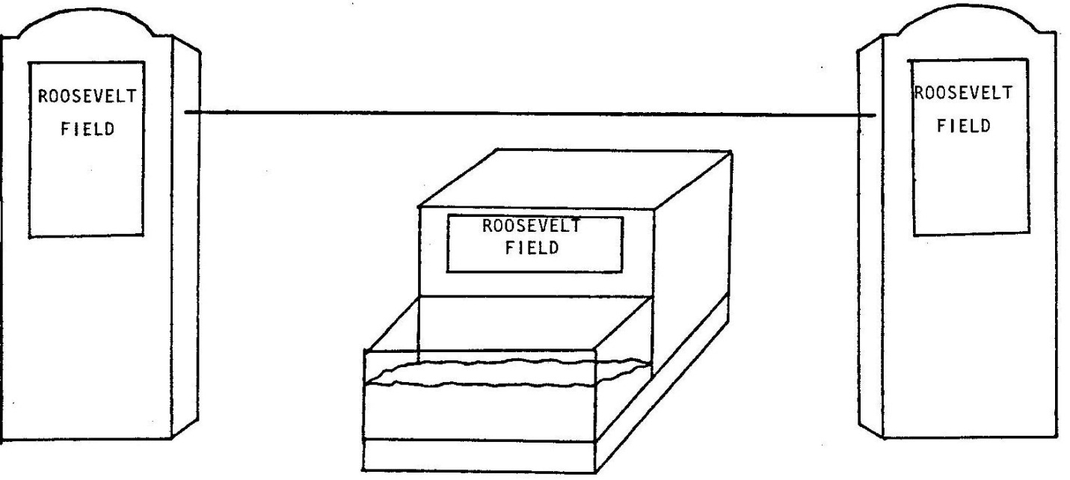

RAYMOND
Oui, Ladies and Gentlemen, I will pay $25,000 to ze first plane to fly New York to ze City of Lights, non—stop. Zis I will call: Ze Orteig Prize...and you very clever Americans are ze first ones I’ve let know.

[THE MAN ENTERS WEARING AVIATOR GOGGLES AS WELL AS TYPICAL FRENCH BERET AND MUSTACHE. HE HOLDS A MAP.]

FONCK
We are Captain Rene’ Fonck and three other smart Frenchmen!

[HE DROPS THE MAP AND REVEALS THREE AVIATOR DOLLS STICKING OUT OF HIS PANTS. THEY TOO WEAR BERETS, GOGGLES AND MUSTACHES.]

RAYMOND
A surpreeze! My own people! And I announced to all at ze same time!

[ASIDE:]

I hope you did like I wrote you, cousin.

FONCK

[ASIDE:]

Mai, oui. Viva la France!

RAYMOND
Captain Rene’, did you bring a plane with you?

[THE GIRL ADVANCES TO SLIDE #18.]

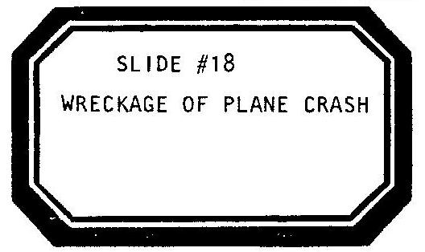

FONCK
Oui! We are four Frenchman, our plane is Sikorsky. We have three big engines and two radio sets. A stove to cook hot meals, a red leather cabin. A bed-

RAYMOND
Oo—la-la!

[FONCK PUTS A CIGAR IN HIS MOUTH.]

FONCK
-and a big bag of presents in back. We weigh 28,000 pounds. We are just like ze future. We are doing zis —

[HE LIGHTS HIS CIGAR. IT EXPLODES IN HIS FACE. HE SHUFFLES OFF-STAGE.]

...exactamoi...

SCENE FIFTEEN.

WOMAN
Scene Fifteen:

[SHE CRANKS THE STAGE RIGHT SIGN. SHE CRANKS THE STAGE LEFT SIGN.]

Back in sulky St. Louis-

THE GIRL ADVANCES TO SLIDE #19.

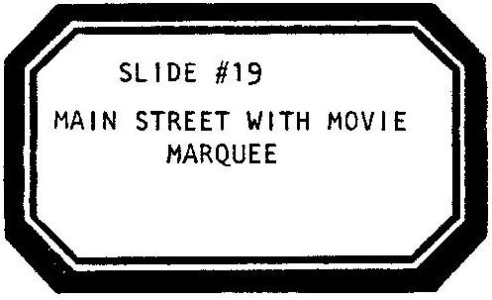

—the day after he’d absentmindedly crashed a mail-plane; Lucky Lindy...remember Lucky Lindy?

[THE PLANE, NOT SEEN SINCE THE DOG'S UNTIMELY DEATH, ENTERS ON THE LINE.]

Well, he goes out to a movie-alone.

[THE GIRL PLAYS A TAPE RECORDING OF SOUSA’S WASHINGTON POST MARCH. THE LIGHTS DIM. THE GIRL AND THE WOMAN PUT TWO CHAIRS TOGETHER CREATING AN AISLE OF SEATS IN A MOVIE THEATRE. THEY SIT AND EAT POPCORN. THE MAN ENTERS WITH THE PLANE.]

He buys a large cup of buttered popcorn and a ticket to see the featured film: WHAT PRICE GLORY? He wonders where he wants to sit, when suddenly, a newsreel comes on first. "I’ve got plenty of time to get settled", the uninterested youth thinks...but then our boy hears about Fonck’s no-count failure for the very first time.

[THE MAN CRANKS THE CENTERSTAGE SIGN.]

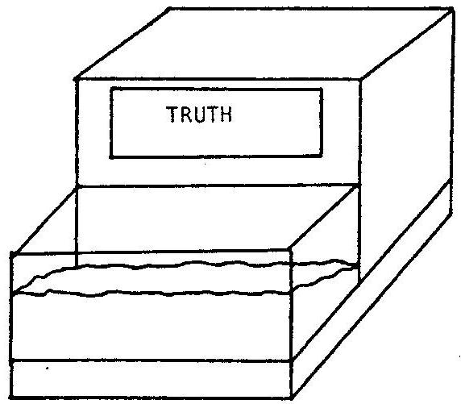

AS THE MAN TALKS FOR THE PLANE, THE GIRL, ABSORBED IN THE IMAGINARY MOVIE, SHUSHES HIS OUTBURSTS.

LINDY/MAN
There's nothing wrong with the idea...only the way in which they tried to do it. Captain Fonck couldn’t help it, he just isn‘t American.

[PAUSE.]

He can’t understand the good old epic U.S. way.

[THE PLANE LOOKS UP TO THE HEAVENS.]

Hey, Pa! Are you up there with the stars? I’m ready to earn my name now. I know I can. I know I can. Watch me, Pa. I know I can. I’ll get that old water back!

SCENE SIXTEEN.

WOMAN
Scene Sixteen: GO!

[THE MAN CRANKS THE STAGE RIGHT SIGN. THE WOMAN CRANKS THE STAGE LEFT SIGN. THE WOMAN CRANKS THE CENTERSTAGE SIGN. THE GIRL ADVANCES TO SLIDE #20.]

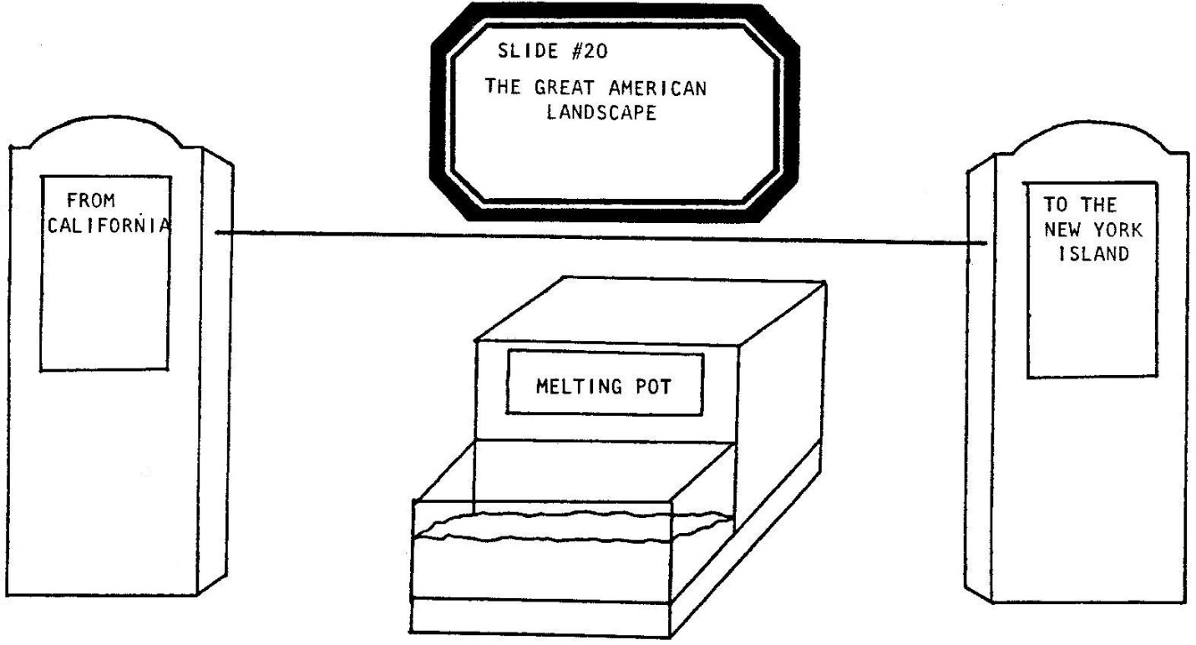

[THE PLANE IS HUNG AT THE CALIFORNIA SIDE OF THE LINE. THE MAN BRINGS OUT A 1920’S RADIO MICROPHONE ON STAND. HE SPEAKS INTO THE MIKE.]

MAN
Lucky Lindy’s gone to San Diego where they’ll build a special plane.

[THE WOMAN, AS LINDY, MAKES A SPEECH ABOUT HER PLANE. THE MAN AND THE GIRL DON SUNGLASSES AND CREATE A CALIFORNIA AUDIENCE.]

LINDY/WOMAN
She’s just gonna be one of those good old, single engined, solo pilot, stripped down, no radio, extra tanked, souped up, built for speed el cheapo planes. I’ll customize her myself. She’ll fit my style. I've got one now. I'm gonna be a traditional American hero—with a typical hometown plane. Everybody else in this contest got big companies, big money behind ‘em; but I’m gonna have the people. All their planes got fancy names: THE COLUMBIA, THE WHITE EAGLE...the etceteras...and they’re all crashing and stuff in test flights. I got no airs about me but the real one. In fact, I got nobody big behind me at all. I’m broke.

[PAUSE.]

I represent the common folk. That’s why I’m building my plane in California: so I’ll have to fly cross-country. Visit my people. Gonna stop in Missouri, name her THE SPIRIT OF ST. LOUIS...

[PAUSE.]

...I hate St. Louis-but it’s the heart of the country, it’ll be a hometown name! The plane’ll say: "Lucky, I’m from Missouri. Show me!" And I will! I’ll take her clear across the continent to New York...and we’ll be ready!

[THE MAN AND GIRL APPLAUD. THEY TAKE OFF THEIR SUNGLASSES. THE MAN GOES UP TO THE MIKE.]

MAN
April, l927. Lucky Lindy makes his first test flight in the new plane.

[HE STICKERS THE TOP OF THE PLANE’S WING: N-X-211.]

LINDY/WOMAN
I’m gonna beat that old seasick feeling! I don’t know how, but I’ll just do it! I know I can. I’ll do it!

[THE WOMAN NARRATES INTO THE MIKE.]

WOMAN
May 10: Lucky Lindy flies from the coast to St. Louis and sets a new speed record.

[THE MAN GRABS ONTO THE PLANE, TWIRLS ITS PROPELLER AND SPEED FLIES TO THE LINE’S CENTER. HE GOES TO THE MIKE TO SPEAK FOR LINDY WHEN THE WOMAN STICKERS THE SIDE OF THE AIRPLANE: THE SPIRIT OF ST. LOUIS. THE GIRL REPRESENTS A MID-WESTERN AUDIENCE: SHE FISHES IN THE AQUARIUM.]

LINDY/MAN
This here’s your plane, named after you people. Only cost eleven thousand... but I know she’s gonna make it first. Noel Davis got a hundred thousand dollar, three engine plane and a co-pilot... he won’t make it. Commander Byrd got another hundred thousand dollar plane with a scientific backer...he won’t make it! Chamberlain don’t even run his plane...he’s got a company OUT FRONT of him...he sure won’t make it. Fonck’s got a second round Sikorsky and...nah, I don't have to tell you about him. And Nungesser and Coli...well, they’re French too. They won’t make it neither! But ST. LOUIS and me-

[HE THROWS THE PLANE A KISS.]

-we’re gonna get there first!

[THE GIRL CLAPS. THE MAN MOVES THE PLANE TO NEW YORK ON THE LINE. THE WOMAN GOES TO THE MIKE AND NOW SPEAKS FOR THE PLANE.]

MAN
May 12: Lucky Lindy flies into New York, Roosevelt Field; and sets himself off from the rest.

[THE MAN AND THE GIRL FOLD UP NEWSPAPERS AS SKILLFULLY AS NATIVE NEW YORK SUBWAY RIDERS AND READ AND GRASP THE LINE LIKE STRAPHANGERS.]

LINDY/WOMAN
I don’t need no multi-engines. I don’t got no good credentials. I don't need commercial offers. I don’t need no second pilot. I don’t need no rabbit's foot-I’m Lucky, on my own. I don’t need no insurance, no science, no teamwork. They told me I gotta wait a month to meet the rules of that Orteig guy...well, maybe I’ll leave anyway and decide I don't even need no prize! And you know what else I don’t need? I don't need no sleep...no alcohol...no cigs...and no coffee! Not me! I live clean!

[THE MAN AND GIRL APPLAUD. THE STAGE GOES DARK EXCEPT FOR THE REAR PROJECTION SCREEN.

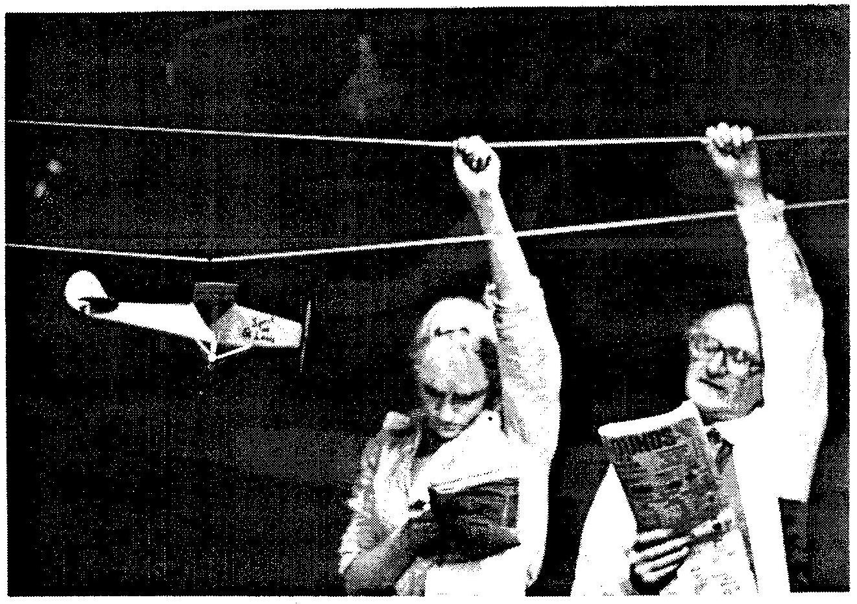

[THE GIRL ADVANCES TO SLIDE #21.]

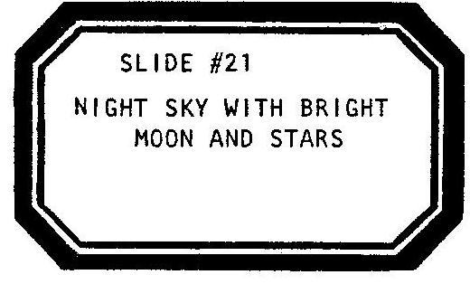

WOMAN
Late in the evening, May 19. Less than eight months after that night at the movies, Lucky Lindy decides to leave the next morning…and stays up all night.

[SHE SETS THE PLANE FAR STAGE RIGHT ON THE LINE. THE MAN GETS DOWN ON HIS KNEES TO PRAY.]

LINDY/MAN
I ain’t afraid of foul weather when I can’t turn back. I ain’t afraid of weird visions when I get tired and lose sense. I ain’t afraid of not knowing navigation very well once there’s no landmarks in sight. I ain’t afraid of going down without much food or fresh water or much chance of rescue. I ain’t afraid of needing sleep when I mustn’t sleep…and I ain’t afraid to leap over water…for the very first time in my life…

ALL
Amen.

[BLACKOUT: SET AND SLIDES AND CRANKY UNIT BACKLIGHTING.]

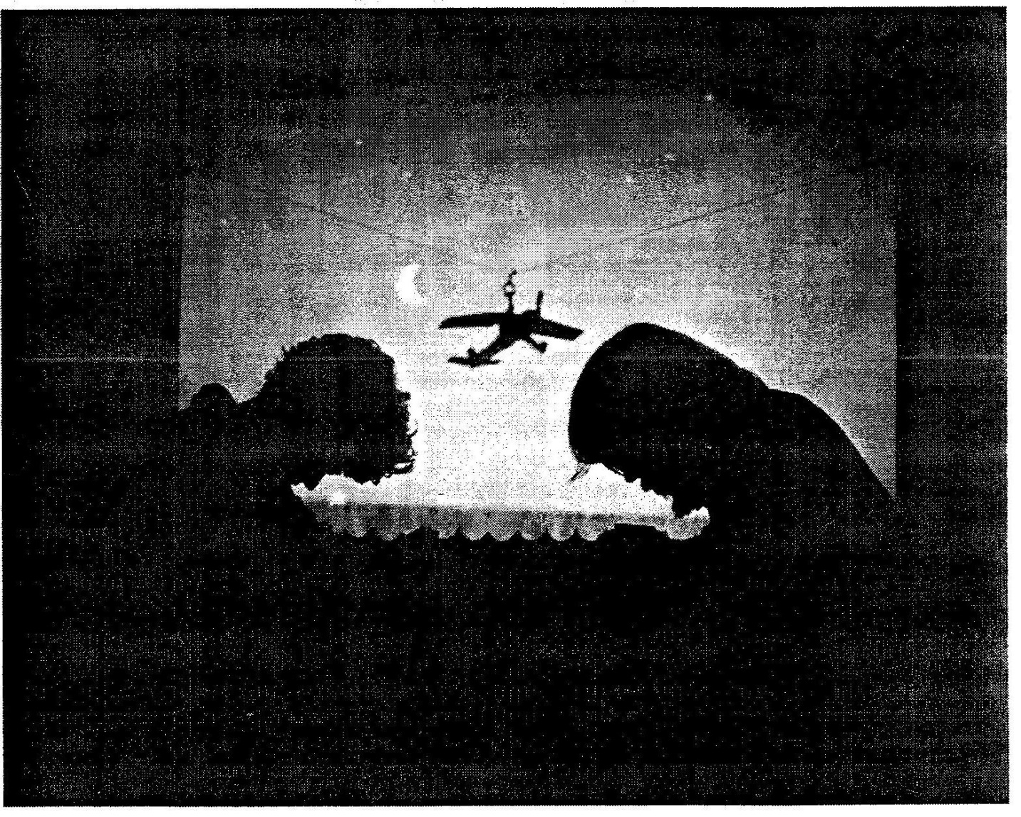

SCENE SEVENTEEN.

[IN THE DARK, THE GIRL PLAYS A TAPE RECORDING OF ARTHUR FIELD’S 1927 RECORDING OF LUCKY LINDY. A PIANO, ON TAPE, BEGINS TO BANG OUT AN UPBEAT, SCRATCHY TUNE. THE GIRL ADVANCES TO SLIDE #22.]

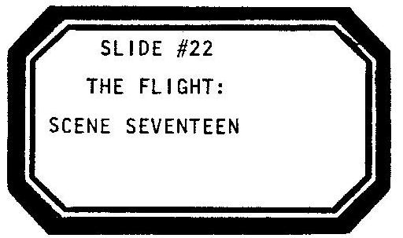

[WHILE IN BLACKOUT, ALL THREE SIGNS HAVE BEEN CRANKED. THE STAGE LIGHTS AND CRANKY BACK LIGHTING COME UP. THE SIGNS NOW READ:]

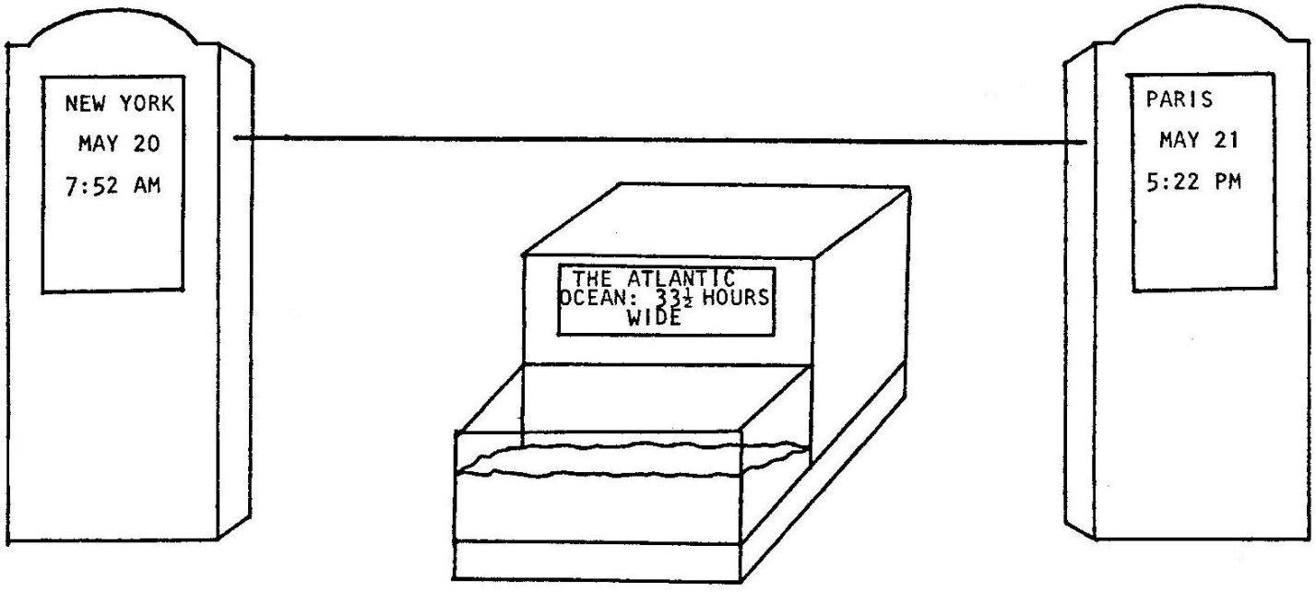

[THE MAN, GIRL AND WOMAN STAND STAGE RIGHT WITH THE MICROPHONE. THE PLANE IS ON THE LINE. THE GIRL ADVANCES TO SLIDE #23.]

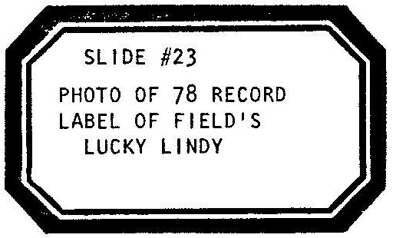

[THE CAST SINGS ALONG WITH, AND OVER, ARTHUR FIELDS ON TAPE.]

RECORD
From coast to coast we all can boast
And sing a toast to one
Who’s made a name, for being game.
He was born with wings as great
As any bird that flies,
A lucky star, guides him afar!

[THE PLANE BEGINS TO FLY ACROSS THE LINE. THEY DANCE.]

Lucky Lindy, up in the sky!
Fair or windy, he’s flying high!
Peerless! Fearless! Knows ev’ry cloud,
The kind of a son makes a mother feel proud!
Plucky Lindy, rides all alone
In a little plane all his own!
Lucky Lindy showed them the way-
And he’s the hero of the day!

[THE CHORUS REPEATS. THE LYRICS ARE PROJECTED ON THE SCREEN. THE HOUSE LIGHTS COME UP. THE GIRL GOES UP TO THE SCREEN WITH A POINTER AND UNDERLINES THE CHORUS LYRICS, BOUNCING BALL FASHION. THE WOMAN GOES INTO THE AUDIENCE AND GETS PEOPLE TO SING. THE MAN INVITES OTHERS TO SING INTO HIS PHONY RADIO MICROPHONE.]

CAST
Everybody sing!

[THE GIRL ADVANCES TO SLIDE #24.]

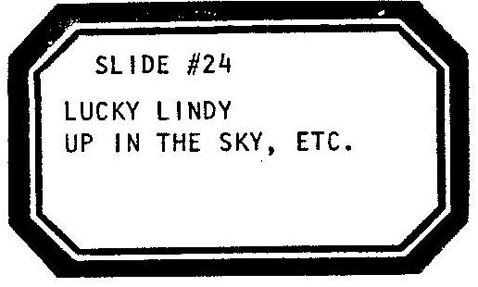

[THE GIRL ADVANCES TO SLIDE #25.]

[AFTER THE CHORUS, THE GIRL ADVANCES TO SLIDE #26.]

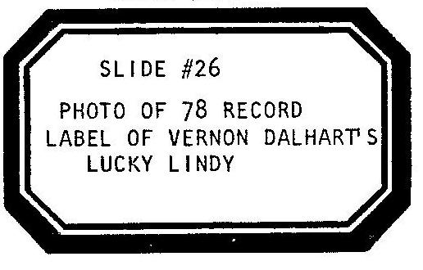

[THE CAST DANCES AND SINGS THE SECOND VERSE WITH ARTHUR FIELDS. THE PLANE FLIES BACKWARDS ON THE LINE.]

Just like a child he simply smiled
While we were wild with fear,
This Yankee lad, the world went mad!
Ev’rywhere they prayed for him
To safely cross the sea,
And he arrived! In Gay Paree!

[THE CHORUS AGAIN FLASHES ON THE SCREEN. THE AUDIENCE IS AGAIN URGED TO SING ALONG. THE GIRL ADVANCES TO SLIDE #27.]

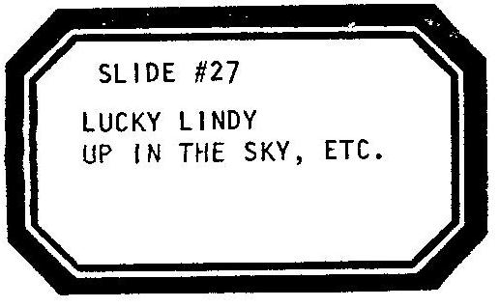

[THE GIRL ADVANCES TO SLIDE #28.]

[AFTER THE CHORUS, THE GIRL ADVANCES TO SLIDE #29.]

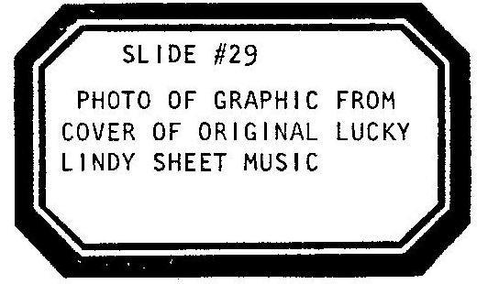
[THE SONG BREAKS INTO A MUSICAL INTERLUDE. THE WOMAN SLOWLY BEGINS TO DANCE THE PLANE ACROSS THE LINE TO PARIS. THE GIRL HOOKS UP A SECOND LINE TRAVELLING IN THE OPPOSITE DIRECTION. CLOUDS, THE SUN, THE MOON, STARS, A CLOCK, A MAP AND A HALF EATEN SANDWICH HANG FROM THE GIRL’S LINE AND SAIL PAST THE PLANE. THE MAN PICKS UP A BOX OF SNOWFLAKES AND A FAN AND TORMENTS THE PLANE WITH A SNOWSTORM. THE WOMAN AND THE PLANE STAGGER BACK. THE MAN WEARS A SEA MONSTER PUPPET THAT BARKS AT THE PLANE LIKE A DEAD DOG’S GHOST. THE MAN POINTS TO THE PUPPET.]

MAN

[ASIDE:]

Weird visions.

[THE GIRL REACHES INTO THE AQUARIUM AND GRABS THE PLASTIC FISH THAT HAS BEEN SITTING AT THE BOTTOM OF THE TANK SINCE THE PROLOGUE. SHE LEAPS THE FISH UP OUT OF THE WATER AND TORMENTS THE PLANE. THE GIRL POINTS TO THE FISH.]

GIRL

[ASIDE:]

MORE weird visions!

[SHE DROPS THE FISH BACK INTO THE TANK. THE WOMAN DANCES THE PLANE ON THE LINE. THE MAN PICKS UP HIS FAN. THE GIRL REVEALS A PLANT SPRAYER-THEY DOUSE THE PLANE WITH RAIN. FINALLY, THESE VARIOUS ABUSES OVER, THE PLANE ALMOST MAKES IT TO PARIS. THE MUSICAL INTERLUDE ENDS AND THE CHORUS COMES ROUND ONCE AGAIN. THE AUDIENCE GETS ONE MORE CHANCE TO SING. THE GIRL ADVANCES TO SLIDE #30.]

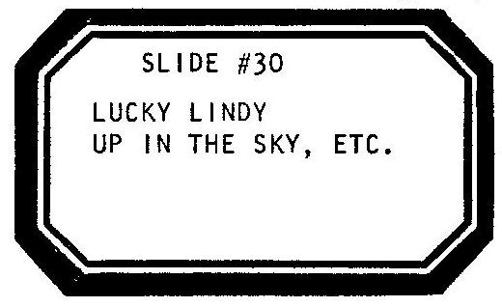

[THE GIRL ADVANCES TO SLIDE #31.]

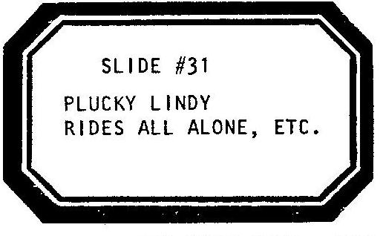

[THE SONG ENDS. THE CAST GATHERS ABOUT THE PLANE. THEY TAKE THEIR APPLAUSE. THEY STAND IN THE ONLY LIGHT LEFT ON STAGE. SUDDENLY, THE WOMAN TURNS THE PLANE’S FACE OUT TO THE AUDIENCE.]

LINDY/WOMAN
Hey, what does Paris look like, anyway?

[BLACKOUT. END OF PART ONE. INTERMISSION.]

PART TWO

[DURING THE INTERMISSION THE CURTAIN REMAINS CLOSED. THE AUDIENCE HAS BEEN GIVEN SEALED ENVELOPES THAT READ:]

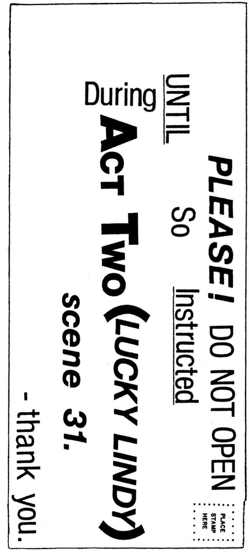

[THE STAGE LEFT AND STAGE RIGHT SIGNS HAVE BEEN CRANKED TO READ:]

PART TWO. SCENE EIGHTEEN.

[LIGHTS UP.]

WOMAN
Scene Eighteen.

[THE WOMAN CRANKS THE STAGE RIGHT SIGN. THE MAN CRANKS THE STAGE LEFT SIGN. THE CURTAIN IS OPENED. THE CENTERSTAGE SIGN HAS ALREADY BEEN CRANKED IN PRESET. THE GIRL HAS ALREADY ADVANCED TO SLIDE #32 IN PRESET. THE GIRL PLAYS A TAPE RECORDING OF THE MARSEILLAISE.]

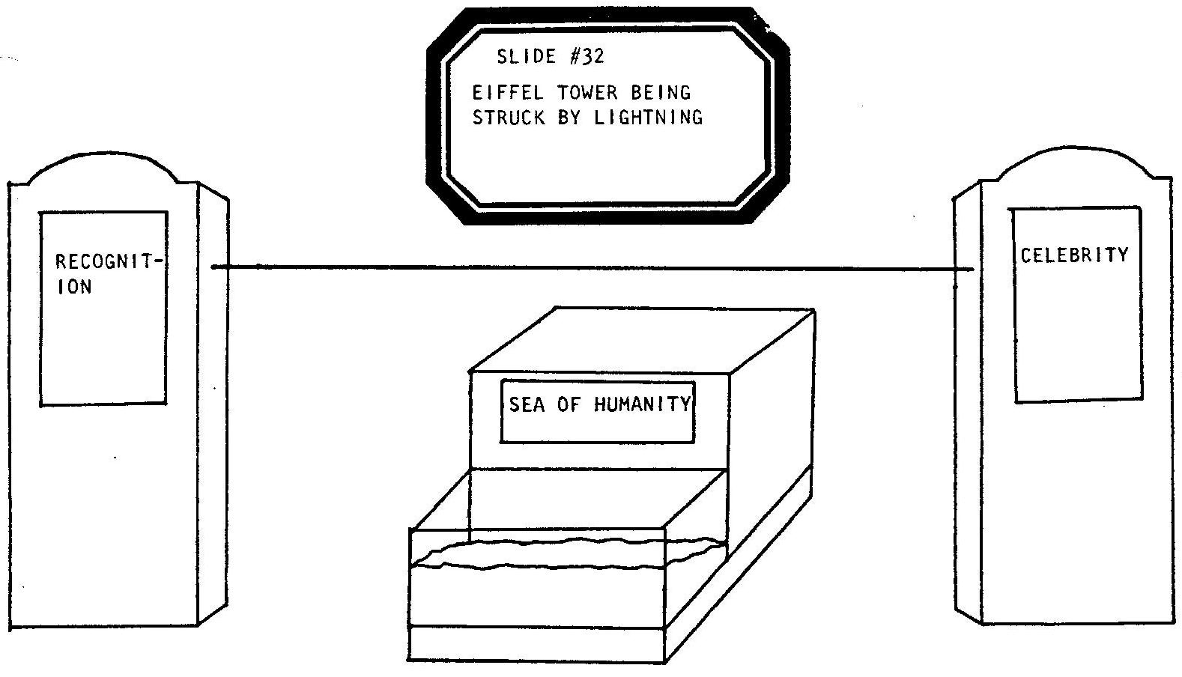

[THE GIRL MIXES IN A RECORDING OF THE ROAR OF A HUGE CROWD OF PEOPLE. THE WOMAN AND THE GIRL ACT FRENCH. THEY RIOT ALL OVER THE STAGE. THE MAN ENTERS AS THE MAYOR OF PARIS. IN ADDITION TO HIS BERET AND MUSTACHE, HE WEARS A CEREMONIAL KEY AND SASH. HE SEARCHES THE SKY. THE PLANE IS NOT ON THE LINE. HE WANDERS AROUND IN A CIRCLE.]

MAYOR DE PAREE
Luck-ie Lind-ie is now coming round for his landing…no?... instead he flies round?...in a circle?...perhaps this is not a familiar place…perhaps he wants to look again at ze tower…we wait.

[HE SITS DOWN. HE WHISTLES LUCKY LINDY. HE STANDS.]

Well, at least we are at his destination…here at the airport de Paree, Le Bourget…we wait.

[HE SITS. THE MOB ROARS. HE STANDS.]

Ze Mayor! Ze key! Ze relatives of Orteig…ze Mob!

[HE SPITS.]

Tens of thousands we have come out here to greet him tonight…we wait!

[HE SITS. HE STANDS. HE LOOKS UP.]

Now he nears again!...he is landing!...oh!...he is…way over there?

[HE POINTS OFF STAGE RIGHT.]

Ze mob, let zem run to St. Louie. Ze mayor, Paree, we will shout Lind-ie’s name: Luck-ie? LUCK-IE? I do not think he can hear me. Perhaps he does not know who I am…OH! Someone tears off his helmet!

[AN AVIATOR’S HELMET IS THROWN ONTO THE STAGE.]

Luck-ie! LUCK-IE! OH! Others now pull him out of ze plane... Luck-ie? LUCK-IE? They carry him around on their shoulders...I will try and get closer...

[HE GRABS ONTO THE LINE AND, HAND OVER HAND, PRETENDS TO STRUGGLE STAGE RIGHT BY PULLING ON THE LINE. HE PULLS THE PLANE ONTO STAGE.]

...I am getting nearer...let go of my leg little girl!...excuse me, I am ze MAYOR...l can see ze plane’s wings...oh, ze mob is incredible!

[HE RIPS OFF THE PLANE'S TAIL WINGS. THE WOMAN SPEAKS FOR THE PLANE.]

LINDY/WOMAN
Stop it! STOP IT!

MAYOR DE PAREE
Excusez-moi...torn wings...how you say?...ze, mob, souvenirs?

[HE PUTS THE WINGS IN HIS POCKET.]

LINDY/WOMAN
This can't be the right piace. Find me an American! Get me the Ambassador!

MAYOR DE PAREE
Oui, oui, oui, oui, oui. Zis, is your key!

LINDY/WOMAN
I don’t want to stay at Pierre Orteig’s hotei!

MAYOR
Qu’estce c’est?

[HE DROPS THE PLANE INTO THE AQUARIUM. HE ABANDONS THE ROLE OF THE MAYOR AND NOW SPEAKS FOR THE PLANE.]

LINDY/MAN
Help! HELP! I’M DROWNING...GLUB-glub...help!

[THE WOMAN DONS A RED, WHITE AND BLUE TOPHAT WITH TWO SMALL AMERICAN FLAGS ATTACHED.]

AMBASSADOR
HI! I am the American Ambassador, Myron T. Herrick.

[SHE TAKES THE PLANE FROM THE WATER AND DRIES IT OFF.]

You’ve just been awake for too many hours, son. You need your rest.

[SHE CRADLES THE PLANE. SHE ROCKS. THE MAN ROCKS BEHIND HER.]

LINDY/MAN
I’m puzzled, sir. It’s just not what-

[SHE UNBUTTONS HER BLOUSE AND BREASTFEEDS THE PLANE. THE MAN PROVIDES APPROPRIATE SOUND EFFECTS.]

AMBASSADOR
Shhh. It’s just these passionate French. Trust me, I live amongst them and I know.

LINDY/MAN
It’s just not what I expected. I thought there’d be a small welcome. I’d care for my plane…my passport would be stamped. My only goal was to arrive.

AMBASSADOR
Shhh. It’s 4:15 in the morning here.

[THE LIGHTS DIM.]

They mark time different than us. You can wear my pajamas and sleep as far past noon as you like.

[THE MAN FALLS ASLEEP ON HIS FEET.]

LINDY/MAN
Zzzzzzzzzzzzzzzzzzzzzz.

AMBASSADOR

[WHISPERS:]

You alone in the air while all the rest were on the ground. You flew and flew and flew and flew…can you imagine what it was like for us…waiting?

[SHE KISSES THE PLANE AND BUTTONS HER BLOUSE.]

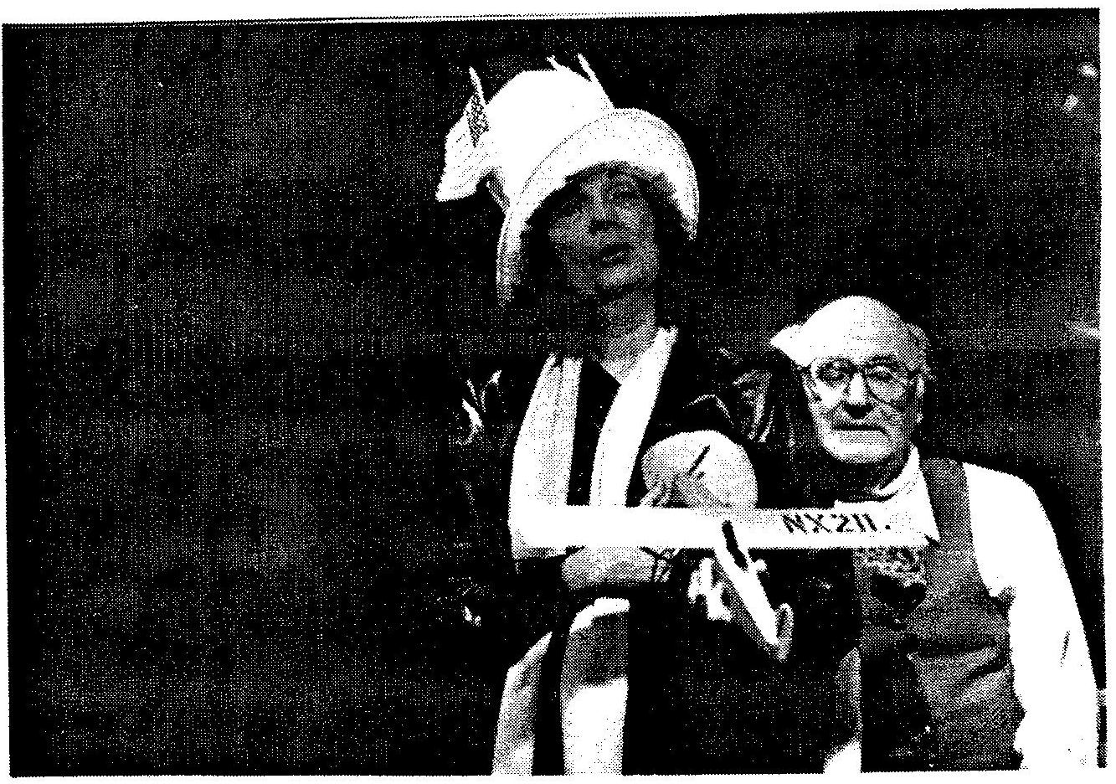

SCENE NINETEEN.

WOMAN
Scene Nineteen. Lucky Lindy’s Nightmare!

[THE LIGHTS DO WEIRD THINGS. THE WOMAN CRANKS THE STAGE RIGHT SIGN. THE MAN CRANKS THE STAGE LEFT SIGN. THE WOMAN CRANKS THE CENTERSTAGE SIGN. THE GIRL ADVANCES TO SLIDE #33 AND PLAYS A TAPE RECORDING OF AN OFF—KEY, OFF—TEMPO VERSION OF RULE BRITANNIA.]

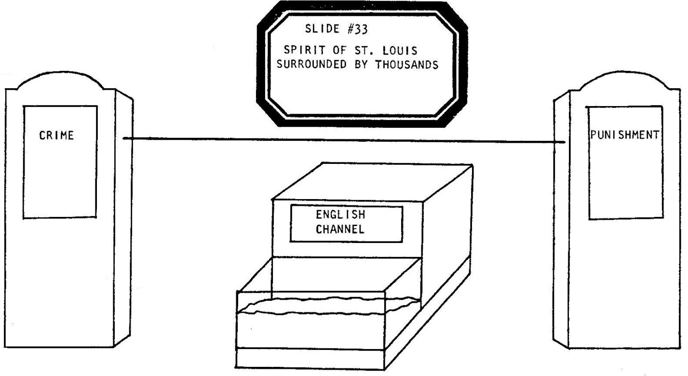

[THE PLANE SITS ON THE LITTLE STAGE OVER THE AQUARIUM. THE ROAR OF THE CROWD BRIEFLY RETURNS. THE WOMAN YELLS FROM OFF-STAGE:]

WOMAN
George-George the Fifth-Fifth-Fifth-Fifth-Fith, King-King of England-England-Britain-England-United Kingdom:

[THE MAN’S HEAD POPS UP FROM BEHIND THE LITTLE STAGE. HE WEARS A WEIRD CROWN WHOSE PEAKS RESEMBLES THE SKYLINE OF LONDON. HIS HEAD BOBS UP AND DOWN AND FLOATS OUT OF SCALE ABOVE THE PLANE. HE SPEAKS WITH A PHONY BRITISH ACCENT:]

KING GEORGE
As we, actually, knight thee, Sir Lucky, quite a knighta fella, as we-we-we, as thee-

LINDY/WOMAN
…zzz…zzz!...uhh-ohh…zzz…not mad dogs and Englishmen, too!...zzz…

KING GEORGE
Just how, and all that, did you, actually, pee-pee?

LINDY/WOMAN
Go away!...zzz…Get away!...

KING GEORGE
Pee…pee…pee…pee…

LINDY/WOMAN
I’m gonna fix up my plane and fly home, sweet, home where a red, white and blue-blooded boy can sleep in peace…zzz…go away! Get away!...fly back where I belong…zzz…when I land there…get away…zzz…they’ll understand me…zzzzzzzzzzzzzzzzzzzzz.

SCENE TWENTY.

WOMAN
A tossing and turning Scene Twenty. Seven days at sea-

[THE WOMAN CRANKS THE STAGE RIGHT SIGN. THE WOMAN CRANKS THE STAGE LEFT SIGN. THE MAN CRANKS THE CENTERSTAGE SIGN. THE GIRL ADVANCES TO SLIDE #34.]

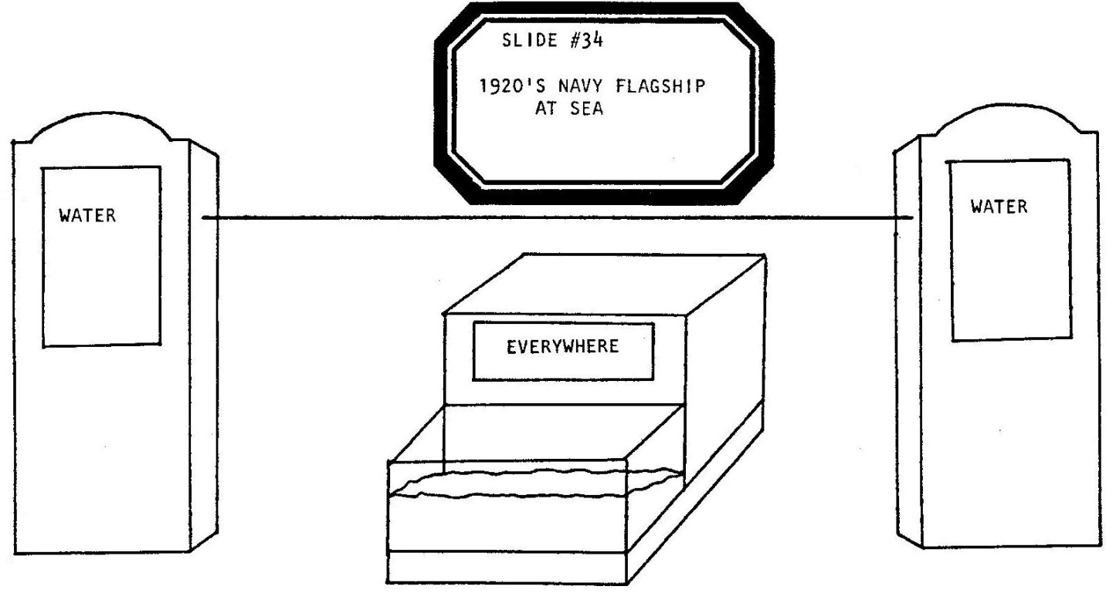

-on the deck of the U.S.S. Memphis.

[SHE EXITS. THE MAN ROLLS THE PLANE BACK AND FORTH ON THE LITTLE STAGE. HE TAKES OUT A SHAVING MUG AND BRUSH AND DIPS THE MUG INTO THE AQUARIUM FOR SOME WATER. HE BEGINS TO ABSENTMINDEDLY LATHER THE SOAP. THE PLANE BECOMES SLIGHTLY SEASICK FROM THE ROLLING MOTION.]

LINDY/MAN
...oop...I better wash up...

[PAUSE.]

Hey, President, Coolidge! Why did you order me back on a boat? I wanted to hopscotch back home by flying around the world, reenter in Alaska, the back door, cross the country again... oop...Hey, President Coolidge! Silent Cal! Calvin Coolidge! Hey! Suppose he won't answer? Suppose he won't talk? ...oop...one whole week on the sea...oop...

[HE PUTS DOWN THE MUG AND PUTS READING GLASSES ON THE PLANE.]

Catch up on reading, read a good American book. A Washington Irving novel…yeah, that’lI ease my mind... _

[HE TAKES OUT A BOOK AND HELPS THE PLANE READ.]

"Now, Rip Van Winkle, he went bowling, got drunk, missed out living a couple of years..." I just missed sleeping one night... Rip in the mountains, me in the clouds, both of us missing out on what everyone else was up to. Rip wakes up, I swoop down, we're back, back in touch-but low and behold, nothing in the world seems the same!...

[HE PUTS DOWN THE BOOK. HE STARTS TO LATHER THE PLANE’S CHIN. HE GIVES THE PLANE A SHAVING CREAM BEARD.]

Yeah, yeah...I’m just like Rip Winkle, just like Old Rip...long white beard...two old men...I’m just twenty five!

[HE WASHES THE PLANE‘S BEARD OFF.

I was just in the air for a day...and everybody else...was down here...what? What?...waiting...I wonder...Hey, Rip! Did I miss something? God bless America! I gotta catch up...Rip! Cal! I gotta understand!...I gotta catch up with everybody else!

SCENE TWENTY ONE.

WOMAN
Scene Twenty One: June 1927. Lucky Lindy heads for the big American city-

[THE MAN CRANKS THE STAGE RIGHT SIGN. THE WOMAN CRANKS THE STAGE LEFT SIGN. THE GIRL CRANKS THE CENTERSTAGE SIGN AND ADVANCES TO SLIDE #35. SHE PLAYS A TAPE RECORDING OF SOUSA’S STARS & STRIPES FOREVER.]

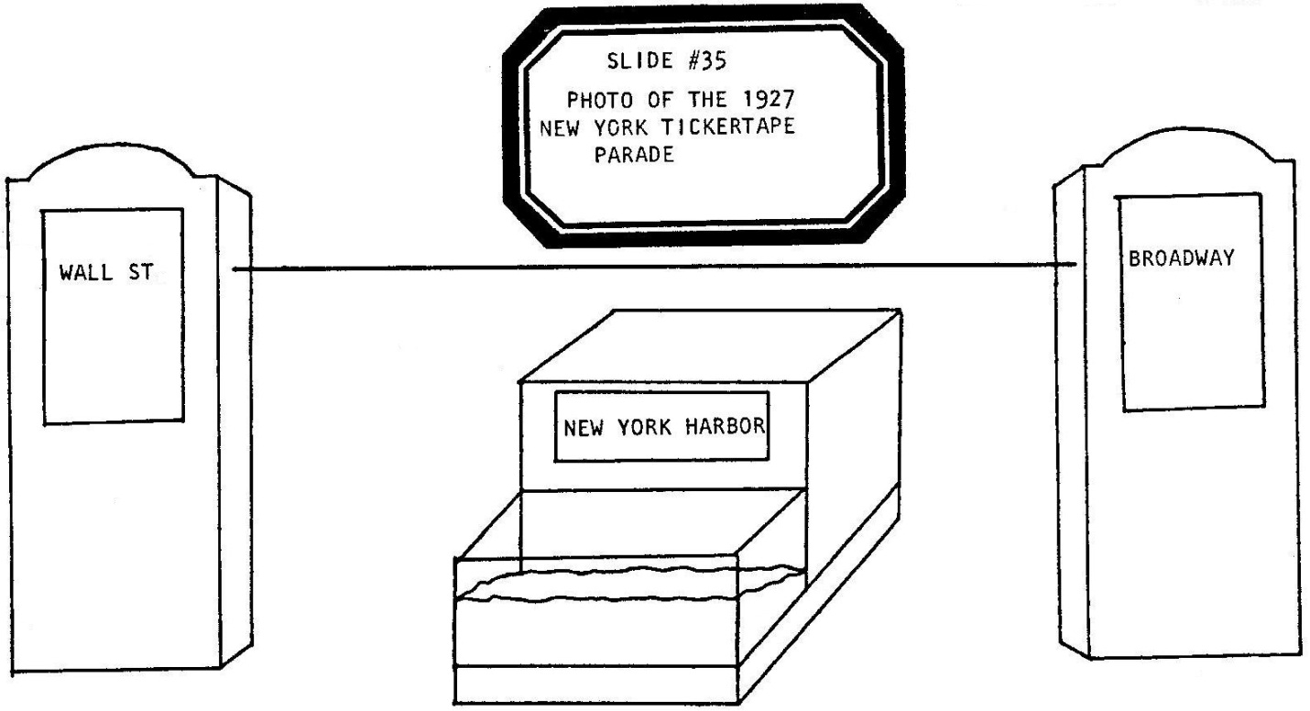

-and parades his way through to the hearts of Manhattan!

[THE PLANE IS PLACED ON THE LITTLE STAGE. THE GIRL EXTENDS A LONG STRING OF CUTOUT PAPER DOLLS ON THE LINE.]

Four and a half million American people had come out to see the flier. Eighteen hundred tons of tickertape and confetti were in their pockets, waiting to be tossed!

MAN
But FIRST:

[THE WOMAN FREEZES.]

Came the speeches!

[HE THROWS PAPER MONEY AT THE PLANE.]

He used Vacuum Oil!

[THE WOMAN, SPEAKING FOR THE PLANE, MUMBLES THROUGH THE REST OF THE SCENE.]

LINDY/WOMAN
Thank you…thank you…gosh…thank you…thank you…gee…thank you… gosh…gee…thank you…etc.

[THE MAN THROWS MORE MONEY AT THE PLANE.]

MAN
NO! He used Mobil Oil!

[THE GIRL HIDES BEHIND THE PAPER GIRLS AND SPEAKS WITH A BRONX ACCENT.]

GIRL
Hey, Lucky! Ova here!

MAN
And he used AC Sparkplugs!

GIRL
Kiss my baby!

MAN
He used a Wright Corporation Engine!

GIRL
Spare a dime?

MAN
You DO use a Waterman Pen?

GIRL
Here’s some thanx-from the Bronx:

[SHE SHOOTS A RASPBERRY AT THE PLANE.]

MAN
I hope you’ll use Brylcream!?!

GIRL
Why won’t he kiss my baby?

[THE MAN AND THE WOMAN TAKE THE PAPER DOLLS FROM THE GIRL. SHE THROWS TWO FISTFULLS OF CONFETTI INTO THE AIR.]

ALL
FLATBUSH AVENUE FAN CLUB, YEA!!!

SCENES TWENTY TWO - TWENTY EIGHT.

WOMAN
Scenes Twenty Two through Twenty Eight:

[THE WOMAN CRANKS THE STAGE RIGHT SIGN. THE MAN CRANKS THE STAGE LEFT SIGN. THE WOMAN CRANKS THE CENTERSTAGE SIGN. THE GIRL CONTINUES TO PLAY THE SOUSA RECORDING.]

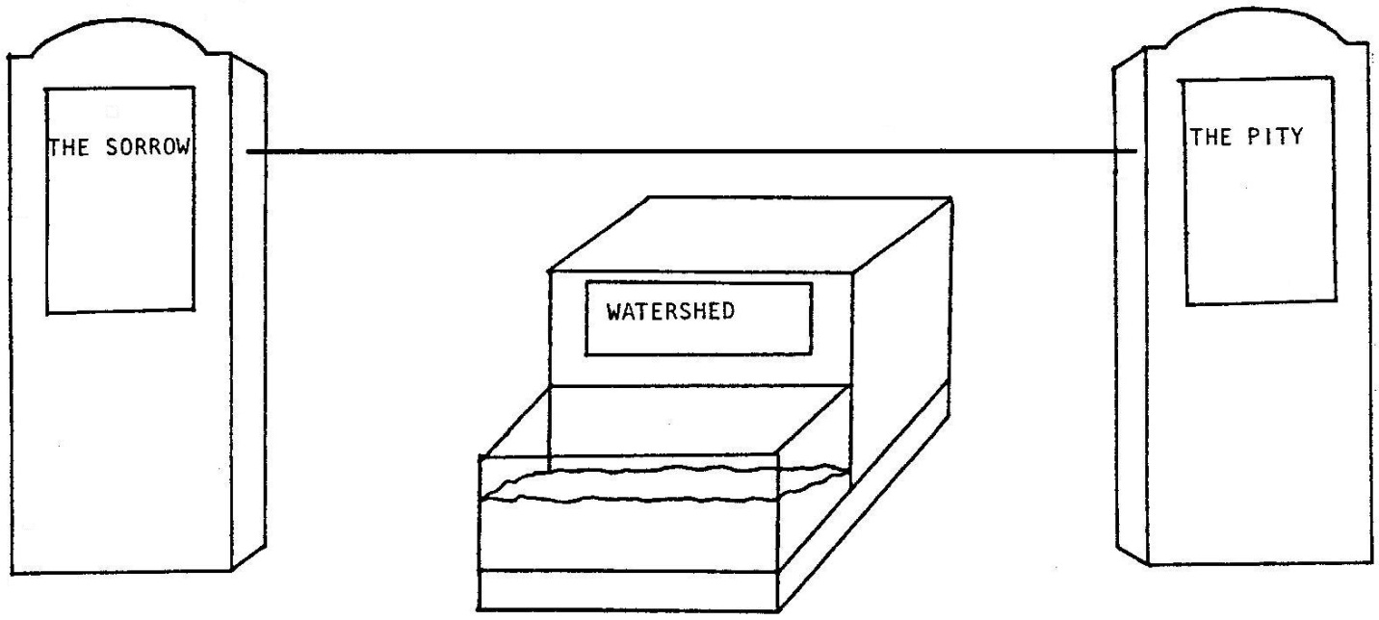

Twenty Two:

[PAUSE.]

July through October, a richer but still restless Lucky Lindy tours the United States in search of peace and quiet and a nice place to spend his dough. They know him in St. Louis, they ask him moronic questions in Oklahoma City, Oklahoma. He checks into and out of some eighty odd towns.

[THE GIRL ADVANCES TO SLIDE #36.]

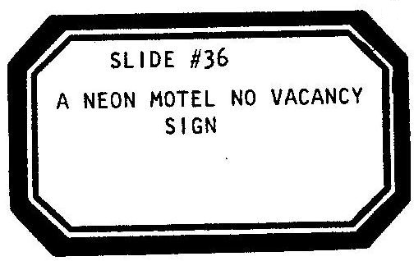

[SHE BECOMES SLEEPY.]

He covers 22,000 miles and counts 260 hours and 45 minutes in flight, visiting all 48 states.

[SHE HIDES THE PLANE. THE SOUSA MUSIC ENDS. THE MAN TAKES OUT A PAD AND PENCIL. HE HAS A FLASH CAMERA. HE PUTS A “PRESS” HAT ON HIS HEAD. HE TALKS OUT OF THE SIDE OF HIS MOUTH AND READS FROM HIS NOTES. HE IS A PUSHY PRESS REPORTER. DURING HIS SPEECH THE WOMAN/PLANE GOES TO SLEEP ONLY TO BE STARTLED BY THE REPORTER.]

REPORTER
A reporter in Fargo, North Dakota asked: "Hey, Lucky! What do you think now that old Chamberlain’s done it! Doing you even one better! He flew to GERMANY! Now, THAT’S far!” Hold it!

[HE SNAPS A FLASH PICTURE OF THE PLANE. THE WOMAN WRAPS A TOWEL AROUND THE PLANE'S WAIST AND BRUSHES HER TEETH.]

A newsman in Cheyenne, Wyoming just a few weeks later hid for three hours inside of a hotel room closet so he could ask: “Do you know that Byrd just did it too? Huh? Huh? It’s getting easier each time!” Hold it!

[HE SNAPS A FLASH PICTURE. THE WOMAN PUTS A LOBSTER BIB AROUND THE PLANE’S CHIN AND PICKS UP A KNIFE AND FORK.]

An admirer in Chattanooga, Tennessee one day just ran right into a luncheon and screamed at the top of her lungs: “Yoohoo! Yoohoo! Mr. Lindy! I just heard about Amelia Earhart! Now she’s done it! And everyone's calling her LADY Lindy for her nickname!” Hold it!

[HE SNAPS A FLASH PICTURE. THE WOMAN/LINDY PRETENDS A DRIVING WHEEL AND DRIVES OFF.]

Trying to hide among the famous, he went to Henry Ford’s Detroit. Edsel Ford, Henry's son, came up and asked: "Excuse me. Ahh, excuse me, please. Would you autograph this picture for me?” Hold it!

[HE ACCIDENTALLY FLASHES THE CAMERA IN HIS OWN FACE. THE WOMAN TAKES THE PLANE OFF.]

Poor little rich Lucky Lindy thought that maybe he too would stop talking... well, at least not much in public. How did he do it? No...not like Ma and Pa. Lucky was more creative than his parents-he went someplace where no one spoke much English-

WOMAN OFF-STAGE
Twenty Three!

[THE GIRL ADVANCES TO SLIDE #37.]

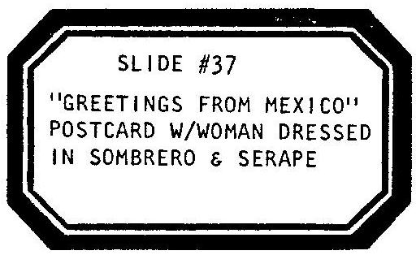

[THE MAN CONTINUES TO WRITE NOTES AS THE REPORTER.]

REPORTER
-he went south of the border. To Mexico. Where he could pick and choose his friends.

[THE GIRL PLAYS A TAPE RECORDING OF THE MEXICAN HAT DANCE. THE WOMAN CROSSES THE STAGE AS AN AMBASSADOR BREASTFEEDING THE PLANE.]

Where there was an American Ambassador, Dwight Morrow-

[THE WOMAN, STILL BREASTFEEDING THE PLANE, ENTERS AGAIN, NOW WEARING A FASHIONABLE, LATE l920’S WOMAN’S HAT.

—and luckiest of all, an attractive young Ambassador's daughter with a good Sounding name:

[HE READIES HIS CAMERA.]

Annie? Hold it!

[SHE TURNS. HE SNAPS A PICTURE. SHE GRIMACES.]

She too was rich and camera shy...so they got married—

[THE WOMAN TAKES AN OVERSIZED PAIR OF SCISSORS AND CLIPS THE WINGS OF THE PLANE. THE MAN TOSSES RICE, SNAPS A PICTURE AND HUMS A BRIEF WEDDING MARCH.]

-in 1929 and moved to a house in New Jersey to be normal...and Lucky Lindy settled down to a job as a consultant to two major airlines.

[THE REPORTER FINISHES WRITING AND PUTS DOWN HIS NOTES.]

WOMAN
Twenty Four!

[IN THE ROLE OF ANNIE, SHE FINDS AND READS THE REMAINDER OF THE REPORTER’S NOTES:]

ANNIE
-and since houses in New Jersey only come with two car garages and never airplane hangers-

[THE MAN RIPS THE LANDING GEAR OFF THE PLANE AND TOSSES THE WHEELS INTO THE AQUARIUM. THE GIRL ADVANCES TO SLIDE #38.]

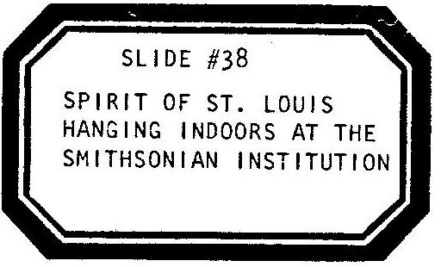

—Lucky Lindy, well adjusted and resigned to the modern world he had wrought, flew his plane—

REPORTER
His one true home.

ANNIE
-one last time, down to Washington. His Dad’s old D.C.

[SHE PUTS DOWN THE NOTES. THE MAN FLIES THE PLANE OVER TO THE “PITY” SIDE OF THE LINE. THE REPORTER CONTINUES HIS STORY.]

REPORTER
-and hung his bird on the wire...dangling from the ceiling of The Smithsonian Institution.

[HE SNAPS ONE LAST FLASH PICTURE OF THE PLANE ON THE LINE. HE HANGS UP HIS REPORTER’S HAT. THE GIRL REMOVES THE PLANE’S PROPELLER AND PLACES IT IN HER HAIR. THEY ALL HOLD HANDS—A MOMENT OF SILENCE AND SILENT SALUTE. THIS COULD BE THE END OF THE STORY...]

MAN
But then!

WOMAN
Twenty Five!

[THE GIRL ADVANCES TO SLIDE #39 AND PLAYS A TAPE RECORDING OF ROCK—A-BYE, BABY.]

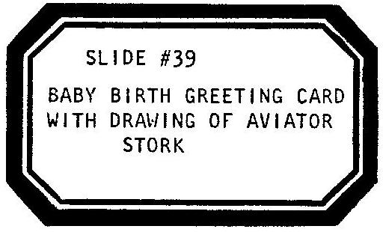

MAN
A kid was born!

[THE MAN AND WOMAN PLAY LINDY AND ANNIE. SHE ROCKS BACK AND FORTH IN TIME TO THE MUSIC. SHE WEARS AN APRON DECORATED WITH A CHICKEN ON THE FRONT. THE MAN STANDS BENEATH HER WITH AN OPEN HANDERCHIEF IN HIS HANDS. HER COSTUME GIVES BIRTH TO AN EGG. HE CATCHES IT. THE EGG GURGLES, COURTESY OF THE MAN.]

LINDY/MAN
I’ll inspire him with a name...Mom!

ANNIE
Pick a good one!...coochie—coochie-coochie-coochie-coo...

[THEY BAPTIZE THE EGG/BABY IN THE WATER.]

LINDY/MAN
I, your father, christen thee...Lucky Lindy, JUNIOR!

[SHE WRAPS THE EGG IN THE HANDKERCHIEF. HE REVEALS AN EGG CUP. THE EGG/BABY GURGLES. THEY PLACE IT IN THE CUP/CRIB, KISS IT GOOD-NIGHT AND BACK OFF-STAGE. THE MAN TAKES THE PLANE WITH HIM.]

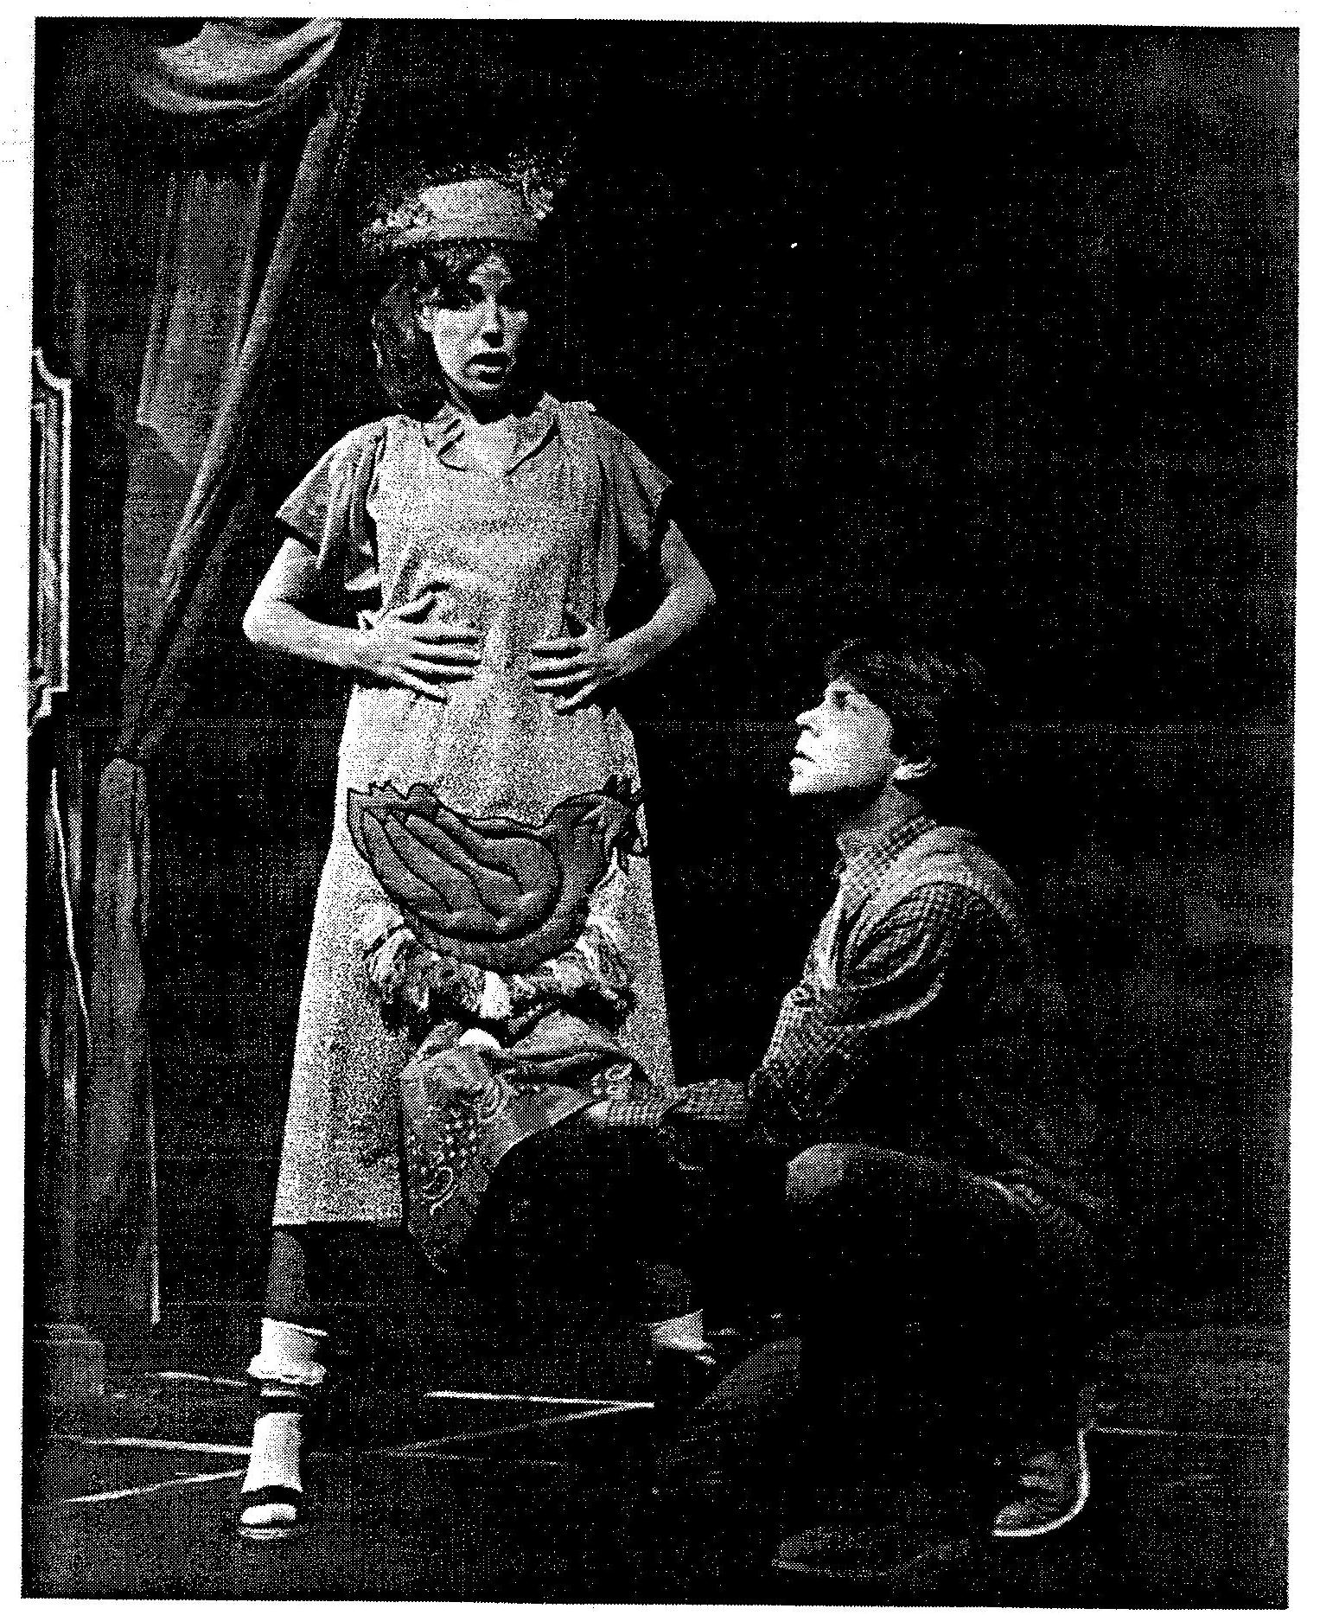

[THE GIRL ADVANCES TO SLIDE #40.]

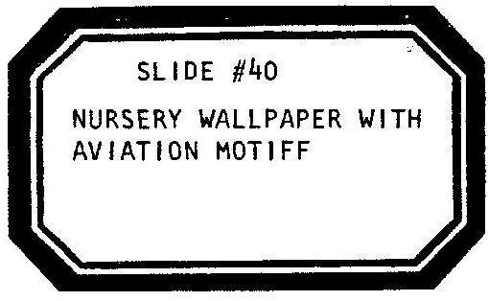

WOMAN OFF-STAGE
Twenty Six. 1932.

[THE LIGHTS DIM. IT IS NIGHT. THE GIRL PLAYS A TAPE RECORDING OF SNEAKY BURGLAR MUSIC. A FLASHLIGHT THROWS A BEAM OF LIGHT ACROSS THE STAGE. THE MAN ENTERS, ON TIPPY-TOE, HOLDING THE FLASHLIGHT AND A BROWN PAPER BAG. HE WEARS A MASK. HE BUMPS INTO THINGS. PERHAPS HE FALLS INTO THE AUDIENCE, IF ANYONE SHOULD LAUGH HE QUIETS THEM: SHHH! HE MIGHT STEAL SOMEONE’S POCKETBOOK. HE MIGHT SHINE HIS LIGHT ON THE CLOCK IN THE SLIDE AND ADJUSTS HIS OWN WATCH. HE SPOTS THE EGG. HE SNAPS OPEN THE PAPER BAG - HE HOPES NO ONE HEARD THE SOUND. HE PUTS THE EGG IN THE BAG AND STARTS TO SNEAK OFF. THE EGG/BABY CRIES. HE REMOVES THE EGG AND PLAYS COOCHIE-COOCHIE— COO. IT QUIETS. HE OPENS THE BAG TO PUT THE EGG INSIDE-HE ACCIDENTALLY DROPS THE RAW EGG-IT SPLATTERS ON THE FLOOR.]

GERMAN KIDNAPPER
…ach du lieber…I didn’t need dis…

[HE SHINES HIS LIGHT ON THE MESS. HE SCOOPS WHAT HE CAN OF THE EGG OFF THE STAGE AND INTO THE PAPER BAG.]

…ach du lieber…I was just going to zell it back…

[HE EXITS]

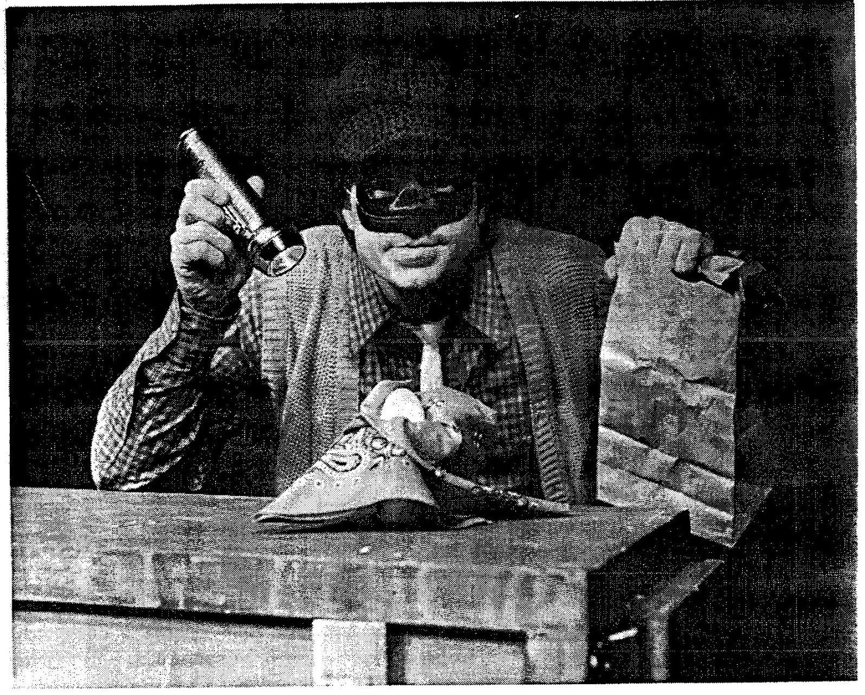

WOMAN
Twenty Seven.

THE GIRL ADVANCES TO SLIDE #41.

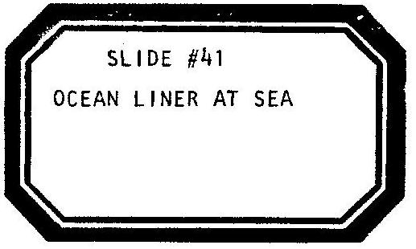

[THE GIRL, WITH NEWSPAPER SACK AND HAT, STANDS AND HOLDS A NEWSPAPER MADE UP ONLY OF FRONT PAGES OF FAMOUS PAPERS OF VARIOUS WORLD CAPITALS. THE GIRL HAWKS THE HEADLINES TO THE AUDIENCE, ONE BY ONE. AS SHE READS THE HEADLINES SHE TWIRLS AND SPINS THE FRONT PAGES LIKE IN A HOLLYWOOD MOVIE COLLAGE.]

NEWS GIRL
Extra! Extra! Nineteen-thirty Five! Baby-killer in Kangaroo Court! Lindy: No comment. Lindy hires thugs to bar press from his door! Lindy: No comment!

[SHE THROWS PAPER.]

Extra! Extra! Final Edition! Guilty! Guilty! Give him the guillotine! Lindy: No comment. Lindy packs suitcase! Sails off on liner! No press on board. No Comment.

[SHE THROWS PAPER.]

Extra! Extra! Hot off the presses! King George OD’s and Lindy goes Brit! No comment. Duke of Windsor in love. Lindy: No comment.

[SHE THROWS PAPER.]

Extra! Extra! Special edition! Electric Chair jolting on dry run in Jersey! Lindy: No comment.

[SHE THROWS MANY PAPERS.]

WOMAN
Twenty Eight.

[THE GIRL ADVANCES TO SLIDE #42.]

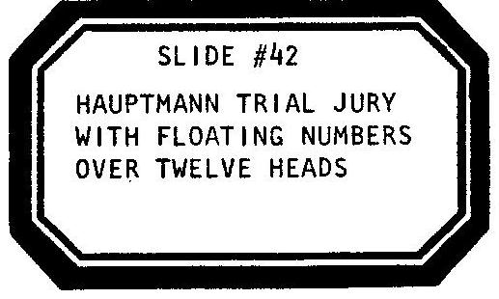

The Night: April Third, 1936. 8:44 PM.

[THE MAN ENTERS, STILL DRESSED AS THE KIDNAPPER. HE CLUTCHES THE BROWN PAPER BAG. THE WOMAN PLAYS A PROSECUTOR WHO’S SEEN IT ALL BEFORE.]

PROSECUTOR
Hey!

KIDNAPPER
Yah?

PROSECUTOR
What’s your name?

KIDNAPPER
…Bruno Hauptmann…

[THEY SHAKE HANDS. SHE HOLDS ON.]

PROSECUTOR
What’s in the bag?

[SHE GRABS THE BAG. THE BAG IS SEARCHED. AN EGG BEATER IS FOUND INSIDE.]

Ummm-hmmm…

KIDNAPPER
Ach du lieber, I vas just-

PROSECUTOR
Move up to here.

[SHE INDICATES THE STAGE OVER THE AQUARIUM. HE SITS ON THE STAGE. HIS FEET DANGLE IN THE WATER.]

KIDNAPPER
Hey, Doktor, I vas just-

PROSECUTOR
Wait here a minute.

[SHE GOES OFF AND BRINGS BACK AN ELECTRIC TOASTER.]

Here, hold this.

[HE TAKES IT.]

KIDNAPPER
Is dis right?

[SHE BENDS HIS FINGERS INTO THE TWO SLOTS FOR THE TOAST. SHE ADJUSTS THE TOASTER CONTROL TO DARK.]

PROSECUTOR
Do you have anything to say for yourseIf?

KIDNAPPER
YAH! I vas just-

[SHE PLUNGES THE TOASTER HANDLE DOWN. THE LIGHTS AND PROJECTOR AND CRANKY BACKLIGHTS FLICKER AND GO OUT-POWER FAILURE ON THE SET. BLACKOUT. THE GIRL PLAYS A TAPE RECORDING OF THE UNEXPECTED SOUND OF BACON FRYING. THE GIRL ADVANCES TO SLIDE #43.]

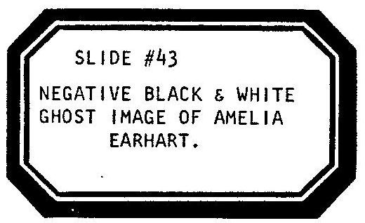

SCENE TWENTY NINE.

[THE MAN CRANKS THE STAGE RIGHT SIGN. THE WOMAN CRANKS THE STAGE LEFT SIGN. LIGHTS UP.]

WOMAN OFF—STAGE
Scene Twenty Nine. 1937.

[THE GIRL PLAYS A TAPE RECORDING OF WAVES ON A BEACH. THE MAN ENTERS AND HANGS THE PLANE ON THE LINE FACING THE SLIDE-SO THAT THE FACE OF EARHART MIGHT BE TALKING TO IT. THE MAN CRANKS THE CENTERSTAGE SIGN.]

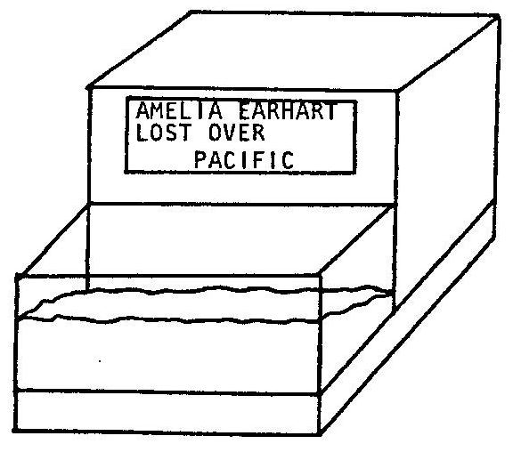

[THE LIGHTS DIM. THE MAN LIGHTS A CANDLE AND CLOSES HIS EYES.]

LINDY/MAN
Blood. Breath. Life. Death.
I seance any spirit left
Of Lady Lindy: Earth or Air,
In Fire, Water, anywhere.

Are you at peace?
Knock two times...
Are the baby and Bruno?
Show me a sign...
Can you read me? Over.
Am I lost or on course? Over.

[LIGHTNING AND THUNDER. THE WOMAN, BEHIND THE REAR PROJECTION SCREEN, FITS INTO THE IMAGE OF AMELIA ON THE SCREEN. THE WOMAN’S SHADOW IN THE PROJECTOR LIGHT BECOMES A MOVING SILHOUETTE/GHOST OF EARHART.]

GHOST OVER MICROPHONE

Whisper...shh...you’ll wake the dead
Our time is brief on this frequency, friend.

LINDY/MAN
What can I do? Searchplanes? The news says that the Japs might have got ya.

GHOST

[LAUGHING:]

You believe what you read in the papers? We’re all at peace, Lucky. What's YOUR forecast today—sunshine or clouds?

LINDY/MAN
It’s been stormy weather here. I need answers to some big questions, Amelia.

GHOST
Well, I'm no Holy Ghost...but why don’t you ask some?

LINDY/MAN
How far is the distance between right and wrong? Where is the point of no return? How many heroes die of old age?

GHOST

[LAUGHS:]

...forgive me, but you sound haunted. I never questioned stretching my grasp. Leaping the gaps. I liked life on the edge. Superman to the rescue.

LINDY/MAN
I need to be careful, cautious…I’m alive!

GHOST
How alive?...for people like us…

LINDY/MAN
Is that the choice?

[SHE GIVES HIM NO ANSWER.]

Once I tried stretching my grasp!

GHOST
Ahh, the day you took off for Paris.

LINDY/MAN
So! The day I took off for Paris!

GHOST
Ahh, and then you landed in Paris…and then?

[LAUGHS.]

LINDY/MAN
So…are you trying to tell me something?

[HE OPENS HIS EYES AND TURNS BUT THE WOMAN HAS LEFT THE IMAGE. HE SEES THE STILL NEGATIVE ONLY.]

Hmmmm…

[HE EXITS.]

SCENE THIRTY.

WOMAN
Scene Thirty:

[THE WOMAN CRANKS THE STAGE RIGHT SIGN. THE MAN CRANKS THE STAGE LEFT SIGN. THE GIRL CRANKS THE CENTERSTAGE SIGN AND ADVANCES TO SLIDE #44.]

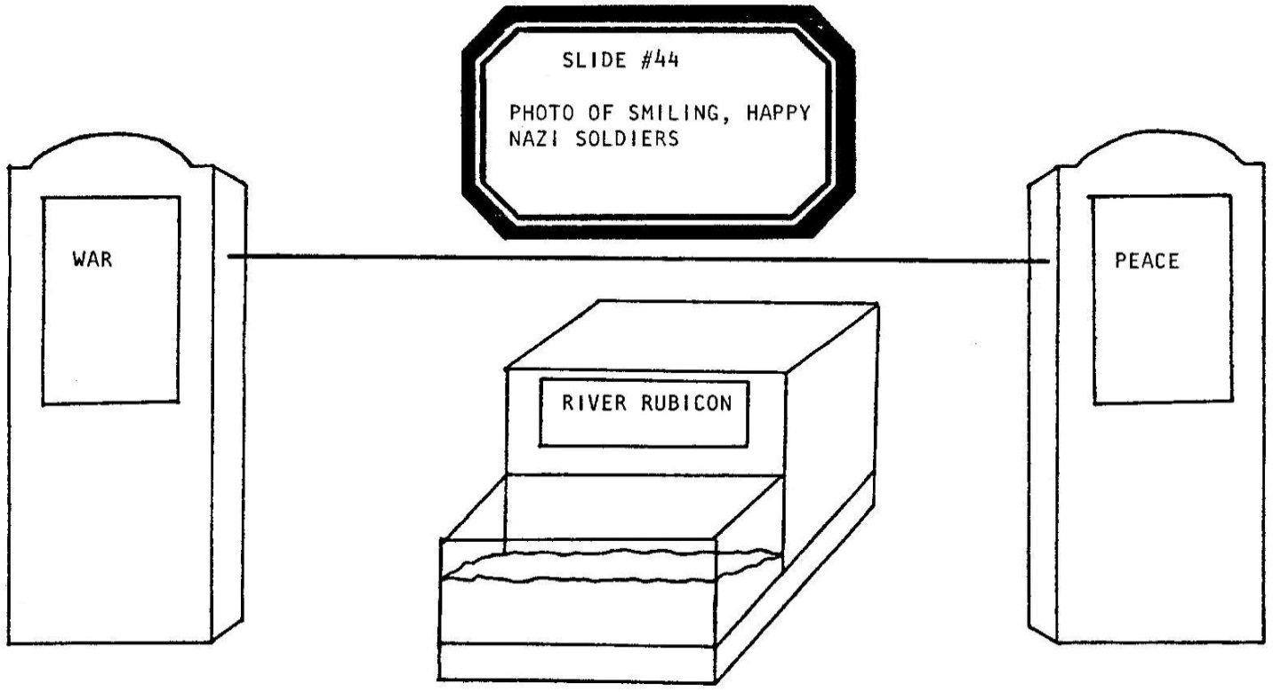

Autumn, 1938.

[THE GIRL PLAYS A TAPE RECORDING OF HAPPY GERMAN BEER HALL MUSIC. SHE BRAIDS HER HAIR AND BRINGS OUT TWO STEINS OF BEER AND A TRAY OF CRACKERS AND DELI FOOD.]

Having not gone out much the past few years, the Lucky Lindys decide to get away from it all, take a vacation. Someplace orderly, with the press under control. Where the trains run on time. They go and visit the sights of Berlin.

[SHE BLOWS A LOUD WHISTLE. SHE ASSUMES A VERY NAZI GERMAN ACCENT AND SWITCHES HER ROLE.]

HERMANN

[ASIDE:]

Ladies and Gentlemen, allow me to introduce myself. De Fuhrer’s master brainwasher.

[SHE ADDRESS LUCKY AND ANNIE.]

Ich bin Hermann Goering!

[THE MAN ENTERS HOLDING THE PLANE IN ONE HAND AND A PUPPET VERSION OF ANNIE IN THE OTHER. HE HAS PUT ANNIE’S HAT ON HIS HAND AND DRAWN MOUTH AND EYES ON HIS PALM. THE WOMAN BLOWS HER WHISTLE AND DRIVES LINDY AND ANNIE AROUND BERLIN. SHE DANGLES HER MANACLE BACK AND FORTH. STILL PLAYING HERMANN, SHE SWITCHES TO A FRIENDLY, NICE GUY, YIDDISH ACCENT.]

So who better else to show you a good time?

[THEY ALL SIT DOWN AND EAT.]

LINDY/MAN
You seem like a nice fellow.

HERMANN
Sure! You'll find us all SUPER Fellows out here. Listen to Hermann, I can take care of whatever you need.

[LINDY WHISPERS TO ANNIE:]

LINDY/MAN
This is a swell place—

[THE MAN NARRATES AS HIMSELF:]

MAN
Lucky whispered.

[LINDY WHISPERS TO ANNIE:]

LINDY/MAN
-and there’s been something on my mind lately that I’ve been dying to try and unload. I had this vision of Amelia Earhart captured by the Japs and they tortured her and poked her eyes out.

[THE PLANE ADDRESSES HERMANN:]

Do you people know of any SAFE way for a fellow to stretch out his grasp?

[THE WOMAN ILLUSTRATES HER POINT BY HOLDING OUT AND CRUSHING CRACKERS:]

HERMANN
Oh, that's not such a tough one! I thought you might stump me! Sure, what you do, my friend, Lindy, is to stretch out your grasp with the one hand, and in the meantime, with the other, what you do is STRANGLE all your other competition.

LINDY/MAN
I didn't know that was a choice.

[THE WOMAN TALKS WITH HER MOUTH FULL:]

HERMANN
Oh, we invented it here. You cheat a little, you get a nice machine, you build a little Luftwaffe.

LINDY/MAN
What does Luftwaffe mean?

HERMANN
Super planes.

LINDY/MAN
Do you have SUPER planes?

HERMANN
Does a Jew have a nose?

LINDY/MAN
Super planes...can I see?

[THE WOMAN UNBUTTONS HER BLOUSE, TAKES THE PLANE FROM THE MAN AND BREASTFEEDS.]

MAN
Back in the rest of the room, however, Mrs. Lucky Lindy was getting jealous of all that secret whispering. She tried to think of a way to divert her husband’s attention-

[HE UNBUTTONS HIS SHIRTSLEEVE UNDER THE HAND DRESSED AS ANNIE. HE OPENS THE CUFF-HIS “PUPPET” OF ANNIE HAS BARED HER BOSOM. SHE WIGGLES-IT IS NO USE. SHE CANNOT DISTRACT THE PLANE’S ATTENTION FROM HERMANN. HE BUTTONS THE SLEEVE.]

-but came up with no idea that worked very well. So, what she did was just whistle-

[HE WHISTLES AMERICA.]

-and then hold her breath.

[HE TAKES A BREATH AND AT THE SAME TIME CLENCHES HIS FIST. ANNIE’S FACE, AS IT WERE, HAS CONTRACTED. THE PLANE POKES OUT FROM HERMANN’S BLOUSE. THE MAN TAKES IT BACK. ONCE AGAIN THE MAN HOLDS A CHARACTER IN EACH HAND. ANNIE BREATHES.]

LINDY/MAN
It’s the misses…

HERMANN
Well, if you have to go, you have to go. But take a snack? Take some fruit? No? Then at least you can take this:

[SHE TAKES A SMALL BLACK WREATH OFF THE TRAY AND SLIPS IT AROUND THE PLANE. SHE SWINGS IT BACK AND FORTH LIKE A HYPNOTIST’S WATCH.]

It’s a medal, from Der Fuhrer. Keep your eye on de medal.

[SHE RETURNS TO HERMANN’S NAZI ACCENT IN AN ASIDE:]

He would want you to keep it. You’re a swell boy-I know. Ich bin Hermann Goering.

[THE MAN HANGS THE PLANE, WEARING THE BLACK WREATH, CENTERED ON THE LINE.]

SCENE THIRTY ONE.

WOMAN
Scene Thirty One: We’re hitting the homestretch!

[IF ANYONE IN THE AUDIENCE STARTS TO RIP OPEN THEIR ENVELOPE SHE TELLS THEM: “NOT YET!” THE WOMAN CRANKS THE STAGE RIGHT SIGN. THE WOMAN CRANKS THE STAGE LEFT SIGN. THE WOMAN CRANKS THE CENTERSTAGE SIGN. THE GIRL ADVANCES TO SLIDE #45.]

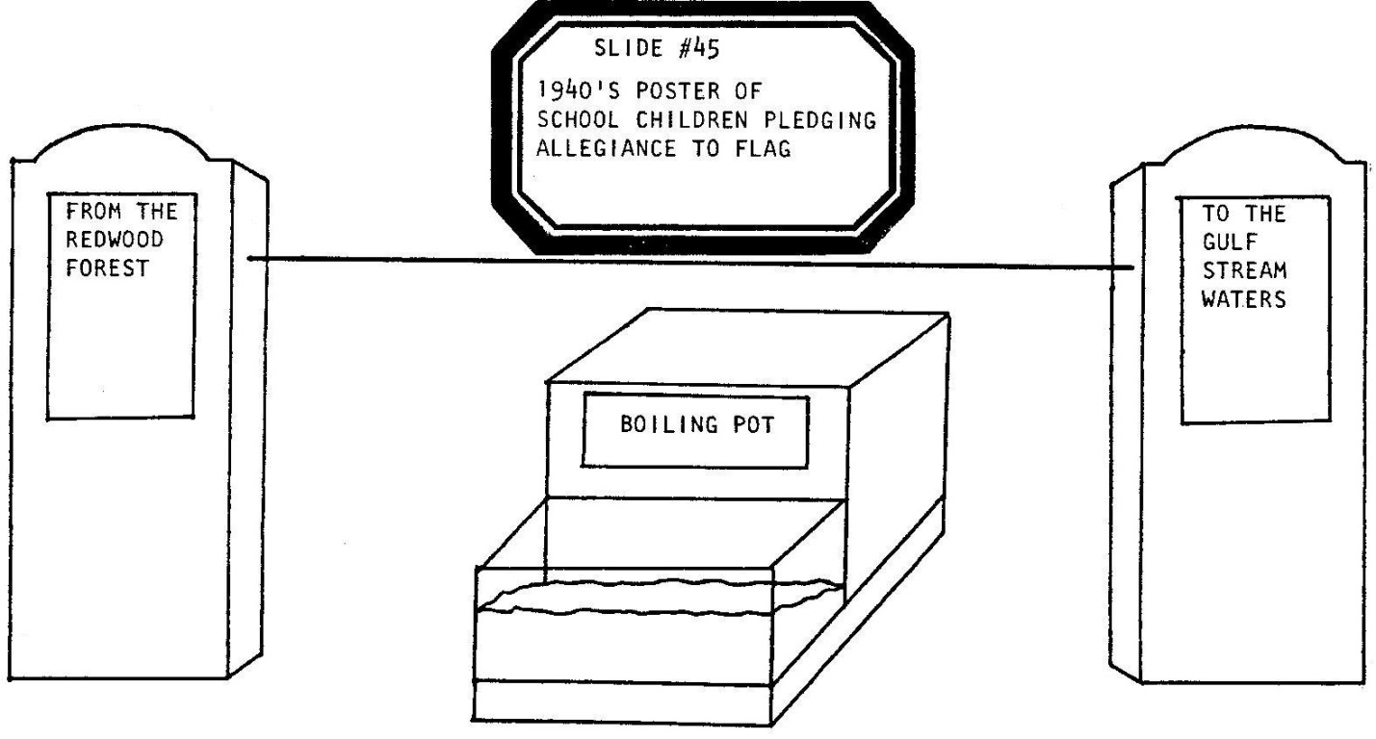

Lucky Lindy comes back to the States and...Stop the Presses! 1939 to 194l: He Talks! Boy, oh boy, does he talk!

[THE GIRL PLAYS A TAPE RECORDING OF AN INSTRUMENTAL VERSION OF TAKE ME OUT TO THE BALLGAME.]

LINDY/WOMAN
Friendly old U.S. of A. My childhood. The homeland. There’s baseball and Buicks and pink cotton candy. Peanuts and popcorn-I HAD to come back. Are you taking this down? I want to visit Mt. Rushmore, have a sauerkraut sandwich, a dark beer and a knockwurst. Buy old Amos and Andy a bar of pure Ivory soap. Weinershnitzel goes better with-

[THE MAN ENTERS RIDING A WHEELCHAIR. HE TRIES TO PULL THE WREATH OFF OF THE PLANE BUT CANNOT REACH THAT HIGH.]

FDR
Now listen to me, Lucky Lindy, this is Roosevelt, the President speaking and I think I can still help you. Take that FUCKING KRAUT THING off!

LINDY/WOMAN
My medal?

FDR
Give it to me. Now.

LINDY/WOMAN
You can’t take my medal.

FDR
You’re an American…I’m the President…

LINDY/WOMAN
It’s a German medal.

FDR
Colonel Lucky Lindy-

WOMAN

[ASIDE:]

He had been given the rank of Colonel for the flight he had made to Paris.

FDR
-Colonel Lucky Lindy, it is now an order from your Commander-in-Chief! Give me that medal or I’ll-

LINDY/WOMAN
OR??

FDR
Or I’ll have to...to...or I’ll have to brand you a______________

[HE HOLDS UP A NEWS HEADLINE: “TRAITOR.”]

—and the next time I’ll do it out loud!

[HE EXITS.]

LINDY/WOMAN
He wouldn’t dare...

FDR OFF-STAGE
Oh, yes I would!

LINDY/WOMAN
...would he?

[THE HOUSE LIGHTS COME UP. THE GIRL HAS A SEALED ENVELOPE IDENTICAL TO THOSE STUFFED INTO EACH AUDIENCE MEMBER’S PROGRAM.]

GIRL
The envelopes, please!

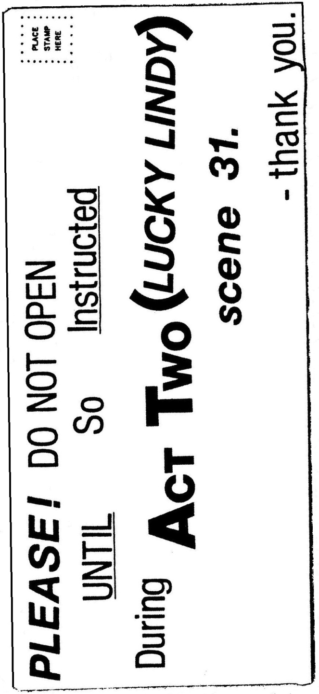

[ALL BUT ONE AUDIENCE MEMBER FINDS THE ENCLOSED STUFFED INTO THEIR ENVELOPE:]
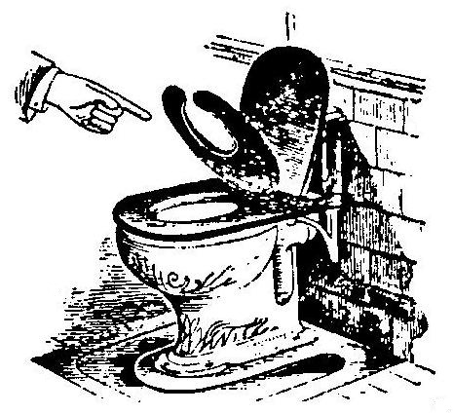

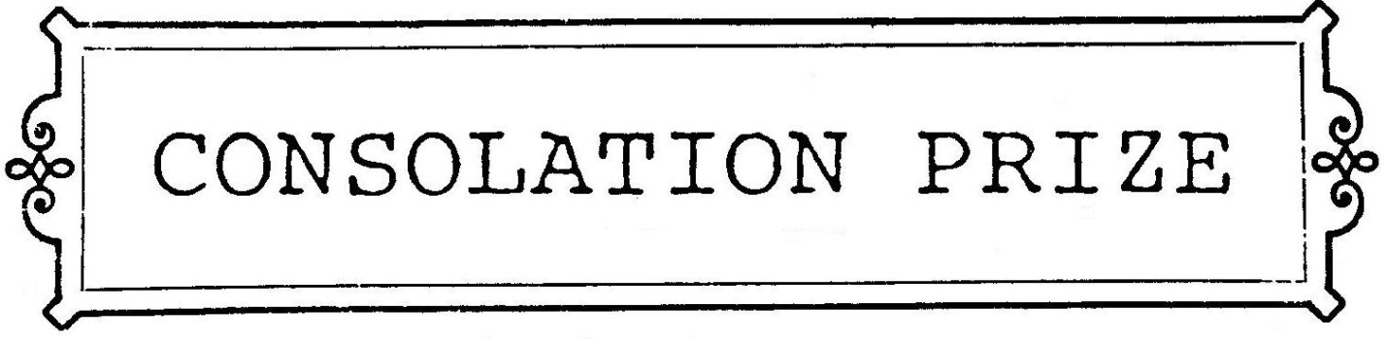

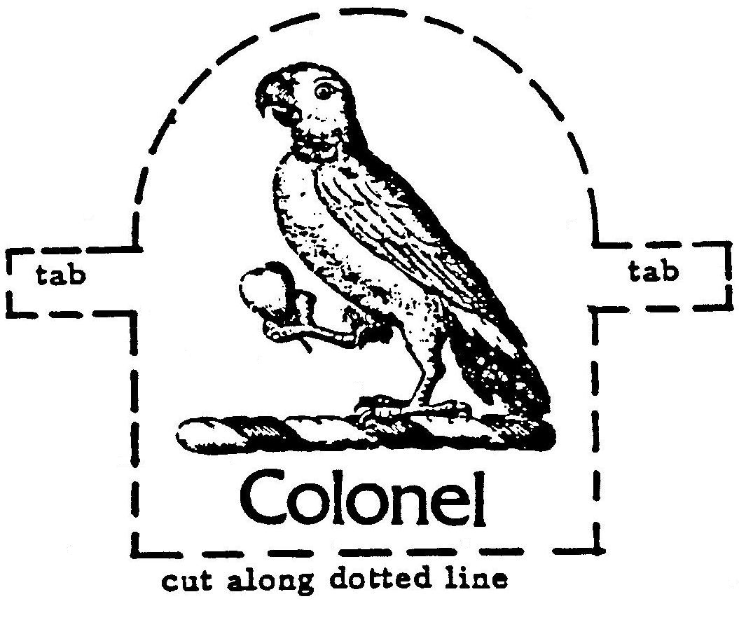
[THE AUDIENCE MEMBER WITH THE ENCLOSED IN THEIR ENVELOPE IS REQUESTED BY THE GIRL TO STAND AND READ THE TELEGRAM ALDUD TO THE CAST AND AUDIENCE. THAT PERSON IS THEN PRESENTED WITH AN INSTANT LOTTERY TICKET SO THAT HE OR SHE CAN RUB OFF THE CARD AND BECOME AN INSTANT WINNER OR LOSER.]

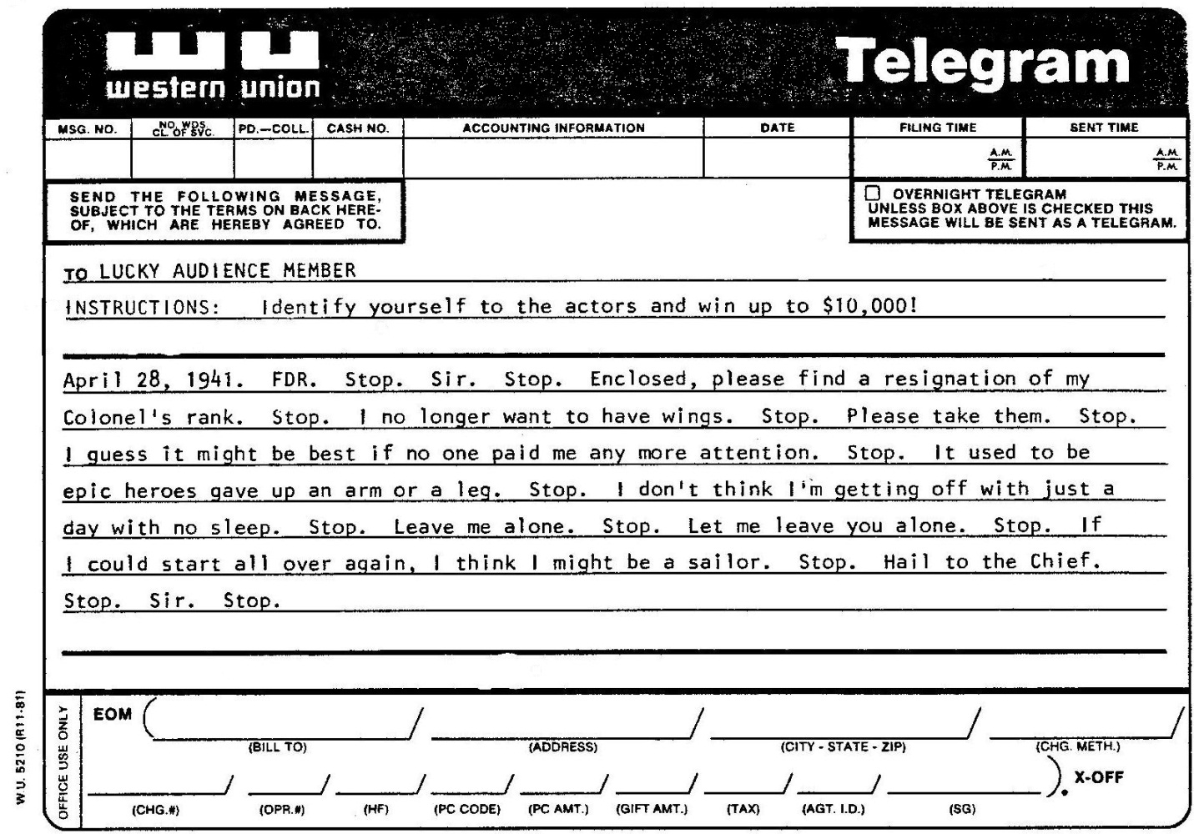

[THE HOUSE LIGHTS GO OUT. THE GIRL PUTS HER COPY OF THE LETTER AWAY, TAKES A PAIR OF SCISSORS AND RITUALISTICALLY CUTS THE PLANE’S LINE. THE PLANE CRASHES TO THE FLOOR.]

SCENE THIRTY TWO.

WOMAN
THIS:

[THE WOMAN CRANKS THE STAGE RIGHT SIGN. THE WOMAN CRANKS THE STAGE LEFT SIGN. THE WOMAN CRANKS THE CENTERSTAGE SIGN. THE GIRL ADVANCES TO SLIDE #46.]

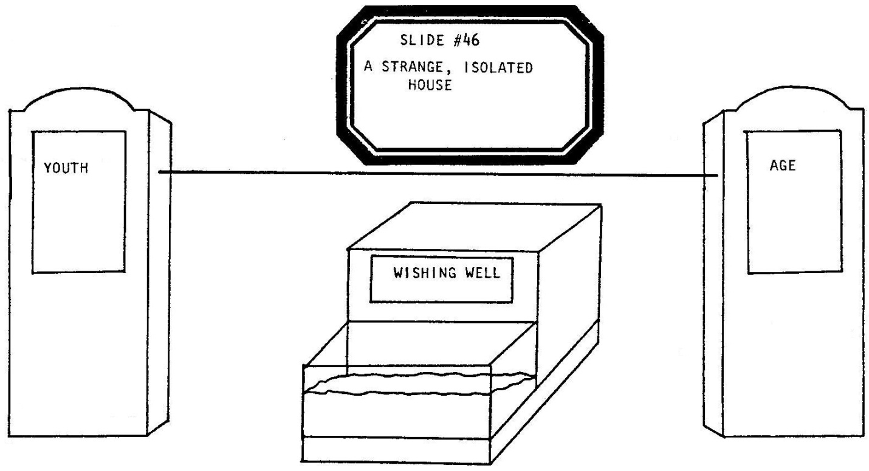

-is Scene Thirty Two.

[SHE EXITS. THE GIRL PLAYS A TAPE RECORDING OF WAVES ON A BEACH. THE MAN ENTERS, PICKS UP THE PLANE AND REMOVES THE BLACK WREATH. HE ATTACHES THE BROKEN PLANE TO A TEN FOOT POLE WHICH HAS TWO WHITE GLOVED HANDS REACHING OUT AT ITS END. THE PLANE HANGS JUST AN INCH OR TWO OUT OF REACH OF THE HANDS. AS THE MAN DELIVERS HIS SPEECH HE SLOWLY EXTENDS THE PLANE OUT HIGH ABOVE THE AUDIENCE. THE POLE SHOULD BE THIN AND FLEXIBLE AND WOBBLE-WHAT HE IS DOING SHOULD APPEAR TO DEMAND SERIOUS BALANCING SKILL AND STRENGTH.]

MAN
Lucky Lindy moved out to a house, high on a cliff, on a small island in the sea, Amelia’s sea -

[THE GIRL ADVANCES TO SLIDE #47.]

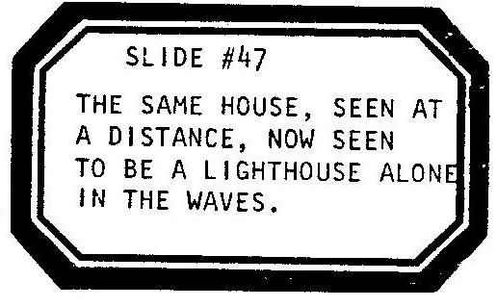

-the Pacific. No electricity, no lights. Remote, inaccessable, high above a deserted beach. No modern conveniences, this house was high on a cliff. It was high as you’ll get... with your feet on the ground. And all Lindy did, for days upon end, was sit in his house on the cliff and look out the windows, and stare at the seagulls and watch the weather and sky, and gaze long at red sunsets, and every once and a while, but not too very often, glance down at the crashing sea.

[PAUSE. THE GIRL ADVANCES TO SLIDE #48.]

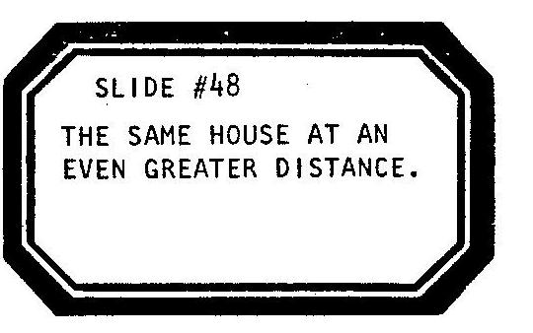

And time passed him by, and time covered a lot. The war came and he helped…he even helped on our side. People forgave him, the press left him alone. He even got back his rank from the Commander-in-Chief. There was a new type Commander, a President Eisenhower, who was what you might have called a “swell” guy-if people still used that word. Yes, old time covered lots, and he still had lots of dough, and for years and years Lucky lived just like a regular guy—except for the house. The house high on a cliff. The cliff he sometimes called Kiwi. Kiwi after the bird. The bird with no wings and the bird with no flight. The Kiwi’s extinct.

[HE SWINGS THE PLANE AND POLE BACK TO STAGE. THE WOMAN CATCHES THE PLANE AND REMOVES IT FROM THE POLE. SHE PLACES THE PLANE ON THE LITTLE STAGE OVER THE AQUARIUM. BETWEEN SCENES 32 AND 33, THE GIRL PLAYS A TAPE RECORDING OF A 60 SECOND SOUND COLLAGE COVERING THE PERIOD FROM THE END OF WORLD WAR TWO THROUGH “THE EAGLE HAS LANDED” AND “ONE SMALL STEP FOR A MAN, ONE GIANT STEP FOR ALL MANKIND” RECORDINGS OF THE FIRST MAN ON THE MOON. THE COLLAGE MIXES SUCH HISTORIC NARRATION WITH BRIEF SEGMENTS FROM POPULAR MUSIC, CARTOONS, ETC. FROM THE 1940’S, 1950’S AND 1960’S. MUCH OF THE COLLAGE SHOULD MAKE REFERENCE TO FLIGHT.]

SCENE THIRTY THREE.

WOMAN
Scene Thirty Three.

[THE WOMAN CRANKS THE STAGE RIGHT SIGN. THE WOMAN CRANKS THE STAGE LEFT SIGN. THE WOMAN CRANKS THE CENTERSTAGE SIGN.]

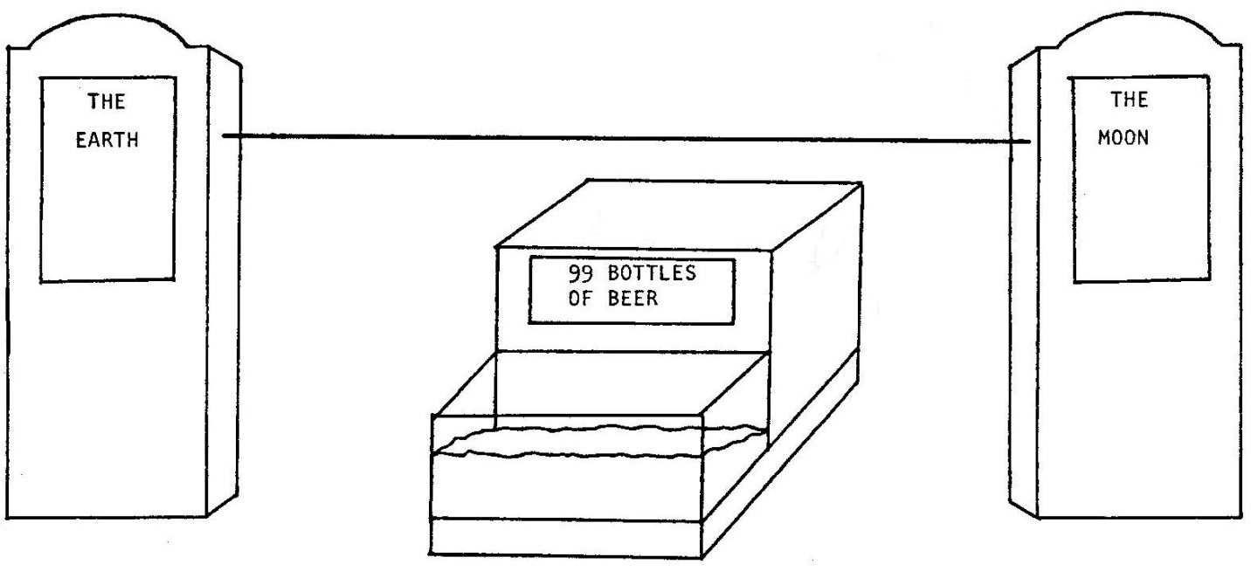

[THE PLANE IS SEATED IN A MINIATURE ARMCHAIR. A STEIN OF BEER AND THE DELI TRAY FROM SCENE THIRTY ARE PLACED BY ITS SIDE. A SMALL PORTABLE, 2 OR 3 INCH SONY TRINITRON TELEVISION IS PLACED NEXT TO THE PLANE ON THE LITTLE STAGE, ITS SCREEN FACING AWAY FROM THE AUDIENCE. THE GIRL SETS A PORTABLE CASSETTE TAPE RECORDER NEAR THE PLANE.]

July 20, 1969.

[THE GIRL ADVANCES TO SLIDE #49.]

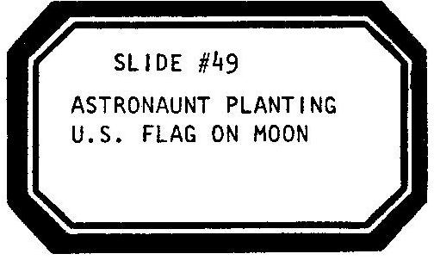

[THE WOMAN PUSHES THE “PLAY” BUTTON ON THE TAPE RECORDER. SHE AND THE MAN LEAVE THE STAGE. THE GIRL REMAINS AND WATCHES. THE PLANE, COURTESY OF THE TAPE RECORDER, BEGINS TO SPEAK FOR ITSELF. ITS VOICE IS ONE ENTIRELY NEW AND NOT THAT OF A CAST MEMBER. THE TV WILL ALSO TALK BY WAY OF ITS BUILT IN SPEAKER. THE VOICE IS ALSO ONE ENTIRELY NEW. PERHAPS A SPOTLIGHT SWITCHES BACK AND FORTH BETWEEN THE PLANE AND TV INDICATING WHICHEVER IS SPEAKING. THE PLAY IS NOW OBJECT TO OBJECT.]

PLANE
Nah, I ain’t gonna stare out at the stars again tonight. Looks the same, same old stars. Lousy show...I’ll see what’s on my battery powered, transistor, portable TV instead. Where are ya, TV? I’m drunk, for the very first time in my life, but I’ll find ya...I like you, TV...you don’t challenge…you’re a voice I don’t mind...

[THE TV SCREEN SUDDENLY BEGINS TO CAST SHADOWS ON THE UPSTAGE WALLS.]

TV
Over here...on the floor.

PLANE
What’s up?

TV
Big stuff.

PLANE
Like what?

TV
You know...the astronaut stuff.

PLANE
They got there?

TV
Today.

PLANE
They walked on it yet?

TV
‘bout to do it right now…

PLANE
…well? Who’s going first? Aldrin?

TV
Yeah.

PLANE
You’re sure? Tell me, come on!

TV
Yeah! Well, I don’t know. Could be Armstrong. I can’t tell ‘em apart. They got those suits on and helmets you know, I can’t even see the face. Lay off.

PLANE
First man ever to walk on the moon and you don’t even know his name for sure?

TV
Aldrin.

PLANE
What’s his full name?

TV
Well, a…no! I mean Armstrong…the first was Neil Armstrong!

PLANE
Yeah? What’s the other one called?

TV
What other one?

PLANE
Didn’t you tell me…a few days ago, there’d be a third one up there, in orbit…around?

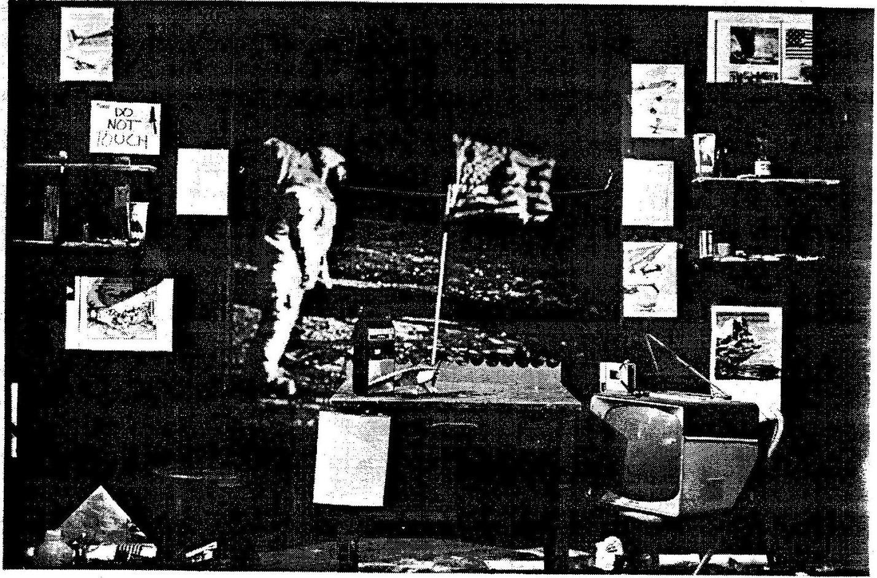

TV
Oh, yeah. I forgot…

PLANE
Forgot, huh? Remember the first man to fly the Atlantic?

TV
I’m talkin’ to him. You drunk?

[PAUSE.]

PLANE
Not enough…I mean, how come everybody remembers way back-

[THE TV CUTS HIM OFF:]

TV
What is this, CONCENTRATION? Come off it!

PLANE
How come? I gotta know.

TV
I don’t know, you were different, back then...yeah, that was historical…we got TV now...I’m a bad Influence...

PLANE
That’s it? Nah. You sure?

TV
I don’t know...

PLANE
Get outa here!

[THE TV TURNS OFF AND STOPS CASTING SHADOWS. BLACKOUT EXCEPT FOR THE REAR PROJECTION SCREEN AS THE GIRL ADVANCES TO SLIDE #50.]

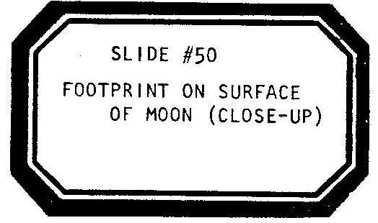

I’m gonna stare out a window and figure something out. I’m gonna sit and finally get this whole thing figured out...all this junk for forty two years. All this crap, something’s not right. Something stopped heroes...this ain’t even America no more...all this junk, all this crap, air conditioning for cold air, self—cleaning ovens, computers for dating...nobody’s doing anything
by themselves anymore; nobody’s making no effort. Not like l did, now it’s all done for ya...those guys up there are only repairmen, they’re mostly along for the ride, not like me. Not like no hero. I’m the last goddamn hero! I took a chance, for a day! You don’t see that no more. No one’s taking no chances, they just get more machines...I’d like to ring the neck of the guy, yeah...I’d like to know the dirty bastard who proved that machines were so good! Who first took a machine with him when he was leaping a gap-

[PAUSE.]

…Oh, God Bless America! How do I take it all back?

[THE GIRL ADVANCES TO SLIDE #51.]

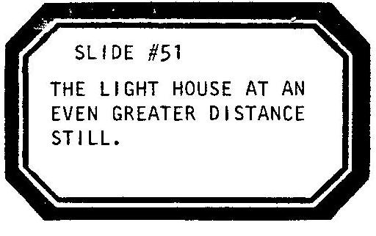

[THE STAGE LIGHTS RESTORE. THE GIRL TURNS OFF THE TAPE RECORDER.]

SCENE THIRTY THREE AND A HALF.

GIRL
Thirty Three...and a half:

[THE GIRL CRANKS THE STAGE RIGHT SIGN. THE GIRL CRANKS THE STAGE LEFT SIGN. THE GIRL CRANKS THE CENTERSTAGE SIGN. THE GIRL ADVANCES TO SLIDE #52.]

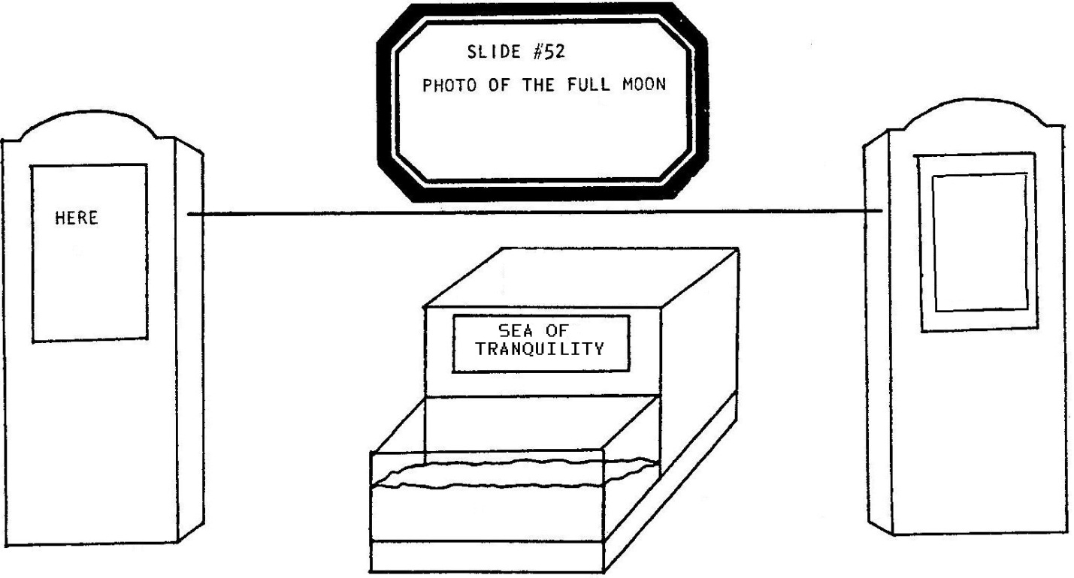

August 26, 1974: it all became clear.

[SHE PICKS UP WHAT THERE IS LEFT OF THE PLANE AND DUMPS IT OUT OF SIGHT.]

The man died at home-

[THE GIRL ADVANCES TO SLIDE #53.]

-wondering how to reverse it.

[THE GIRL CRANKS THE STAGE LEFT SIGN. THE GIRL CRANKS THE STAGE RIGHT SIGN. THE CENTERSTAGE SIGN REMAINS THE SAME.]

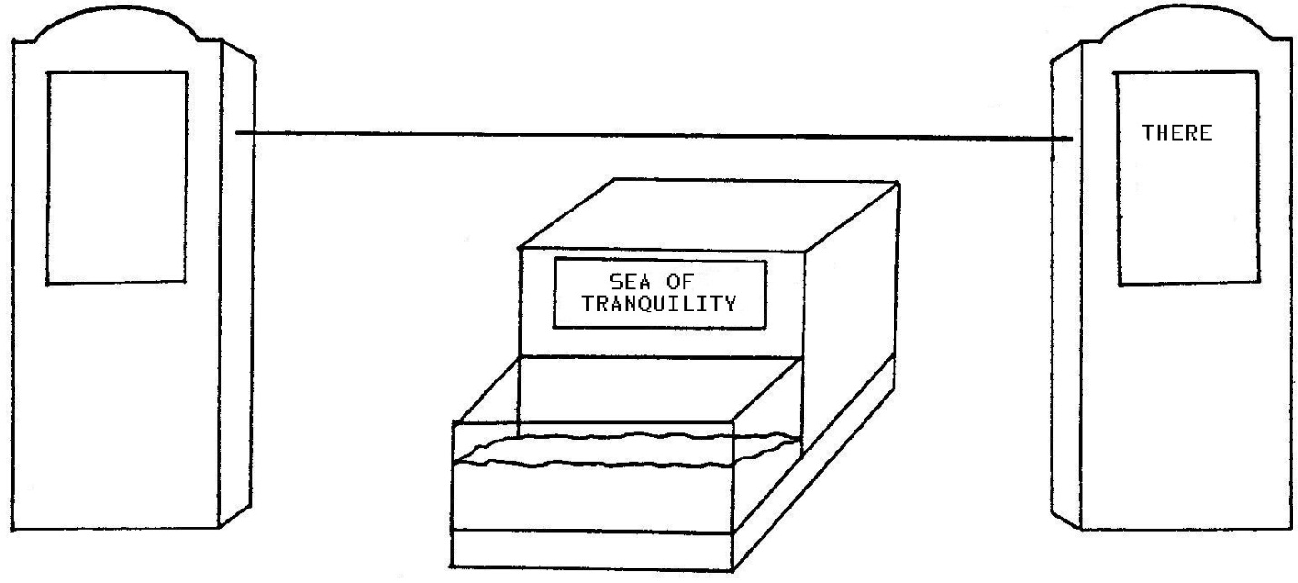

He was dreaming of one flight, one more.

[SHE CROSSES TO THE STAGE LEFT “THERE” SIGN AND BEGINS TO POINT WITH HER FINGER ACROSS THE STAGE, TRACING THE LINE THAT USED TO HANG BETWEEN THE TWO POINTS.]

He went back up into the air-

[THE GIRL ADVANCES TO SLIDE #54.]

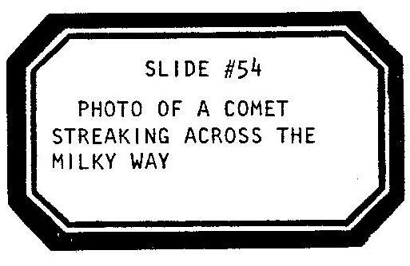

-once more he flew out over a sea. He flew and he flew and he flew. We might say he kept stretching his grasp. He felt almost like he had felt a day once before. Maybe even a little bit braver. You see, this journey, it was the same length as the first one...

[WHEN SHE POlNTS TO EXACTLY WHERE THE LlNE’S CENTER USED TO BE SHE SNAPS HER FINGERS AND ADVANCES TO SLIDE #55.]

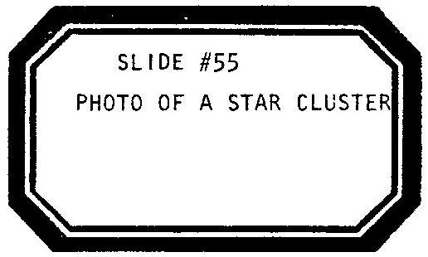

...but now this time around...

[AFTER SNAPPING HER FINGERS THE GIRL HAS CLENCHED HER HAND OVER HER HEAD AND NOW TOSSES THE EMPTY CONTENTS OF THAT FIST, UNDERHAND, INTO AN OPEN HAND RELEASE AND ADVANCES TO SLIDE #56.]

...he didn’t take no damn machine.

[SHE CONTINUES TO POINT OUT HER IMAGINARY PROGRESSION ON THE NO LONGER SUSPENDED LINE, POINTING ALL THE WAY TO THE BLANK SIGN AT STAGE RIGHT. THE GIRL PLAYS A TAPE RECORDING OF LUCKY LINDY BY VERNON DALHART. THE SCRATCHY 78 RECORDING IS, THIS TIME, A SLOW, SAD COUNTRY FIDDLE AND GUITAR TUNE; A SENTIMENTALIZED VERSION OF THE SAME SONG. THE MAN AND WOMAN RETURN AND HELP THE GIRL CLEAN UP THE STAGE. THE GIRL ADVANCES TO SLIDE #57.]

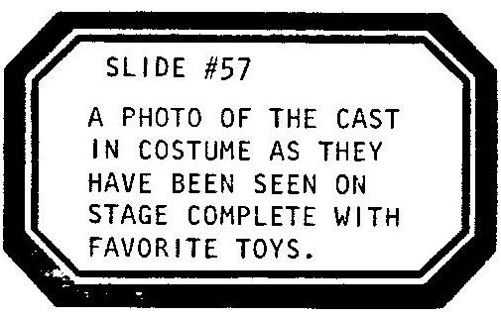

[THEY TIDY THE STAGE. THEY PUT ON THEIR STREET COATS. THE SONG FADES. THEY EXIT. THE SLIDE REMAINS ON. END OF ACT TWO.]

ACT THREE

GRAND FINALE
-A Tabletop Theatre-

ACT THREE

[EXACTLY AS BEFORE. THE SAME MESSY STAGE. THE SAME SLIDE. THE MAN, STILL WEARING HIS COAT, SNEAKS BACK ONTO STAGE. HE CARRIES A TRAY HOLDING TWO SMALL STANDING FIGURES AND A COLORFUL CUT-OUT PAPER HOUSE. HE SETS THE TRAY DOWN ON THE LITTLE STAGE OVER THE AQUARIUM. HE LOOKS LEFT. HE LOOKS RIGHT. THE MAN ADVANCES TO SLIDE #58.]

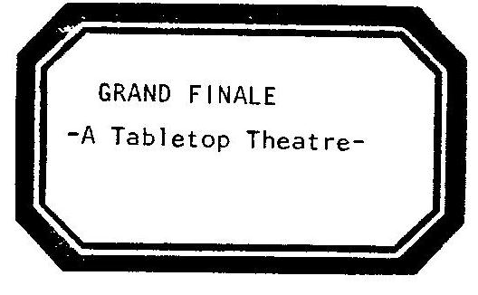

[HE WHISPERS HIS FIRST LINE:]

MAN
Act Three: Grand Finale! A Tabletop Theatre!

[HE POINTS TO THE HOUSE.]

A house.

[HE POINTS OUT THE TWO FIGURES.]

The tenants.

[HE OPENS THE ROOF OF THE HOUSE AND DROPS THEM INSIDE.]

Bing-Bong...

[HE PUTS HIS HAND T0 HIS EAR.]

...the doorbell.

[HE REACHES INTO A COAT POCKET.]

The relatives.

[HE SHOWS TWO MORE PLASTIC FIGURES.]

The guestroom:

[HE OPENS THE SHUTTERS TO A WINDOW ON THE SIDE OF THE HOUSE AND DROPS THEM INSIDE. HE PUTS HIS HANDS IN HIS POCKETS.]

Bing-Bong…more relatives.

[HE CRAMS TWO MORE FIGURES INTO THE GUESTROOM.]

…MORE relatives…

[HE SHOVES TWO ADDITIONAL FIGURES INSIDE. HE LIGHTS A CIGARETTE WITH A BUTANE LIGHTER THAT HAS ITS FLAME TURNED UP HIGH. HE RELAXES. HE TAKES A PUFF. THE LIGHTER KEEPS FLAMING.]

Someone smokes in bed.

[HIS EYES GROW HEAVY, THE ARM HOLDING THE LIGHTER ACCIDENTALLY FINDS ITSELF NEXT TO THE HOUSE. IT CATCHES ON FIRE. THE HOUSE FLAMES AND BURNS.]

LOOK!

[HE CALMS DOWN. HE WATCHES THE FIRE. HE BLOWS SMOKE AT THE FLAMES. HE CIRCLES THE TABLE, NODDING HIS HEAD AS THE HOUSE TURNS TO ASH.]

…tsk-tsk-tsk-tsk-tsk…look…

[HE SUDDENLY WHEELS OVER A HOOK AND LADDER TOY FIRE TRUCK WITH TWO MORE FIGURES RIDING ON IT.]

Ding-ding-ding-ding-ding-ding-ding-ding-ding-ding-ding.

[HE WALKS THE TWO LITTLE FIREMEN UO THE TRUCK’S LADDER AND TOSSES THEM INTO THE FLAMING BUILDING. HE EXTINGUISHES THE LAST OF THE FLAMES WITH A SELTZER BOTTLE.]

The firemen are hard at work.

[HE SCRAPES THE ASHES WITH THE CLAW SIDE OF A HAMMER.]

My, my, two charred bodies.

[HE FLICKS THE TWO OFF THE TABLE.]

Let me see: Two out of thirty-seven, that’s not so bad.

[PAUSE. HE FLIPS OVER HIS HAMMER AND VIOLENTLY SMASHES THE OTHER CHARRED FIGURES. HE SQUIRTS CATSUP ON THE BODIES.]

Mass murder!

[HE BLOWS A POLICE WHISTLE.]

The police are called in:

[HE PUTS ON A COP’S CAP. HE ASSUMES AN ETHNIC POSE FOR EACH COP AND MAKES USE OF AN ACCOMPANYING SERIES OF ETHNIC ACCENTS:]

Flannagan. Harrigan. O’Reiley. Schwartz. Cohen. Levi. Levinksy. Gianelli. Alberghetti. Genoveso. Ballobisa. Santana. Juarez. Binero. e’ Sanchez…and Sgt. Steve Smith-

[PAUSE.]

-go out to lunch.

[HE HOLDS UP A ROLL.]

The roll is taken.

[HE ORDERS LUNCH AS EACH OF THE COPS IN APPROPRIATE STANCE AND SPEECH.]

Irish coffe, Irish stew. Lucky Charms. Matzoball soup. Bagel, lox and creamcheese. Hot knishes. Pastrami, a little pickle on pumpernickel. Manicotti. Linguini. Prince Spaghetti. Buitoni Macaroni. Refried beans. Refried beans. Refried beans. e’ Refried beans…and I’ll have a steak and a potatoe and a chocolate milk.

[HE BITES THE ROLL. HE GAGS.]

Food poisoning!

[HE GAGS. THE COP HAT COMES OFF.]

Everybody’s dead.

[HE PLAYS A TAPE RECORDING OF THE BEEGEES SINGING STAYING ALIVE.]

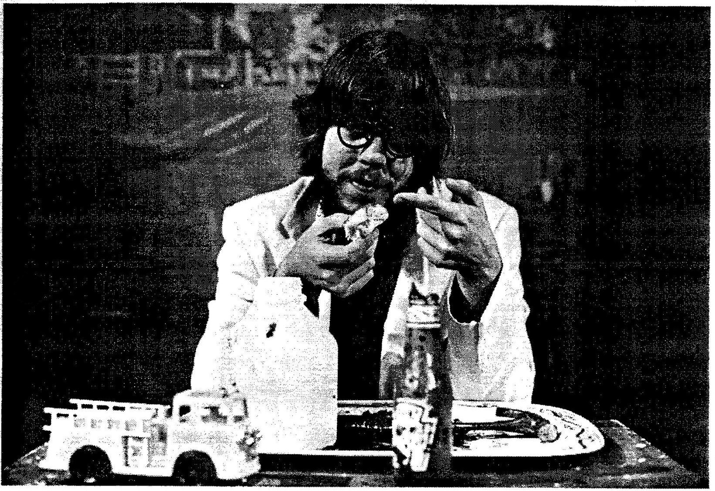

Meanwhile: The mastermind mass murderer goes to a single’s bar in another town.

[HE PICKS UP TWO GINGERBREAD COOKIES. THEY DANCE WITH EACH OTHER.]

“What’s your sign?” – he says.
“Stop.” - she says.
“Tough bitch!” – he says.
“You like?” - she says.

BANG! BANG!
Uhh…Uhh…!

[HE HAS FLICKED TWO APPENDAGES OFF THE FEMALE OF THE COOKIES.]

The other patrons consider whether he resembles the artist’s rendering in the morning papers.

[HE PICKS UP A NEWSPAPER. HE TURNS IT TO THE AUDIENCE. THE HEADLINE READS: “WATCH OUT FOR THIS MAN” OVER AN OUTLINE SKETCH OF A GINGERBREAD COOKIE.]

The band takes a short break.

[HE TURNS OFF THE BEEGEES.]

The maniac is lynched, his pants are pulled down to his ankles, he will kill no more!

[HE COMMITS AN ESPECIALLY BRUTAL LYNCHING/CASTRATION OF THE COOKIE. HE SQUIRTS CATSUP WHERE HIS LIMBS HAVE BEEN BROKEN.]

But, the mob has tasted blood for the first time.

[HE TAKES A BITE OF THE BROKEN COOKIE, LIKES THE TASTE, STIRS THE COOKIE INTO MORE ASH AND CATSUP AND TAKES A SECOND BITE.]

God, or someone in a similar position-

[THE GIRL AND WOMAN ENTER WITH THEIR COATS ON AND IMPATIENTLY WAIT FOR THE MAN. HE SWEEPS ALL HIS PROPS ONTO THE FLOOR.]

God, or someone in a similar position, destroys the world.

[HE STARTS TO GO, FINDS ANOTHER PLASTIC FIGURE IN HIS POCKET, HOLDS IT UP AND THEN TOSSES IT INTO THE WATER.]

To be continued.

[THEY ARE GONE. END OF ACT THREE.]

CURTAIN CALL:

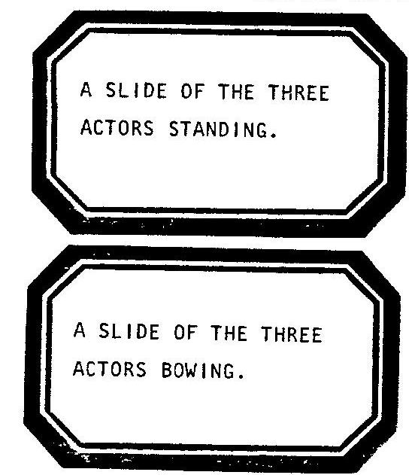

[THESE TWO SLIDES ALTERNATE THROUGHOUT THE APPLAUSE.]

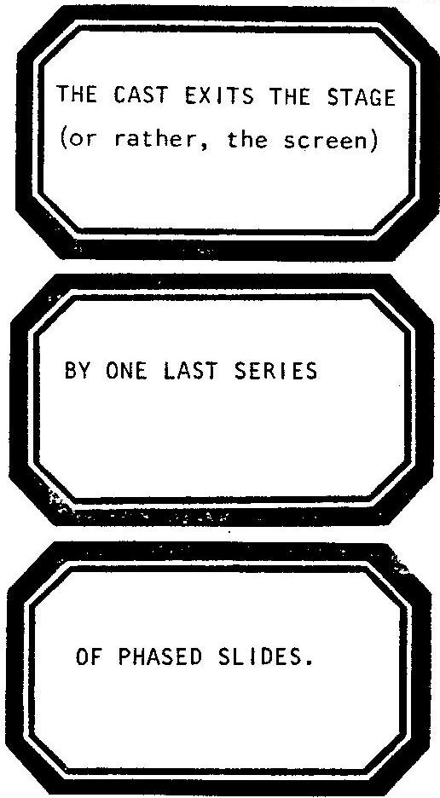
[END OF PLAY.]

APPENDIX

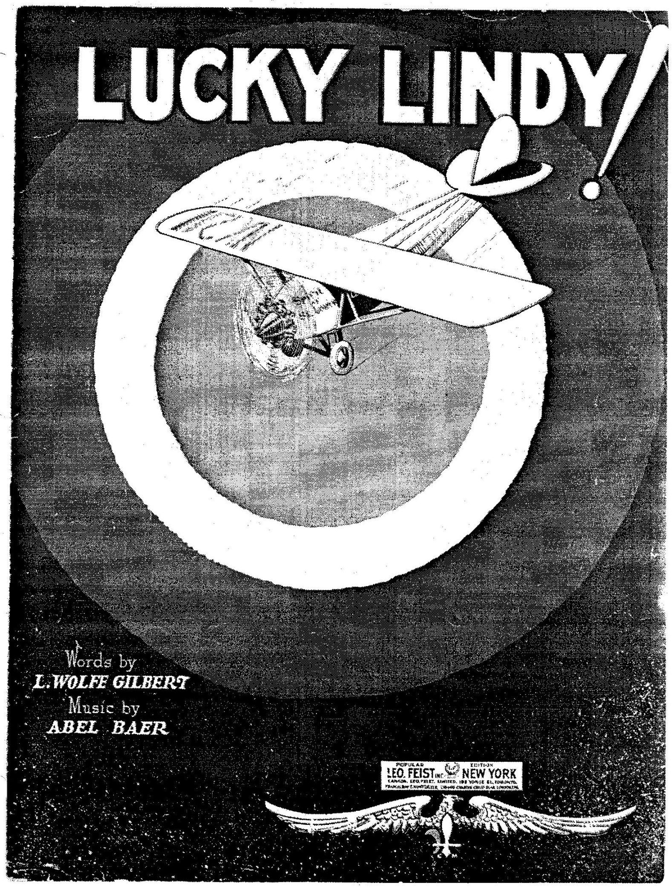

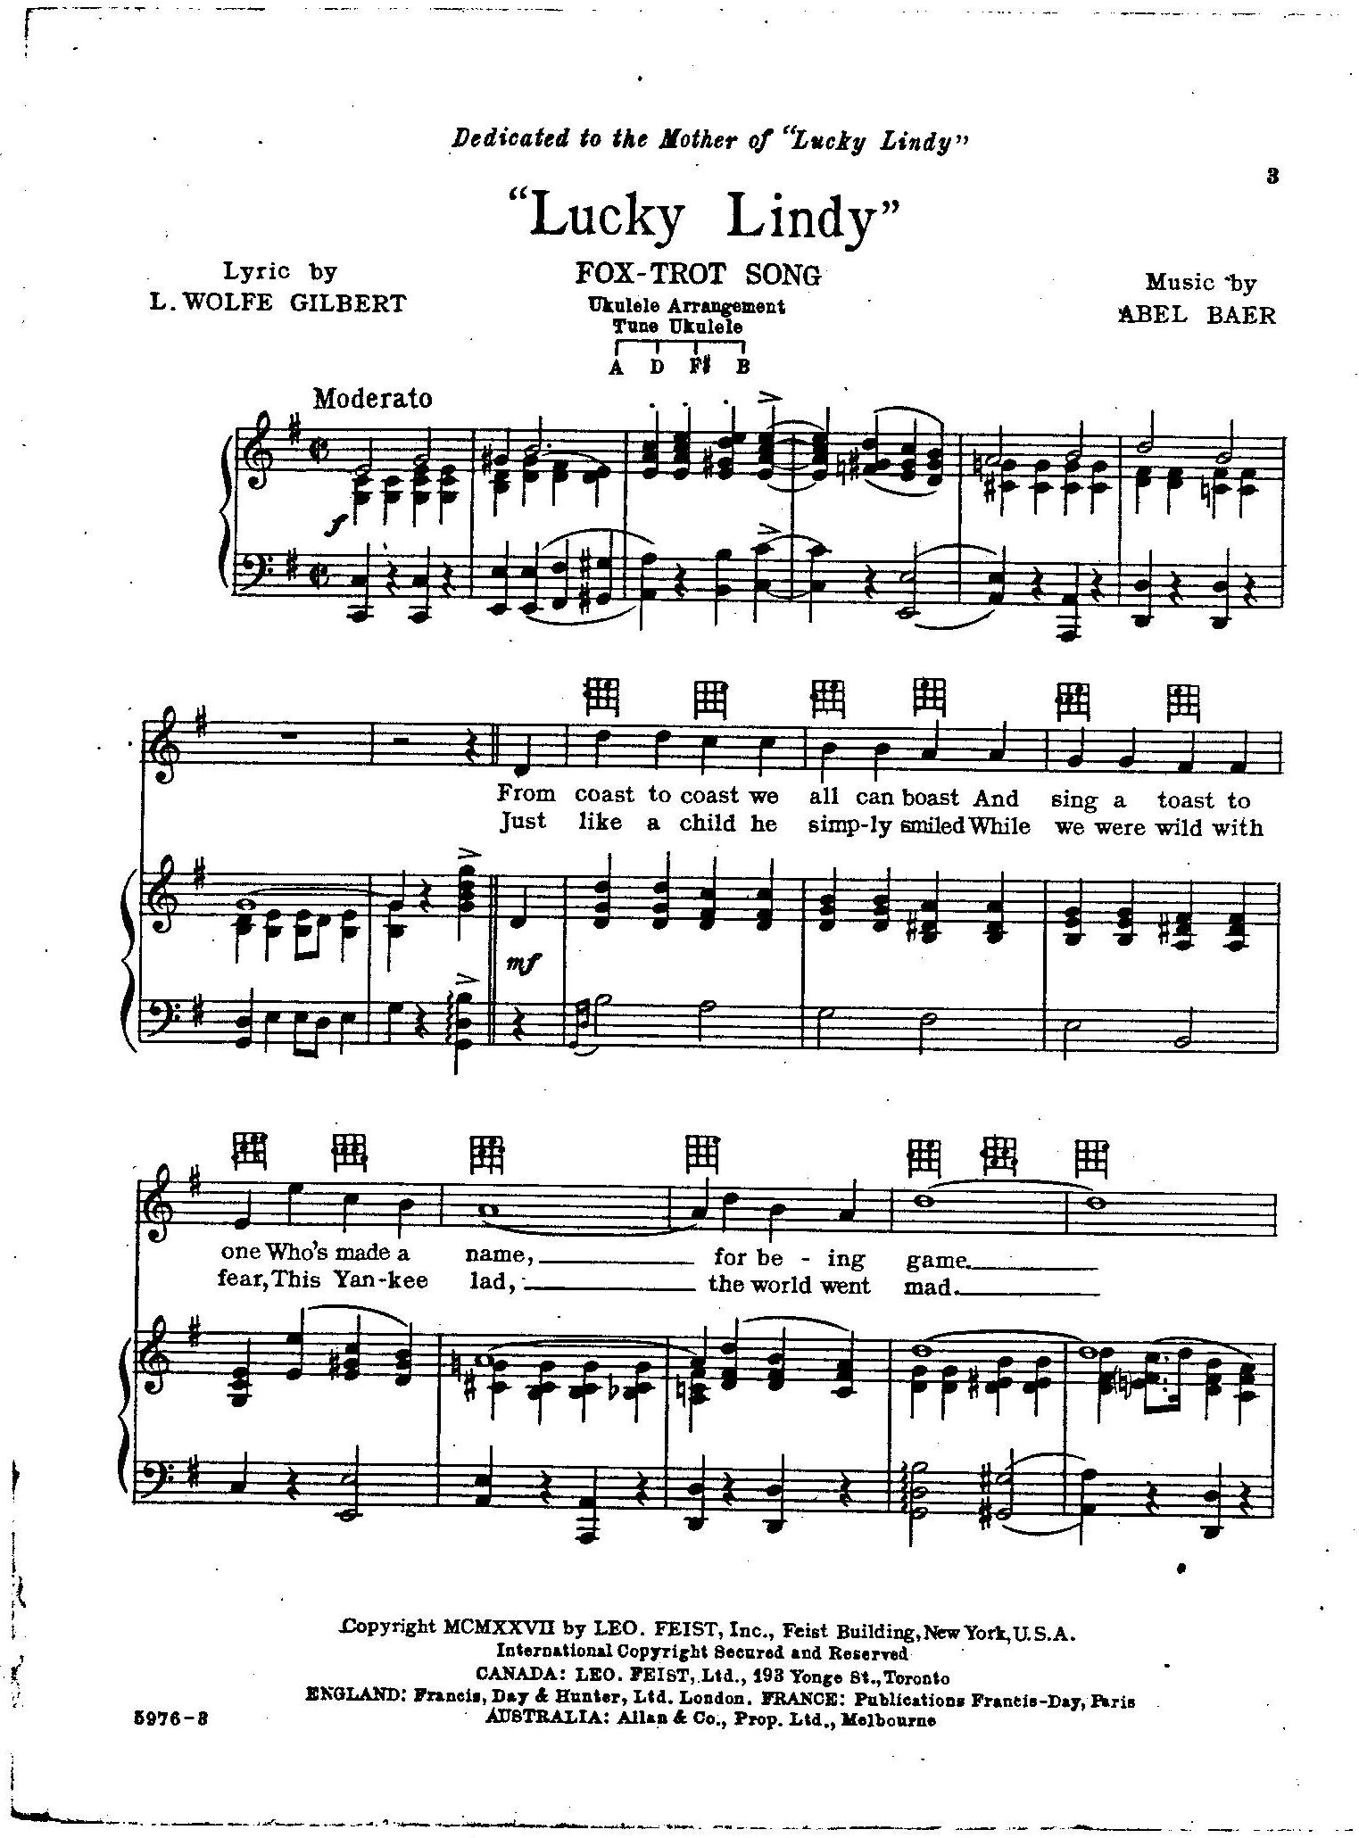

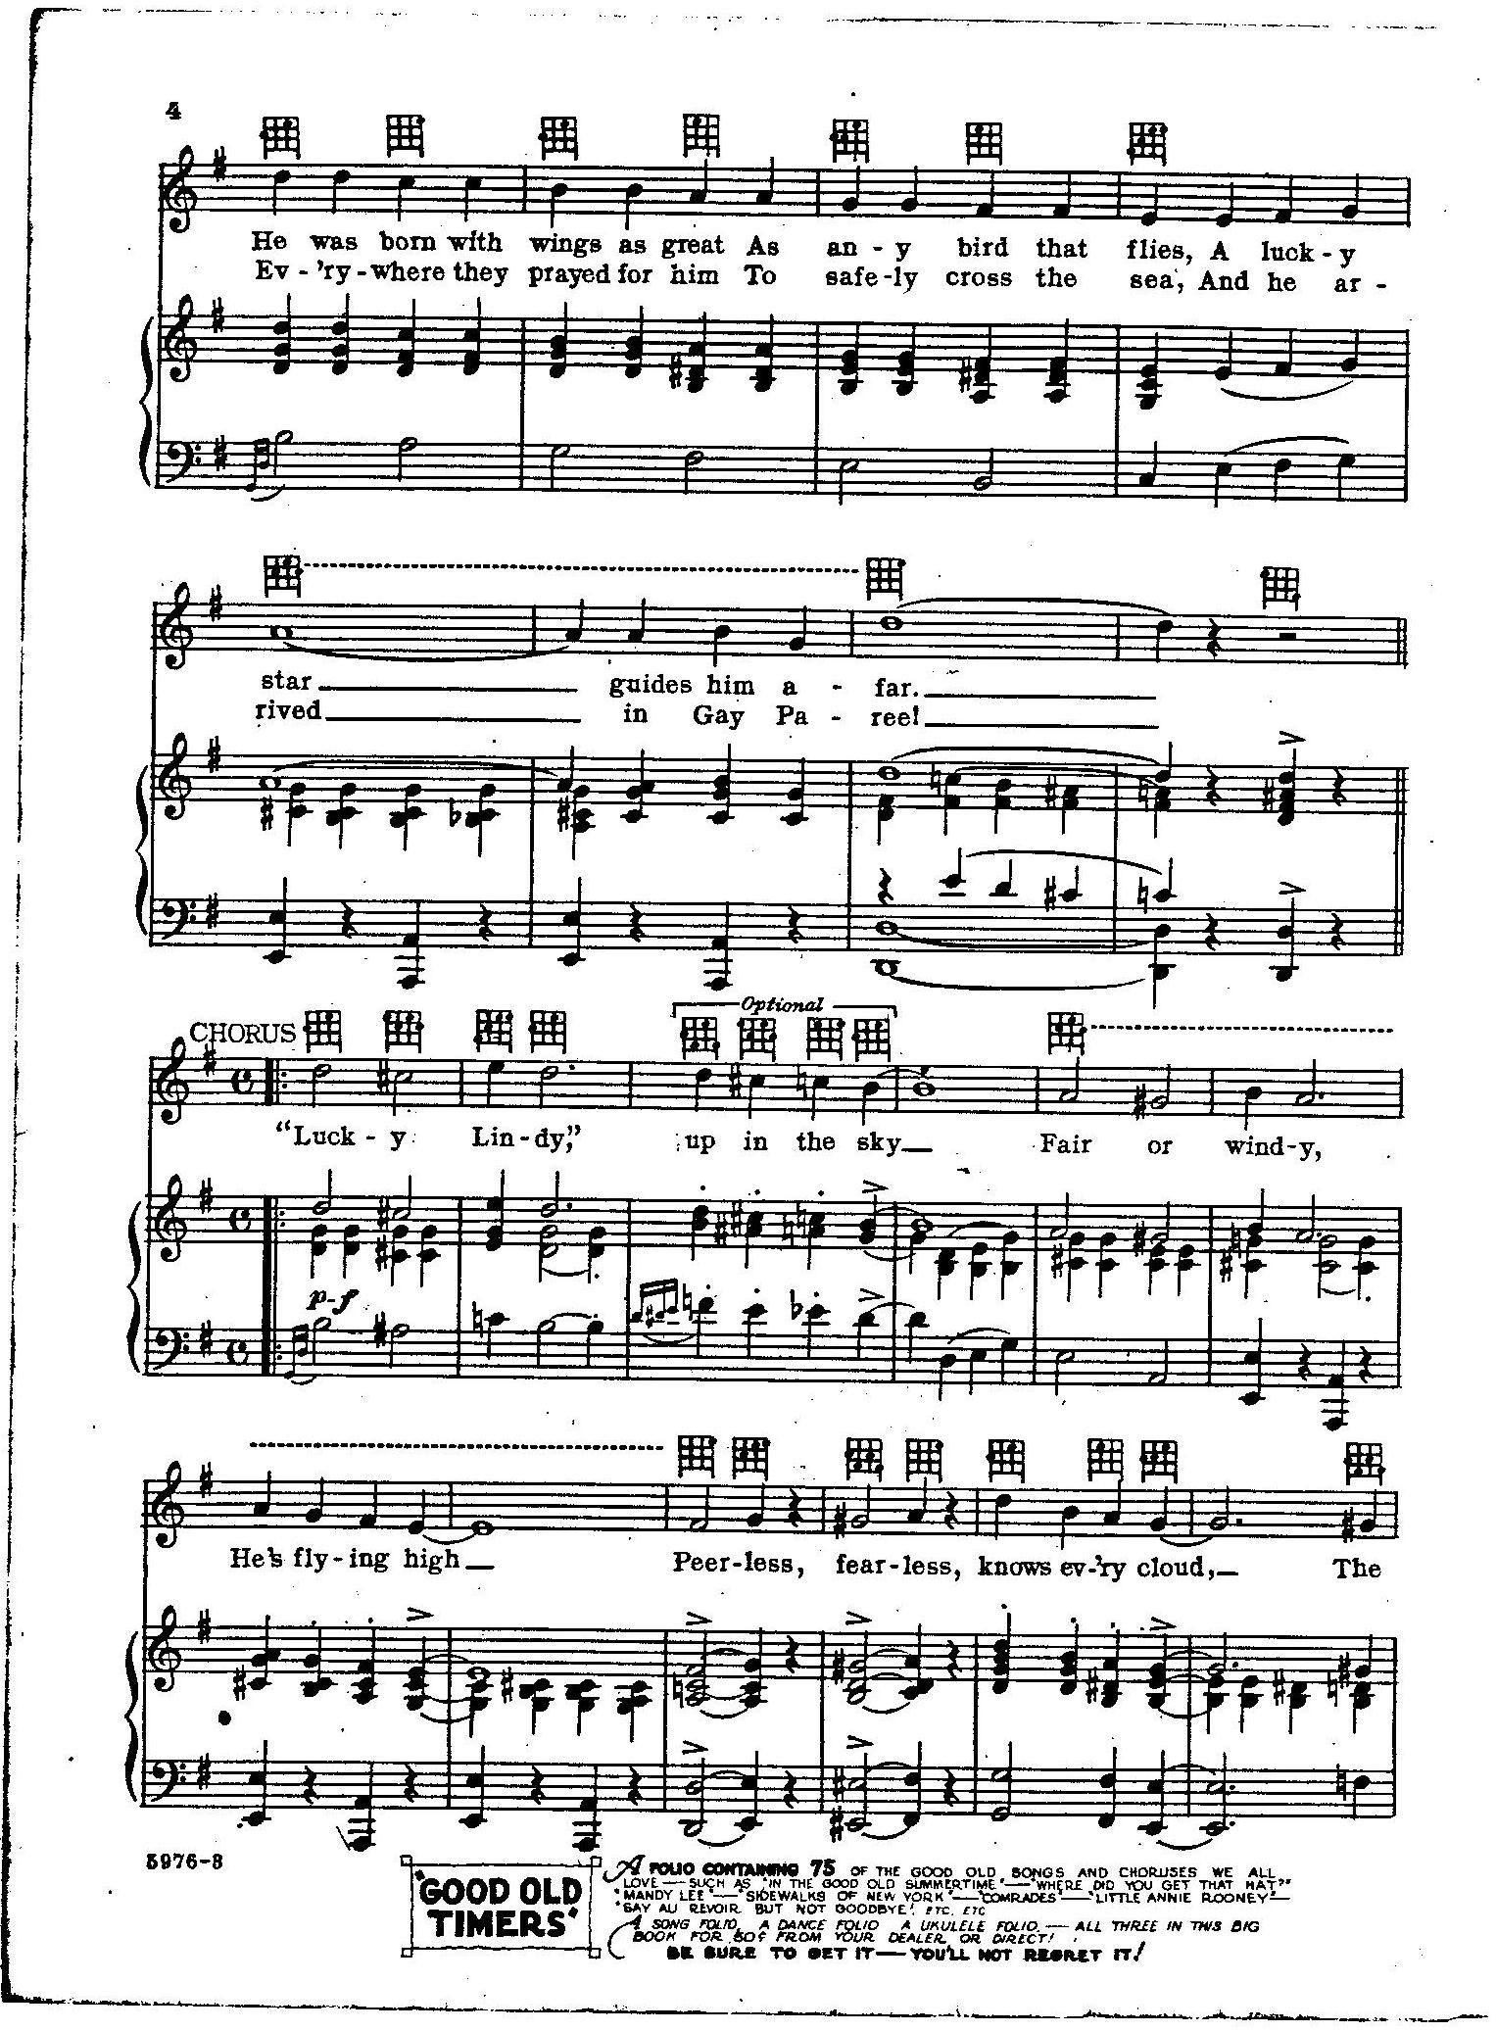
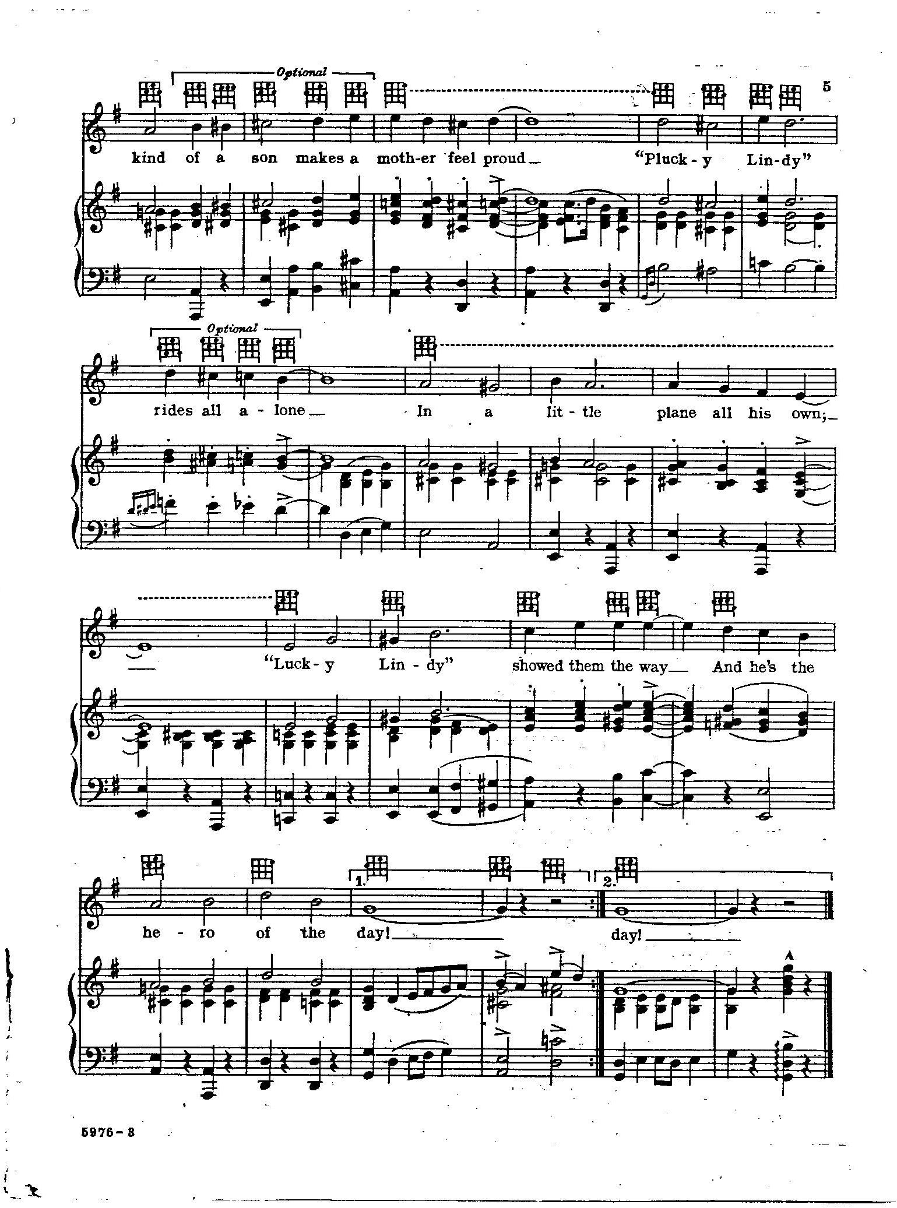

THE ENCLOSED DESIGN FOR A MODEL OF THE SPIRIT OF ST. LOUIS IS FROM A 1927 BOY SCOUT PUBLICATION.

IT IS ENCLOSED AS A POINT OF DEPARTURE.
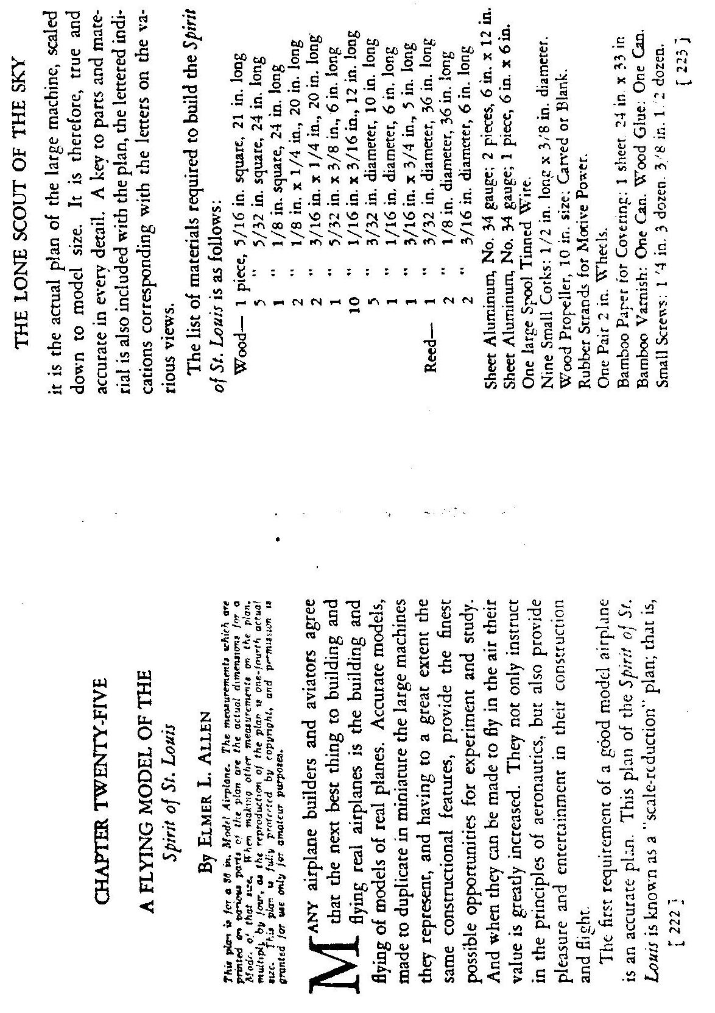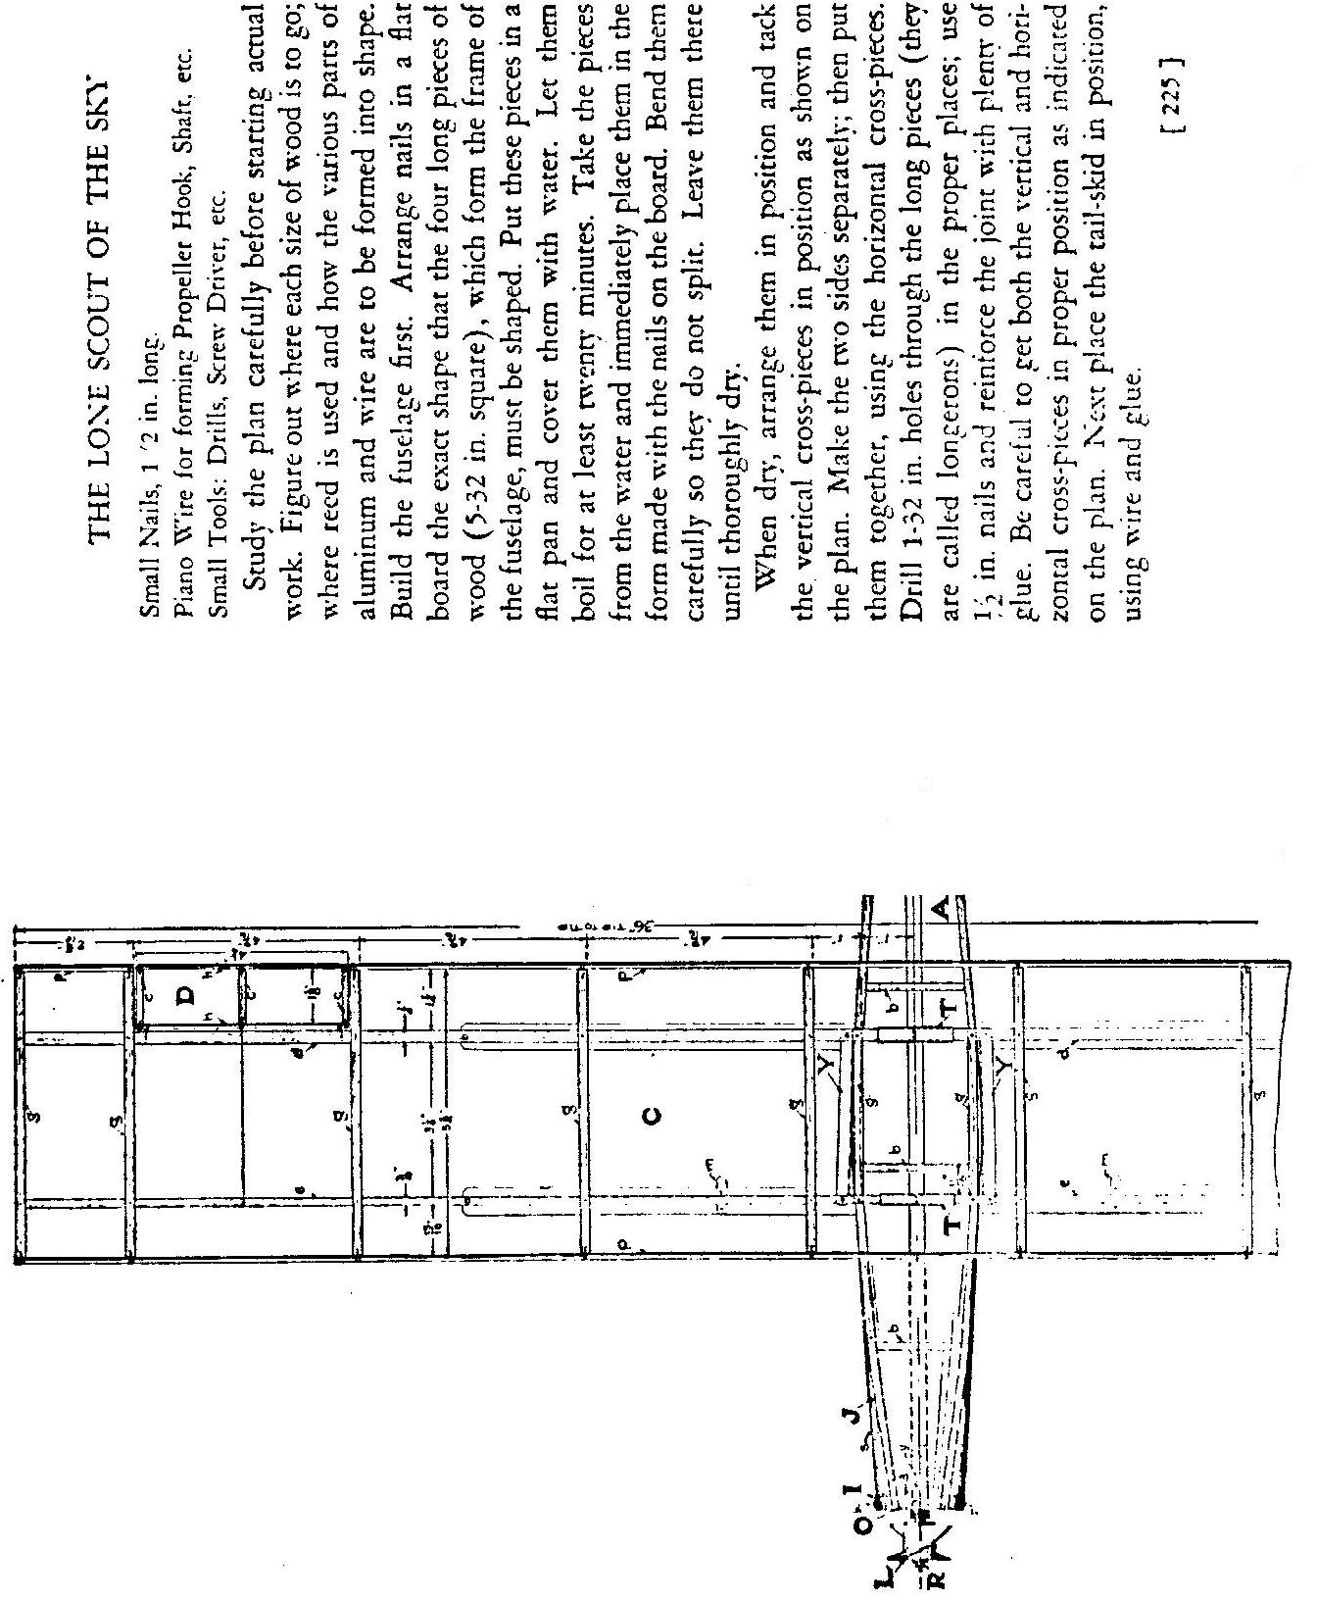
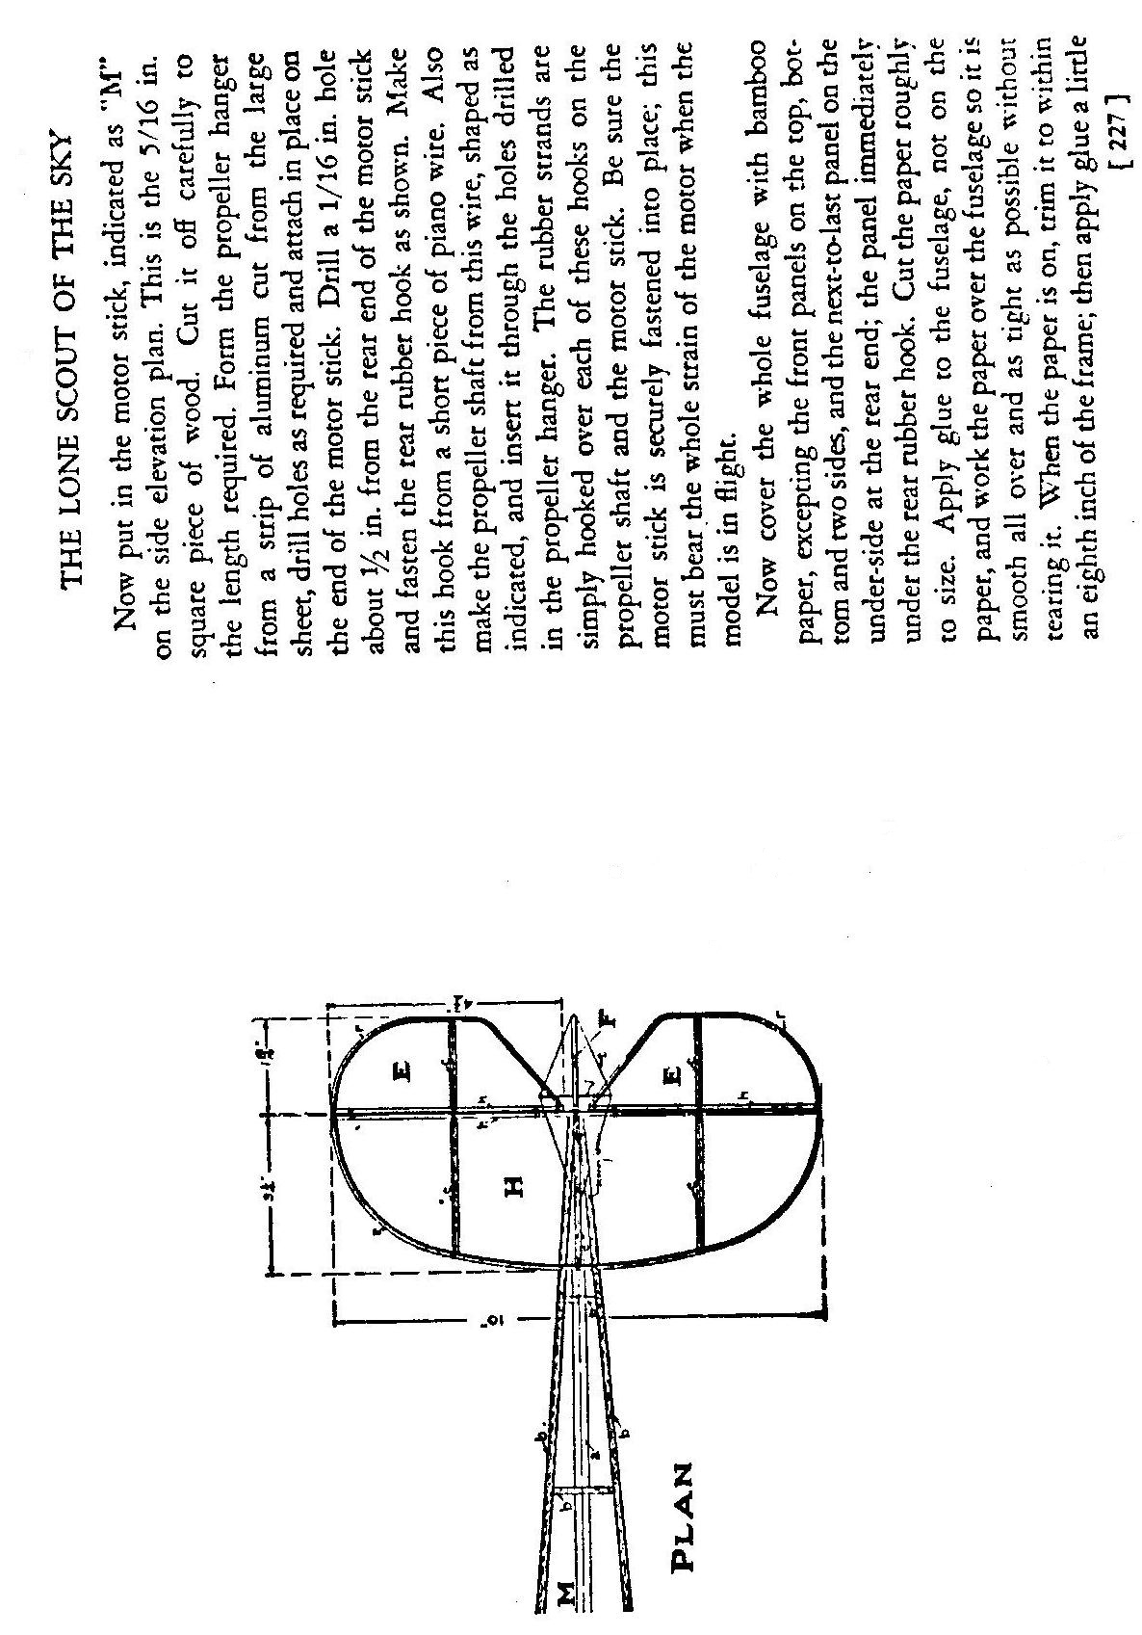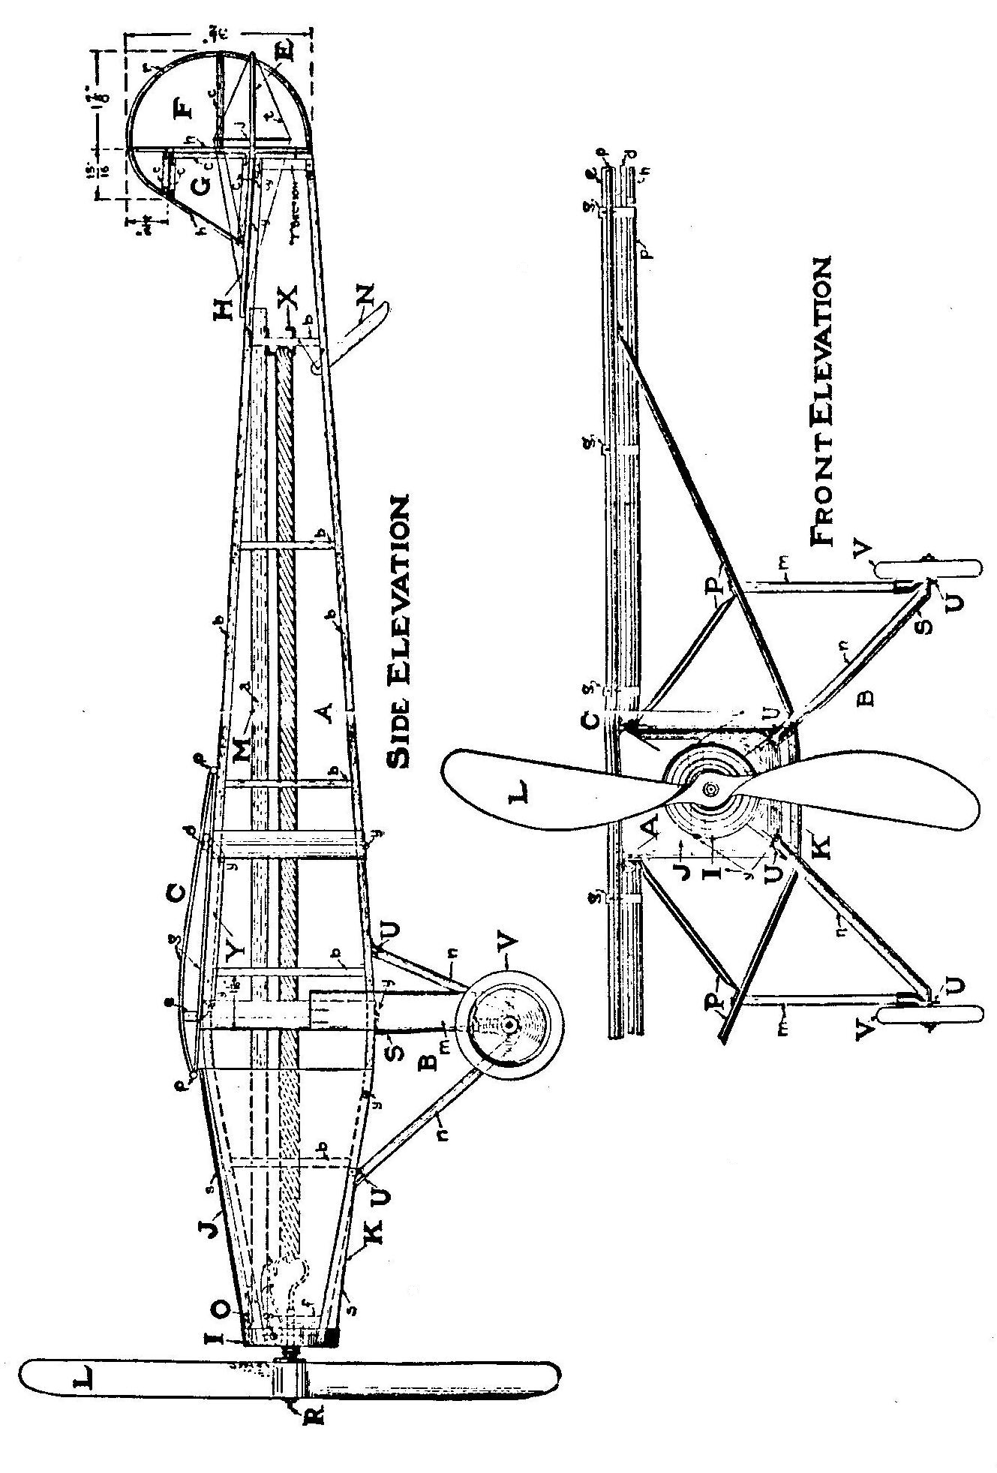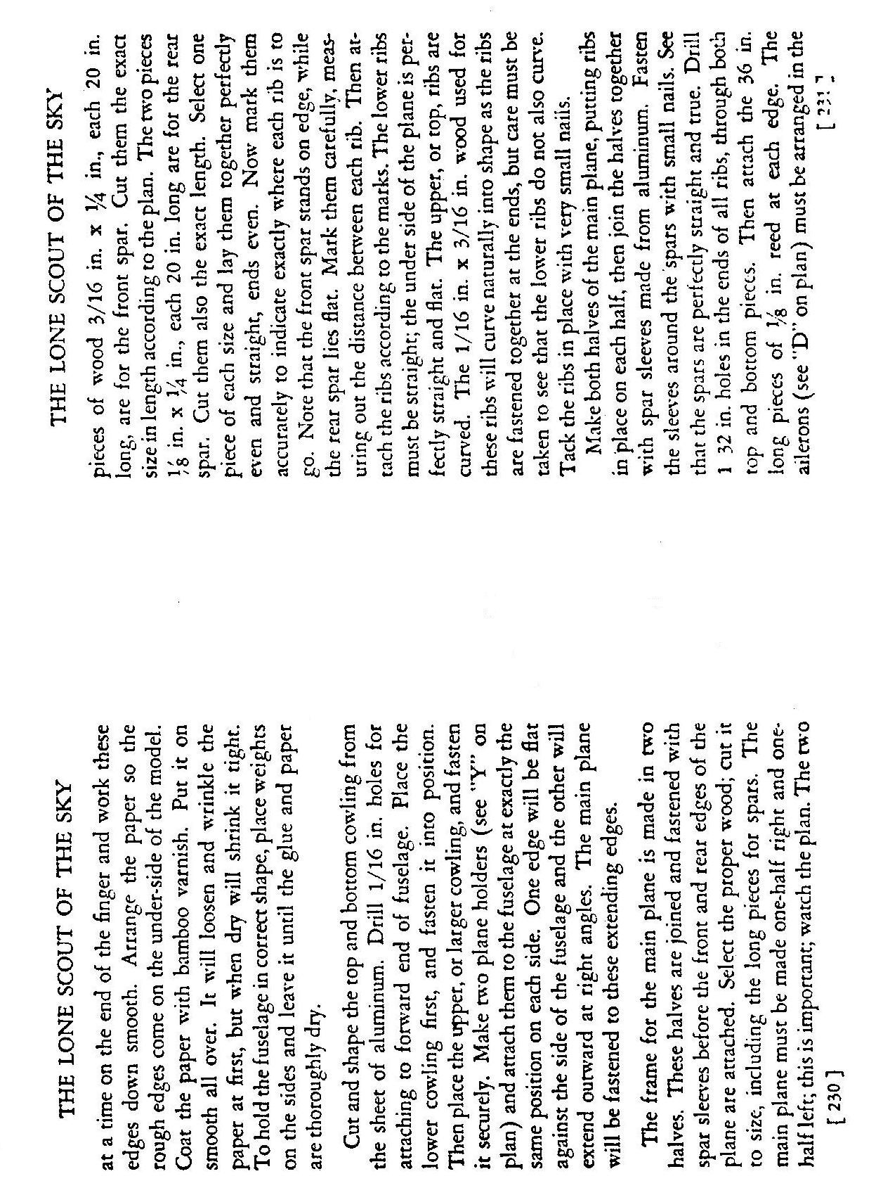
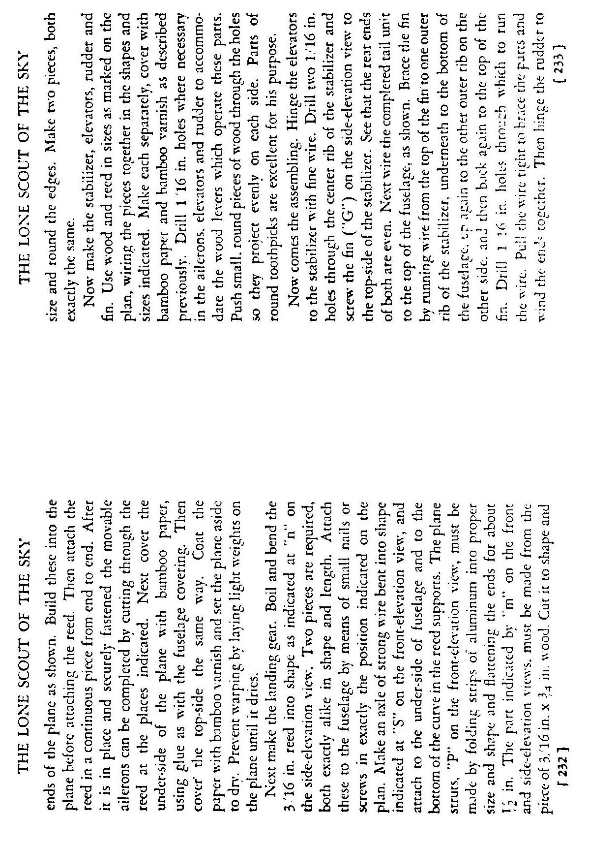
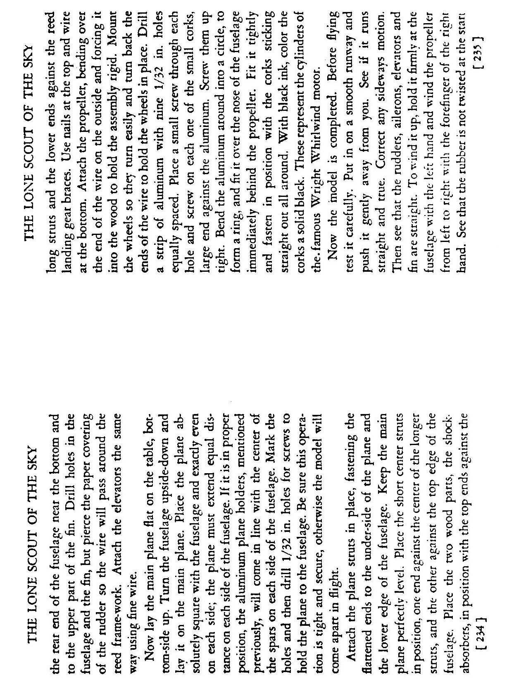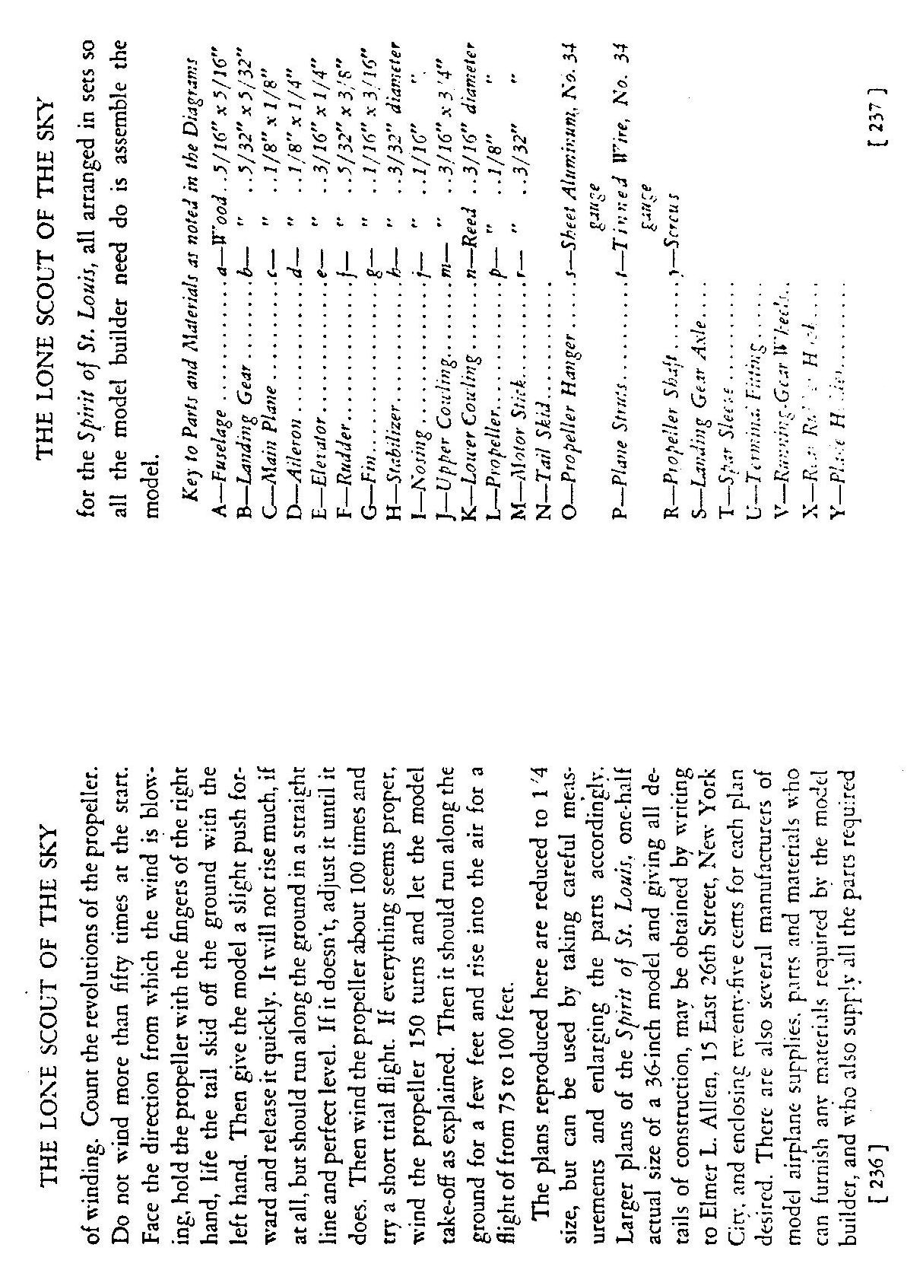

CREDITS FOR LUCKY LINDY

* The song LUCKY LINDY was copyright in 1927, words by L. Wolfe Gilbert, music by Abel Baer. The copyright was renewed in 1955 and 1966 by the publisher, Leo Feist, Inc., New York, N.Y. Renditions of that song on original 78 recordings by Arthur Fields on Bell Records and Vernon Dalhart on Cameo Records are called for in this script. All rights to the song and these recordings must be secured by each producer of the play.

* The set design contained herein was created by artist Stephen Pearson, based on an original concept by Dick D. Zigun. Any production making use of this design, or based substantially on this design, must offer appropriate program credit and payment to Pearson and Zigun. Other designs for the signs have resulted in video screens, cardboard signs, etc.

* All slides called for in this script are available from Coney Island, USA, Inc.

* LUCKY LINDY was orignally written and produced as the second act of a full length play entitled THREE UNNATURAL ACTS and has, at times, been produced under that title. LUCKY LINDY, alone, can be performed by 2 actors.

* For more background on Charles Lindbergh, three books are suggested: Lindbergh: A Biography by Leonard Mosley, 1976; We: His Own Story by Charles Lindbergh, 1927; and The Spirit of Saint Louis, also by Lindbergh, 1953.

PRODUCTION HISTORY

1978 Yale School of Drama, Molly Kazan Award
Portland Conservatory Theatre

1979 Mark Taper Forum, Los Angeles

1982 New Dramatists (Reading)
Playwrights Horizons (Reading)
Honorable Mention, Theater Magazine Contest
Eureka Theatre, San Francisco

1984 Coney Island, USA at Franklin Furnace, NYC

1987 Repertory Theatre of St. Louis, Missouri

