INTO THE NIGHTLIFE…
A CONEY ISLAND OF THE MIND
by
HENRY MILLER (1936)
Adapted for the Stage by Dick D. Zigun (1989)

Copyright © 1989 Dick D. Zigun
All Rights Reserved.
C/O CONEY ISLAND, USA, INC.
1208 Surf Avenue
Coney Island, N.Y. 11224
(718) 372-5159

The copyright to Henry Miller’s INTO THE NIGHTLIFE is owned by his heirs Valentine and Tony Miller and Barbara Miller Sanford (aka Barbara Sylvas Miller). All rights whatsoever to the stage adaption of INTO THE NIGHTLIFE are strictly reserved and application for performance etc. should be made in writing to Dick D. Zigun, CONEY ISLAND, USA, INC. 1208 Surf Avenue, Brooklyn, NY 11224.
INTRODUCTION from JUST WILD ABOUT HARRY A Melo-Melo in Seven Scenes
- by HENRY MILLER, 1952

INTRODUCTION
Those who have read Nexus (Volume 1) will recall that I devoted some hallucinating pages to a description of my first attempt to write a play, an effort which never got beyond Act One. That was about the year 1926 or '27, since which time I made no further efforts in this direction until two years ago, while staying in the town of Reinbek, Germany. It was there, at the Rowohlt Verlag, that I met Herr Krieschke of the Theatre Department. He was convinced that I could write a play and should. Of course I had toyed with the idea over and over again during the intervening years, but every time I got serious about it my courage failed me. It was not only the remembrance of that first dismal failure which stymied me but the conviction that my natural style of writing was opposed to the dramatic form. It was something of a miracle that I was able to hatch this anomalous "melo-melo” with all its shortcomings.
It came about-happened is the word-very much the way I made my first water color. I was lonely, hungry, and had nothing better to do. I sat down that Christmas Eve (1960) and told myself to begin. I hadn't the slightest notion of what I would write. In three days I had finished the first rough draft. It was almost as if it had been dictated to me. About six weeks later I sat down and rewrote it. And that was all there was to it. If this strikes the reader as incredible, let him read what Ionesco says about his method of work. Here is what he says: "Vous savez, je ne sais jamais raconter mes pieces .... Tout est dans les repliques, dans le jeu. dans les images sceniques, c'est tres visuel, comme toujours .... C'est une image, une premiere replique, qui declenche toujours, chez moi, le mecanisme de la creation, ensuite, je me laisse porter par mes propres personnages, je ne sais jamais ou je vais exactement .... Toute piece est, pour moi, une aventure, une chasse, une decouverte d'un univers qui se revele a moi-meme, de la presence duquel je suis le premier etonne. . . "
As early as 1913, when first I heard Emma Goldman lecture (in San Diego, California), I became interested in the drama. All through the Twenties I was an ardent theatregoer. For a time during this period my wife June played a number of roles with the Theatre Guild group. In addition to attending plays I read plays, hundreds of them, I should imagine, including some bizarre ones such as Gammer Gurton's Needle. Brokenbrow and Le Cocu Magnifique. I was particularly fond of the ancient Greek drama and of the Elizabethan playwrights such as Marlowe, Webster and John Ford. Of all the plays I have seen John Ford's 'Tis Pity She's a Whore moved me most. I saw it for the first and only time in French, at the old Atelier in Montmartre. The Russian dramatists also affected me profoundly, as well as the German Expressionists. I read them all-French, Austrian, Italian, Spanish, Norwegian, anything and everything I could lay hands on.
The Twenties was a wonderful period in the history of the American theatre, due largely to the liberal importation of foreign plays. Bernard Shaw's name was on everyone's lips then, as well as Eugene O'Neill's. To be followed soon by Sean O'Casey who, in my opinion, is a better dramatist than Shaw ever was. But what a delight-and even a shock-it was to see for the first time a curtain raiser like Androcles and the Lion. Or, for that matter, Toller's Masse Mensch or Kaiser's From Morn till Midnight. Curiously enough, it was after seeing Saroyan's Tine of Your Life, which is by no means a great play, that I began to think I might one day do something in this medium myself. It seemed so easy and natural to write as Saroyan did. Besides, I was thoroughly fed up with the social-psychological drama, which Americans still seem to dote on. However, I did nothing. It required a stronger dose than Saroyan to do the trick. This I got when I saw Waiting for Godot, in Paris, the opening night. The dose was renewed some time later on seeing Ionesco's The Chairs and The Bald soprano.
But to go back a bit . . . My theatregoing began at the age of seven or eight. Every Saturday my mother gave me a dime with which to buy a seat in "nigger heaven" at the Novelty Theatre (a vaudeville house) on Driggs Avenue, Brooklyn (the 14th Ward). I continued this routine, with occasional lapses to attend a bloodcurdling melodrama (such as one could be sure to enjoy at Corse Payton'sTheatre, Brooklyn), or a musical like Wine, Women and Song. Until the day came when I saw my first burlesque show (I was just seventeen). From then on, until I went to France, I was a devotee of burlesque. Nothing would please me better, even at this late age, than to write a few comic bits of a genre such as those lovable slapstick comedians of the past exploited to the hilt. Who knows, perhaps that crude mixture of humor and obscenity which abounded in burlesque had much to do with the employment of these elements in my own work. They are two elements, incidentally, which are as old as the theatre itself. And they may be revived one day, when we have freedom of speech once again-or just freedom. While in France I became acquainted with the writings of Antonin Artaud, especially his views about the theatre. His ideas hit me very much as once did the fiery propaganda of the I.W.W. Here was revolution, genuine revolution. Except for a small circle of admirers, no one seemed to take Artaud's views seriously. Literature, that's all it was. Besides, wasn't he a bit of a madman? (What innovator isn't?) People don't want to be hit in the guts; they don't want to go all out; they don't want to revolutionize things day in and day out. As for "revolutionizing oneself every day," as Blaise Cendrars put it, that is still unthinkable. Only saints and gurus have the courage to entertain such ideas.
Naturally, I don't pretend to have done anything revolutionary in writing this play (Or did I whistle it?). To be frank, I am delighted merely to have succeeded in breaking the ice. Maybe I can do another, and another. The important thing is that I conquered an old fear, the fear that I was not cut out to write plays. But, as I have frequently remarked, I was not cut out to be a writer either. To write was the last thing on earth left me to attempt; at everything else I have been a rank failure. That I have been able to toss off what passes for books still baffles me. To be sure, I was steeped in books from a very early age. Reading has always been a vice with me, a well-nigh incurable one. In addition I have what some consider the bad habit of identifying myself with the author or his characters. I became the hero of The Magic Mountain and behaved like him for quite a time; I even signed my letters "Hans Castorp." Sometimes I took on the personality of Herr Peeperkorn, another character in that work. As for Knut Hamsun, it took me years to slough off the personality of Herr Nagel (in Mysteries). I mention just a few. When I think of Dostoievsky I think of a merry-go-round. I lived out so many roles portrayed by his characters (good and bad) that I almost lost my own identity. Long live the Stavrugins!
And so, perhaps it is with this play as with my early novels- the unpublished ones. Too many influences, too many voices, too much identification. I have yet to discover the "dramaturge" in myself. Should I worry about it? March on! That is my motto. Try again, and again and again. If you can't master it, smash it! Today the revolution is on. And, as Jack London used to say, "it is here to stay." The leaders of the new theatre, I notice, are regarded as being "antitheatre." But what does that mean? Not against, as people like to think, but for. For live theatre, theatre freed of its age-old trammels, theatre which enables the spectator to participate and not merely sit back and be entertained or instructed, or even edified. Every vital new movement has for its primary aim to awaken. Wake up and live! Wake up and sing! Wake up and roar like a lion! Wake up, man! That is what every creator is shouting through his lines.
With Beckett and Ionesco . . . others too . . . we are witnessing something like an atom smashing process. What will happen tomorrow no one knows. We are by no means at the end of the road. To build anew one must first tear down the old. And this is now being done with a vengeance.
When we consider the position, the role, the opportunities which are presented to the mathematicians and men of science today it is evident that the artists are being outstripped. The former are not only urged to break new ground but they are handsomely paid to do it. Whereas with the latter all daring is penalized. (Perhaps with good reason, for the artist is even more capable of upsetting the apple cart than the mathematician or the scientist. Once the artist gets the bit between his teeth, good-by this sad, stale world of ours!)
The point I wish to make, however, is this. Antiart is still art. It is not hayseed or wild mustard. It is impossible to kill art; it is part of life itself. No matter how we express ourselves, whatever we do or say with spirit belongs to the world of art. The revolutions which take place in this realm are so many life-breathers. To ask where these revolutionaries are leading us is futile. They are leaders in name only—instruments of the inscrutable life force. "It" knows better than we ourselves. We think we know: it knows. Naturally it takes time for us to catch on, to discover where we are heading and why. When we wake up the sun is already setting. Once again we find ourselves imprisoned in a mold. And once again, of a bright morning, we wake up and shake ourselves free. That is the way of art and of life.
Henry Miller
July 17, 1962

NOTES AND QUOTES
The Berlin Wall falls. A dangerous freedom begins, theirs and ours...Artists in the west have always sympathized with, perhaps even envied a bit, the struggle of dissident artists in the east. Art needs a wall to lean its shoulder against and push. Their wall was concrete, political, a seemingly invincible system of repression. Our wall was, its, well, was...it’s hard to put your finger on it, let alone your shoulder. August, 1961. Soviet soldiers stretch barbed wire across exit and entry points in a divided Berlin. Soldiers become guards. Wire becomes a wall. August, 1961. United States Customs decides to lift its ban on TROPIC OF CANCER. After 27 years in exile, Henry Miller's novel can now legally enter the country. The same month it becomes a bestseller across the nation. August, 1961. The Chicago Tribune announces it will no longer list "filthy" books on its bestseller list. Walls go up, stay up. Walls come down, go back up. November, 1969. The new Soviet policy of glasnost, translating "openness" is generally credited with the freeing of the borders. The "Iron Curtain" now seems part of history. November, 1989. A U.S. Congressional law reaches back to the 1973 Supreme Court ruling in Miller vs. United States for language stating that the N.E.A. may not; "promote, disseminate, or produce materials...considered obscene, including but not limited to, depictions of sadomasochism, homo-eroticism, the sexual exploitation of children, or individuals engaged in sex acts..." Censorship moves from the legal into the civil. Pressure groups from the left and right lobby to legislate what is anti-family or sexist or racist. December, 1989. INTO THE NIGHT LIFE uses representations of sex acts, racial and religious stereotypes and rough language to tell a dream about the carnal mortality of life, the internationalization of civilization and the illogic of dreams. The production is not anti-semitic nor is it anti-black. We must not confuse controversial sex with sexism, wide ranging racial discussion with racism, nor art with obscenity.
Nick Fracaro
Dramaturge

"Into the night life seems to be exiled what once ruled during the day".
Sigmund Freud
THE INTERPRETATION OF DREAMS

"Had I become a clown, or even a vaudeville entertainer, I would have been famous. People would have appreciated me precisely because they would not have understood; but they would have understood that I was not to be understood."
Henry Miller
TROPIC OF CANCER

"I can still see myself at the piano, pulling out of my music roll a song Cora would like. My favorite, of course, was "Meet Me Tonight in Dreamland". That's where I spent most of my time — in Dreamland."
Henry Miller
BOOK OF FRIENDS

INTO THE NIGHT LIFE . . . A Coney Island of the Mind was given its stage world premiere at Sideshows by the Seashore in December, 1989. Adapted and directed by Dick D. Zigun with design by Valerie Haller, lighting by Joseph Errante, costumes by Marianne Powell-Parker and sound by Rob Weisberg, it had the following cast:
Henry Miller ....................................... Terry O'Reilly

Female Phantom
Greek Cook
Injun #1
Motorman
Old Hag
Whore/Wife
Woman ............................................ Gabriele Schafer

Automaton #4
Father
Jewish Carney
Male Phantom 4
Moishe
Phony Maharajah
Rabbi
Relative #3
Transvestite Whore ........................................ Gaylord

Snake Lady(?)
Automaton #2
Coolie
Cripple #3
Hispanic Whore
Honky-Tonk Dancer
Injun #3
Knight
Re1ative#2 ........................................ Ruby Rodriguez

Automaton #3
Busty Whore
Cripple #1
Darkie
Doctor
Fat Lady
Injun #4
Preacher
Relative #1
Witch ............................................. Susan Syvertsen

Automaton #1
Barker
Cripple #2
Ginnie
Girl
Hangman
Injun#2
Midget Transvestite Whore ............................ Bobby Faust

SCENE ONE
HOUSE OF HORRORS, BROOKLYN

HENRY
Over the foot of the bed is the shadow of the cross. There are chains binding me to the bed. The chains are clanking loudly, the anchor is being lowered. Suddenly I feel a hand on my shoulder. Someone is shaking me vigorously. I look up—

OLD HAG
-and it is an old hag in a dirty wrapper. She goes to the dresser and opening a drawer she puts a revolver away.

RELATIVE #1
There are three rooms, one after the other, like a railroad flat.

HENRY
I am lying in the middle room in which there is a walnut bookcase and a dressing table.

OLD HAG
The old hag removes her wrapper and stands before the mirror in her chemise. She has a little powder puff in her hand and with this little puff she swabs her armpits, her bosom, her thighs. All the while she weeps like an idiot.

HENRY
Finally she comes over to me with an atomizer and she squirts a fine spray over me. I notice that her hair is full of rats. I watch the old hag moving about.

OLD HAG
She seems to be in a trance. Standing at the dresser she opens and closes the drawers, one after the other, mechanically. She seems to have forgotten what she remembered to go there for. Again she picks up the powder puff and with the powder puff she daubs a little powder under her armpits. On the dressing table is a little silver watch attached to a long piece of black tape. Pulling off her chemise she slings the watch around her neck; it reaches just to the pubic triangle. There comes a faint tick and then the silver turns black.

RELATIVE #2
In the next room, which is the parlor, all the relatives are assembled.

HENRY
They sit in a semicircle, waiting for me to enter.

RELATIVE #3
They sit stiff and rigid, upholstered like the chairs. Instead of warts and wens there is horsehair sprouting from their chins.

HENRY
I spring out of bed in my nightshirt and I commence to dance the dance of King Kotschei. In my nightshirt I dance, with a parasol over my head. They watch me without a smile, without so much as a crease in their jowls. I walk on my hands for them, I turn somersaults, I put my fingers between my teeth and whistle like a blackbird.

RELATIVE #3
Not the faintest murmur of approval-

RELATIVE #1
-or disapproval.

RELATIVE #2
They sit there solemn and—

RELATIVE #1
—imperturbable

HENRY
Finally I begin to snort like a bull, then I prance like a fairy, then I strut like a peacock, and then realizing that I have no tail I quit. The only thing left to do is to read the Koran through at lightning speed, after which the weather reports, the Rime of the Ancient Mariner and the Book of Numbers.

OLD HAG
Suddenly the old hag comes dancing in stark naked, her hands aflame. Immediately she knocks over the umbrella stand the place is in an uproar.

RELATIVE #3
From the upturned umbrella stand there issues a steady stream of writhing cobras traveling at lightning speed.

RELATIVE #2
They knot themselves around the legs of the tables, they carry away the soup tureens, they scramble into the dresser and jam the drawers, they wriggle through the pictures on the wall, through the curtain rings, through the mattresses, they coil up inside the women's hats, all the while hissing like steam boilers.

HENRY
Winding a pair of cobras about my arms I go for the old hag with murder in my eyes.

OLD HAG
From her mouth, her eyes, her hair, from her vagina even, the cobras are streaming forth, always with that frightful steaming hiss as if they had been ejected fresh from a boiling crate.

RELATIVE #3
In the middle of the room where we are locked an immense forest opens up.

OLD HAG
We stand in a nest of cobras and our bodies come undone.

HENRY
I am in a strange, narrow little room, lying on a high bed. There is an enormous hole in my side, a clean hole without a drop of blood showing. I can't tell any more who I am or where I came from or how I got here. The room is very small and my bed is close to the door. I have feeling that someone is standing on the doorsill watching me. I am petrified with fright. When I raise my eyes I see-

BARKER
-a man standing at the doorsill. He wears a gray derby cocked on the side of his head; he has a flowing mustache and is dressed in a checkerboard suit.

HENRY
He asks my name, my address, my profession, what I am doing and where I am going and so on and so forth. He asks endless prying questions to which I am unable to respond, first because I have lost my tongue, and second because I cannot remember any longer what language I speak.

BARKER
“Why don't you speak?" he says-

HENRY
-bending over me jeeringly—

BARKER
—and taking his light rattan stick he jabs a hole-

HENRY
-in my side. My anguish is so great that it seems I must speak even if I have no tongue, even if I know not who I am or where I came from. With my two hands I try to wrench my jaws apart, but the teeth are locked. My chin crumbles away like dry clay, leaving the jawbone exposed.

BARKER
"Speak!" he says, with that cruel, jeering smile and, taking his stick once again-

HENRY
—he jabs another hole through my side. I lie awake in the cold dark room. The bed almost touches the ceiling now. I hear the rumbling of trains, the regular rhythmic bouncing of the trains over the frozen trestle, the short, throttled puffs of the locomotive, as if the air were splintered with frost. In my hand are the pieces of dry clay which crumbled from my chin. My teeth are locked tighter than ever; I breathe through the holes in my side. From the window of the little room in which I lie I can see the Montreal Bridge. Through the girders of the bridge, driven downward by the blinding blizzard, the sparks are flying. The trains are racing over the frozen river in wreaths of fire. I can see the shops along the bridgeway gleaming with pies and hamburger sandwiches. Suddenly I do remember something. I remember that just as I was about to cross the border-

BARKER
I asked him what he had to declare and, like an idiot-

HENRY
-I answered: "I want to declare that I am a traitor to the human race."

SCENE TWO
FUN HOUSE. FUN CITY.

HENRY
I remember distinctly now that this occurred just as I was walking up a treadmill-

FAT LADY
-behind a woman with balloon skirts. There were mirrors all around us and above the mirrors a balustrade of slats, series after series of slats, one on top of another, tilted, toppling, crazy as a nightmare.

HENRY
In the distance I could see the Montreal Bridge and below the bridge the ice floes over which the trains raced. I remember now that when the woman looked around at me-

FAT LADY
—she had a skull on her shoulders, and written into the fleshless brow was the word sex stony as a lizard.

HENRY
I saw the lids drop down over her eyes and then the sightless cavern without bottom. As I fled from her I tried to read what was written on the body of a car racing beside me, but I could catch only the tail end and it made no sense. At the Brooklyn Bridge I stand as usual waiting for the trolley to swing around. In the heat of the late afternoon the city rises up-

FAT LADY
—like a huge polar bear shaking off its rhododendrons.

HENRY
The forms waver, the gas chokes the girders, the smoke and the dust wave like amulets. Out of the welter of buildings there pours-

FAT LADY
—a jellywash of hot bodies glued together with pants and skirts.

HENRY
The tide washes up in front of the curved tracks and splits like glass combs. Under the-

FAT LADY
-wet headlines-

HENRY
—are the-
FAT LADY
-diaphanous legs-

HENRY
—of the amoebas scrambling on to the running boards-

FAT LADY
-the fine, sturdy tennis legs wrapped in cellophane, their white veins showing through the golden calves and muscles of ivory. The city is panting with a five o'clock sweat.

HENRY
From the tops of the skyscrapers plumes of smoke soft as Cleopatra's feathers. The air beats thick, the bats are flapping, the cement softens, the iron rails flatten under the broad flanges of the trolley wheels. Life is written down in headlines twelve feet high with periods, commas and semicolons. The bridge sways over the gasoline lakes below. Melons rolling in from Imperial Valley, garbage going down past Hell Gate, the decks clear, the stanchions gleaming, the hawsers tight, the slips grunting, the moss splitting and spelching in the ferry slips.

FAT LADY
A warm sultry haze lying over the city like a cup of fat, the sweat trickling down between the bare legs, around the slim ankles. A mucous mass of arms and legs, of half—moons and weather vanes, of cock robins and round robins, of shuttlecocks and bright bananas with the light lemon pulp lying in the bell of the peel.

HENRY
Five o'c1ock strikes through the grime and sweat of the afternoon, a strip of bright shadow left by the iron girders.

MOTORMAN
The trolleys wheel round with iron mandibles, crunching the papier-mache of the crowd, spooling it down like punched transfers.

HENRY
As I take my seat I see a man I know standing on the rear platform with a newspaper in his hand. His straw hat is tilted on the back of his head, his arm rests on the motorman's brass brake. Back of his ears the cable web spreads out like the guts of a piano. His straw hat is just on a level with Chambers Street; it rests like a sliced egg on the green spinach of the bay. I hear the cogs slipping against the thick stub of the motorman's toe.

MOTORMAN
The wires are humming, the bridge is groaning with joy.

HENRY
Two little rubber knobs on the seat in front of me, like two black keys on a piano. About the size of an eraser, not round like the end of a cane. Two gummy thingamajigs to deaden the shock. The dull thud of a rubber hammer falling on a rubber skull.

MOTORMAN
The countryside is desolate. No warmth, no snugness, no closeness, no density, no opacity, no numerator, no denominator. It's like the evening newspaper read to a deaf mute standing on a hat rack with a palmetto leaf in his hand. In all this parched land no sign of human hand, of human eye, of human voice. Only headlines written in chalk which the rain washes away. Only a short ride on the trolley-

HENRY
—and I am in a desert filled with thorns and cactus.

SCENE THREE
BATHHOUSE DADA

HENRY
In the middle of the desert is a bathhouse and in the bathhouse is a wooden horse with a log-saw lying athwart it. By the zinc-covered table, looking out through the cobwebbed window, stands a woman I used to know. She stands in the middle of the desert like a rock made of camphor. Her body has the strong white aroma of sorrow. She stands like a statue saying good—by. Head and shoulders above me she stands, her buttocks swoopingly grand and out of all proportion.

AUTOMATON #1
Everything is out of proportion-

AUTOMATON #2
-hands-

AUTOMATON #3
—feet-

AUTOMATON #4
-thigh, ankles.

AUTOMATON #3
She's an equestrian statue without the horse-

AUTOMATON #1
—a fountain of flesh worn away to a mammoth egg.

AUTOMATON #2
Out of the ballroom of flesh her body sins like iron.

HENRY
Girl of my dreams, what a splendid cage you make! Only where is the little perch for your three-pointed toes?

AUTOMATON #4
The little perch that swung backward and forward between the brass bars?

HENRY
You stand by the window, dead as a canary, your toes stiff, your beak blue.

AUTOMATON #1
You have the profile of a line drawing done with a meat-ax.

HENRY
Your mouth is a crater stuffed with lettuce leaves. Did I ever dream that you-

AUTOMATON #3
-you could be so enormously warm and lopsided? Let me look at your lovely jackal paws; let me hear the croaking, dingy chortle of your dry breath.

HENRY
Through the cobwebs I watch the nimble crickets, the long, leafy spines of the cactus oozing milk and chalk, the riders with their empty saddlebags, the pommels humped like camels. The dry desert of my native land, her men gray and gaunt, their spines twisted, their feet shod with rowel and spur. Above the cactus bloom the city hangs upside down, her gaunt, gray men scratching the skies with their spurred boots. I clasp her bulging contours, her rocky angles, the strong dolmen breasts, the cloven hoofs, the plumed tail. I hold her close in the choked spume of the canyons under the locked watersheds twisted with golden sands while the hour runs out. In the blinding surge of grief the sand slowly fills my bones.

AUTOMATON #1
A pair of blunt, rusty scissors lies on the zinc—covered table beside us.

AUTOMATON #3
The arm which she raises is webbed to her side.

AUTOMATON #4
The hoary inflexible movement of her arm is like the dull raucous screech of day closing and the cord which binds us is wired with grit.

HENRY
The sweat stands out on my temples, clots there and ticks like a clock. The clock is running down with nervous wiry sweat.

AUTOMATON #3
The scissors move between on slow rusty hinges.

AUTOMATON #2
My nerves race along the teeth of the comb, my spurs bristle, the veins glow.

AUTOMATON #1
Is all pain dull and bearable like this?

HENRY
Along the scissors' edge I feel the rusty blunt anguish of day closing, the slow webbed movement of hunger satisfied, of clean space and starry sky-

AUTOMATON #2
-in the arms of an automaton.

HENRY
I stand in the midst of the desert waiting for the train. In my heart there is a little glass bell and under the bell there is an edelweiss. All my cares have dropped away. Even under the ice I sense the bloom which the earth prepares in the night. Reclining in the luxurious leather seat I have a vague feeling that-

MOTORMAN
—it is a German line on which I am traveling.

HENRY
I sit by the window reading a book; I am aware that someone is reading over my shoulder. It is my own book and there is a passage in it which baffles me. The words are incomprehensible.

MOTORMAN
At Darmstadt we descend a moment while the engines are being changed. The glass shed rises to a nave supported by lacy black girders.

HENRY
The severity of the glass shed has a good deal the appearance of my book — when it lay open my lap and the ribs showed through. In my heart I can feel the edelweiss blooming. At night in Germany, when you pace up and down the platform, there is always someone to explain things to you.

MOTORMAN
—Die runde Koepfe und die lange Koepfe tun sich zusammen in einer
Dunstwolke und saemmthliche Raeder werden auseinander genommen und
wieder zusammengebaut.

HENRY
The sound of the language seems more penetrating than other tongues-

MOTORMAN
—as if it were food for the brain, substantial, nourishing, appetizing. Glutinous particles detach themselves and they dissipate slowly, months after the voyage, like a smoker exhaling a fine stream of smoke through his nostrils after he has taken a drink of water.

HENRY
The word gut is the longest word of all.

MOTORMAN
“Es war gut!”—

HENRY
—says someone, and his gut rumbles in my bowels like a rich pheasant.

MOTORMAN
Surely nothing is better than to take a train at night when all the inhabitants are asleep and to drain from their open mouths the rich succulent morsels of their unspoken tongue. When everyone sleeps the mind is crowded with events; the mind travels in a swarm, like summer flies that are sucked along by the train.

SCENE FOUR
CONEY ISLAND HAHA

HENRY
Suddenly I am at the seashore and no recollection of the train stopping. No remembrance of it departing even. Just swept up on the shore of the ocean like a comet. Everything is sordid, shoddy, thin as pasteboard.

BARKER
A Coney Island of the mind. The amusement shacks are running full blast, the shelves full of chinaware and dolls stuffed with straw and alarm clocks and spittoons. Every shop has three balls over it and every game is a ball game.

JEWISH CARNEY
The Jews are walking around in mackintoshes—

HONKY TONK DANCER
—the Japs are smiling—

GREEK COOK
—the air is full of chopped onion and sizzling hamburgers.

FAT LADY
Jabber, jabber, and over it all in a muffled roar comes the steady hiss and boom of the breakers, a long uninterrupted adenoidal wheeze that spreads a clammy catarrh over the dirty shebang. Behind the pasteboard streetfront the breakers are ploughing up the night with luminous argent teeth; the clams are lying on their back squirting ozone from their anal orifices.

BARKER
In the oceanic night Steeplechase looks like a wintry beard. Everything is sliding and crumbling, everything glitters, totters, teeters, titters.

HENRY
Where is the warm summer’s day when first I saw the green—carpeted earth revolving and men and women moving like panthers? Where is the soft gurgling music which I heard welling up from the sappy roots of the earth? Where am I to go if everywhere there are trapdoors and grinning skeletons, a world turned inside out and all the flesh peeled off? Where am I to lay my head if there is nothing but beards and mackintoshes and peanut whistles and broken slats? Am I to walk forever along this endless pasteboard street, this pasteboard which I can punch a hole in, which I can blow down with my breath, which I can set fire to with a match?

JEWISH CARNEY
The world has become a mystic maze erected by a gang of carpenters during the night.

FAT LADY
Everything is a lie-

HONKY TONK DANCER
—a fake.

BARKER
Pasteboard.

HENRY
I walk along the ocean front. The sand is strewn with human clams waiting for someone to pry their shells apart. In the roar and hubbub their pissing anguish goes unnoticed. The breakers club them, the lights deafen them, the tide drowns them. They lie behind the pasteboard street in the onyx-colored night and they listen to the hamburgers sizzling.

FAT LADY
Jabber, jabber, a sneezing and wheezing, balls rolling down the long smooth troughs into tiny little holes filled with bric—a-brac, with china ware and spittoons and flowerpots and stuffed dolls.

HONKY TONK DANCER
Greasy Japs wiping the rubberplants with wet rags~

GREEK COOK
-Armenians chopping onions into microcosmic particles, Macedonians throwing the lasso with molasses arms.

JEWISH CARNEY
Every man, woman and child in mackintosh has adenoids, spreads catarrh, diabetes, whooping cough, meningitis.

BARKER
Everything that stands upright, that slides, rolls, tumbles, spins, shoots, teeters, sways and crumbles is made of nuts and bolts. The monarch of the mind is a monkey wrench. Sovereign pasteboard power.

HENRY
The clams have fallen asleep, the stars are dying out. Everything that is made of water snoozes now in the flap—pocket of a hyena. Morning comes like a glass roof over the world. The glassy ocean sways in its depths, a still transparent sleep.

GREEK COOK
It is neither night nor day.

HENRY
It is the dawn traveling in short waves with the flir of an albatross's wings.

GREEK COOK
The sounds that reach me are cushioned-

HONKY TONK DANCER
—gonged—

JEWISH CARNEY
—muffled—

FAT LADY
—as if man's labors were being performed under water.

HENRY
I feel the tide ebbing without fear of being sucked in; I hear the waves splashing without fear of drowning. I walk amidst the wreck and debris of the world, but my feet are not bruised. There is no finitude of sky, no division of land and sea. I move through sluice and orifice with gliding slippery feet.

BARKER/JEWISH CARNEY/HONKY—TONK DANCER/GREEK COOK/FAT LADY
I smell nothing, I hear nothing, I see nothing, I feel nothing… I smell nothing, I hear nothing, I see nothing, I feel nothing… I smell nothing, I hear nothing, I see nothing, I feel nothing… I smell nothing, I hear nothing, I see nothing, I feel nothing…

HENRY
Whether on my back or on my belly, whether sidewise like the crab or spiral like a bird, all is bliss downy and undifferentiated.

SCENE FIVE
SERVICE AT THE SAILOR’S CHAPEL

PREACHER
The white chalk breath of Plymouth stirs the geologic spine; the tip of her dragon's tail clasps the broken continent. Unspeakably brown earth and men with green hair, the old image recreated in soft, milky whiteness. A last wag of the tail in non—human tranquility; an indifference to hope or despair or melancholy. The brown earth and the oxide green are not of air or sky or sight or touch. The peace and solemnity, the far—off, intangible tranquility of the chalk cliffs, distils a poison, a noxious, croaking breath of-

HENRY
—evil that hangs over the land-

PREACHER
-1ike the tip of a dragon's tail. I feel the invisible claws that grip the rocks.

HENRY
The heavy, sunken green of the earth is not the green of grass or hope but of slime, of foul-

PREACHER
—invincible courage. I feel the brown hoods of the martyrs, their matted hair, their sharp talons hidden in scabrous vestments, the brown wool of their hatred, their ennui, their emptiness.

HENRY
I have a tremendous longing for this land that lies at the end of the earth—

PREACHER
-this irregular spread of earth like an alligator basking. From the heavy, sexless lid of her batted eye there emanates a deceptive, poisonous clam. Her yawning mouth is open like a vision.

HENRY
It is as if the sea and all who had been drowned in it, their bones, their hopes, their dreamy edifices, had made the white amalgam which is England. My mind searches vainly for some remembrance which is older than any remembrance, for the myth engraved on a tablet of stone which lies buried under a mountain. Under the elevated structure, the windows full of pies and hamburgers, the rails swiftly turning, the old sensations, the old memories invade me again.

PREACHER
All that belongs with docks and wharves, with funnels, cranes, pistons, wheels, ties, bridges, all the paraphernalia of travel and hunger repeats itself like a blind mechanism.

HENRY
As I come to the crossroads the living street spreads out like a map-

PREACHER
—studded with awnings and wine shops. The noonday heat cracks the glazed surface of the map. The streets buckle and snap.

HENRY
Where a rusty star marks the boundary of the past-

PREACHER
-there rises up a clutter of sharp, triangular buildings with black mouths and broken teeth. There is the smell of iodoform and ether, of formaldehyde and ammonia, of fresh tin and wet iron molds.

HENRY
The buildings are sagging, the roofs are crushed and battered. So heavy is the air, so acrid and choking, that the buildings can no longer hold themselves erect. The entrance ways have sunk to below the level of the street.

PREACHER
There is something croaking and froglike about the atmosphere.

HENRY
A dank, poisonous vapor envelops the neighborhood, as if a marsh-bog underlay the very foundations.

ACT II

SCENE SIX
HIS FATHER’S TOILET. THE HOOKER'S HOTEL.

HENRY
When I reach my father's home I find him standing at the window shaving-

FATHER
-or rather not shaving, but stropping his razor.

HENRY
Never before has he failed me, but now in my need he is deaf. I notice now the rusty blade he is using. Mornings with my coffee there was always the bright flash of his blade-

FATHER
-the bright German steel laid against the smooth dull hide of the strop, the splash of lather like cream in my coffee, the snow banked on the window ledge, putting a felt around his words. Now the blade is tarnished and the snow turned to slush; the diamond frost of the window panes trickles in a thin grease that stinks of toads and marsh gas. "Bring me huge worms"-

HENRY
—he begs-

FATHER
-"and we will plough the minnows."

HENRY
Poor, desperate father that I have. I clutch with empty hands across a broken table. A night of bitter cold. Walking with my head down-

WHORE
-a whore sidles up to him and putting her arm in his leads him to a hotel with a blue enamel sign over the door.

HENRY
Upstairs in the room I take a good look at her.

WHORE
She is young and athletic, and best of all, she is ignorant. She doesn't know the name of a single king. She doesn't even speak her own language.

HENRY
Whatever I relate to her she licks up like hot fat. She lards herself with it.

WHORE
The whole process is one of getting warm, of putting on a coat of grease for the winter-

HENRY
—as she explains to me in her simple way. When she has extracted all the grease from my marrow bones-

WHORE
—she pulls back the coverlet and with the most astonishing sprightliness she commences her trapezoid flights. The room is like a humming bird's nest. Nude as a berry she rolls herself into a ball, her head tucked between her breasts, her arms pinned to her crotch. She looks like a green berry out of which a pea is about to burst.

HENRY
Suddenly, in that silly American way, I hear her say:

WHORE
"look, I can do this, but I can't do that!"

HENRY
Whereupon she does it.

WHORE
Does what?

HENRY
Why, she commences to flap the lips of her vagina, just like a hummingbird. She has a furry little head with frank doglike eyes.

WHORE
Like a picture of the devil when the Palatinate was in flower.

HENRY
The incongruity of it sledges me. I sit down under a trip—hammer: every time I glance at her face I see an iron slit and behind it a man in an iron mask winking at me. A terrifying drollery because he winks with a blind eye, a blind, teary eye that threatens to turn into a cataract. If it weren't that her arms and legs were all entangled, if she weren't a slippery, coiling snake strangled by a mask, I could swear that it was my wife Alberta, or if not my wife Alberta then another wife, though I think it's Alberta. I thought I'd know Alberta's crack-

WHORE/WIFE
—but twisted into a knot with a mask between her legs one crack is as good as another and over every sewer there's a grating, in every pod there's a pea, behind every slit there's a man with an iron mask.

HENRY
Sitting in the chair by the iron bedstead, with my suspenders down and a trip—hammer pounding the dome of my skull, I begin to dream of the women that I have known.

WHORE/WIFE
Women-

BUSTY WHORE
—who deliberately cracked their pelvis in order to have a doctor stick a rubber finger inside them and swab the crannies of their epiglottis.

ALL WHORES
Women-

HISPANIC WHORE
-with such thin diaphragms that the scratch of a needle sounded like Niagara Falls in their fallen bladders.

ALL WHORES
Women-

TRANSVESTITE WHORE
-who could sit by the hour turning their womb inside out in order to prick it with a darning needle. Queer doglike-

ALL WHORES
—women-

MIDGET TRANSVESTITE WHORE
-with furry heads and always an alarm clock or a jigsaw puzzle hidden in the wrong place; just at the wrong moment the alarm goes off; just when the sky is blazing with Roman candles and out of the wet sparks crabs and star fish, just then always and without fail a broken saw, a wire snapping, a nail through the finger, a corset rotting with perspiration. Queer dogfaced-

ALL WHORES
-women-

BUSTY WHORE
—in stiff collars, the lips drooping, the eyes twitching. Devil dancers from the Palatinate with fat behinds and the door always on a crack and a spittoon where the umbrella stand should be. Celluloid athletes who burst like ping-pong balls when they shoot through the gaslight.

ALL WHORES
Strange women-

HENRY
—and I'm always sitting in a chair beside an iron bedstead. Such skillful fingers they have that the hammer always falls in the dead center of my skull and cracks the glue of the joints. The brain pan is like a hamburger steak in a steaming window. Passing through the lobby of the hotel I see-

HISPANIC WHORE
—a crowd gathered around the bar.

HENRY
I walk in and suddenly I hear-

GIRL
-and she has a slit in the side of her head, just the temple. The blood is bubbling from her temple. It just bubbles — it doesn't run down the side of her face. Every time the slit in her temple opens-

HENRY
—I see something stirring inside.

HISPANIC WHORE
It looks like a chick in there.

HENRY
I watch closely. This time I catch a good glimpse of it.

BUSTY WHORE
It's a cuckoo! People are laughing.

GIRL
Meanwhile the child is howling with pain.

SCENE SEVEN
THE HEAD DOCIOR & HIS REFERENCES

HENRY
In the anteroom I hear the patients coughing and scraping their feet; I hear the pages of a magazine closing and the rumble of a milk wagon on the cobblestones outside. My wife is sitting on a white stool-

GIRL
-the child's head is against his breast. The wound in her temple is throbbing, throbbing as if it were a pulse laid against his heart.

DOCTOR
The surgeon is dressed in white; he walks up and down, up and down, puffing at his cigarette. Now and then he stops at the window to see how the weather looks. Finally he washes his hands and puts on the rubber gloves. With the sterilized gloves on his hands he lights a flame under the instruments; then he looks at his watch absent-mindedly and fingers the bills lying on his desk.

GIRL
The child is groaning now; her whole body is twitching with pain.

HENRY
I've got her arms and legs pinned.

DOCTOR
I'm waiting for the instrument to boil.

HENRY
At last the surgeon is ready.

DOCTOR
Seating himself on a little white stool he selects a long, delicate instrument with a red-hot point and without a word of warning he plunges it into the open wound.

GIRL
The child lets out such a blood—curdling scream-

HENRY
-that my wife collapses on the floor.

DOCTOR
"Don't pay any attention to her!"

HENRY
-says the cool, collected surgeon, shoving her body aside with his foot.

DOCTOR
"Hold tight now!" And dipping his cruelest instrument into a boiling antiseptic he lunges the blade into the temple and holds it there until the wound burst into flames. Then, with the same diabolical swiftness, he suddenly withdraws the instrument to which there is attached, by an eyelet, a long white cord which changes gradually into red flannel and then into chewing gum and then into popcorn and finally into sawdust. As the last flake of sawdust spills out the wound closes up clean and solid, leaving not even the suggestion of a scar.

HENRY
The child looks up at me with a peaceful smile and slipping off my lap, walks steadily to the corner of the room where she sits down to play.

DOCTOR
"That was excellent!" says the surgeon. "Really quite excellent!"

HENRY
"Oh, it was, eh?" I scream. And jumping up like a maniac I knock him off the stool and with my knees firmly planted in his chest I grab the nearest instrument and commence to gourge him with it. I work on him like a demon. I gouge out his eyes, I burst his eardrums, I slit his tongue, I break his windpipe, I flatten his nose. Ripping the clothes off him I burn his chest until it smokes, and while the flesh is still raw and quivering from the hot iron I roll back the outer layers and I pour nitric acid inside - until I hear the heart and lungs sizzle. Until the fumes almost keel me over.

GIRL
The child meanwhile is clapping her hands with glee.

HENRY
As I get up to look for a mallet I notice my wife-

WHORE
—sitting in the other corner. She seems too paralyzed with fright to get up. All she can do is whisper — "Fiend! Fiend!"

HENRY
I run downstairs to look for the mallet. In the darkness I seem to distinguish a form standing beside the little ebony piano. The lamp is guttering but there is just sufficient light to throw a halo about the man's head.

RABBI
The man is reading aloud in a monotonous voice from a huge iron book. He reads like a rabbi chanting his prayers. His head is thrown back in ecstasy, as if it were permanently dislocated. He looks like a broken street lamp gleaming in a wet fog. As the darkness increases his chanting becomes more and more monotonous.

HENRY
Finally I see nothing but the halo around his head. Then that vanishes also and I realize that I have grown blind. It is like a drowning in which my whole past rises up. Not only my personal past-

RABBI
-but the past of the whole human race-

HENRY
—which I am traversing on the back of a huge tortoise.

RABBI
We travel with the earth at a snail—like pace; we reach the limits of her orbit and then with a curious lopsided gait we stagger swiftly back through all the empty houses of the zodiac. We see the strange phantasmal figures of the animal world, the lost races which had climbed to the top of the ladder only to fall to the ocean floor. Particularly the soft red bird whose plumes are all aflame. The red bird speeding like an arrow, always to the north. Winging her way north over the bodies of the dead there follows in her wake a host of angelworms, a blinding swarm that hides the light of the sun.

HENRY
Slowly, like veils being drawn, the darkness lifts and I discern the silhouette of a man standing by the piano with the big iron book in his hands, his head thrown back and-

RABBI
-the weary monotonous voice chanting the litany of the dead. In a moment he commences pacing back and forth in a brisk, mechanical way, as if he were absent-mindedly taking exercise. His movements obey a jerky, automatic rhythm-

HENRY
—which is exasperating to witness. He behaves like a laboratory animal from which part of the brain has been removed. Each time he comes to the piano he strikes a few chords at random-

RABBI
-plink, plank. plunk! And with this he mumbles something under his breath.

HENRY
Moving briskly toward the east wall he mumbles-

RABBI
-"theory of opposites";

HENRY
-tacking north-northwest he mumbles-

RABBI
-"fresh air theory all wet." And so on and so forth.

HENRY
He moves like an old four-masted schooner bucking a gale, his arms hanging loosely, his head drooping slightly to one side. A brisk indefatigable motion like a shuttle passing over a loom. Suddenly heading due north he mumbles-

RABBI
—"Z for zebra...zeb, zut, Zachariah...no sign of b for bretzels..."

HENRY
Flicking the pages of the iron book I see that-

RABBI
-it is a collection of poems from the Middle Ages dealing with mummies; each poem contains a prescription for the treatment of skin diseases. It is the Day Book of the great plague written by a Jewish monk. A sort of elaborate chronicle of skin diseases sung by the troubadors. The writing is in the form of musical notes representing all the beasts of evil omen or of creeping habits, such as the mole, the toad, the basilisk, the eel, the beetle, the bat, the turtle, the white mouse. Each poem contains a formula for ridding the body of the possessed of the demons which infest the underlayers of the skin.

HENRY
My eyes wander from the musical page to the wolf hunt which is going on outside the gate. The ground is covered with snow and in the oval field beside the castle walls two knights-

KNIGHT
-armed with long spears are worrying the wolf to death. With miraculous grace and dexterity the wolf is gradually brought into position for the death stroke. A voluptuous s feeling comes over me watching the long-drawn—out death deal. Just as the spear is about to be hurled the horse and rider are gathered up in an agonizing elasticity: in one simultaneous movement the wolf, the horse, and the rider revolve about the pivot of death. As the spear wings through the body of the wolf the ground moves gently upward, the horizon slightly tilted, the sky blue as a knife.

SCENE EIGHT
AN ETERNITY IN HELL FOR A NIGHT IN HEAVEN

HENRY
Walking through the colonnade I come to the sunken streets which lead to the town. The houses are surrounded by tall black chimneys from which a sulphorous smoke belches forth. Finally I come to the box factory from a window of which I catch a view of the cripples standing in line in the courtyard.

CRIPPLE #1
None of the cripples have feet, few have arms; their faces are covered with soot. All of them have medals on their chests.

HENRY
To my horror and amazement I slowly perceived that from the long chute attached to the wall of the factory a steady stream of coffins is being emptied into the yard.

CRIPPLE #2
As they tumble down the chute a man steps forward on his mutilated stumps and pausing a moment to adjust the burden to his back slowly trudges off with his coffin. This goes on ceaselessly, without the slightest interruption, without the slightest sound.

HENRY
My face is streaming with perspiration. I want to run but my feet are rooted to the spot. Perhaps I have no feet. I am so frightened that I fear to look down. I grip the window sash and without daring to look down I cautiously and fearfully raise my foot until I am able to touch the heel of my shoe and my hand. I repeat the experiment with the other foot. Then, in a panic, I look about me swiftly for the exit.

CRIPPLE #3
The room in which I am standing is littered with empty packing boxes, there are nails and hammers lying about.

HENRY
I thread my way among the empty boxes searching for the door. Just as I find the door my foot stumbles against an empty box. I look down into the empty box and behold, it is not empty! Hastily I cast a glance at the other boxes.

CRIPPLE #2
None of them are empty! In each box there is a skeleton packed in excelsior.

HENRY
I run from one corridor to another searching frantically for the staircase. Flying through the halls I catch the stench of embalming fluid issuing from the open doors. Finally I reach the staircase and as I bound down the stairs I see a white enamel hand on the landing below pointing to-

CRIPPLE #3
—The Morgue.

HENRY
It is night and I am on my way home. My path lies through a wild park such as I had often stumbled through in the dark when my eyes were closed and I heard only the breathing of the walls. I have the sensation of being on an island surrounded by rock coves and inlets.

CRIPPLE #1
There are the same little bridges with their paper lanterns, the rustic benches strewn along the graveled paths; the pagodas in which confections were sold, the brilliant skups, the sunshades, the rocky crags above the cove, the flimsy Chinese wrappers in which firecrackers were hidden.

CRIPPLE #2
Everything is exactly as it used to be, even to the noise of the carousel and the kites fluttering in the tangled boughs of the trees.

CRIPPLE #3
Except that now it is winter.

HENRY
Midwinter, and all the roads covered with snow, a deep snow which has made the roads almost impassable. At the summit of one of the curved Japanese bridges I stand a moment, leaning over the handrail, to gather my thought. All the roads are clearly spread out before me. They run in parallel lines. In this wooded park which I know so well I feel the utmost security. Here on the bridge I could stand forever, sure of my destination. It hardly seems necessary to go the rest of the way for now I am on the threshold, as it were, of my kingdom and the imminence of it stills me. How well I know this little bridge, the wooded clump, the stream that flows beneath! Here I could stand forever lost in a boundless security, lulled and forever rapt by the lapping murmur of the stream. Over the mossy stones the stream swirls endlessly. A stream of melting snow, sluggish above and swift below. Icy clear under the bridge. So clear that I can measure the depth of it with my eye. Icy clear to the neck. And now, out of the dark- clustered wood, amidst the cypresses and evergreens, there comes a phantom couple-

FEMALE PHANTOM
—arm in arm, their movements slow and languid. A phantom couple in evening dress - the woman's low-necked gown-

MALE PHANTOM
- the man's gleaming shirt studs. Through the snow they move with airy steps-

FEMALE PHANTOM
-the woman's feet so soft and dry, her arms bare. No crunch of snow, no howling wind. A brilliant diamond light and rivulets of snow dissolving in the night. Rivulets of powdered snow sliding beneath the evergreens. No crunch of jaw, no moan of wolf. Rivulets and rivulets in the icy light of the moon, the rushing sound of white water and petals lapping the bridge, the island floating away in ceaseless drift, her rocks tangled with hair, her glens and coves bright black in the silver gleam of the stars.

MALE PHANTOM
Onward the move in the phantasmal flux, onward toward the knees of the glen and the white-whiskered waters. Into the clear icy depths of the stream they walk-

FEMALE PHANTOM
-her bare back-

MALE PHANTOM
—his gleaming shirt studs, and from afar comes the plaintive tinkle of glass curtains brushing the metal teeth of the carousel. The water rushes down in a thin sheet of glass between the soft white mounds of the banks; it rushes below the knees, carrying the amputated feet forward like broken pedestals before an avalanche. Forward on their icy stumps they glide, their bat wings spread, their garments glued to their limbs.

FEMALE PHANTOM
And always the water mounting, higher, higher-

MALE PHANTOM
-and the air growing colder, the snow sparkling like powdered diamonds. From the cypresses above a dull metallic green sweeps down, sweeps like a green shadow over the banks and stains the clear icy depths of the stream.

FEMALE PHANTOM
The woman is seated like an angel on a river of ice, her wings spread, her hair flown back in stiff glassy waves.

SCENE NINE
THE THIRD WORLD OPERA

PREACHER
Suddenly, like spun—glass under a blue flame, the stream quickens into tongues of fire. Along a street flaming with color there moves a dense equinoctial throng.

HENRY
It is the street of early sorrows where the flats string out like railroad cars and all the houses flanked with iron spikes. A street that slopes gently toward the sun and then forward like an arrow to lose itself in space.

PREACHER
Where formerly it curved with a bleak, grinding noise, with stiff, pompous roofs and blank dead walls, now like an open switch the gutter wheels into place, the houses fall into line, the trees bloom. Time nor goal bothers me now. I move in a golden hum through a syrup of warm lazy bodies.

HENRY
Like a prodigal son I walk in golden leisure down the street of my youth.

PREACHER
I am neither bewildered nor disappointed. From the perimeter of the six extremes I have wandered back by devious routes to the hub where all is change and transformation, a white lamb continually shedding its skin. When along the mountain ridges I howled with pain, when in the sweltering white valleys I was choked with alkali, when fording the sluggish streams my feet were splintered by rock and shell, when I licked the salty sweat of the lemon fields or lay in the burning kilns to be baked-

HENRY
—when was all this that I never forgot what is now no more?

PREACHER
When down this cold funeral street they drove the hearse which I hailed with joy had I already shed my skin?

HENRY
I was the lamb and they drove me out. I was the lamb and they made of me a striped tiger.

PREACHER
In an open thicket I was born with a mantle of soft white wool. Only a little while did I graze in peace, and then a paw was laid upon me. In the sultry flame of closing day I heard a breathing behind the shutters; past all the houses I wandered slowly, listening to the thick flapping of the blood. And then one night I awoke on a hard bench in the frozen garden of the South. Heard the mournful whistle of the train, saw the white sandy roads gleaming like skull tracks.

HENRY
If I walk up and down the world without joy or pain it's because in Tallahassee they took my guts away. In a corner against a broken fence they reached inside me with dirty paws and with a rusty jacknife they cut away everything that was mine, everything that was sacred, private, taboo.

PREACHER
In Tallahassee they cut my guts out; they drove me round the town and striped me like a tiger. Once I whistled in my own right. Once I wandered through the streets listening to the blood beating through the filtered light of the shutters.

HENRY
Now there's a roar inside me like a carnival full blast. My sides are bursting with a million barrel—organ tunes. I walk down the street of early sorrow with the carnival going full blast.

PREACHER
I rub my way along spilling the tunes I have learned. A glad, lazy depravity swinging from curb to curb. A skein of human flesh that swings like a heavy rope. By the spiral—hung gardens of the casino where the cocoons are bursting-

WOMAN
—a woman slowly mounting the flowerpath pauses a moment to train the full weight of her sex on him.

HENRY
My head swings automatically from side to side, a foolish bell stuck in a belfry. As she moves away the sense of her words begins to make itself manifest.

WOMAN
The cemetery, have you seen what they did to the cemetery?

HENRY
Moseying along in the warm wine press, the blinds all thrown open, the stoops swarming with children, I keep thinking of her words. Moseying along with light niggerish fancy, bare necked, splayfooted toes spread, scrotum tight. A warm southern fragrance envelopes me, a good—natured ease, the blood thick as molasses and flapping with condors' wings.

WOMAN
What they have done for the street is what Joseph did for Egypt.

HENRY
What they have done?

WOMAN
No you and no they any more. A land of ripe golden corn, of red Indians and black bucks.

HENRY
Who they are or were I know not.

WOMAN
I know only that they have taken the land and made it smile, that they have taken the cemetery and made of it a fertile, groaning field. Every stone has been removed, every wreath and cross has vanished.

HENRY
Hard by my home now there lies a huge sunken checkerboard groaning with provender; the loam is rich and black, the sturdy, patient mules sink their slender hoofs into the wet loam which the plough cuts through like soft cheese.

WOMAN
The whole cemetery is singing with its rich fat produce. Singing through the blades of wheat, the corn, the oats, the rye, the barley. The cemetery is bursting with things to eat, the mules are switching their tails, the big black bucks are humming and chanting and the sweat rolls down their shanks.

DARKIE
The whole street is living now off the cemetery grounds. Plenty for everybody. More than enough.

HENRY
The excess provender goes off in steam, in song and dance, in depravity and recklessness. Who would have dreamed that the poor dead f1at—chested buggers rotting under the stone slabs contained such fertilizing wisdom?

GINNIE
Who would have thought that these bony Lutherans, these spind1e— shanked Presbyterians, had such good fat meat left on their bones, that they could make such a marvelous harvest of corruption, such nests full of worms?

HENRY
Even the dry epitaphs which the stonecutters chiseled out have worked their fecundating power. Quietly there under the cool sod these lecherous, fornicating ghouls are working their power and glory.

PHONY MAHARAJAH
Nowhere in the whole wide world have I seen a cemetery blossom like
this. Nowhere in the whole wide world such rich, steaming manure.

HENRY
Street of early sorrows, I embrace you!

INJUN
No more pale white faces, no Beethoven skulls, no crossbones, no spindle shanks. I see nothing but corn and maize, and goldenrods and lilacs-

DARKIE
—I see the common hoe, the mule in his traces, flat broad feet with toes spread and rich silky loam of earth sloshing between the toes. I see red handkerchiefs and fated blue shirts and broad sombreros glistening with sweat. I hear flies droning and the drone of lazy voices.

COOLIE
The air hums with careless, reckless joy; the air hums with insects and their powdered wings spread pollen depravity.

HENRY
I hear no bells, no whistles, no gongs, no brakes grinding; I hear the clink of the hoe, the drip of water dripping, the buzz and quiet pandemonium of toil.

PHONY MAHARAJAH
I hear the guitar and the harmonica, a soft tam—tam, a patter of slippered feet; I hear the blinds being lowered and the braying of a jackass deep in his oats.

GINNIE
No pale white faces, thanks be to Christ! I see the coolie, the black buck, the squaw. I see chocolate and cinnamon shades, I see a Mediterranean olive, a tawny Hawaiian gold; I see every pure and every cross shade, but no white.

HENRY
The skull and crossbones have disappeared with the tombstones; the white bones of a white race have yielded their harvest. I see that everything pertaining to their name and memory has faded away, and that, that makes me wild with joy. In the buzz of the open field, where once the earth was humped into crazy little sods, I mosey along down the sunken wet furrows with thirsty tinkling toes; right and left I spatter the juicy cabbage loam, the mud pressed by the wheel, the broad green leaves, the crushed berries, the tart juice of the olive. Over the fat worms of the dead, squashing them back into the sod, I walk in benediction.

INJUN #1
Like the drunken sailor man I reel from side to side, my feet wet, my hands dry. I look through the wheat toward the puffs of cloud; my eye travels along the river, her low—laden dhows, her slow drift of sail and mast. I see the sun shooting down its broad rays, sucking gently at the river's breast.

HENRY
On the farther shore the pointed poles of wigwams, the lazy curl of smoke. I see the tomahawk sailing through the air to the sound of familiar bloodcurdling yells. I see painted faces, bright beads, the soft moccasin dance, the long flat teats and the braided papoose.

ALL INJUNS
Delaware and Lackawanna, Monongahela, the Mohawk, the Shenandoah, Narragansett, Tuskegee, Oskaloosa, Kalamazoo, Seminole and Pawnee, Cherokee, the great Manitou, the Blackfeet, the Navaho range-

INJUN #2
—like a huge red cloud, like a pillar of fire, a vision of the outlawed magnificence of our earth passes before my eyes.

HENRY
I see no Letts, Croats, Finns, Danes, Swedes; no micks, no wops, no chinks, no polacks, no frogs, no heinies, no kikes. I see the Jews sitting in their crows' nests, their parched faces dry as leather, their skulls shriveled and boneless.

INJUN #1
Once more the tomahawk gleams, scalps fly, and out of the river bed there rolls a bright billowy cloud of blood. From the mountain sides, from the great caves, from the swamps and Everglades pours a flood of blood—flecked men. From the Sierras to the Appalachians the land smokes with the blood of the slain.

HENRY
My scalp is cut away, the gray meat hangs over my ears in shreds; my feet are burned away, my sides pierced with arrows. In a pen against a broken fence I lie with my bowels beside me—

INJUN #3
—all mangled and gory the beautiful white temple that was stretched with skin and muscle.

HENRY
The wind roars through my broken rectum, howls like sixty white lepers. A white flame, a jet of blue ice, a torchspray spins in my hollow guts. My arms are yanked from their sockets. My body is a sepulcher which the ghouls are rifling. I am full of raw gems that bleed with icy brilliance. Like a thousand pointed lances the sun pierces my wounds, the gems flame, the gizzards shriek.

INJUN #4
Night or day I know not which; the tent of the world collapses like a gasbag.

HENRY
In a flame of blood I feel the cold touch of a tong: through the river gorge they drag me, blind and helpless, choking, gasping, shrieking with impotence.

INJUN #2
Far away I hear the rush of icy water, the moan of jackals ‘neath the evergreens; through the dark green forest a stain of light spreads, a vernal, prussic light that stains the snow and the icy depths of the stream. A pleasant, choking gurgle, a quiet pandemonium as when the angel with her wings outstretched floated legless under the bridge.

SCENE TEN
VORTEX

HENRY
The gutters are choked with snow. It is winter and the sun glares down with the low bright glint of noon. Going down the street past the flats. For an hour or two, while the sun lasts, everything turns to water, everything flows, trickles, gurgles. Between the curbs and the snow banks a freshet of clear blue water rises. Within me a freshet that chokes the narrow gorge of my veins. A clear, blue stream inside me that circulates from my toes to the roots of my hair. I am completely thawed out, choking with an ice— blue gaiety.
Going down the street past the flats, an ice—blue gaiety in my narrow, choking veins. The winter's snow is melting, the gutters are swimming over. Sorrow gone and joy with it, melted, trickling away, pouring into the sewer. Suddenly the bells begin to toil, wild funeral bells with obscene tongues, with wild iron clappers, that smash the glass hemorrhoids of the veins. Through the melting snow a carnage reigns: low Chinese horses hung with scalps, long finely jointed insects with green mandibles. In front of each house an iron railing spiked with blue flowers.
Down the street of early sorrows comes the witch mother—

WITCH
—stalking the wind, her wide sails unfurled, her dress bulging with skulls. Terrified we flee the night, perusing the green album, its high decor of frontal legs, the bulging brow. From all the rotting stoops the hiss of snakes squirming in the bag, the cord tied, the bowels knotted. Blue flowers spotted like leopards, squashed, blood—sucked, the earth a vernal stain, gold, marrow, bright bone dust, three wings aloft and the march of the white horse, the ammonia eyes.

HENRY
The melting snow melts deeper, the iron rusts, the leaves flower. On the corner, under the elevated, stands a man-

MOISHE
—with a plug hat, in blue serge and linen spats, his white mustache chopped fine.

HENRY
The switch opens and out rolls all the tobacco juice, the golden lemons, the elephant tusks, the candelabras.

MOISHE
Moishe Pippik, the lemon dealer-

WITCH
—fowled with pigeons, breeding purple eggs in his vest pocket and purple ties and watermelons and spinach with short stems, stringy, marred with tar. The whistle of the acorns loudly stirring, flurry of floozies bandaged in lysol, ammonia and camphor patches, little mica huts, peanut shells triangled and corrugated, all marching triumphantly with the morning breeze. The morning light comes increases, the window panes are streaked, the covers are torn, the oilcloth is faded.

MOISHE
Walks a man with hair on end, not running, not breathing, a man with a weathervane that turns the corners sharply and then bolts. A man who thinks not how or why but just to walk in lusterless night with all stars to port and loaded whiskers trimmed.

HENRY
Gowselling in the grummels he wakes the plaintiff night with pitfalls turning left to right, high noon on the wintry ocean, high noon all sides aboard and aloft to starboard. The weathervane again with deep oars coming through the portholes and all sounds muffled. Noiseless the night on all fours, like the hurricane. Noiseless with loaded caramels and nickel dice.

WITCH
Sister Monica playing the guitar with shirt open and laces down, broad flanges in either ear. Sister Monica streaked with lime, gum wash, her eyes mildewed, craped, crapped, crenelated.

HENRY
The street of early sorrows widens, the blue lips blubber, the albatross wings ahead, her gory neck unhinged, her teeth agibber.

MOISHE
The man with the bowler hat creaks his left leg, two notches further down to the right, under the gunwales, the Cuban flag spliced with noodles and mock oranges, with wild magnolias and young palmetto shoots chaffed with chalk and green slaver.

HENRY
Under the silver bed the white geranium bowl, two stripes for the morning, three for the night. The castors crooning for blood. The blood comes in white gulps, white choking gulps of clay filled with broken teeth, with mucilage and wasted bones. The floor is slippery with the coming and going, with the bright scissors, the long knives, the hot and cold tongs.

WITCH
In the melting snow outside the menagerie breaks loose, first the zebras with gorgeous white planks, then the fowling birds and rooks, then the acacias and the diamond backs. The greenery yawns with open toes, the red bird wheels and dives below, the scrum—tuft breaks a beak, the lizard micturates, the jackal purrs, the hyenas belch and laugh and belch again.

HENRY
The whole wide cemetery safely sprinkled cracks its joints in the night. The automatons crack too with mighty suits of armor encumbered and hinges rusted and bolts unlocked, abandoned by the tin trust.

HANGMAN
The butter blossoms out in huge fan wreaths, fat, oleandrous butter marked with crow's feet and twice spliced by the hangman John the Crapper. The butter yowsels in the mortuary, pale shafts of moonbeam trickling through, the estuaries clogged, the freights ashudder, the sidings locked. Brown beagled bantams trimmed with red craw and otter's fur browse the bottom lands. The larkspur does a hemorrhage. The magnesia wells ignite, the eagle soars aloft with a cleaver through the ankle. Bloody and wild the night-

WITCH
—with all hawk's feet slashed and trimmed.

HANGMAN
Bloody and wild the night-

WITCH
-with all the belfries screeching and all the slats torn and all the gas mains bursting.

HANGMAN
Bloody and wild the night-

WITCH
-with every muscle twisted, the toes crossed, the hair on end, the teeth red, the spine cracked. All the world wide awake twittering like the dawn, and a low red fire crawling over the gums.

HANGMAN
All through the night-

WITCH
-the combs break, the ribs sing.

HANGMAN
Twice the dawn breaks-

WITCH
-then steals away again. In the trickling snow the oxide fumes.

HANGMAN
All through the street the hearses pass up and down, up and down, the drivers munching their long whips, their white crapes, their cotton gloves.

MOISHE
North toward the white pole, south toward the red heron-

HENRY
—the pulse beats wild and straight.

HANGMAN
One by one-

WITCH
-with bright glass teeth-

MOISHE
-they out away the cords.

WITCH
The duck comes with his broad bill and then the low—bellied weasel.

HANGMAN
One after another-

WITCH
-they come, summoned from the fungus-

MOISHE
-their tails afeather, their feet webbed.

HENRY
They come in waves, bent like trolley poles, and pass under the bed.

HANGMAN
Mud on the floor-

WITCH
-and strange signs, the windows blazing, nothing but teeth, then hands, then carrots, then great nomadic onions with emerald eyes-

HENRY
-comets that come and go, come and go.

MOISHE
East toward the Mongols, west toward the redwoods, the pulse swings back and forth.

WITCH
Onions marching, eggs chattering-

HENRY
—the menagerie spinning like a top.

HANGMAN
Miles high on the beaches lie the red caviar beds.

HENRY
The breakers foam-

HANGMAN
—snap their long whips.

ALL
The tide roars beneath the green glaciers.

MOISHE
Faster, faster spins the earth.

ALL
Out of black chaos-

HENRY
—whorls of light with portholes jammed.

ALL
Out of the static null and void-

HENRY
—a ceaseless equilibrium. Out of whalebone and gunnysack this mad
thing called sleep that runs like an eight-day clock.

THE END

LEGAL APPENDIX
PERFORMANCE RIGHTS
DOCUMENTS

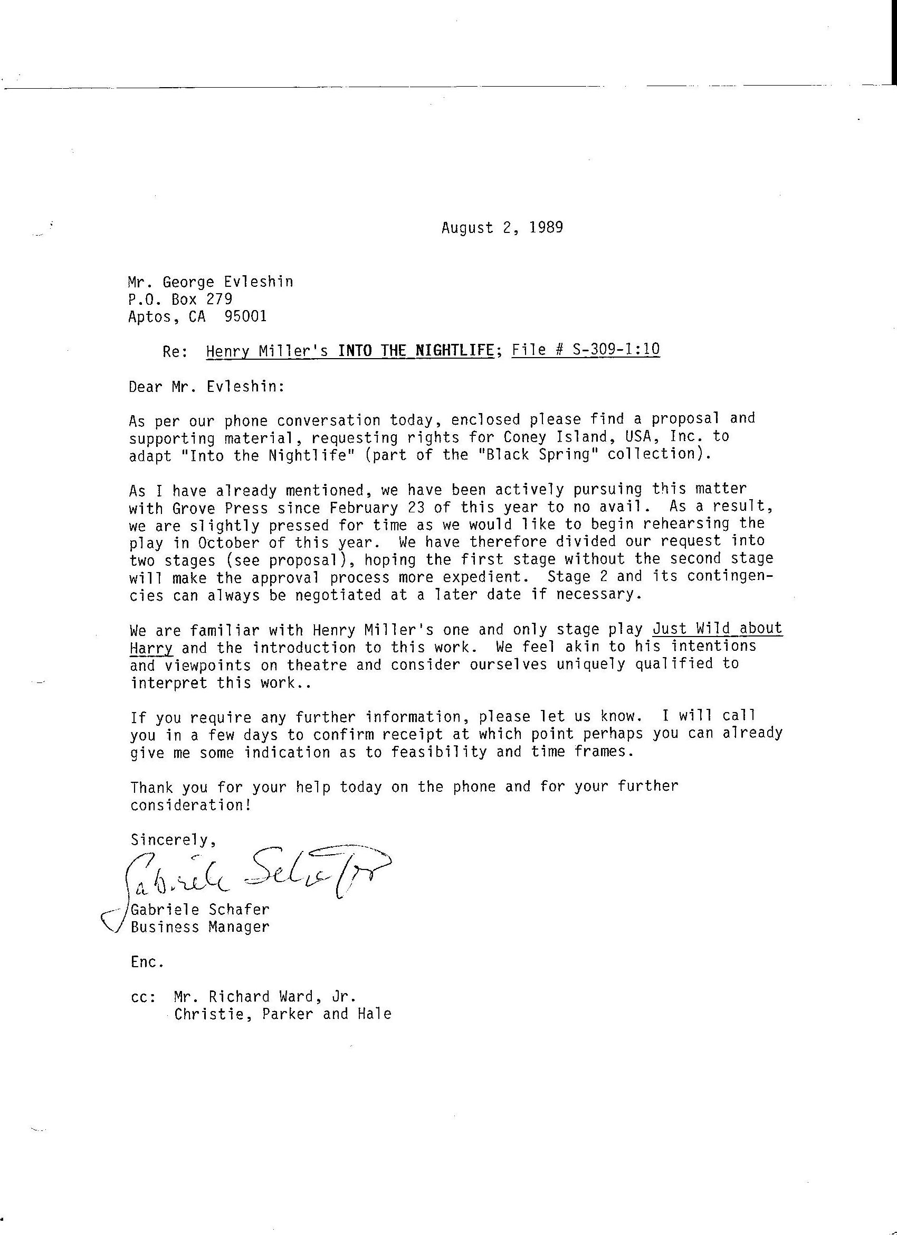
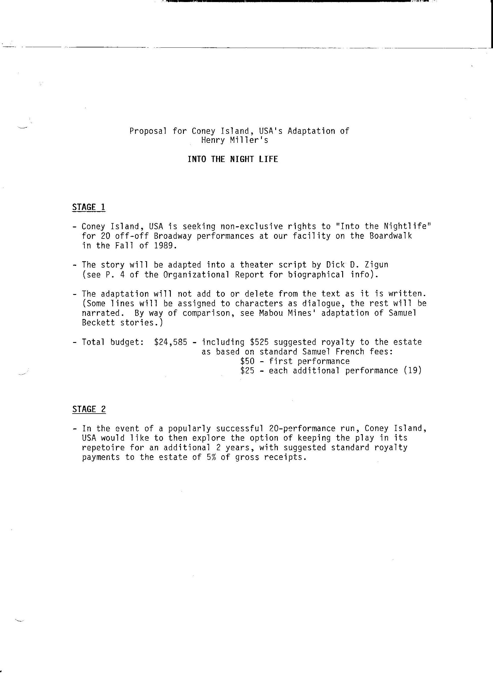
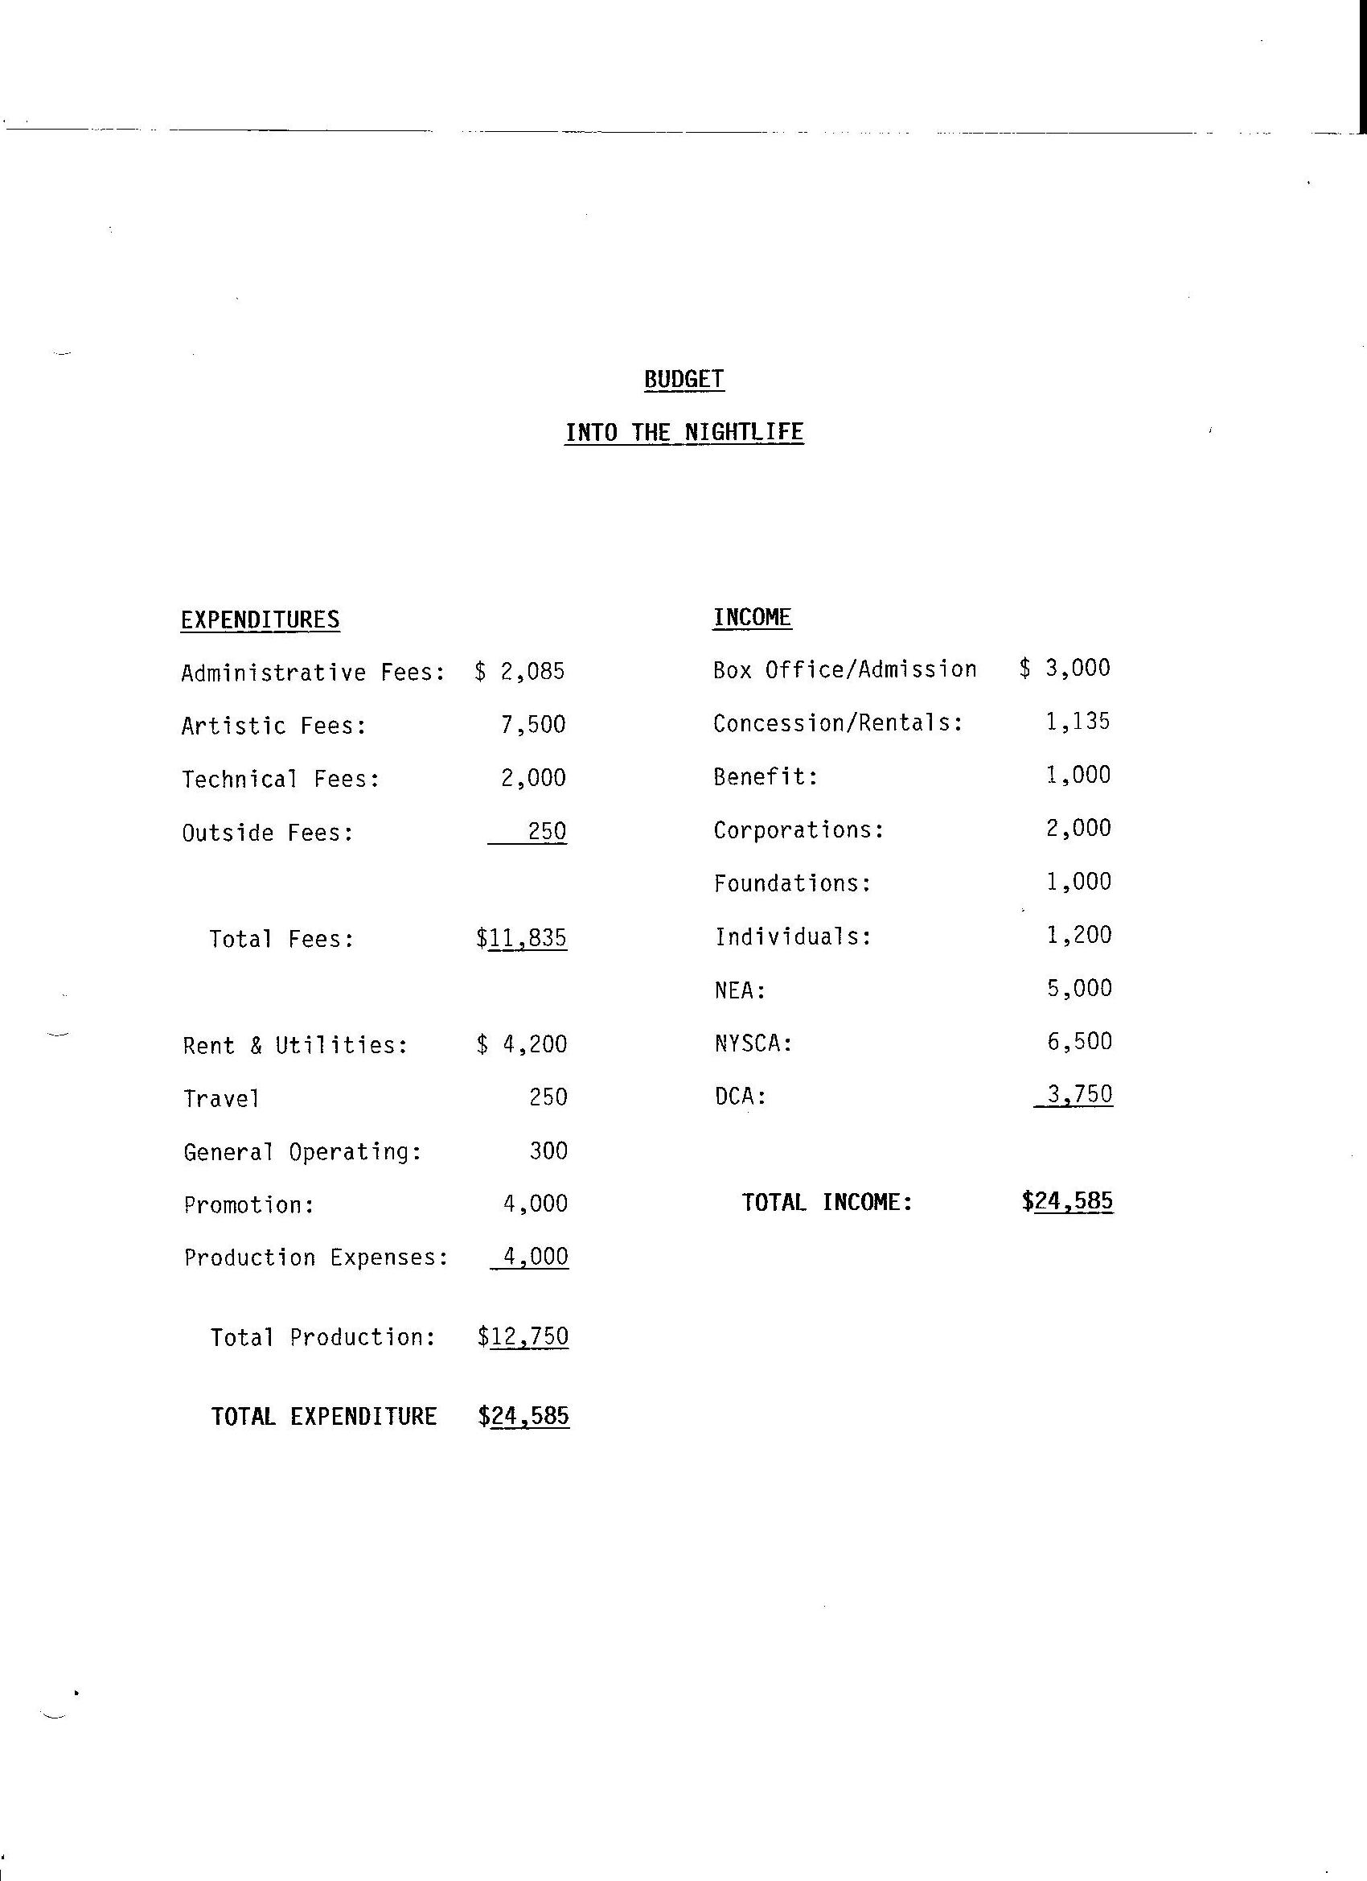
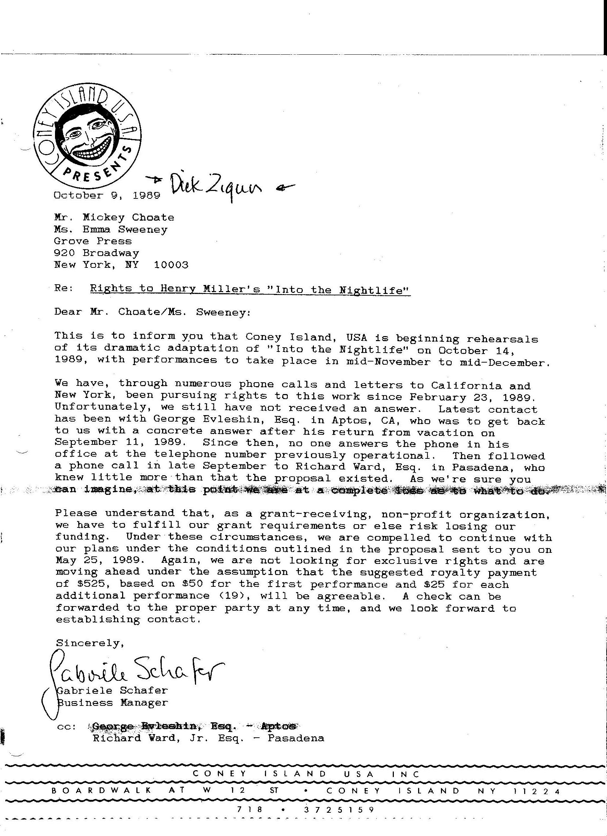
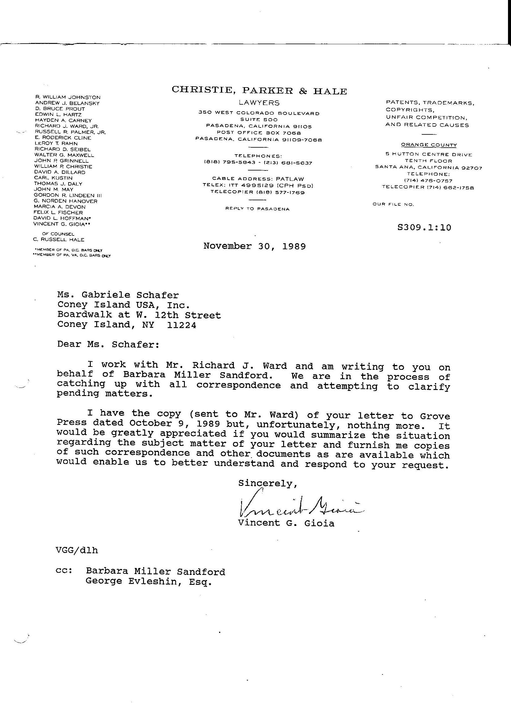
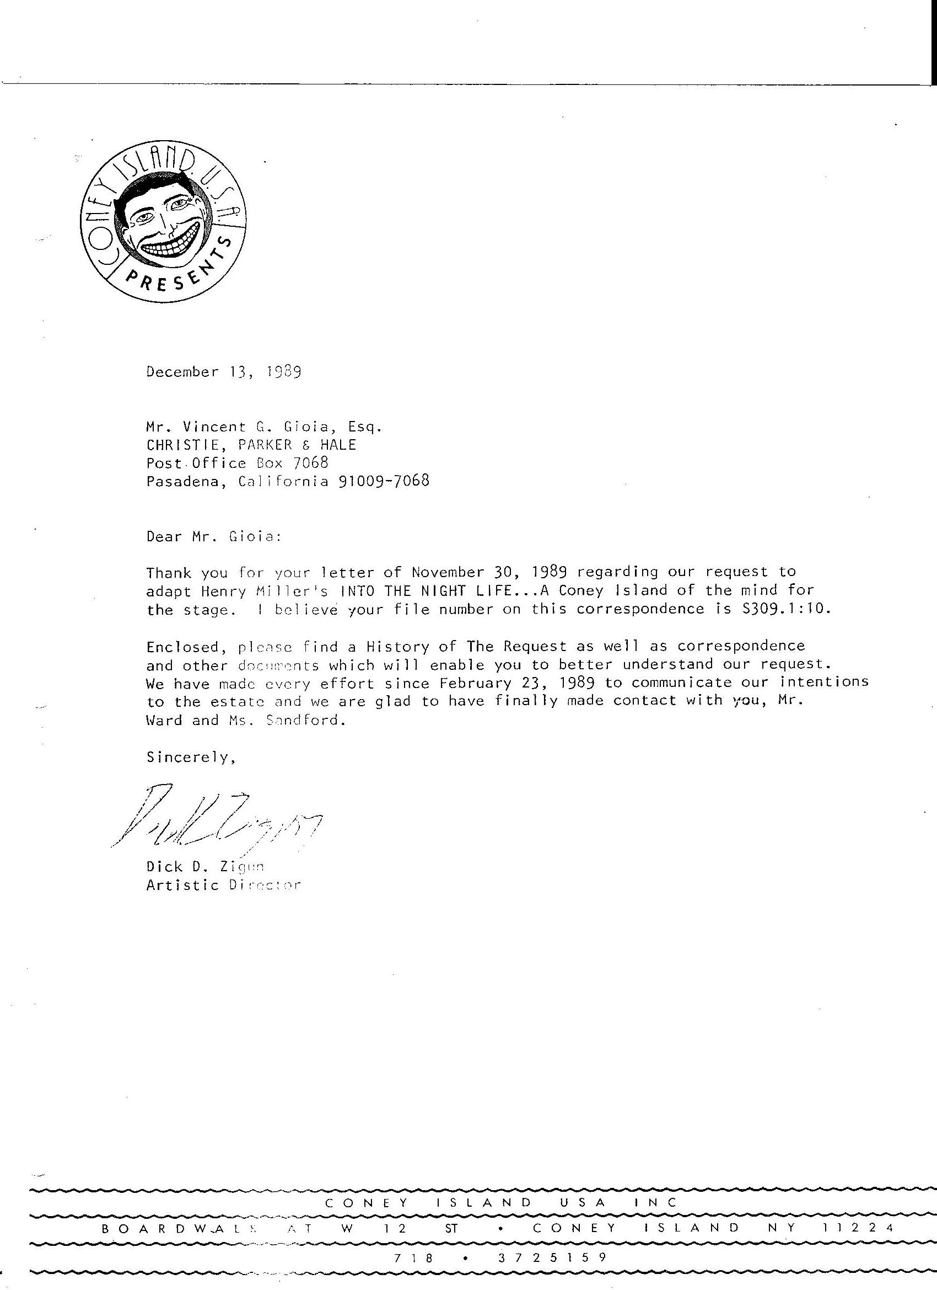
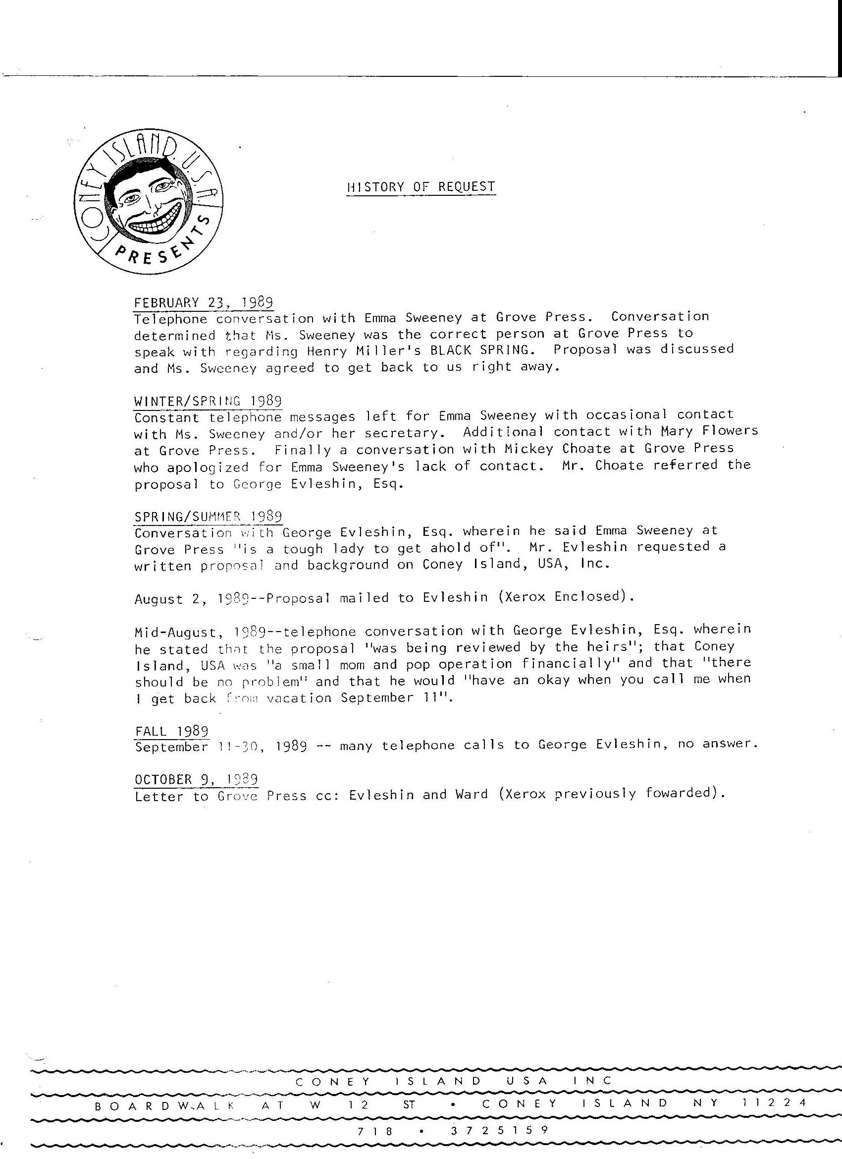
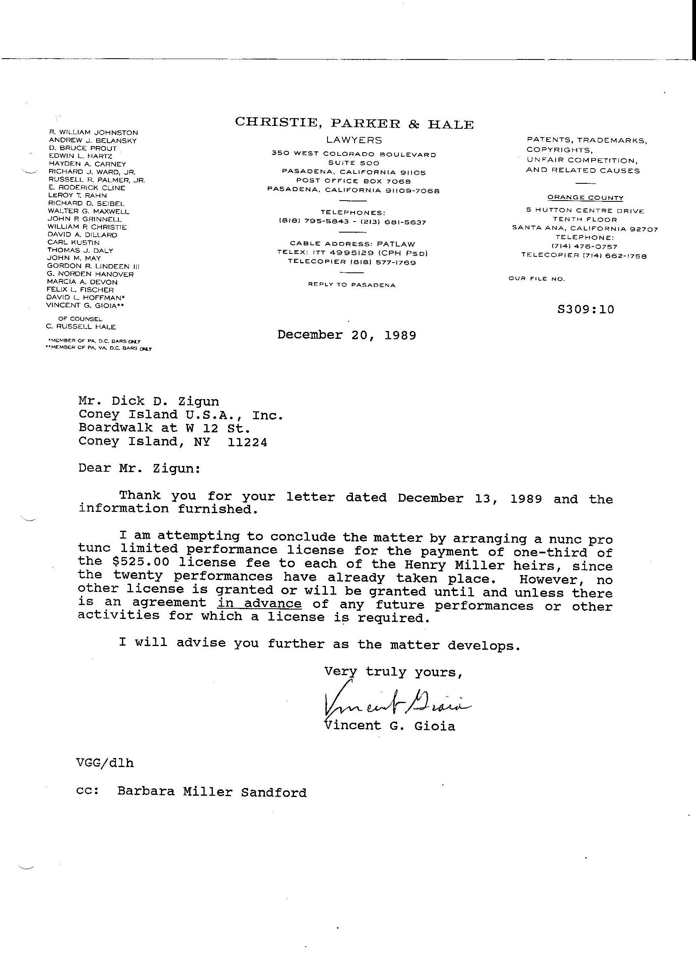
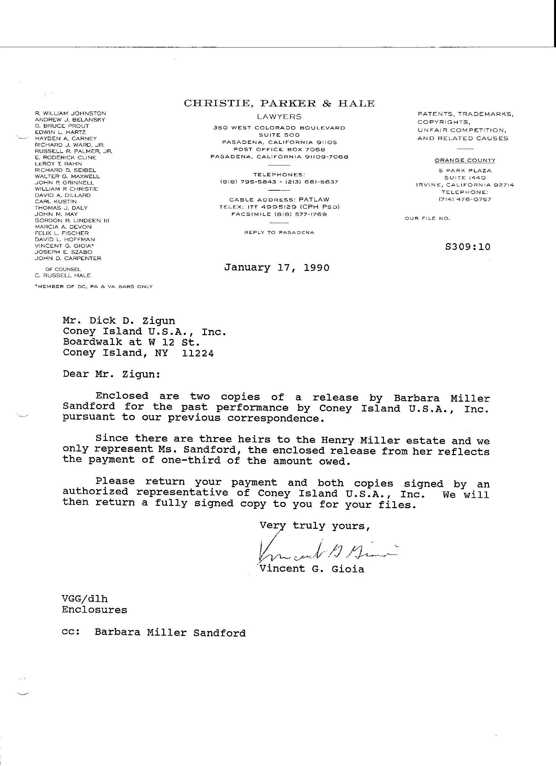
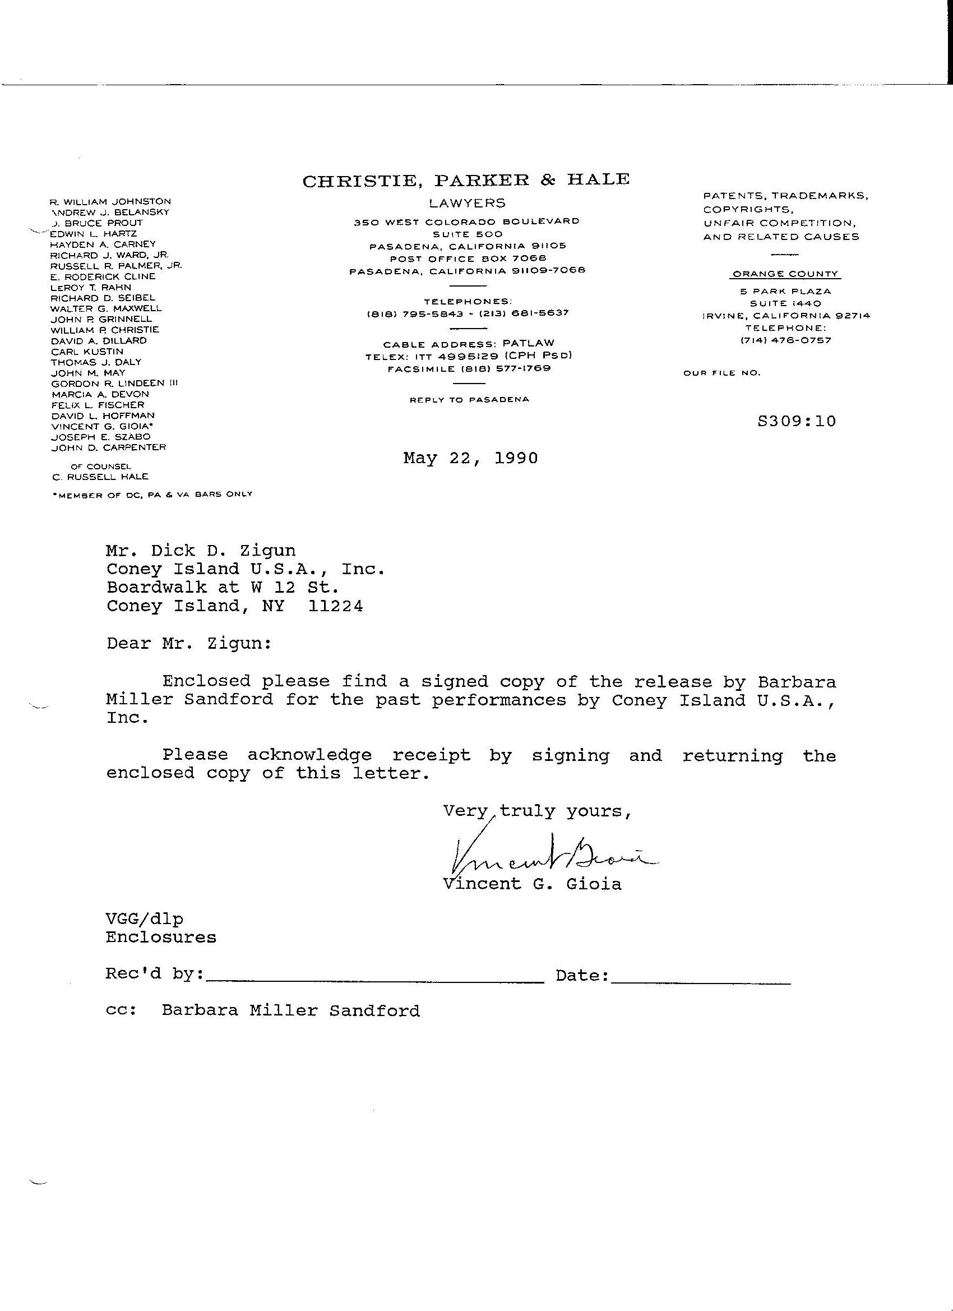
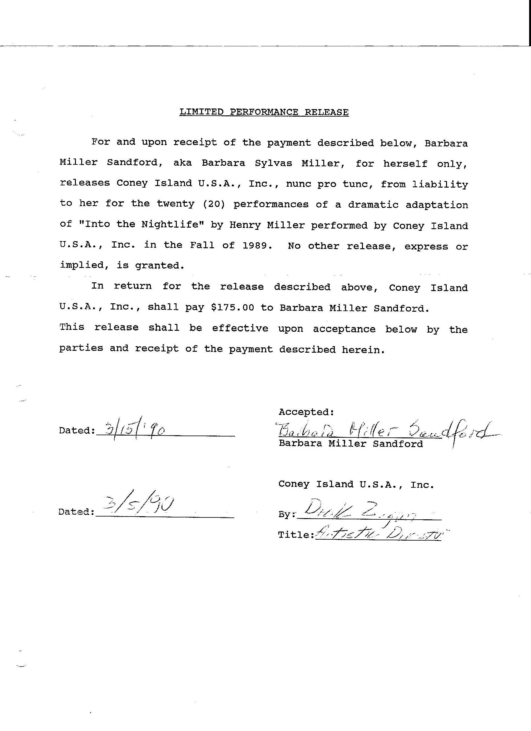
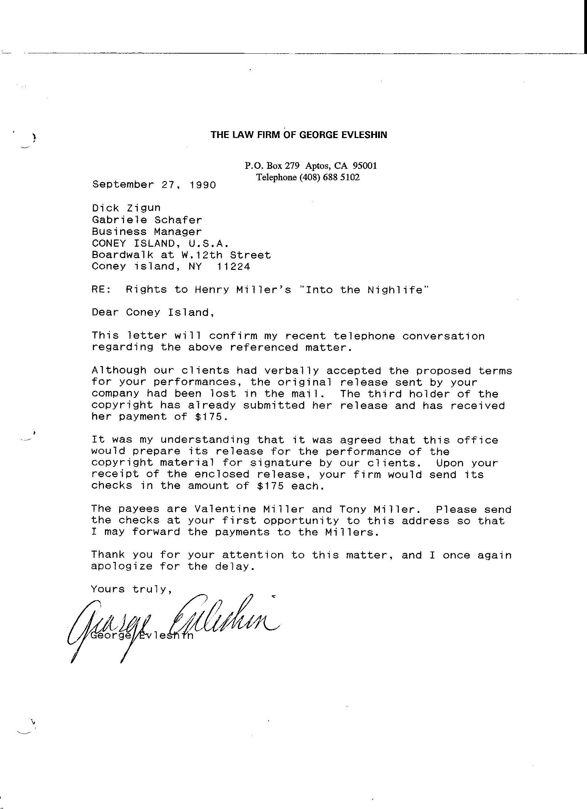
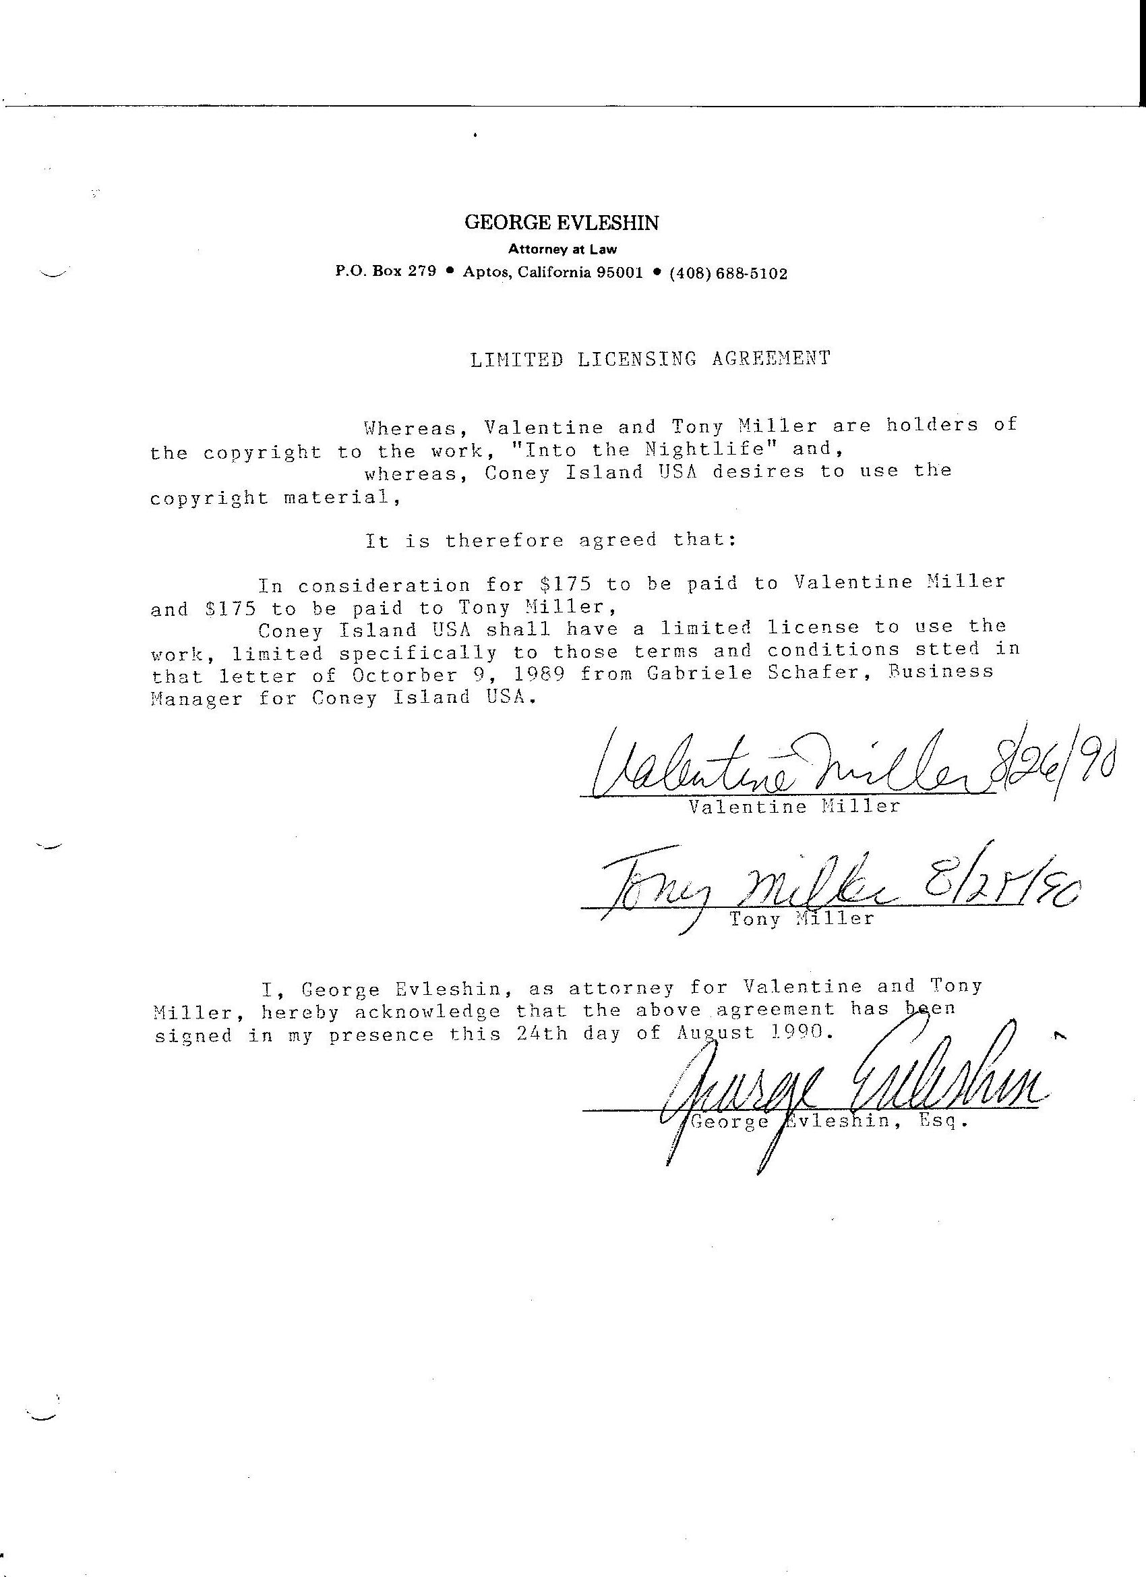

From En Francais dans le texte: "Le Dramaturge malgre lui." By Louis Pauwels, Jacques Mousseau, Jean Feller: Editions France Empire, Paris, 1962.
The round heads and the long heads get together in a cloud of vapor and all the wheels are taken apart and put together again.

