RED LETTER DAYS

by

DICK D. ZIGUN

Copyright (c)1986-2012 by Dick D. Zigun
All Rights Reserved.
C/O CONEY ISLAND, USA, INC.
1208 Surf Avenue
Coney Island, N.Y. 11224
(718) 372-5159
PRODUCTION HISTORY

1978 - LOVER'S LEAP
An earlier version of the play was presented February 12 under the title THE LETTER TO SARA at PSI performed by Elaine Hartnett and Dick Zigun. That performance was created for Jean Dupuy‘s A TOWER IN THE AUDITORIUM OF PS 1 — a series of art performances based on a given space limitation and documented in the book, COLLECTIVE CONSCIOUSNES$/ Art Performance In The Seventies, published by Performing Arts Journal Publications, l980.

1984 - LOVER'S LEAP
World Premiere at The People's Light and Theatre Company, Danny S. Fruchter, Producing Director, Susan Medak, Managing Director. Subsequent producers should credit as stated above.

1985 - 3 MINUTE MANIFESTO & UNTIMELY DEATH WITH DOGS, ETC.
Both plays originally commissioned by New Dramatists. Both plays originally published in THIS MAGAZINE, Volumes l & 2. Both plays published in SHORT PIECES FROM THE NEW DRAMATISTS, available from Broadway Play Publishing Inc., (212) 627-1055. Stock and amateur rights must be obtained from that source.

l986 - RED LETTER DAYS
World Premier (Equity Showcase) at Sideshows By The Seashore, the non-profit Museum/Theatre operated by Coney Island, USA, Inc. Dick D. Zigun, Artistic Director. Production directed by Costa Mantis.

1987 - GHOST STORY
To be published in THE NEW DRAMATISTS GENERAL AUDITION BOOK OF MONOLOGUES available from New American Library.

1990 – 54Th ANNIVERSARY… & LOVER’S LEAP
Both plays produced at West Bank Theater.

2009 – GHOST STORY
Produced at Sideshows By The Seashore, the non-profit Museum/Theatre operated by Coney Island, USA, Inc. Dick D. Zigun, Artistic Director.

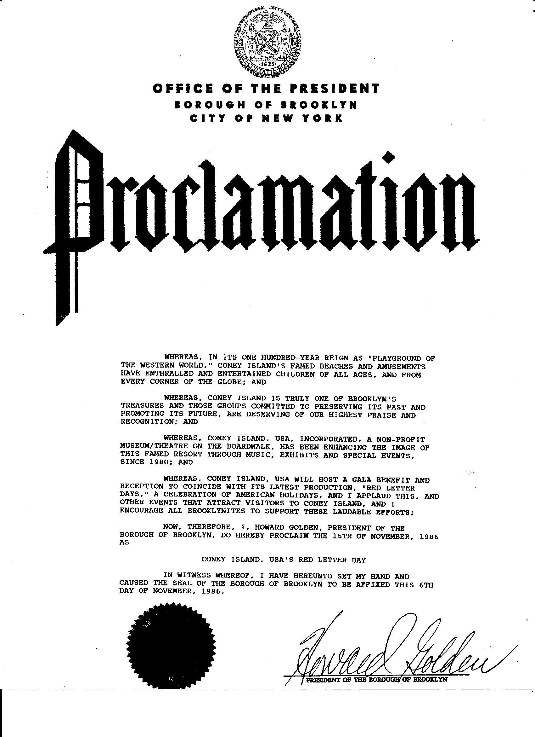
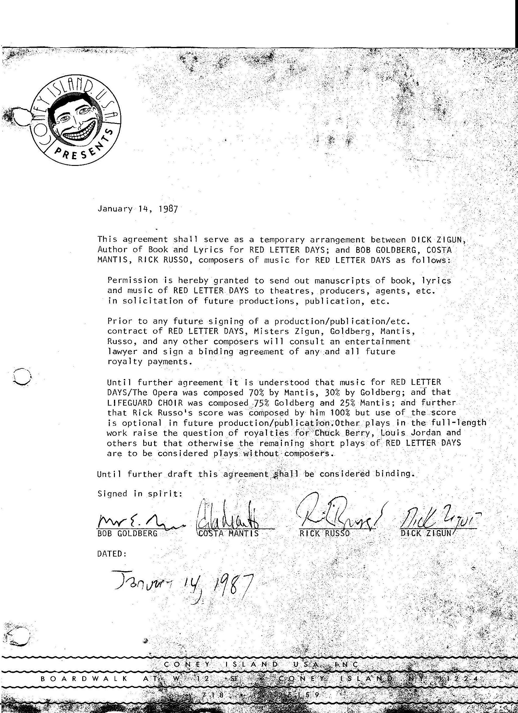

RED LETTER DAYS
An Opera For School Children

CAST (In Order of Appearance)
SANTA CLAUS
GEORGE WASHINGTON
CHRISTOPHER COLUMBUS
MOTHER
ABRAHAM LINCOLN
GROUND HOG
FATHER
REVEREND DOCTOR MARTIN LUTHER KING, JR.
EASTER BUNNY
SAINT PATRICK
CHORUS:
Laborer
Veteran
Indian
Pilgrim

SONG ONE
SANTA CLAUS
Happy Birthday to You
Happy Birthday to You
Happy Birthday Dear George Washington
Happy Birthday to You.

GEORGE WASHINGTON
Thank You.
My favorite holiday is Columbus Day
And I will never forget my Mother.

CHRISTOPHER COLUMBUS
Thank you.

MOTHER
Thank you.

SANTA CLAUS
Happy Birthday to You
Happy Birthday to You
Happy Birthday Dear Abraham Lincoln
Happy Birthday to You

ABRAHAM LINCOLN
Thank you.
My favorite holiday is Ground Hog's Day
And I will never forget my Father.

GROUND HOG
Thank you.

FATHER
Thank you.

SANTA CLAUS
Happy Birthday to You
Happy Birthday to You
Happy Birthday Dear Reverend Doctor Martin Luther King, Jr.
Happy Birthday to You.

MARTIN LUTHER KING
Thank You.
My favorite holiday is Easter
And I will never forget Saint Patrick.

EASTER BUNNY
Thank you.

SAINT PATRICK
Thank you.

ALL
Happy Birthday Dear George, Abraham and Martin
Happy Birthday to You.

WASHINGTON/LINCOLN/KING
Thank You.

SONG TWO
(THE HEROES SIT AROUND CASUALLY, IN
GROUPS, AS SANTA DELIVERS PRESENTS.)

SANTA CLAUS
Ho-Ho—Ho—Ho—Ho
Ho—Ho-Ho-Ho-Ho
Ho-Ho—Ho-Ho—Ho

OFF STAGE CHORUS
Knock-Knock

SANTA CLAUS
Ho—Ho—Ho—Ho—Ho
Ho-Ho—Ho-Ho-Ho
Ho-Ho—Ho-Ho-Ho

OFF STAGE CHORUS
Knock—Knock

SANTA CLAUS OFF STAGE CHORUS
Open the door, Richard Knock - Knock
Open the door, Richard Knock - Knock
Open the door, Richard

OFF STAGE CHORUS
Knock—Knock

SANTA CLAUS
Richard, why don't you open that door?

OFF STAGE CHORUS
Knock-Knock
Knock-Knock

EASTER BUNNY
I'll get it.

GROUND HOG
I'll get it.

OFF STAGE CHORUS
Knock—Knock
Knock—Knock

MOTHER
I'll get it.

FATHER
I'll get it.

OFF STAGE CHORUS
Knock-Knock
Knock-Knock

CHRISTOPHER COLUMBUS
I'll get it.

SAINT PATRICK
I'll get it.

OFF STAGE CHORUS
Knock-Knock
Knock—Knock

ABRAHAM LINCOLN
I'll get it.

MARTIN LUTHER KING
I'll get it.

OFF STAGE CHORUS
Knock-Knock
Knock-Knock

(GEORGE WASHINGTON OPENS THE DOOR)

GEORGE WASHINGTON
I got it.
I'm the one who went and got it!

SANTA CLAUS
Thank you.

CHORUS
We wish you a Merry Christmas
We wish you a Merry Christmas
We wish you a Merry Christmas
But what about us?

SANTA CLAUS
Thank you.
Thank you.
Thank you.
But who are you?

LABORER
I've been working on the railroad-

VETERAN
I've been fighting for the country-

INDIAN & PILGRIM
We've been eating all the turkey-

CHORUS
We wish you a Merry Christmas, Santa,
But what about us?

OTHERS
Ho—Ho-Ho—Ho-Ho
Ho—Ho—Ho—Ho—Ho
Ho—Ho—Ho—Ho—Ho

GEORGE WASHINGTON
I've got it!
I've got it!
Why don't we call you all John Doe?
Why don't we call you all John Doe?
The banks will close for John Doe.
The post office closed for John Doe.
All the schools will be closed for John Doe.
John Doe Day!

OTHERS
Ho-Ho—Ho—Ho-Ho
Ho-Ho-Ho-Ho-Ho
Ho-Ho-Ho-Ho-Ho

CHORUS
Labor deserves a day all its own

SANTA CLAUS
We'll have to take a vote

CHORUS
Veterans deserve a day all their own

SANTA CLAUS
We'll have to take a vote

CHORUS
Thanksgiving deserves a day all its own

SANTA CLAUS
We'll have to take a vote

CHORUS
We accept.
We thank you.
Labor-Thanks-Veterans!
We wish you a Merry Christmas.

GEORGE WASHINGTON
John Doe Day!
John Doe Day!

SANTA CLAUS
We'll have to take a vote.
A democratic vote.

GEORGE WASHINGTON
I accept.
I thank you.

OTHERS
Ho—Ho—Ho—Ho-Ho
Ho-Ho-Ho-Ho—Ho
Ho—Ho—Ho-Ho—Ho

SONG THREE
SANTA CLAUS
Christopher Columbus:
How do you vote?
How do you vote?
Christopher Columbus:
Innocent or Guilty?
Flat or Round?
East or West?
Elephant or Donkey?

Christopher Columbus:

GEORGE WASHINGTON
John Doe Day!

CHORUS
Labor-Thanks—Veterans!

SANTA CLAUS
How do you vote?
How do you vote?

CHRISTOPHER COLUMBUS
In-a Fourteen Hundred and-a Ninety Two
I—a sail me-a three tiny ships
Just to-a be with you.
America she's—a my home you see
And America's so-a nice
They built—a so many statues of me
So I think and I think
About what George-a Washington said
'cause George-a Washington wears
A white-a wig on his head
I can-a see a John Doe
John, he's-a my kind-a guy
I vote-a we give John—a Doe A Day
Hey, we gonna give it a try

GEORGE WASHINGTON
Thank you.

CHRISTOPHER COLUMBUS
Thank—a you!

SANTA CLAUS
Abraham Lincoln:
How do you vote?
How do you vote?

Abraham Lincoln:
Innocent or Guilty?
North or South?
Grey or Blue?
Elephant or Donkey?

Abraham Lincoln:

COLUMBUS & WASHINGTON
John-a Doe—a Day}

CHORUS
Labor—Thanks-Veterans!

SANTA CLAUS
How do you vote?
How do you vote?

ABRAHAM LINCOLN
John Brown‘s body lies a
Molderin' in the grave
John helped me win the Civil War
But where's his holiday?
I vote John Brown Day and
Labor Day and Thanksgiving Day and
Veteran's Day and John Doe Day and
Butcher Day and Baker Day and
Candlestick Maker Day and
Robert E. Lee Day and Ulysses S. Grant Day and
Dixie Day and Yankee Day and
Brooklyn Dodger Day.

CHORUS
Thank you.

ABRAHAM LINCOLN
Lincoln thanks
Labor-Thanks-Veterans

SANTA CLAUS
Can you hear me Saint Patrick:
How do you vote?
How do you vote?

Can you hear me Saint Patrick:
Innocent or Guilty?
Sun or God?
Snakes or Rats?
Elephant or Donkey?

Can you hear me Saint Patrick:

COLUMBUS & WASHINGTON
John O'Doe O'Day!

LINCOLN & CHORUS
Lincoln Thanks
Labor—Thanks—Veterans
Want to Thank
Saint Patrick

SANTA CLAUS
How do you vote?
How do you vote?

SAINT PATRICK
Me name is Saint O'Patrick
I'm the clover o' the clan
They toast to me in Boston,
Ireland and O'Japan
Me leprechauns and I believe
O'Doe is worth o'fight
O'Doe is just o'way
To kiss O‘Blarney days goodnight
I vote Irish ayes From:
Flannigan, Harrigan, Mulligan, Sullivan,
McDonald and McMack
Me Friend McGillicuddy‘s out
But he'll vote aye when he gets back

COLUMBUS 6 WASHINGTON
Thank O'You

SAINT PATRICK
Thank O'You!

SANTA CLAUS
Reverend Doctor Martin Luther King, Jr.
How do you vote?
How do you vote?

Reverend Doctor Martin Luther King, Jr.
Innocent or guilty?
Black or White?
Free or Slave?
Elephant or Donkey?

Reverend Doctor Martin Luther King, Jr.:

SAINT PATRICK & WASHINGTON & COLUMBUS
John Doe Day
Amen!

LINCOLN & CHORUS
Lincoln Thanks
Labor—Thanks—Veterans
Want to Thank
Reverend Doctor Martin Luther King, Junior
Amen!

SANTA CLAUS
How do you vote?
How do you vote?

MARTIN LUTHER KING
When Moses was in Pharaoh land
Let his people go—go
The law was changed at Moe's demand
Let your people go—go

Walk, don't run on the White House
We want more deeds for days to come
We're Warning you Wacky Washington
Uncle John Doe's got to go—go

LINCOLN & CHORUS
Hallelujah!... Hallelujah!
Thank you.

MARTIN LUTHER KING
The Reverend Doctor Martin Luther King Junior Thanks
Lincoln Thanks
Labor—Thanks-Veterans!

SANTA CLAUS
Father and Mother:
How do you vote?
How do you vote?

Father and Mother:
Innocent or Guilty?
Boy or Girl?
Young or Old?
Elephant or Donkey?

Father and Mother:

SAINT PAT & COLUMBUS & WASHINGTON
Little Johnny Doe, Jr. Day!

KING & LINCOLN & CHORUS
King thanks Lincoln thanks
Labor-Thanks-Veterans
Want to thank
Father and Mother

SANTA CLAUS
How do you vote?
How do you vote?

FATHER & MOTHER
Rock-a-bye, baby
Take your first step
Do well in school
And Become President
If there's a law
Against a Day named for you
Then why should our baby
Learn the hard things to do?

KING & LINCOLN & CHORUS
Thank you, Pa.
Thank you, Ma. ·
We're ahead — four to two!
We're ahead - we're winning!

GEORGE WASHINGTON
We're not done with our vote
Our democratic vote!

FATHER & MOTHER
Father thanks Mother thanks
King thanks Lincoln thanks
Labor-Thanks—Veterans.

SANTA CLAUS
Easter Bunny and Ground Hog:
How do you vote?
How do you vote?

Easter Bunny and Ground Hog:
Innocent or Guilty?
Man or Mouse?
Snow or Rain?
Elephant or Donkey?

Easter Bunny and Ground Hog:

ST. PAT & COLUMBUS & WASHINGTON
John's a Doe Day!

FATHER/MOTHER/KING/LINCOLN/CHORUS
Father thanks Mother thanks
King thanks Lincoln thanks
Labor-Thanks-Veterans hope to thank
Easter Bunny and Ground Hog!

SANTA CLAUS
How do you vote?
How do you vote?

GROUND HOG
Me and My Shadow:

EASTER BUNNY
In your Easter Bonnet:

BUNNY & GROUND HOG
We vote
We vote
We vote to vote in
Our native tongue:
Bark—Bark—Bark
Meow-Meow—Meow
Bow—Wow—Wow
Chirp—Chirp—Chirp
(sniff)—(sniff)—(sniff)
Club—Club—Club
Growl—Growl
Buzz-Buzz
Screech—Screech
Ribbit—Ribbit
Ruff—Woof
Tweet—Tweet

SANTA CLAUS
Ho—Ho—Ho—Ho—Ho
Ho-Ho—Ho—Ho—Ho
Ho—Ho-Ho—Ho-Ho

OTHERS
How did they vote?
How did they vote?

SANTA CLAUS
I count the vote
At four to four

WASHINGTON/ST. PATRICK/COLUMBUS
Thank you, animals,
Thank you

BUNNY & GROUND HOG
(sniff)—(sniff)
Thank you

CHORUS
Santa Claus!

WASHINGTON
Santa Claus?

ALL
How do you vote?
How do you vote?

SANTA CLAUS
I don‘t vote
I can't vote
I'm a citizen of the North Pole
The final vote's a tie.

(GRUBLES, COMPLAINTS AND
A CALL FOR A RECOUNT)

SONG FOUR
(WASHINGTON DISCOVERED PACING.
WATER GLASSES CLINKED WITH SPOONS)

GEORGE WASHINGTON OTHERS
Verse 1:
Ladies and Gentlemen
George Washington here
Please allow me
To conclude these festivities
With my Concession Speech: Da-da-da-da-da-da-da

Verse 2:
I cannot tell a lie
Not after eating apple pie
I forgot what John Doe
Did to impress me

Verse 3:
John Doe was not such a memorable guy
John Q. Public was not such a memorable guy
Guy Fawkes was not such a memorable guy

Verse 4:
You guys here are very memorable guys
Who wouldn't want more gals or guys like you guys?
Washington welcomes
Labor, Thanksgiving and Veterans

CHORUS
For he's a jolly good fellow
For he‘s a jolly good fellow
For he's a jolly good fellow
Which nobody can deny

INDIAN OTHERS
Verse 1:
Ladies and Gentlemen
The American Indian here
Please allow me
To conclude these festivities
With my
Peace Pipe Spirit Speech: Da-da-da—da—da-da-da

Verse 2:
How will the new people know the old people?
How will the old people know the new old people?
How will the new people know?
How? How?

ALL
Chorus:
For he's a jolly good fellow
For he's a jolly good fellow
For he's a jolly good fellow
Which nobody can deny

Verse 1:
Ladies and Gentlemen
The American Heroes here
Please allow us
To conclude these festivities
With our
Holiday Speech:

Verse 2:
Thank you for the meal
Thank you for the Main Street parade
Thank you for the red letter days

CHORUS
Coda:
Which nobody can deny
Which nobody can deny
(THEY POINT TO THE ENTIRE CAST)
For he's a jolly good fellow
Which nobody can deny

SANTA CLAUS
Happy Holidays

ALL
Thank you
(BOW)
Thank you
(BOW)
Thank you!

Red Letter Days: notes for performance

Instrumentation:
Voices
Sound Effects (cowbell, finger-cymbals, slide whistle, bike horn)
Strummed Instrument (guitar, mandolin, banjo, or other chordal/rhythmic instrument)
Percussion (tambourine, bass drum)
Piano
The score is written as originally performed, Sideshows by the Seashore, November 1986.
The instrumentalists were:
1) Piano / Percussion
2) Sound Effects
3) Occasional Mandolin

Piano and percussion parts are meant to be performed by one player (left hand piano, right hand percussion). Where there are parts written for both the piano and percussion, the player may (a) choose to play one or the other, or (b) attempt to play both. please note: it is possible to do this by placing the tambourine in one's lap at such an angle as it may be struck with the wrist while playing a piano chord. This technique poses no danger to the player's wrists.
The percussion and sound effects parts may be distributed differently if desired. Substitutions may be made (eg. pocket siren for slide whistle, wood block for cow bell, etc.).
Voices are written on a single staff (owing to spatial considerations). Please consult the script for proper distribution of parts.
Due to discrepancies between written note and typed word, it was not always possible to align the proper word under the proper note. Have patience. It is somewhere nearby.

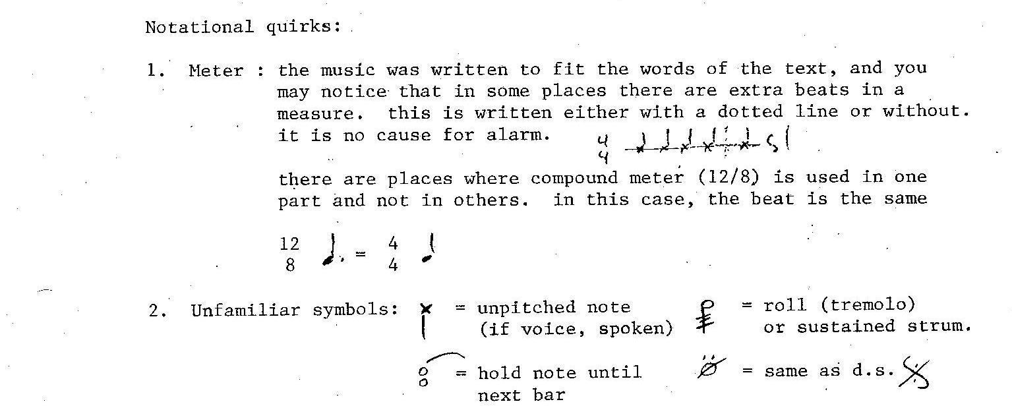

Red Letter Days:

Scene 3: This scene has a repeating intro (or "recitative") and song (or "solo") structure. In general, the intro is more free in rhythm, and the song is usually a bit faster than the intro.

Scene 4: This scene has a verse/chorus structure. Only the first verse is written in the score. The remaining verses are in the script.

Transitions between scenes:
In the instance that you may need or desire music between scenes (eg. whilst waiting for set or lighting changes) any holiday songs are appropriate (in original or altered form as you see fit).

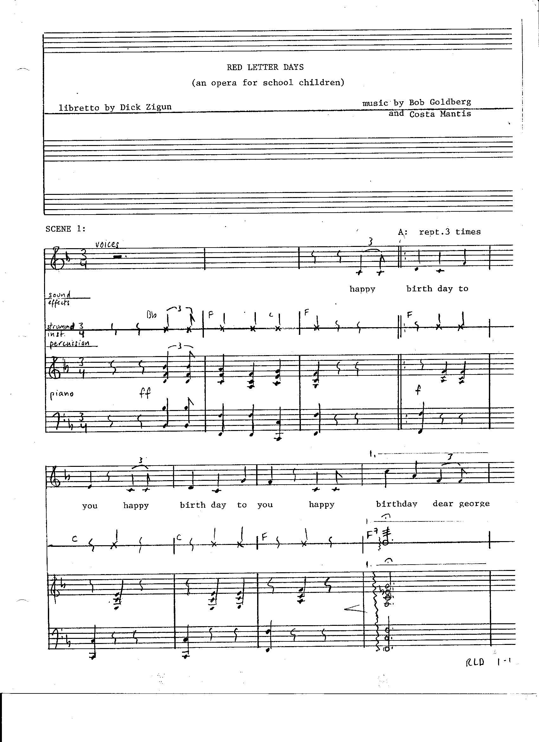
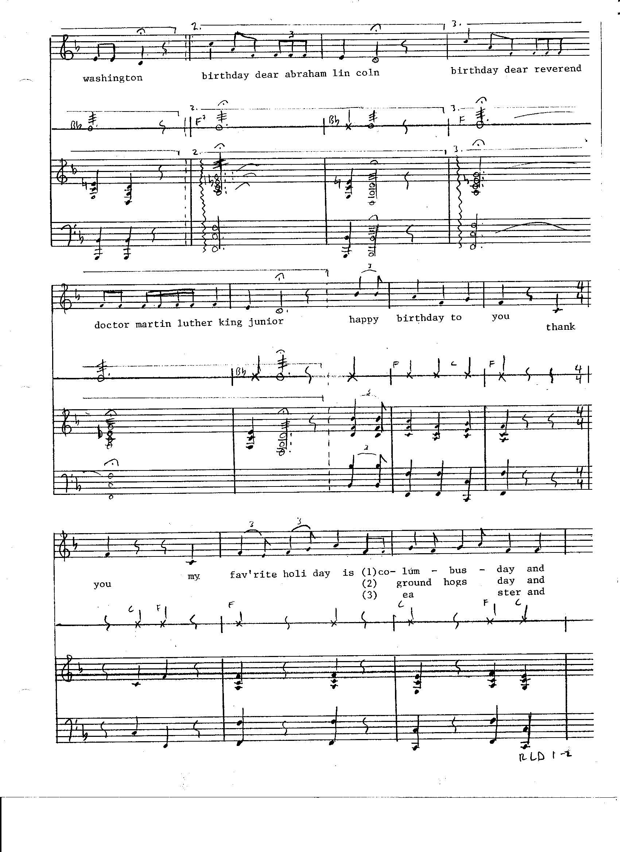
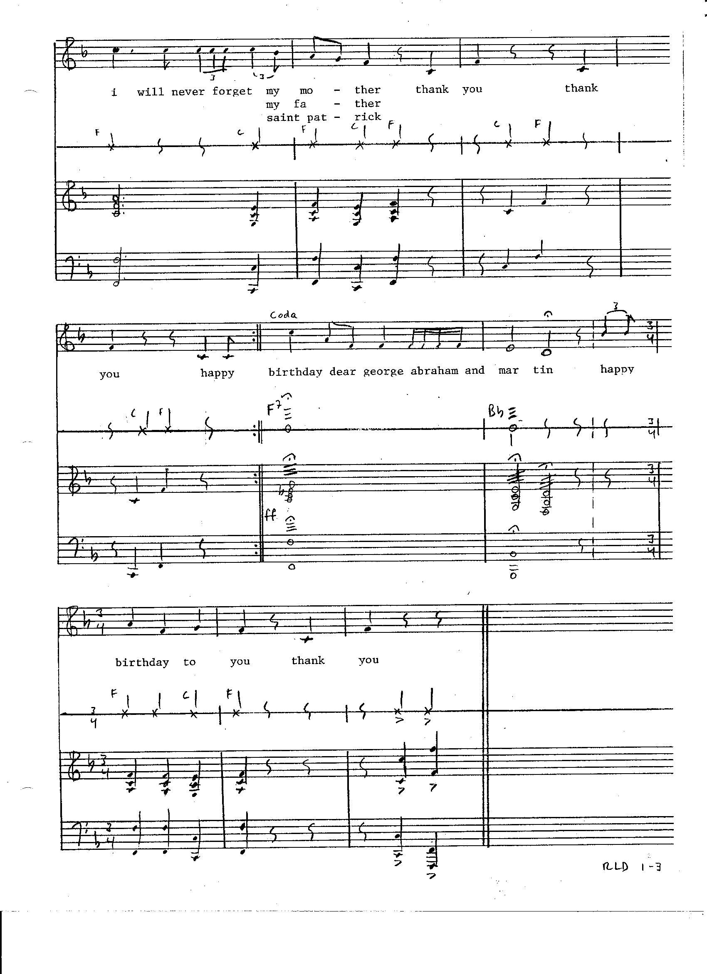
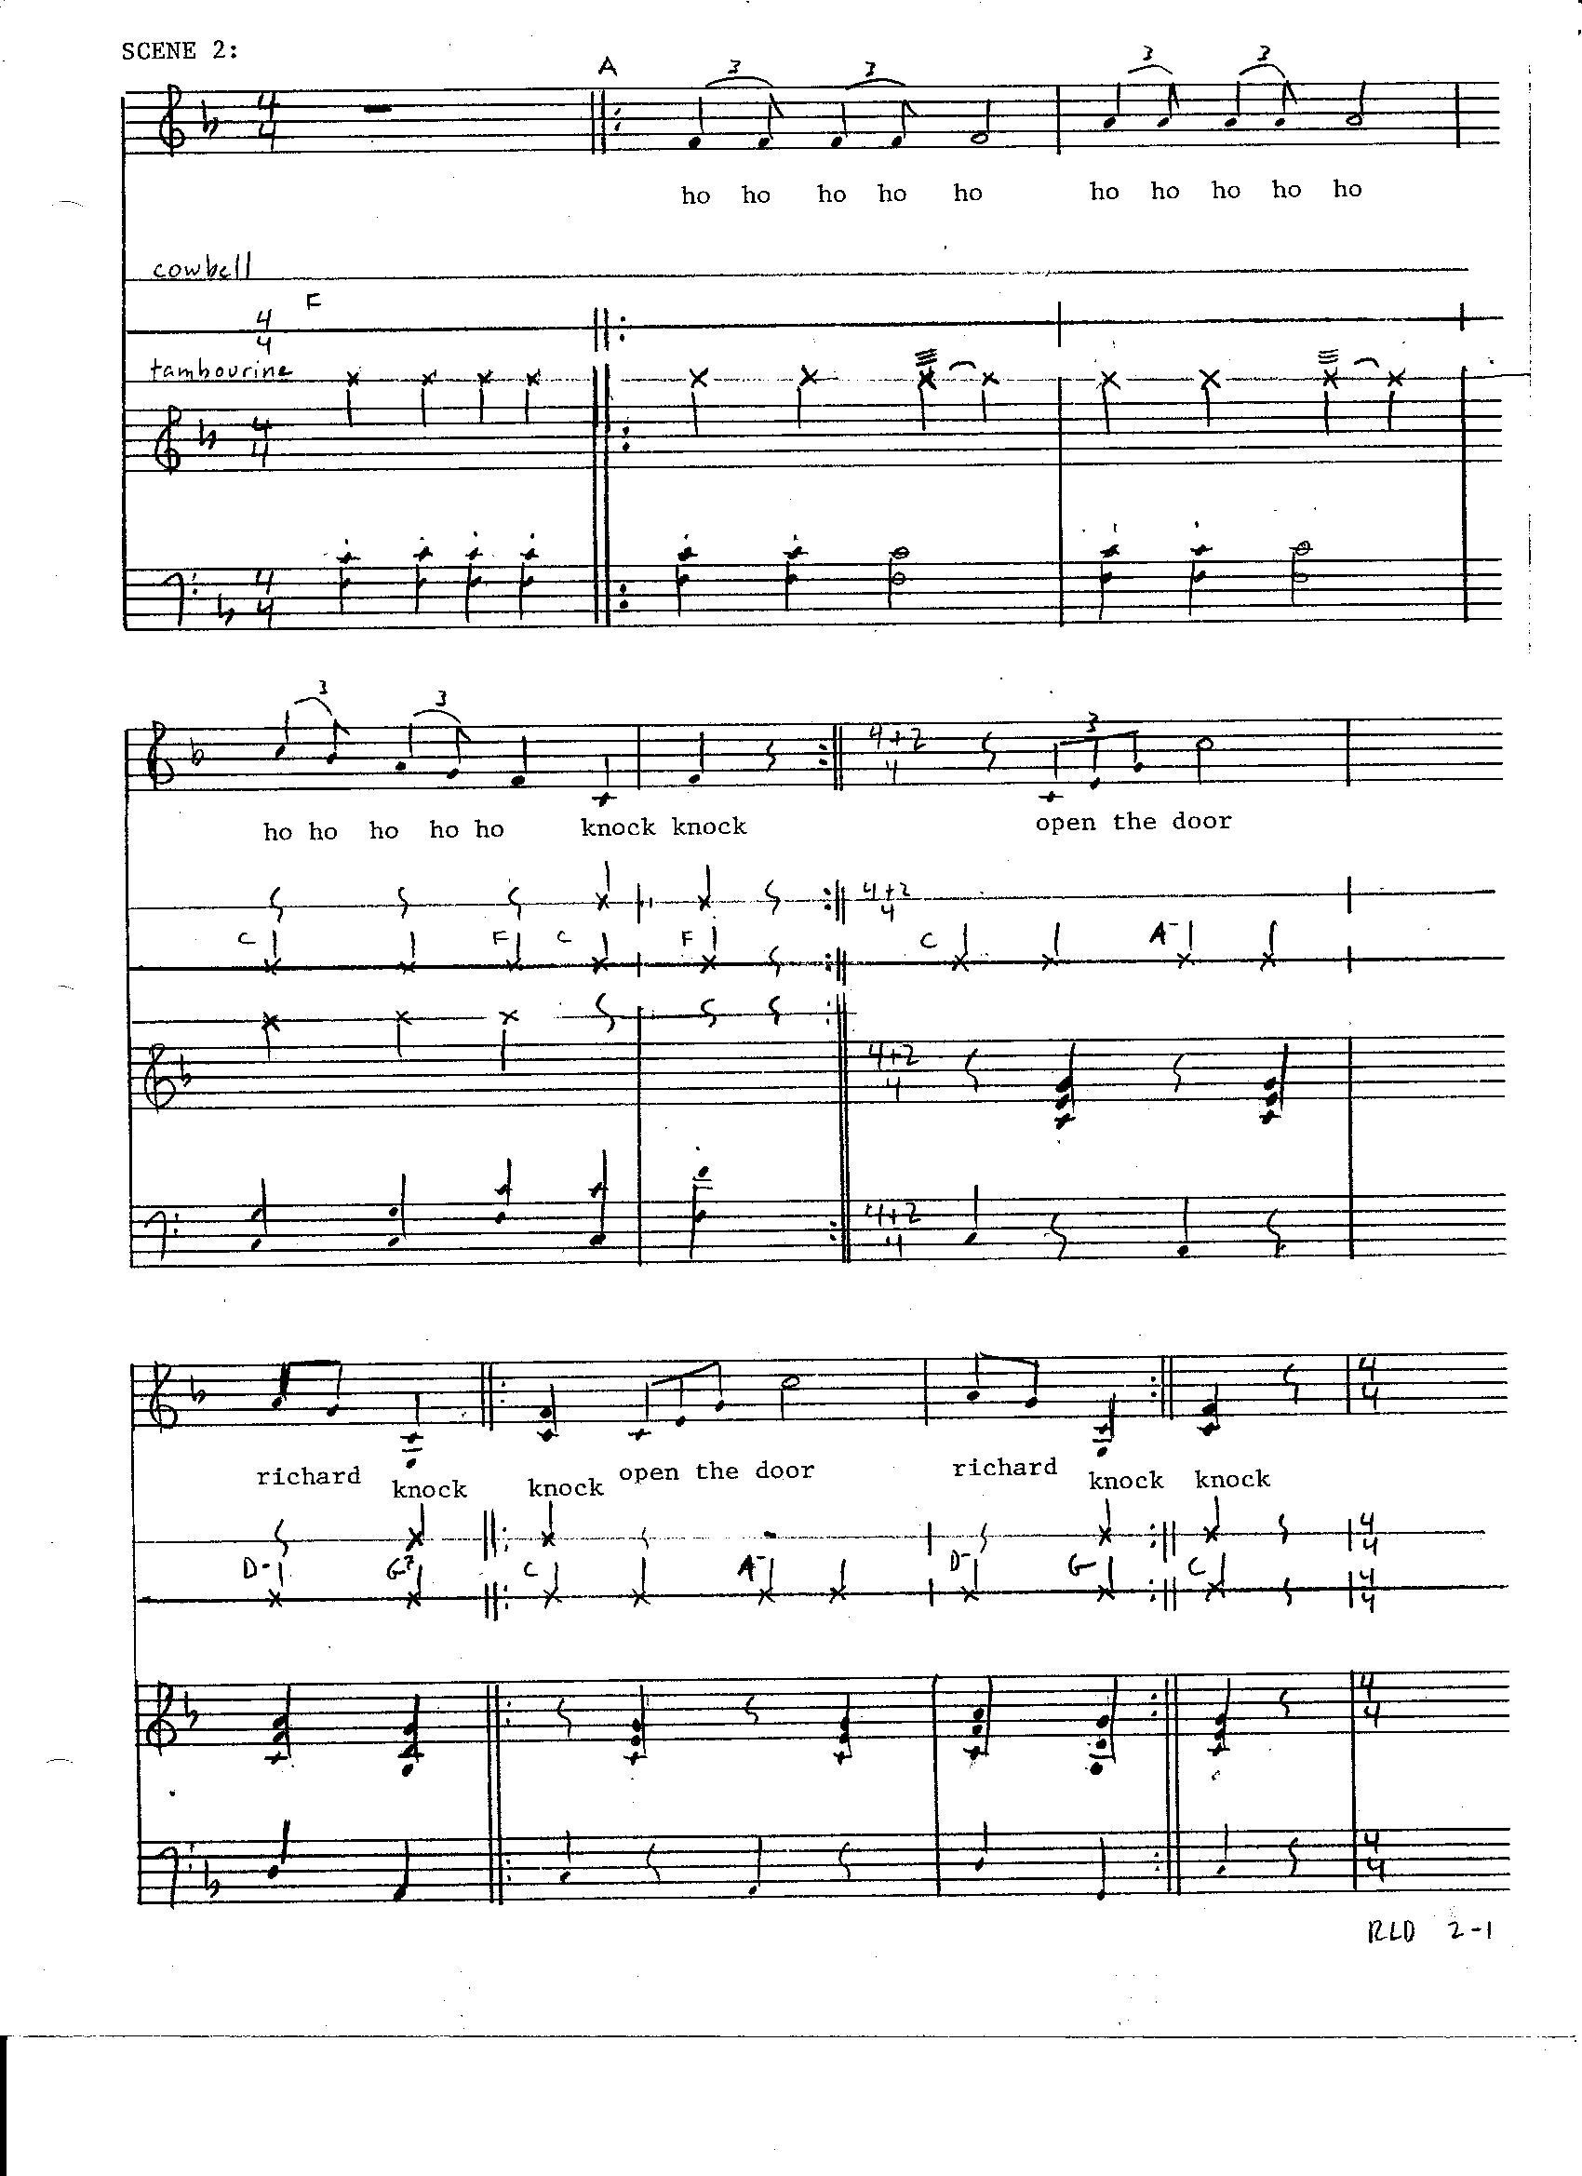
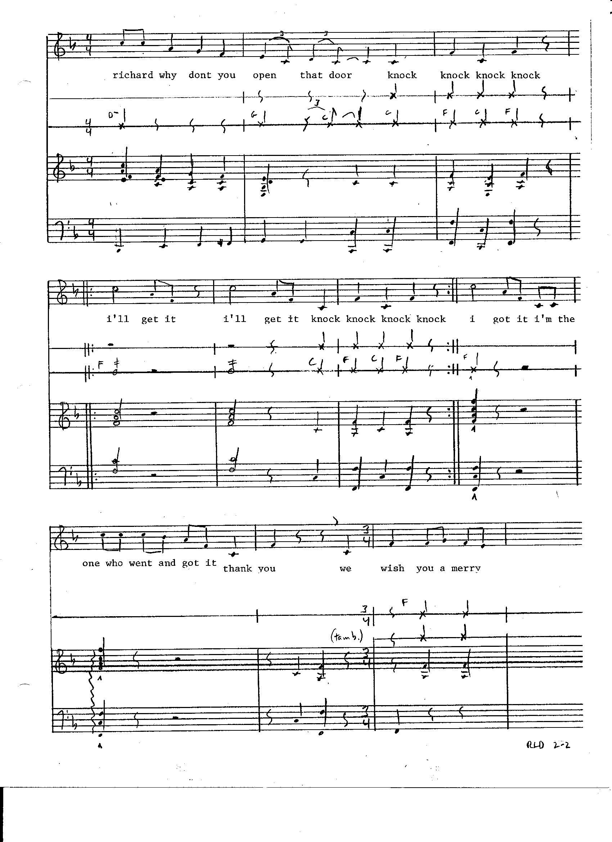
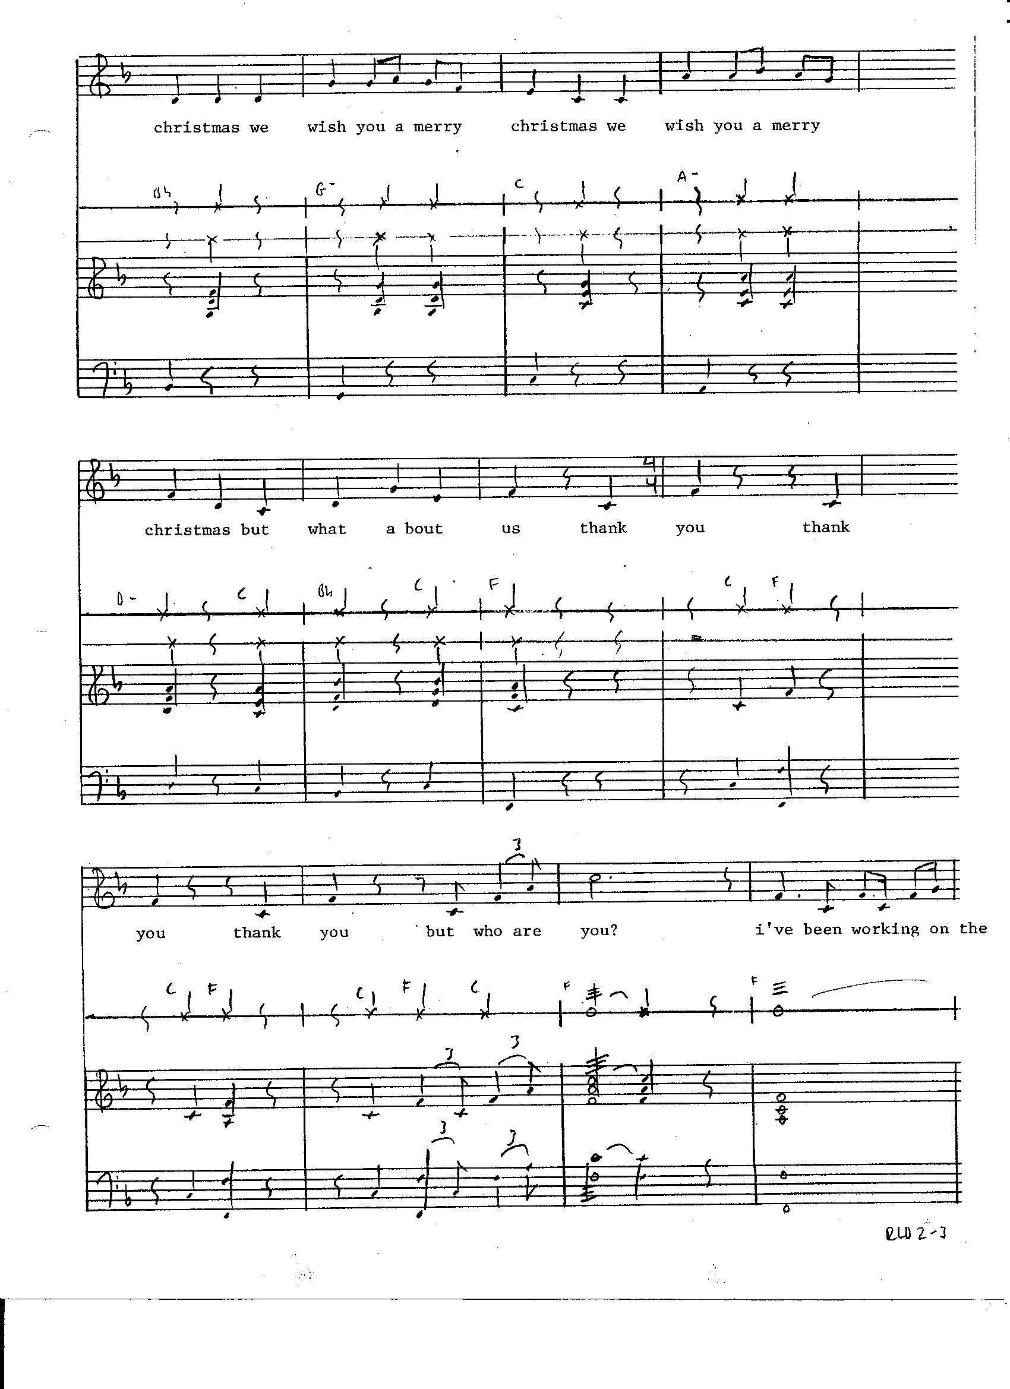
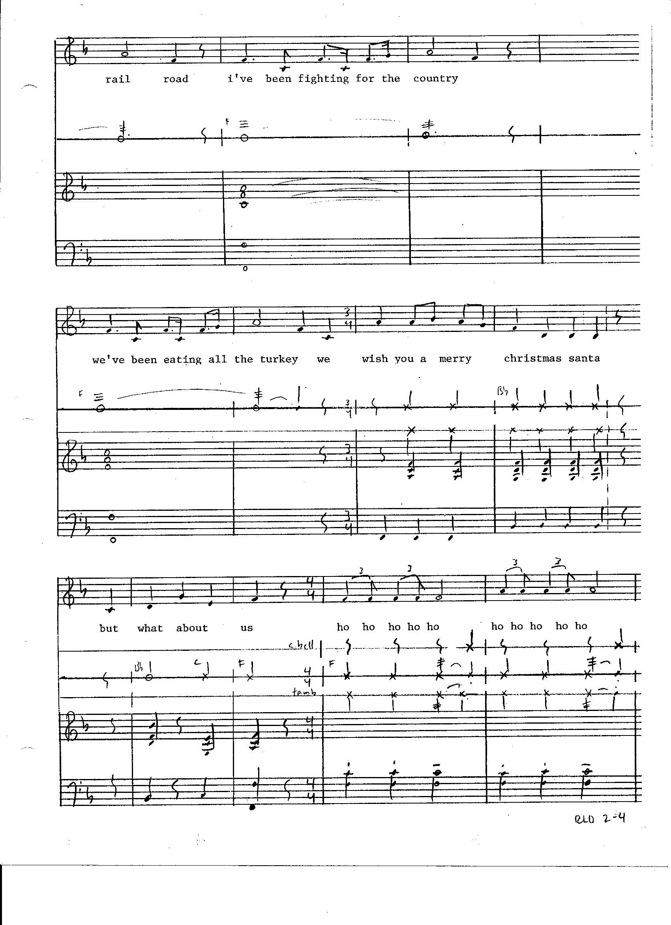
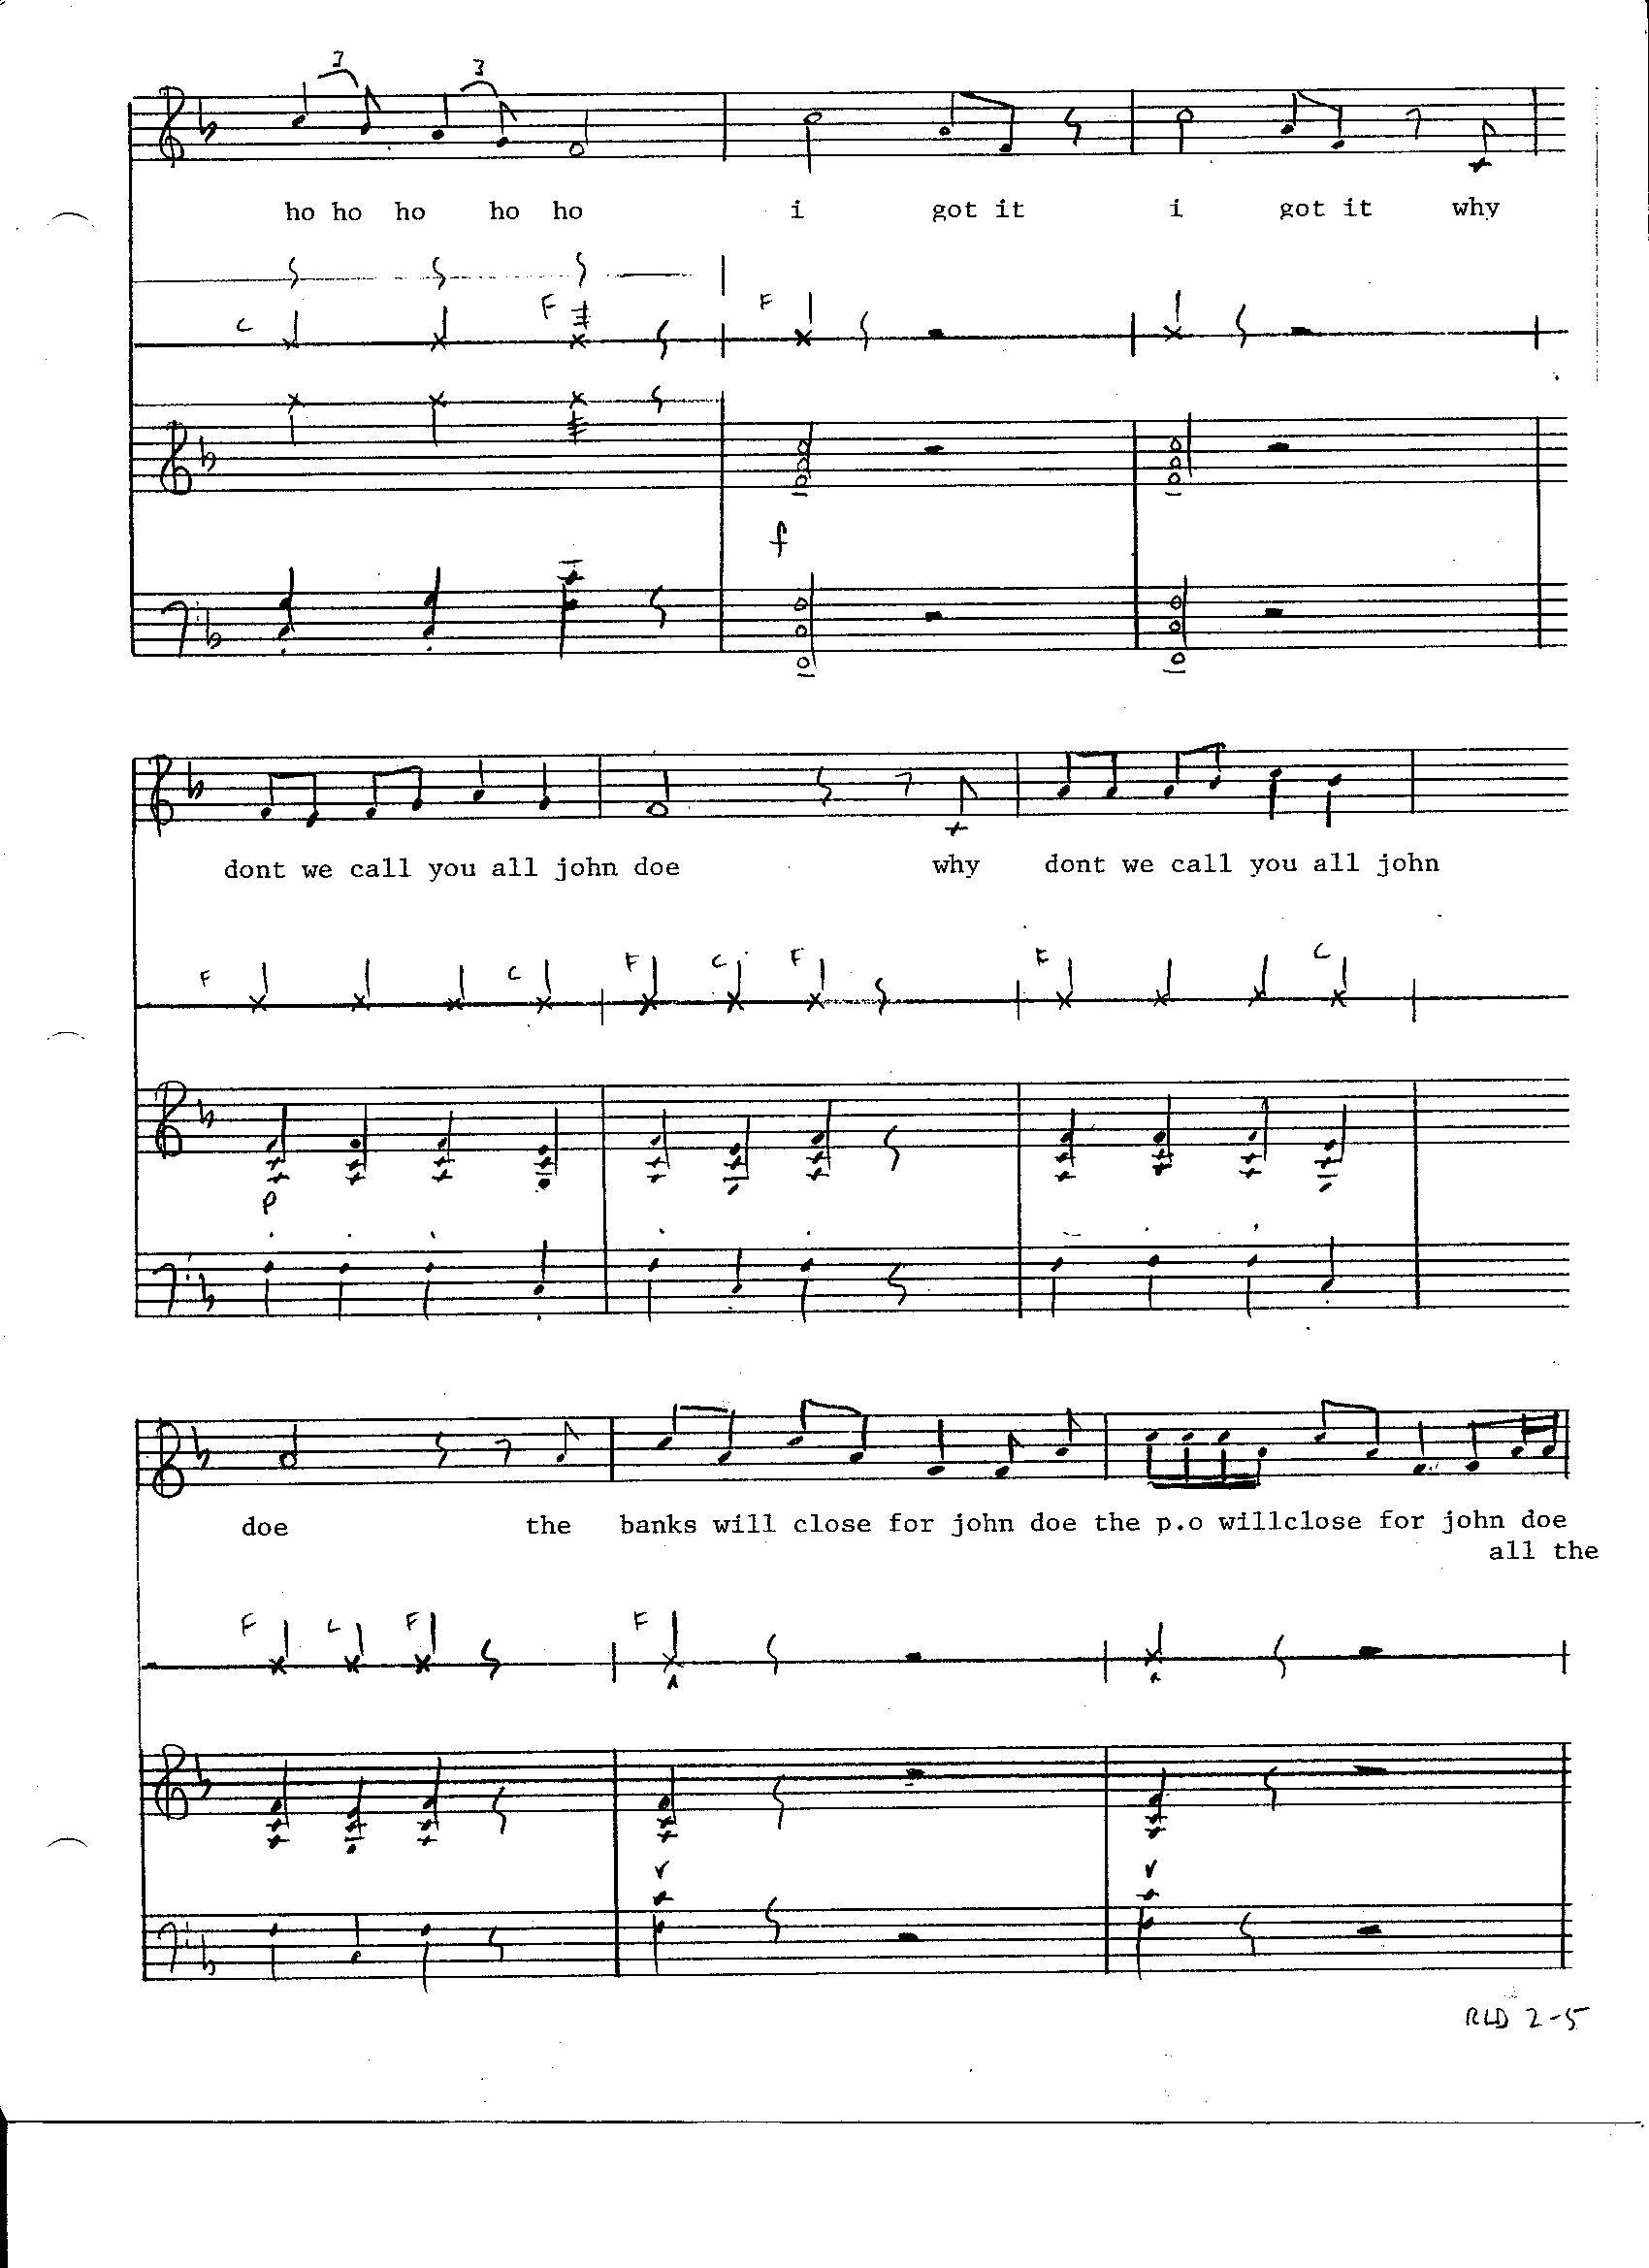
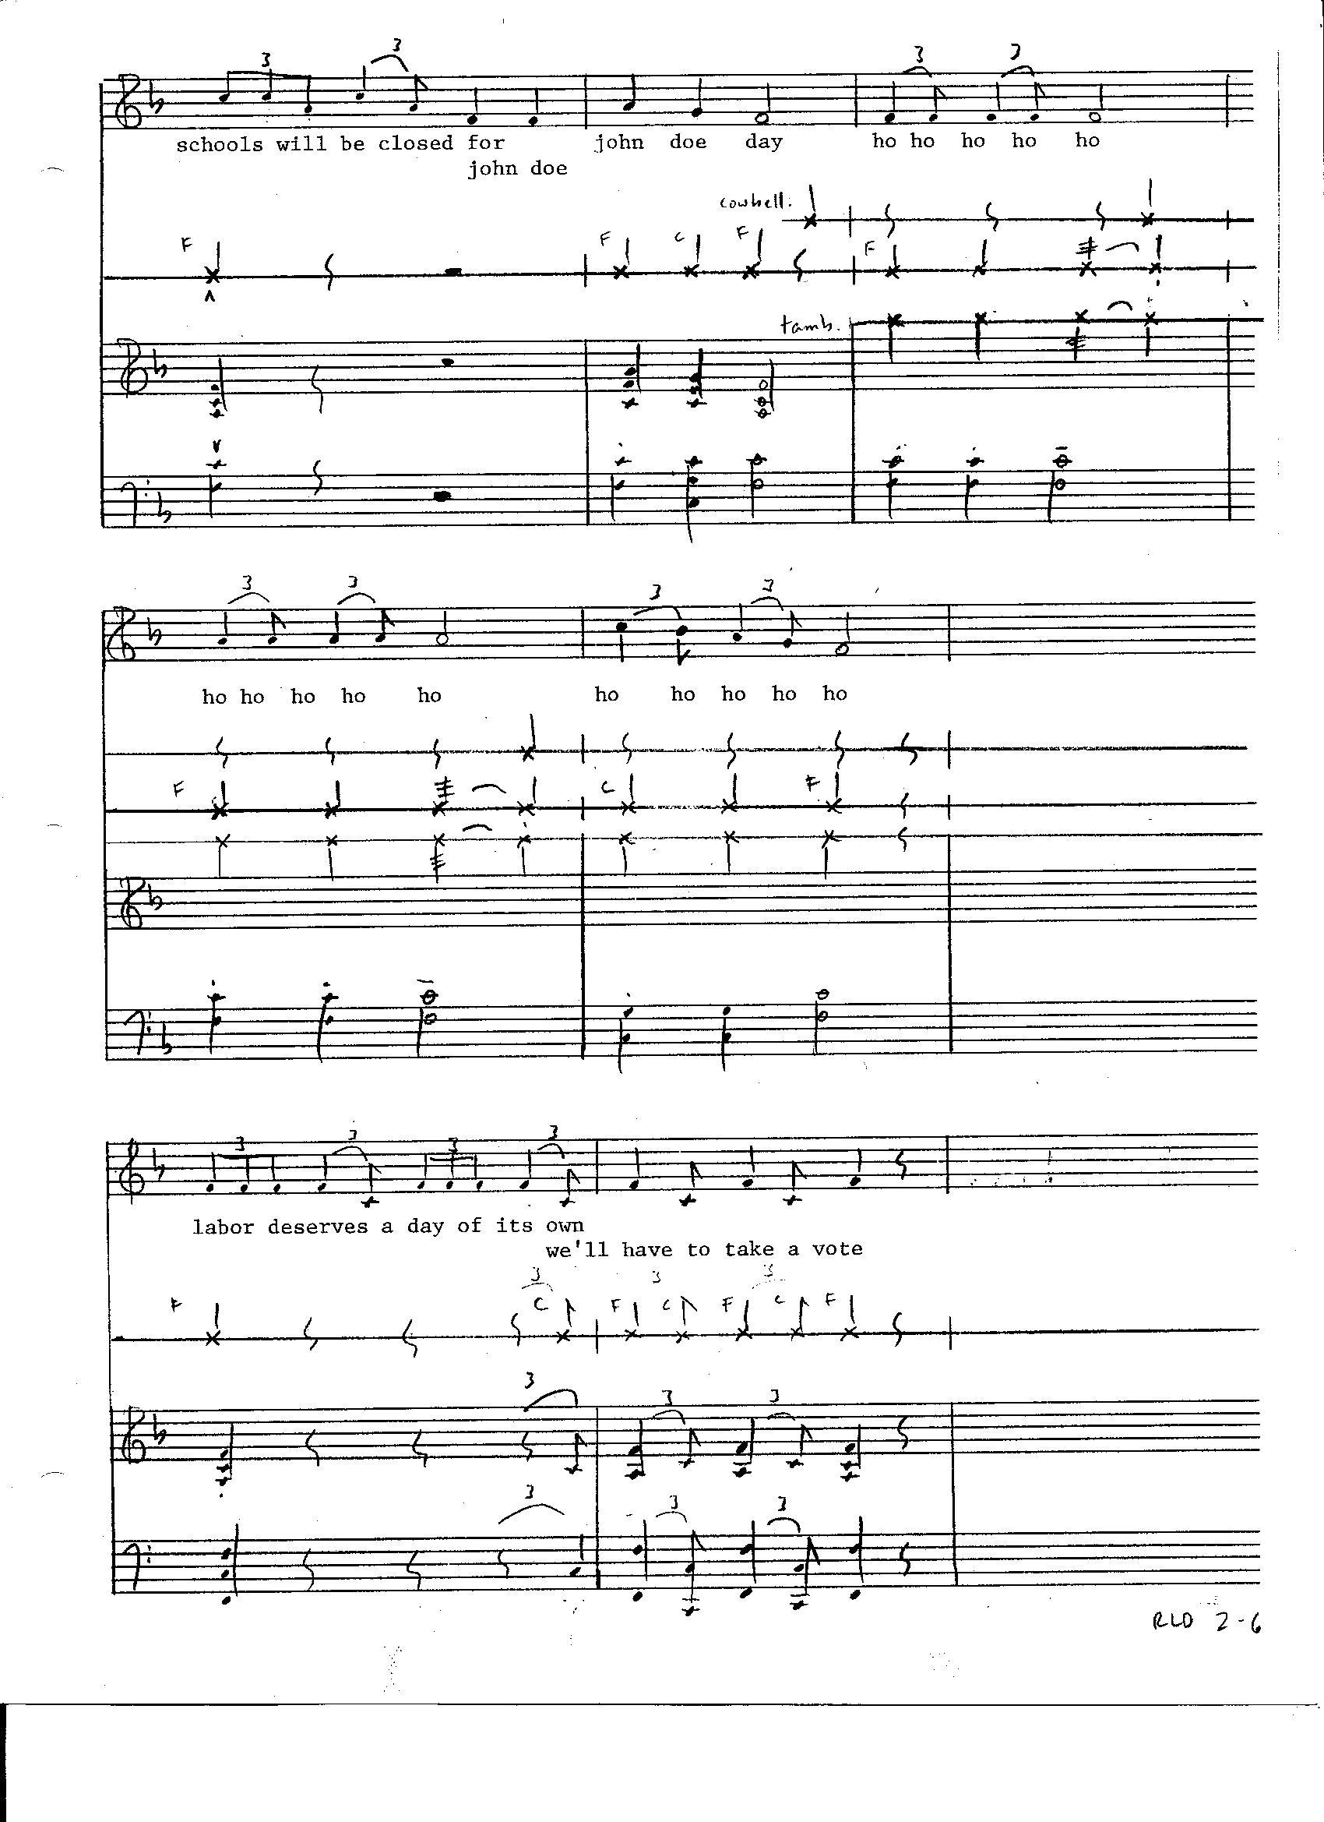
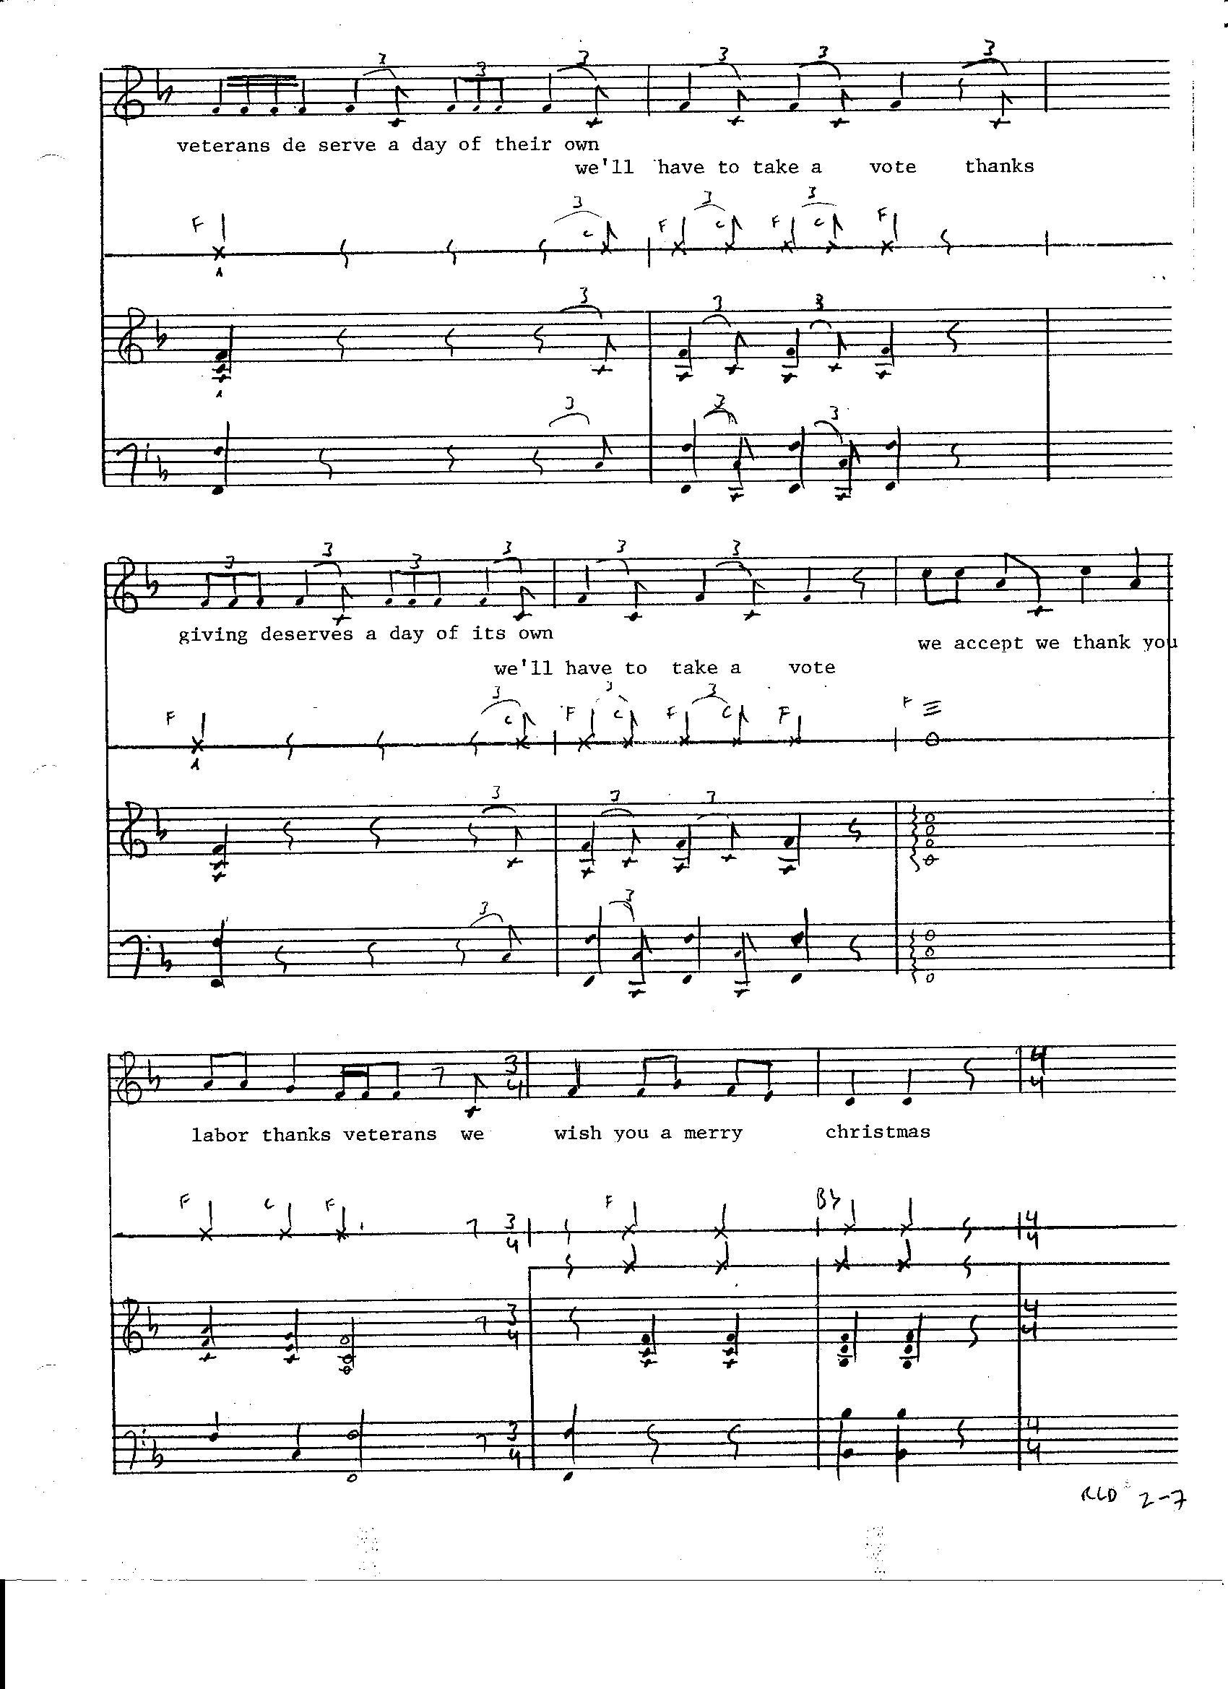
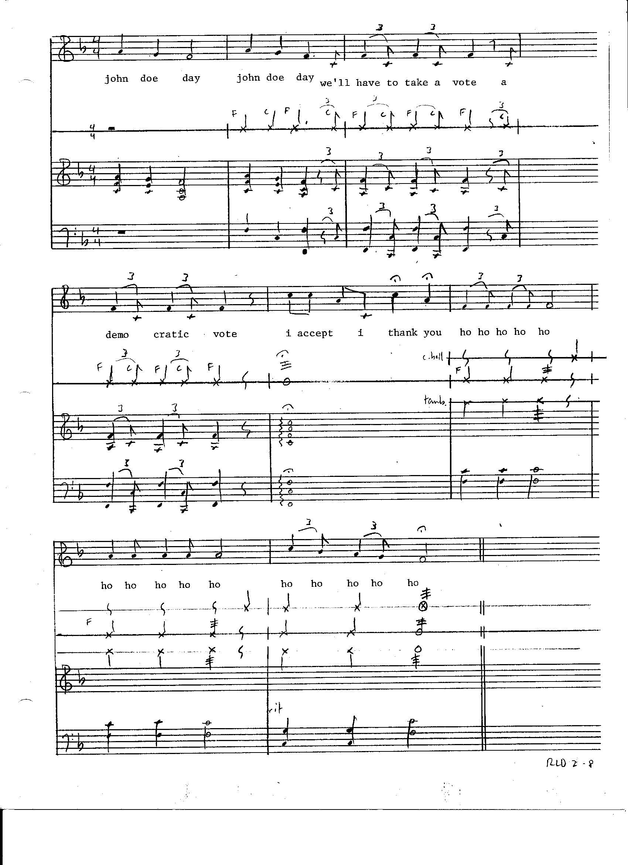
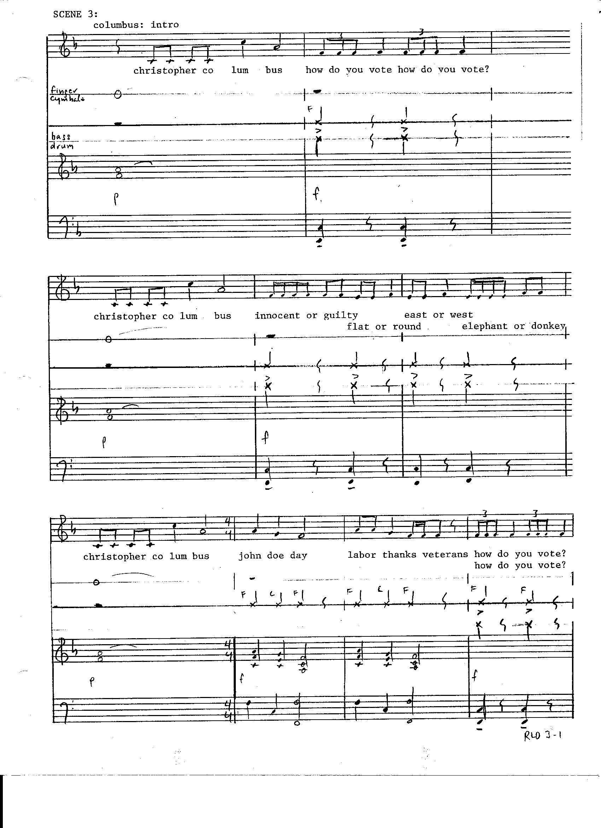
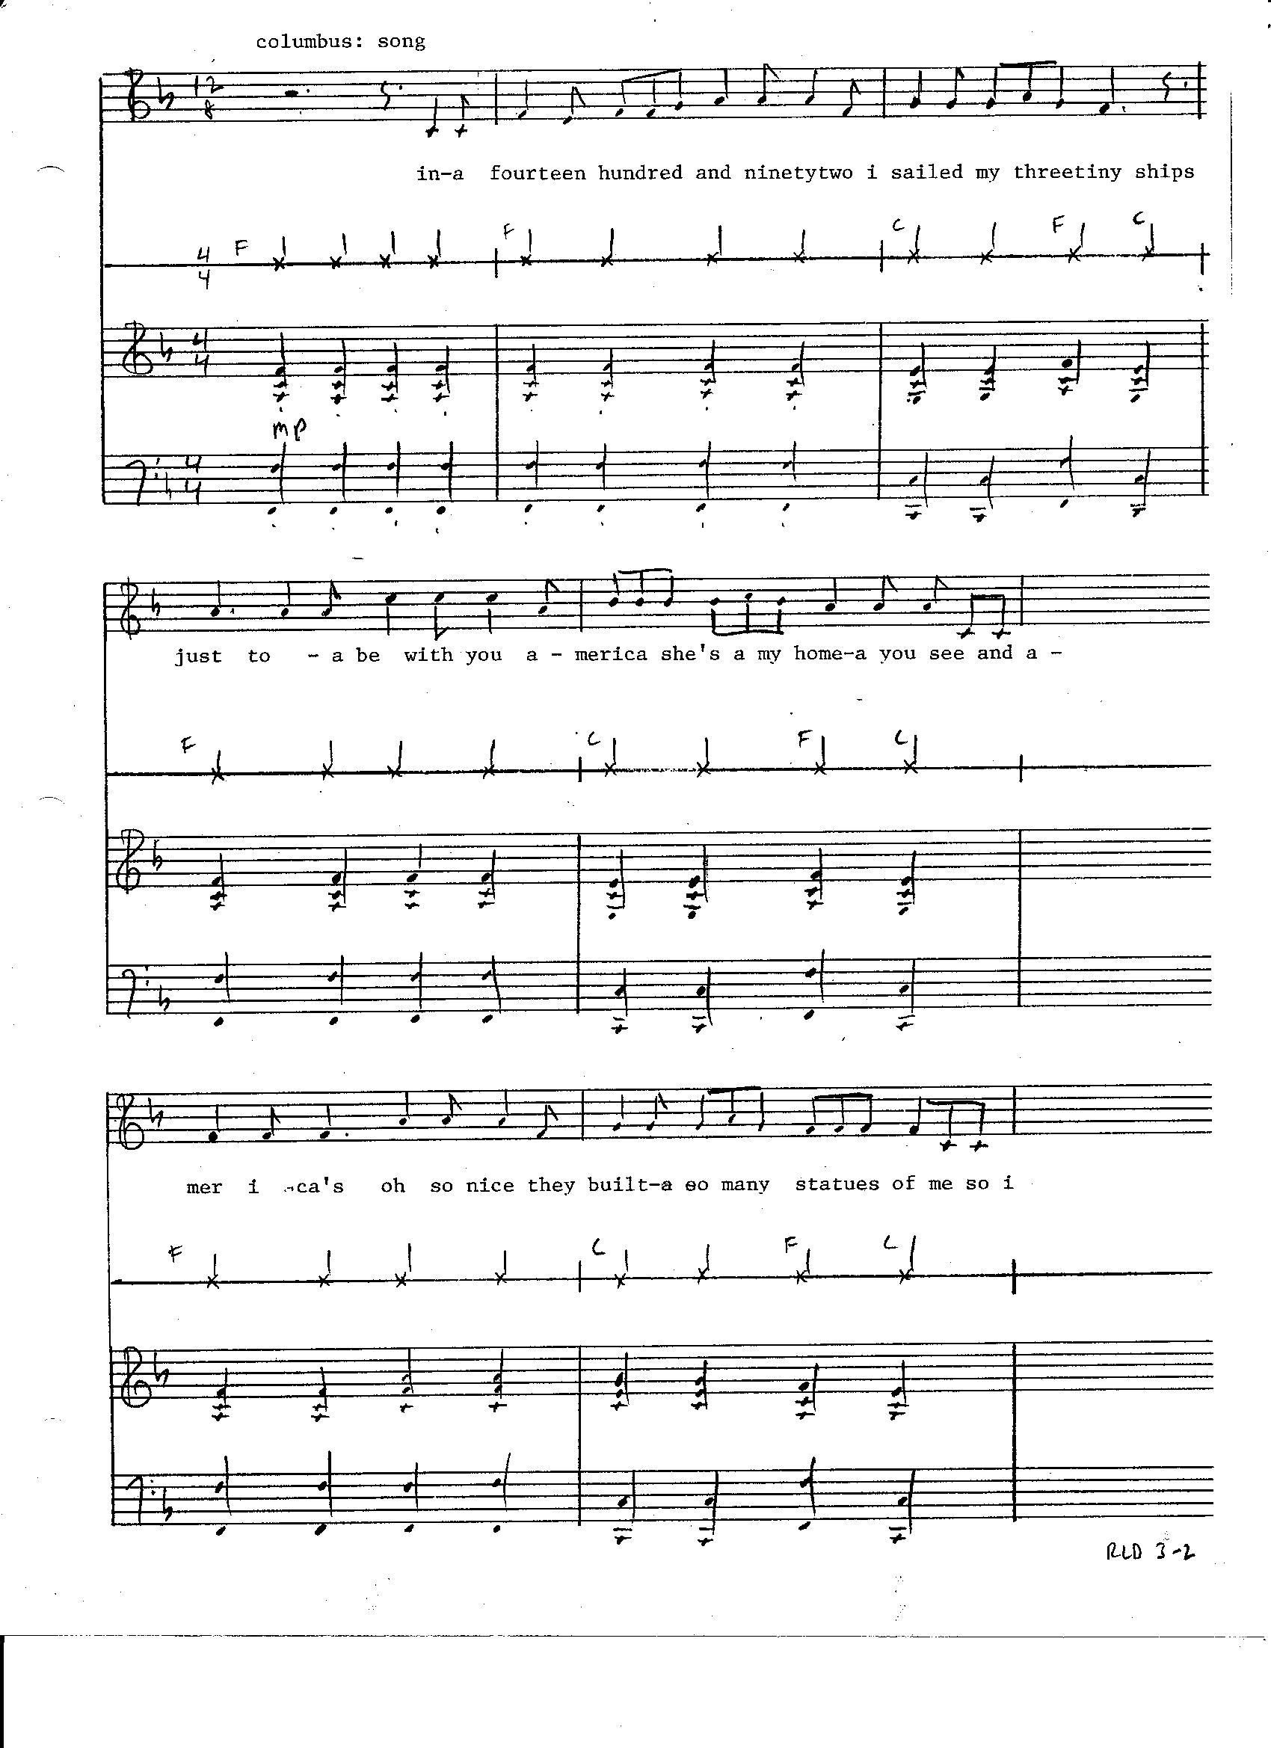
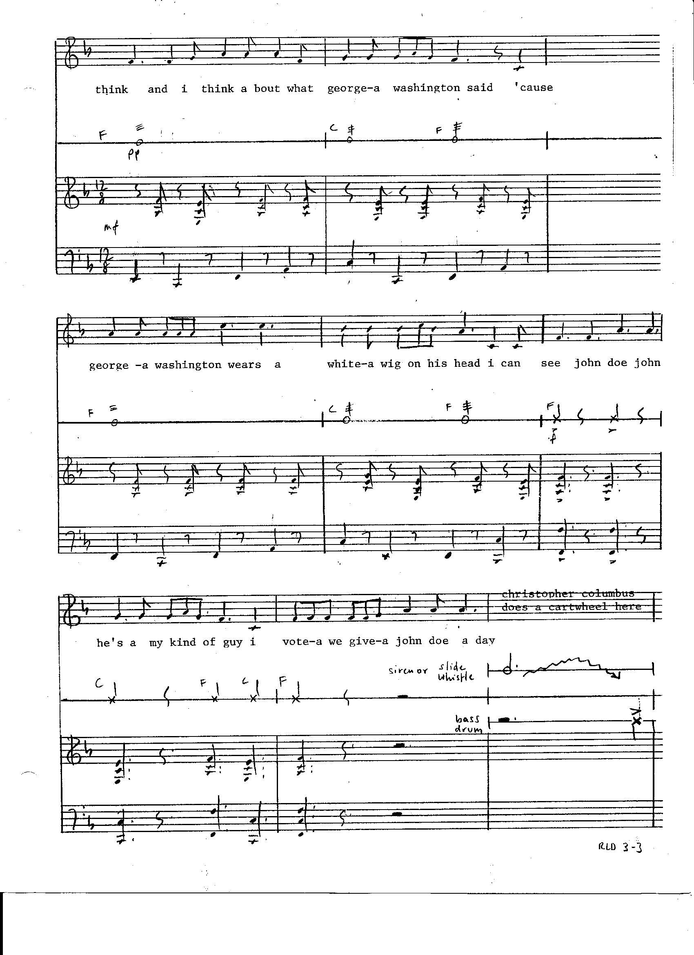
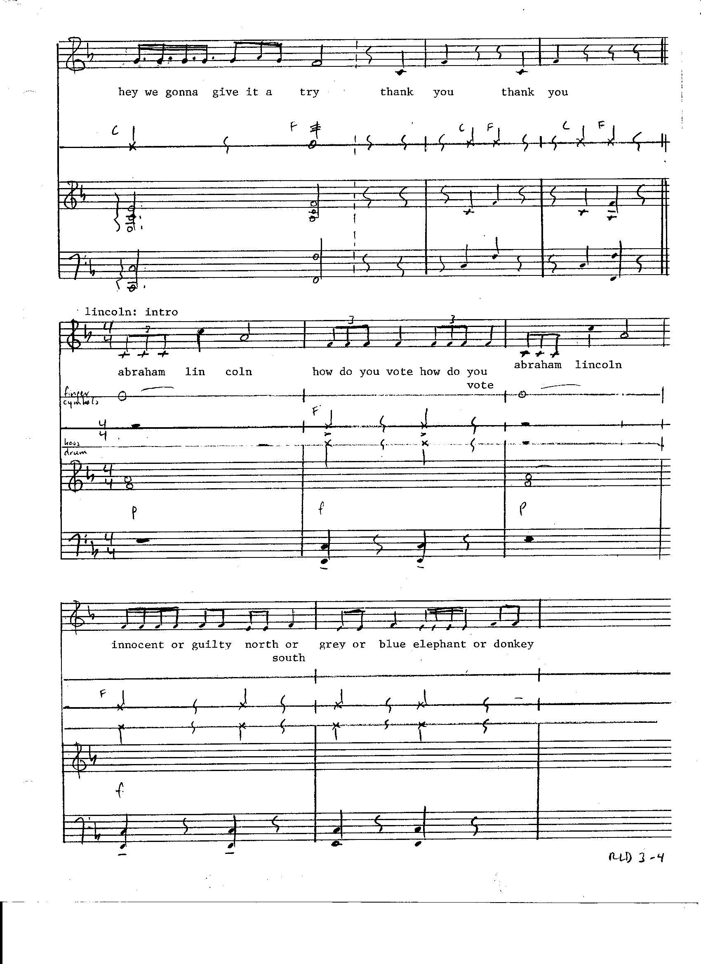
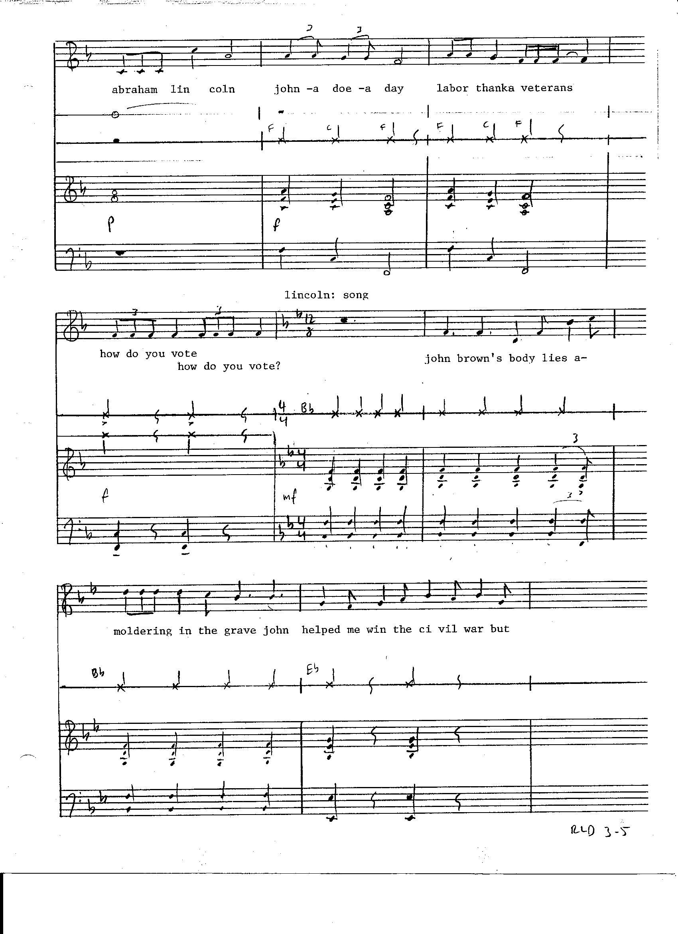
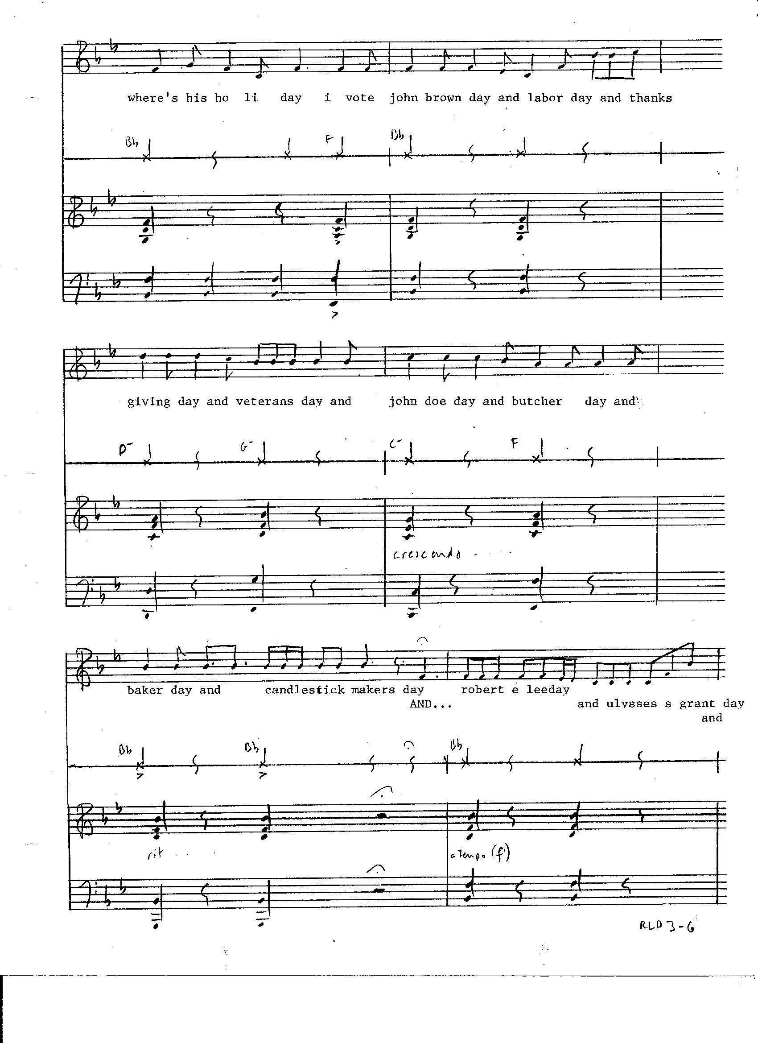
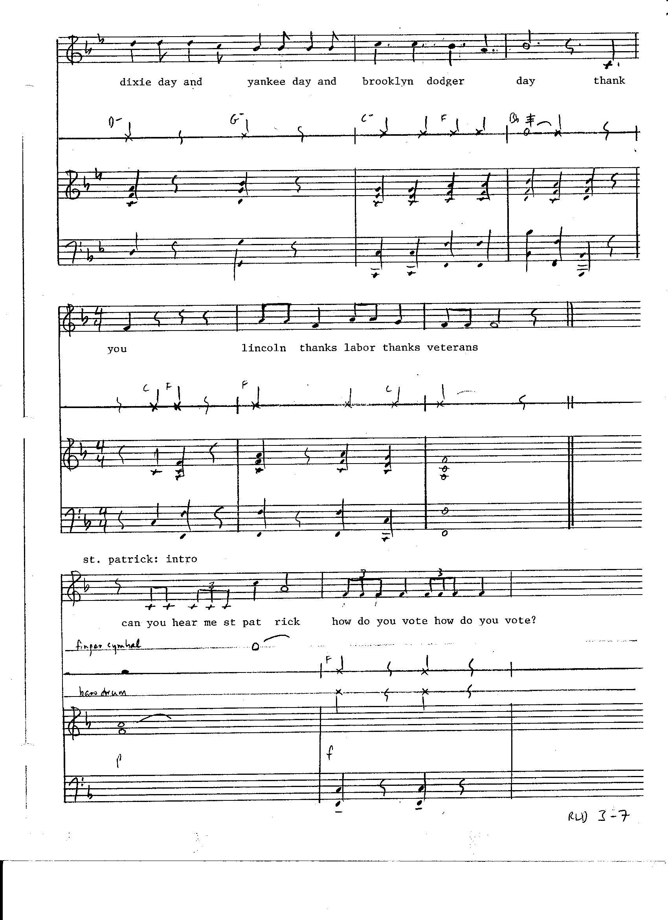
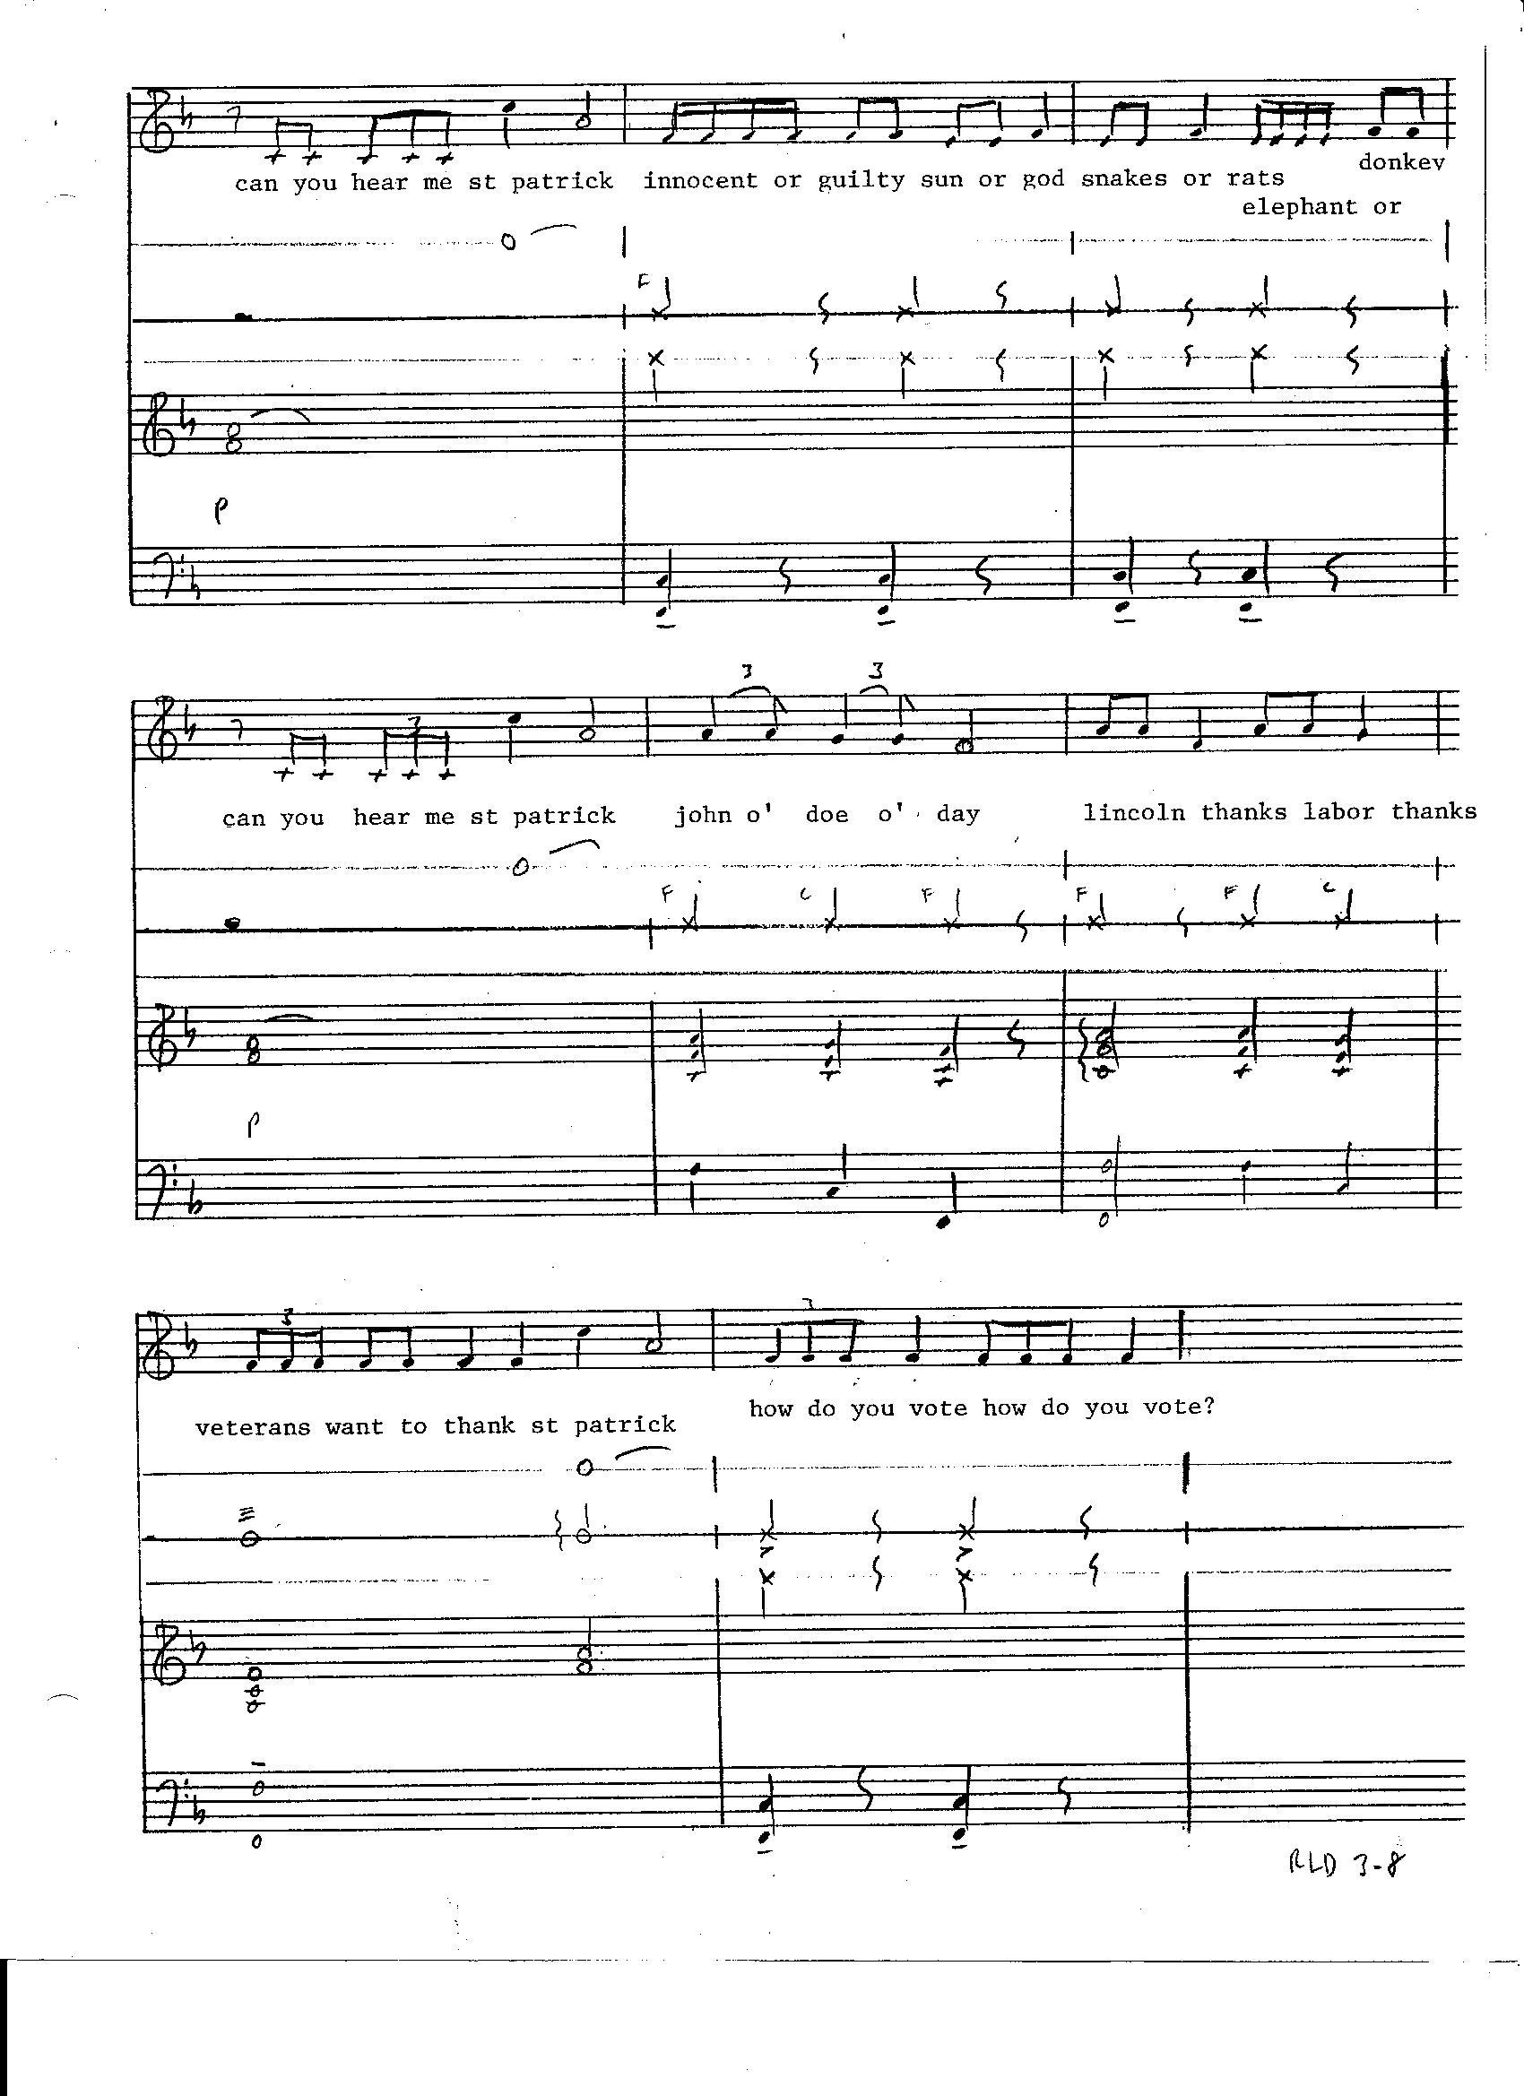
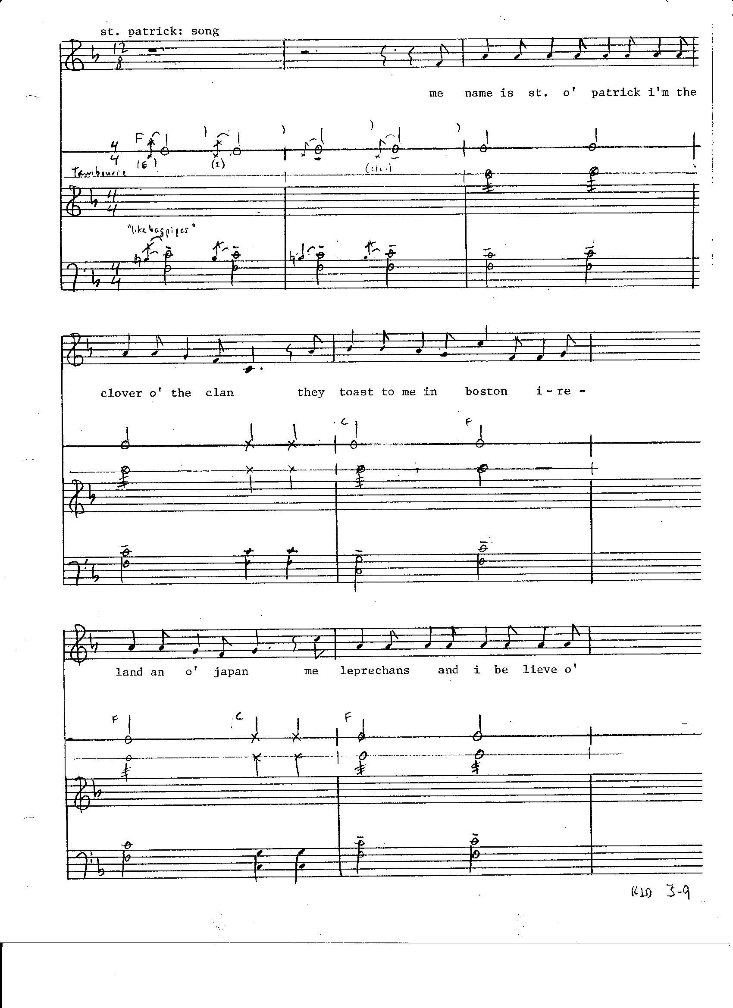
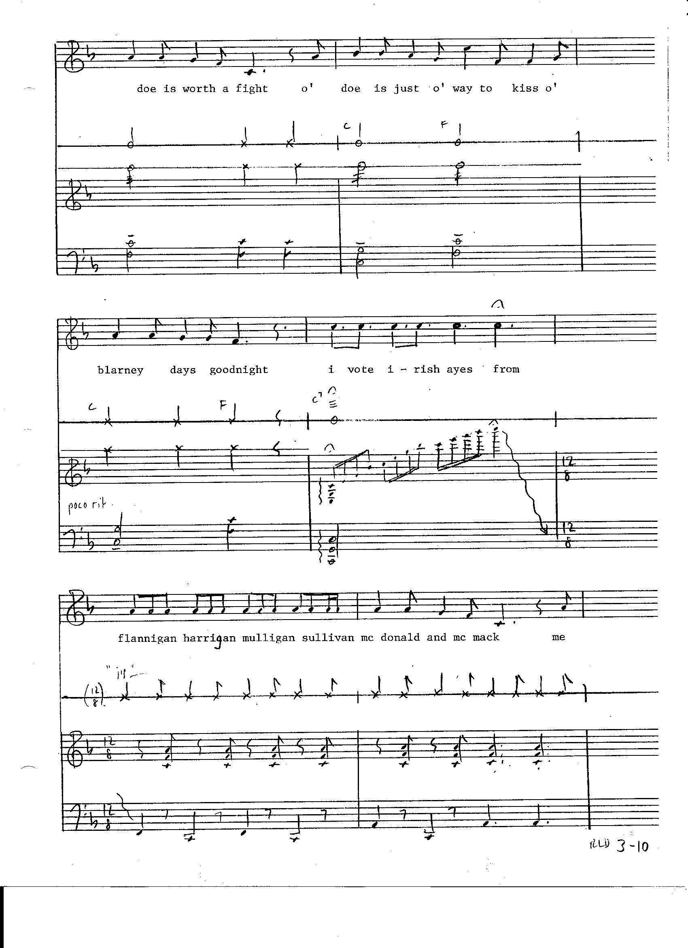
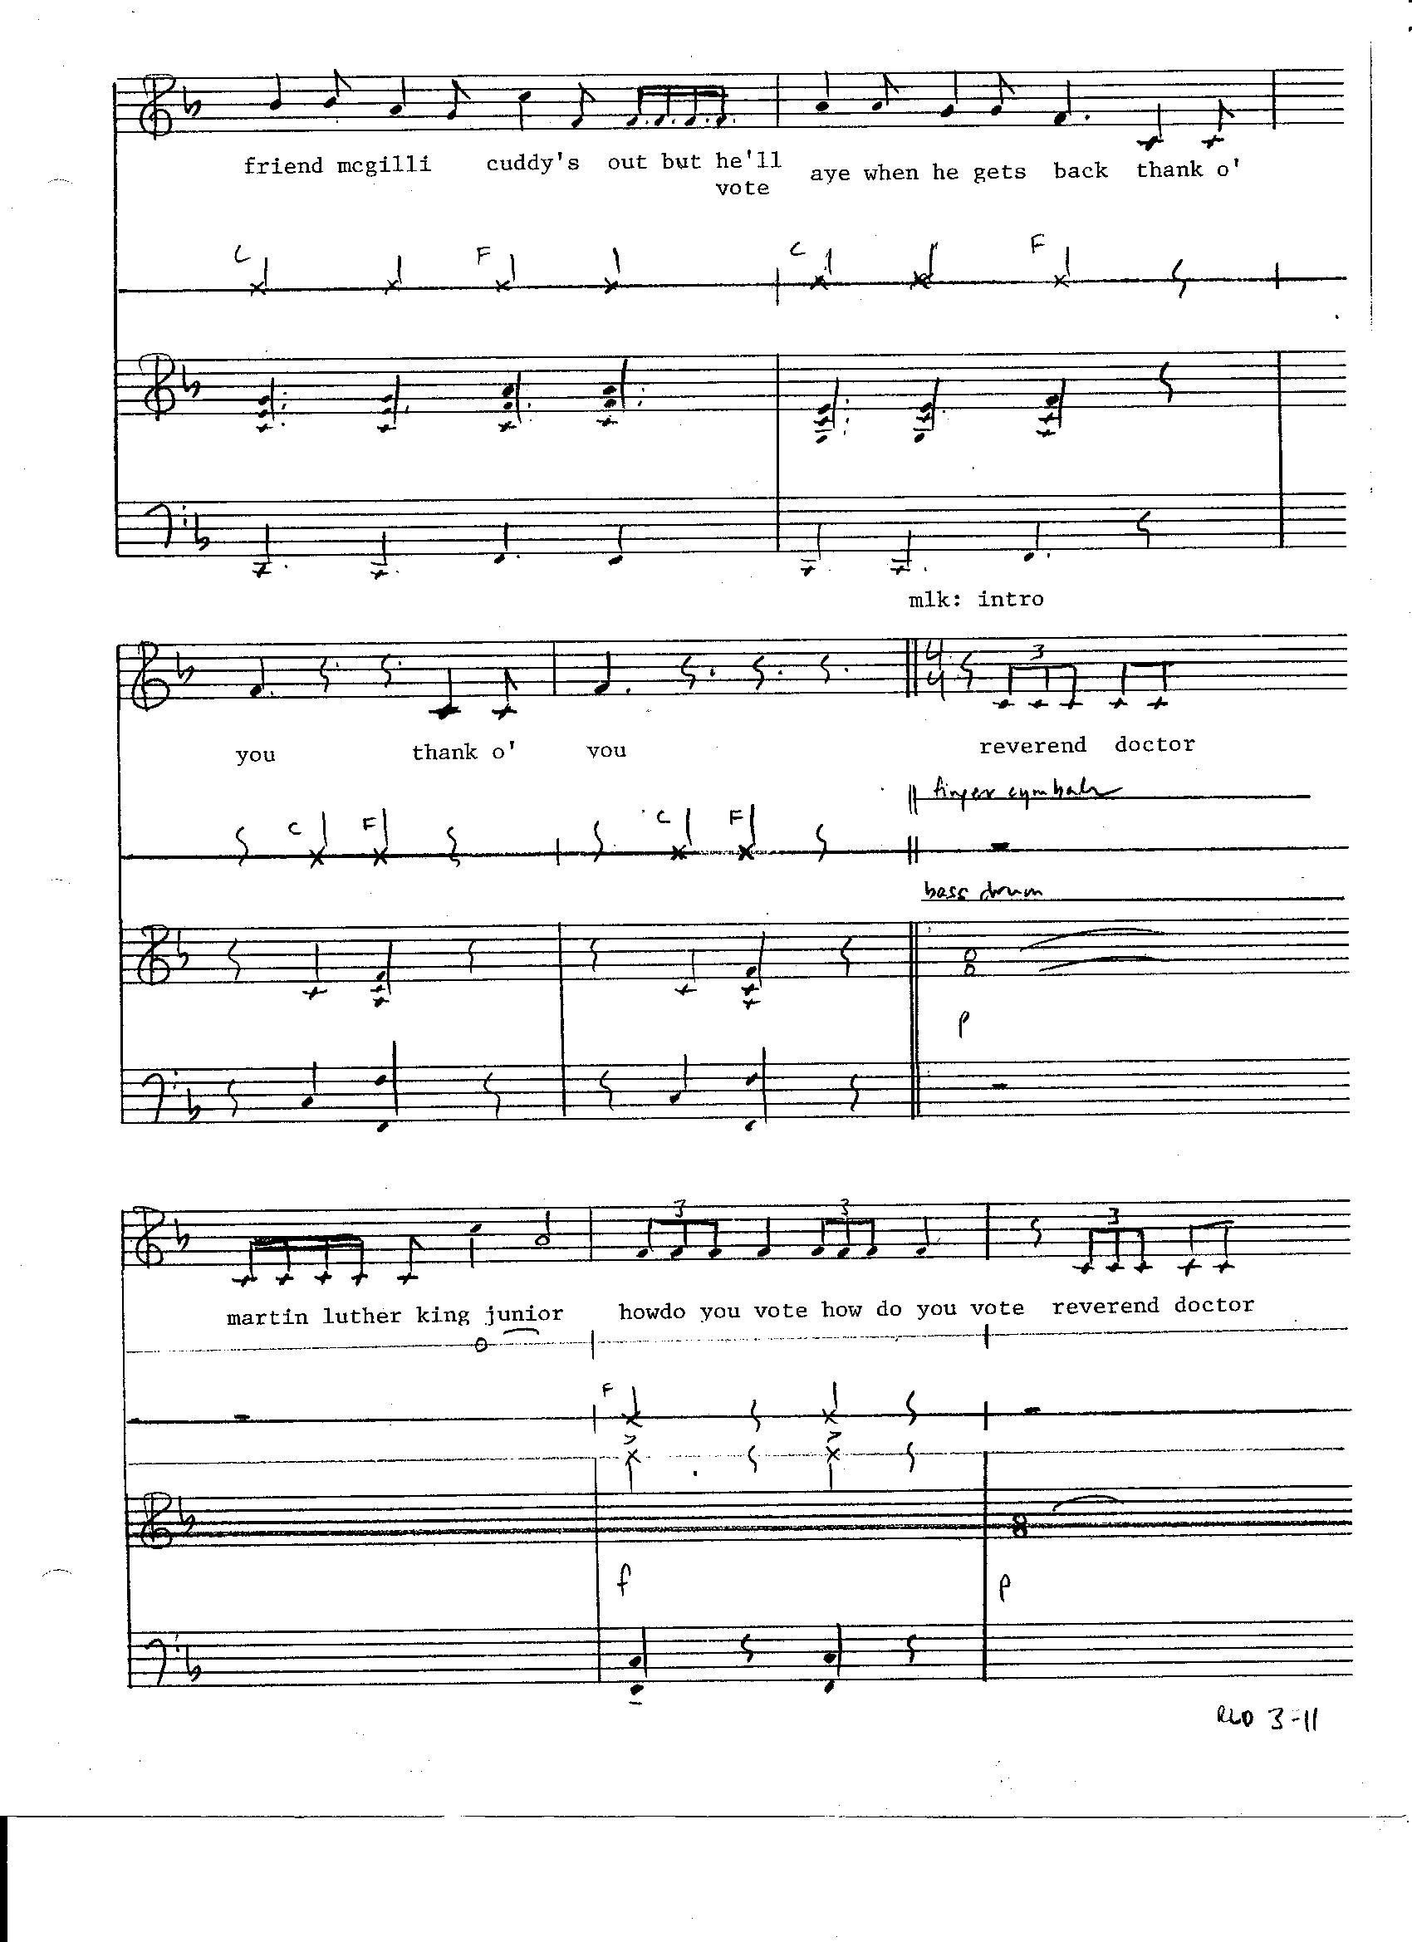
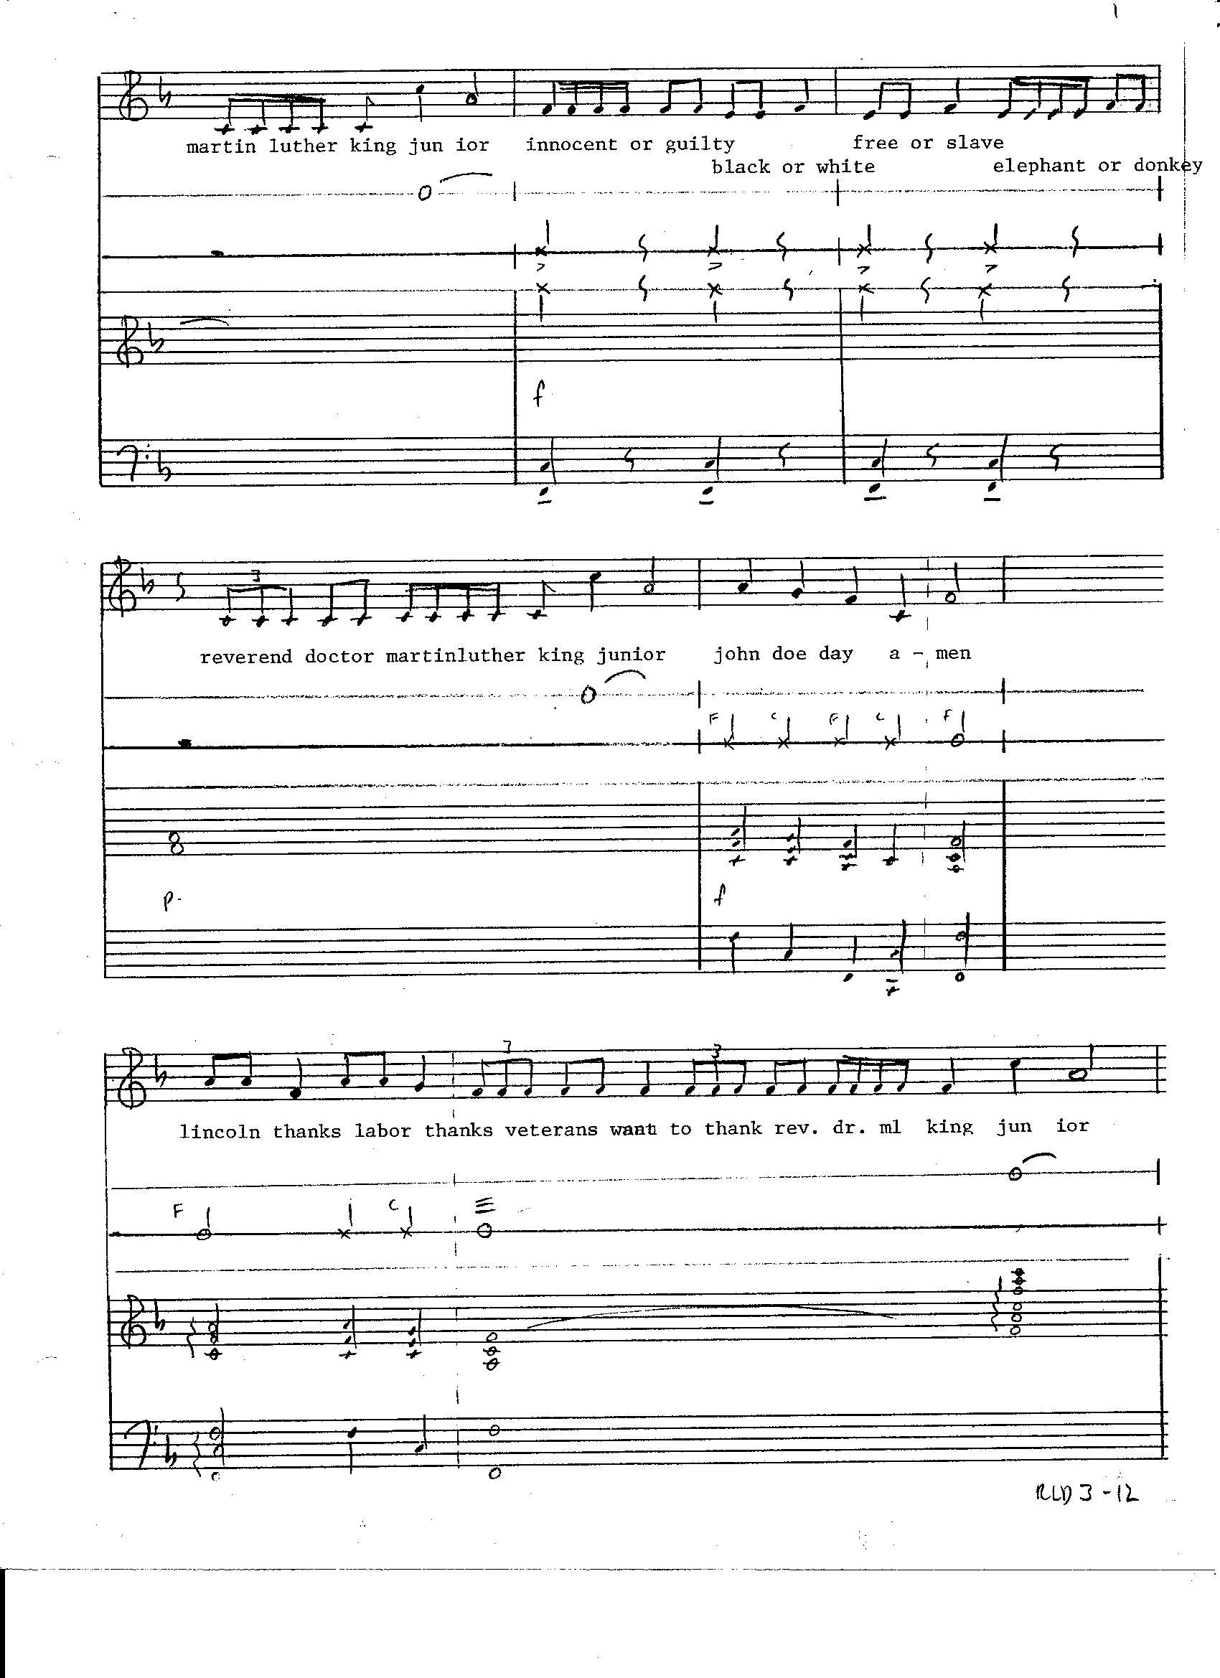
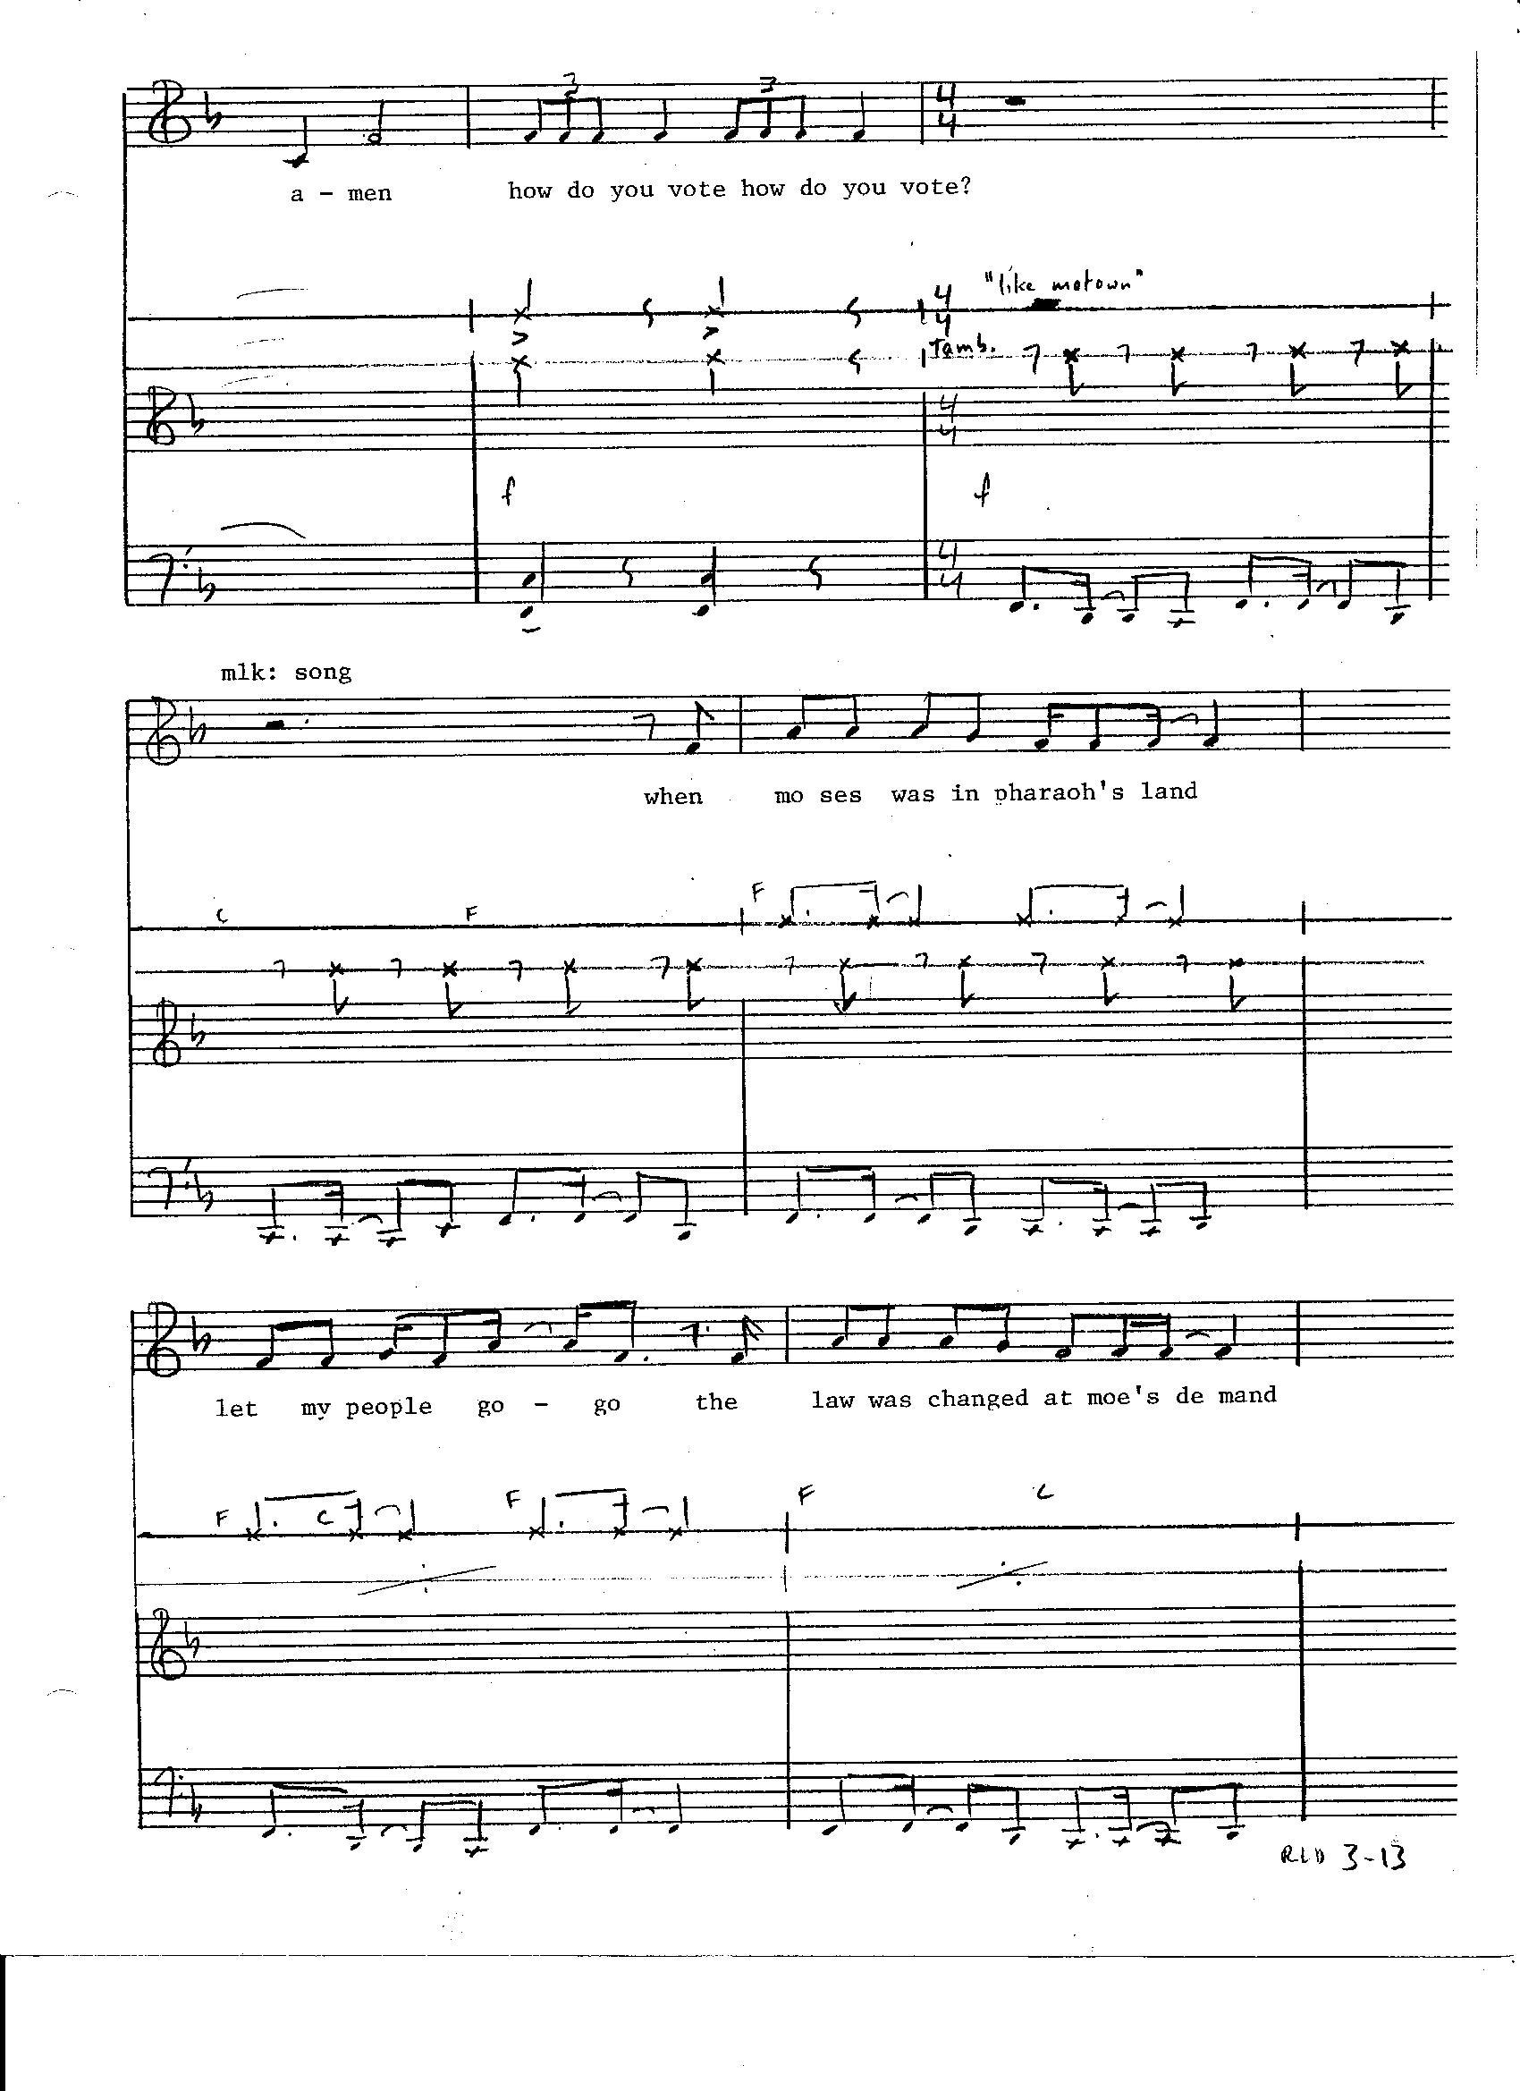
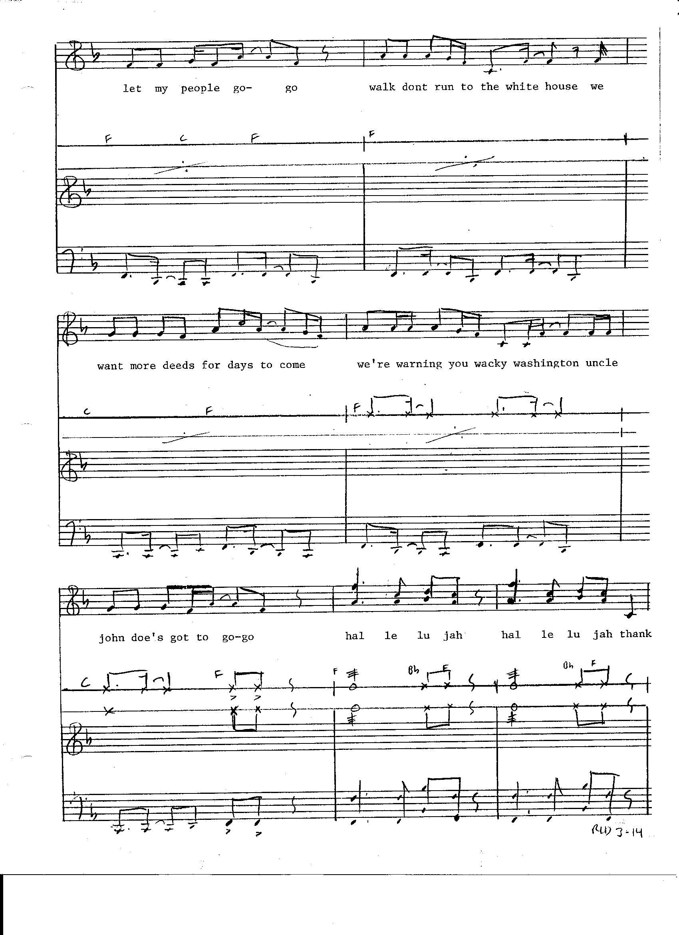
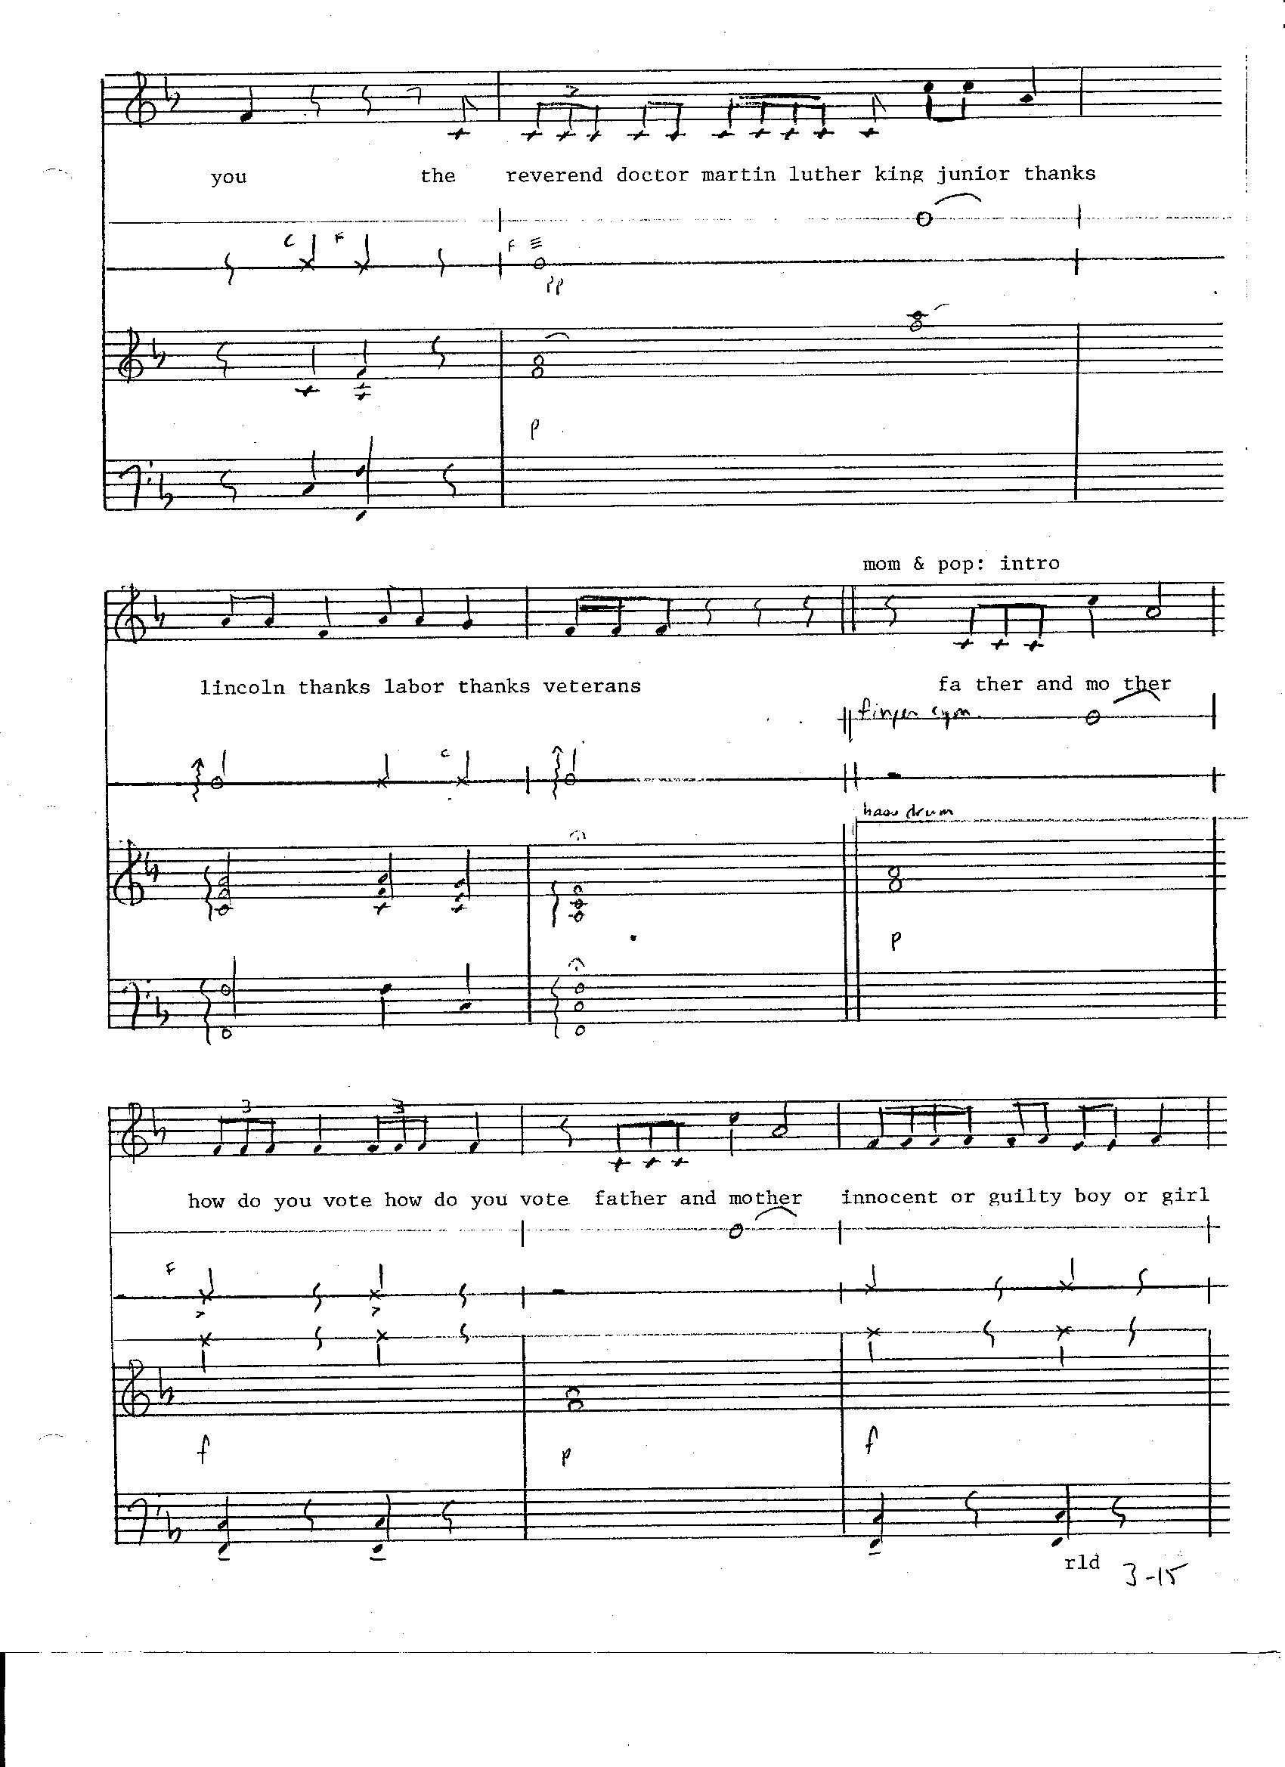
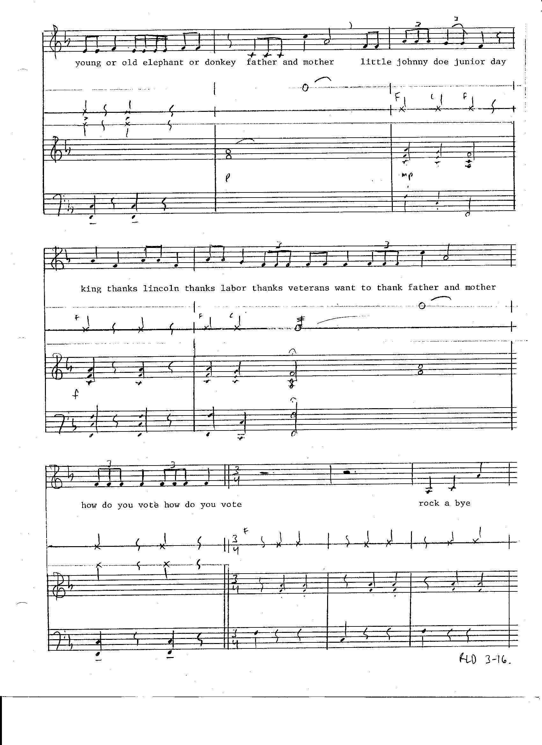

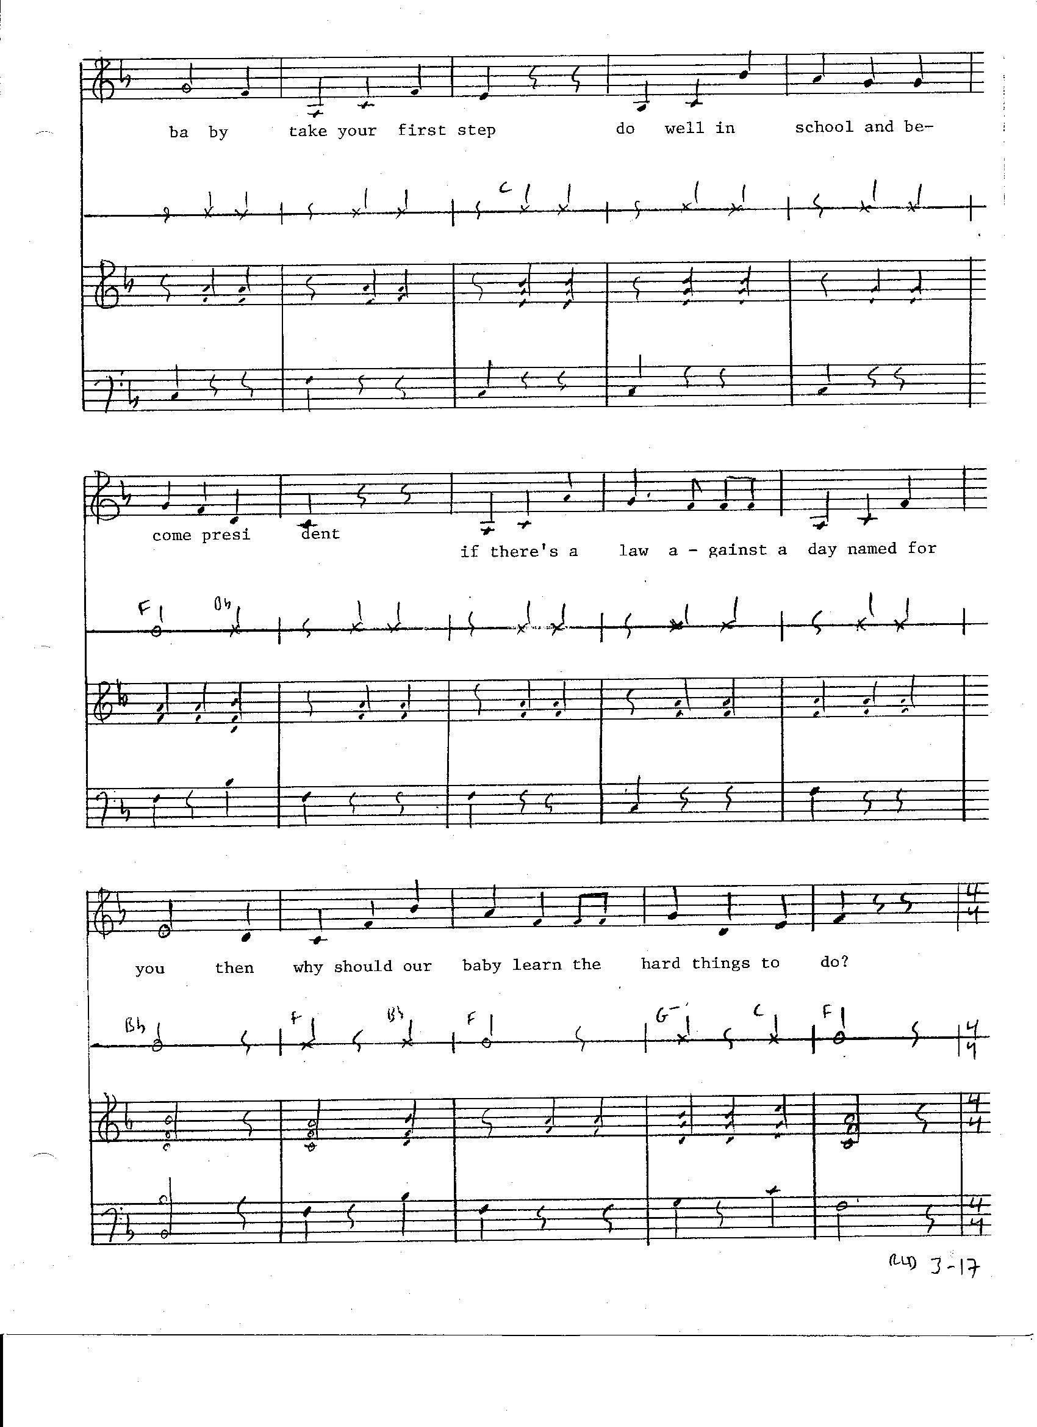
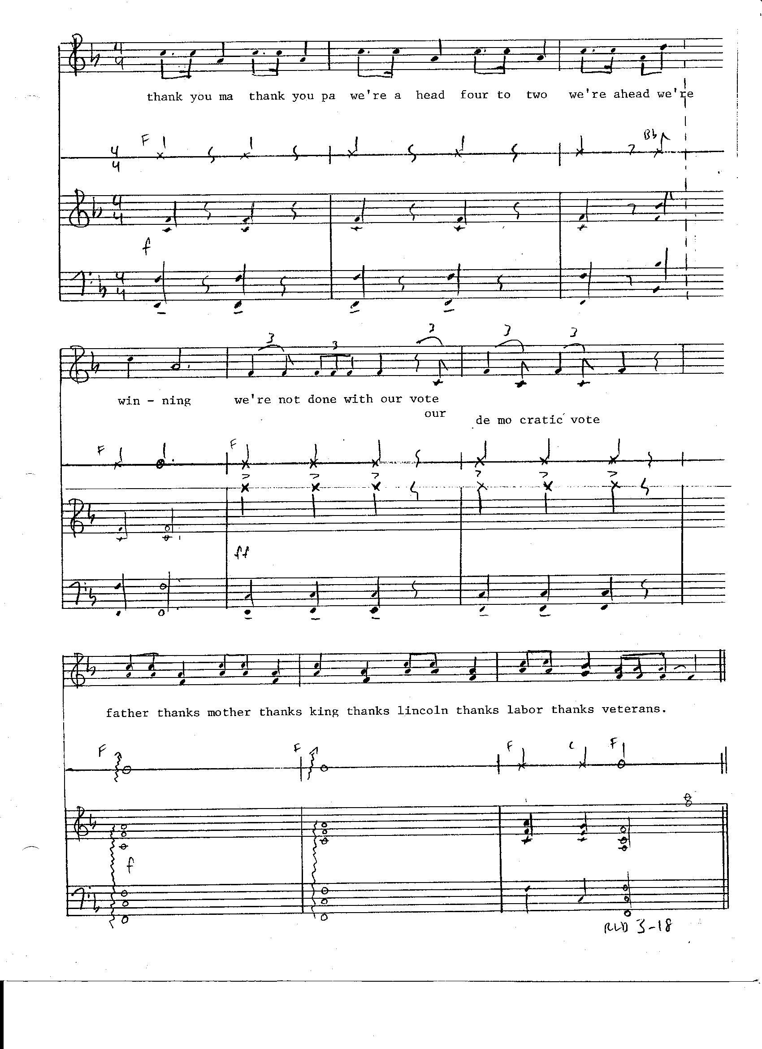
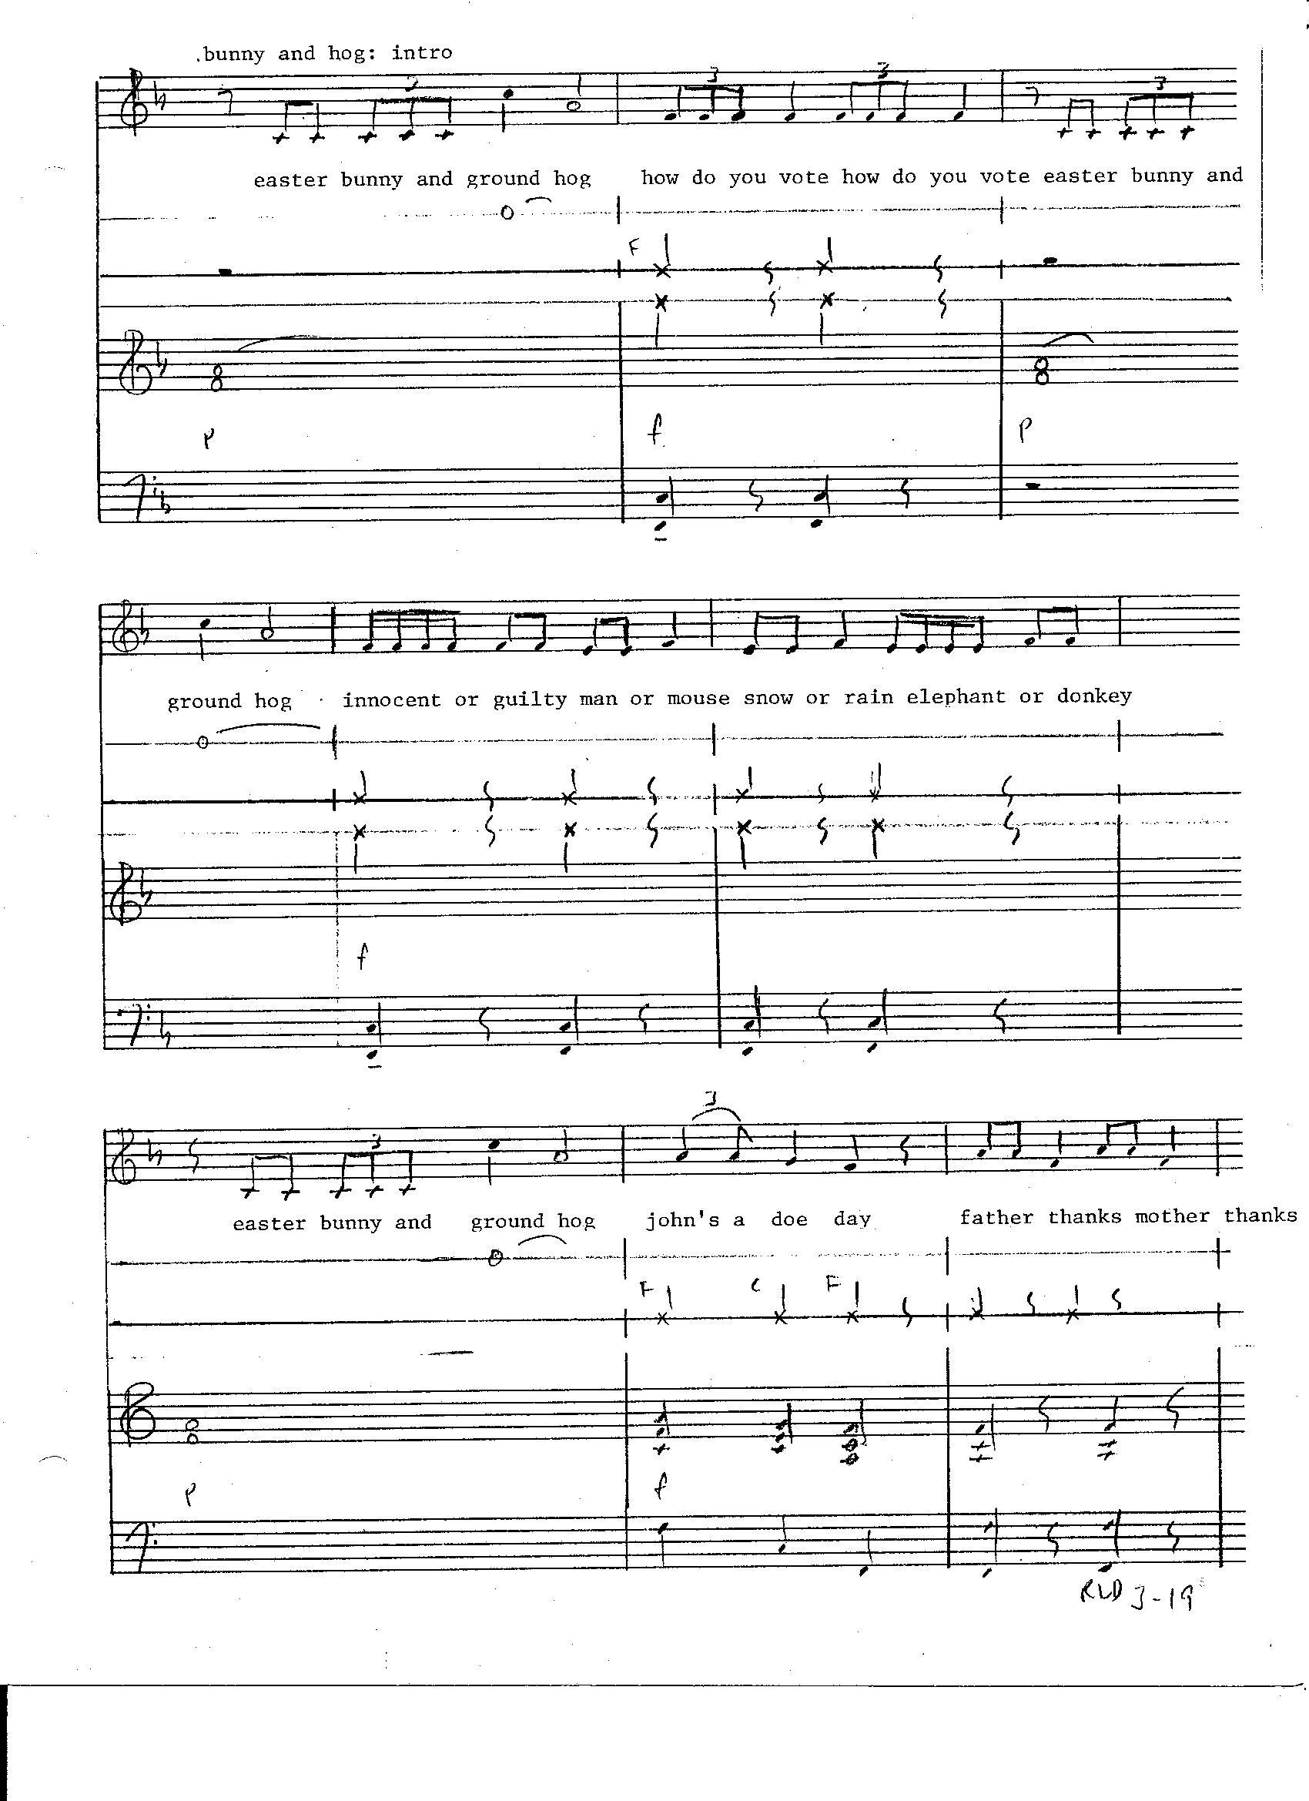
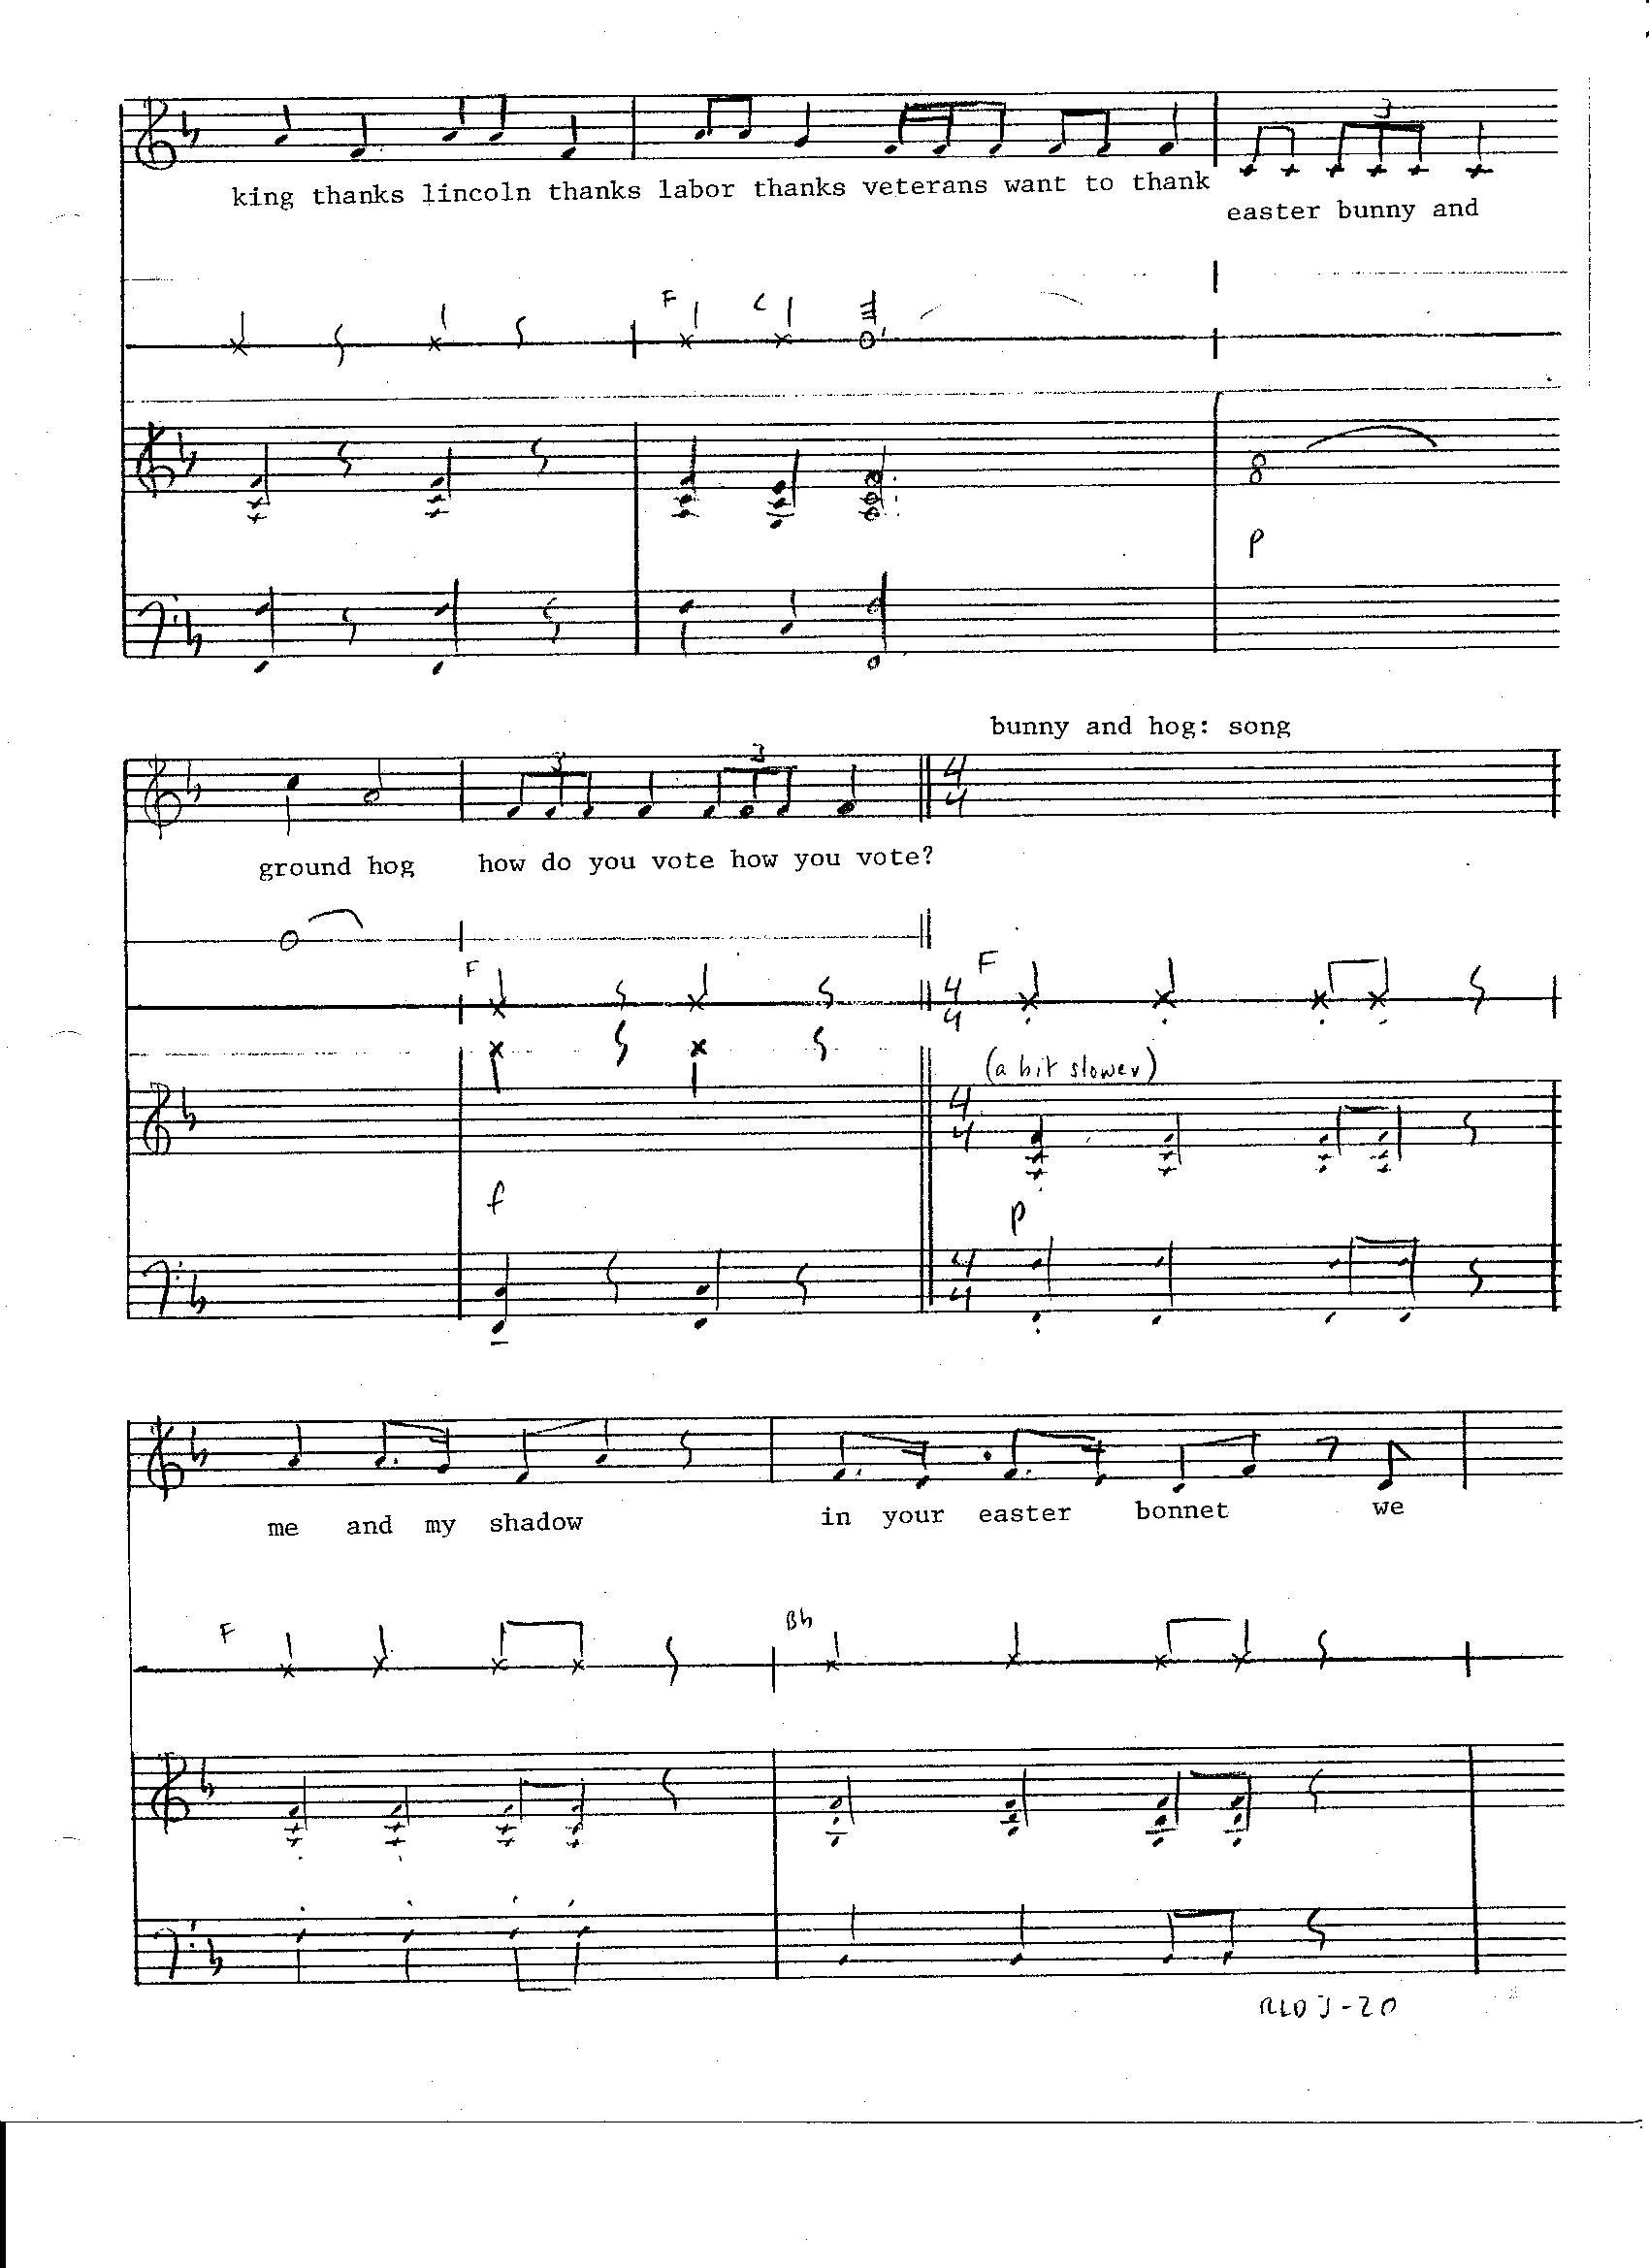
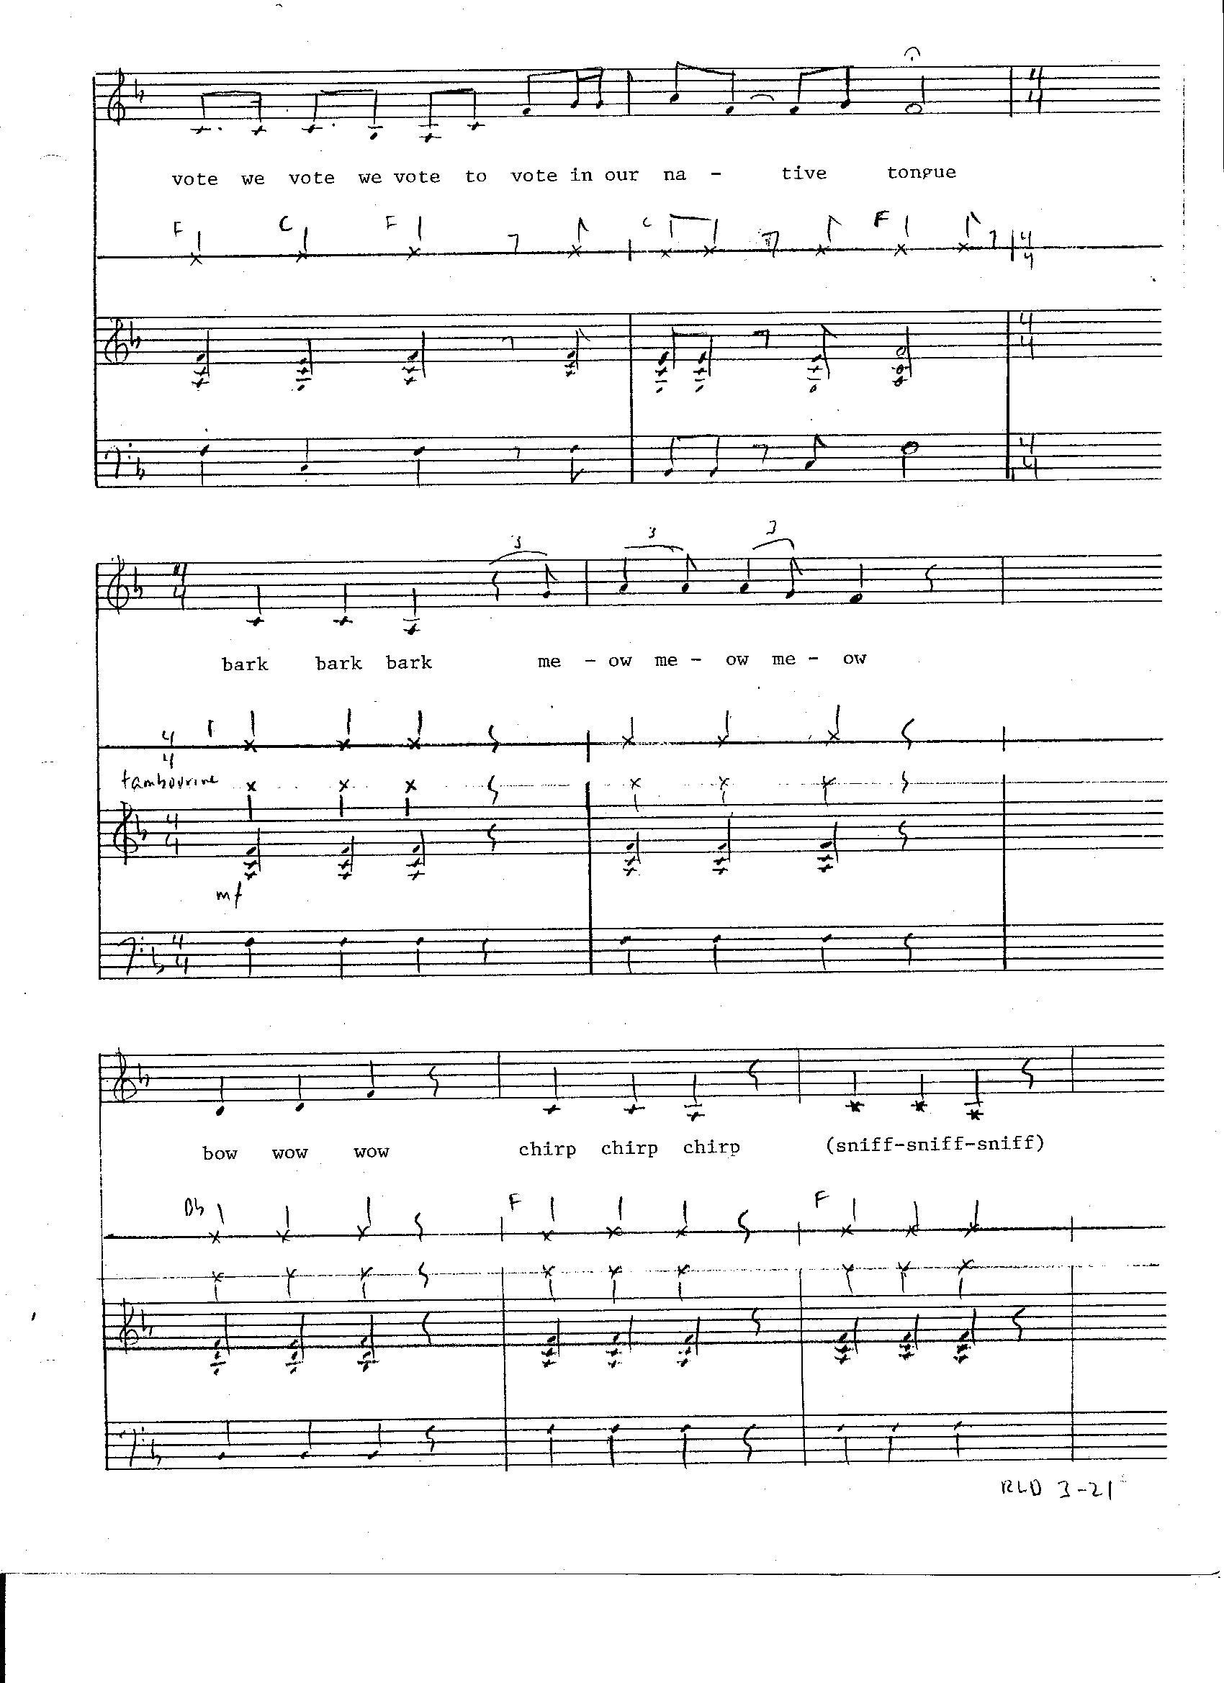
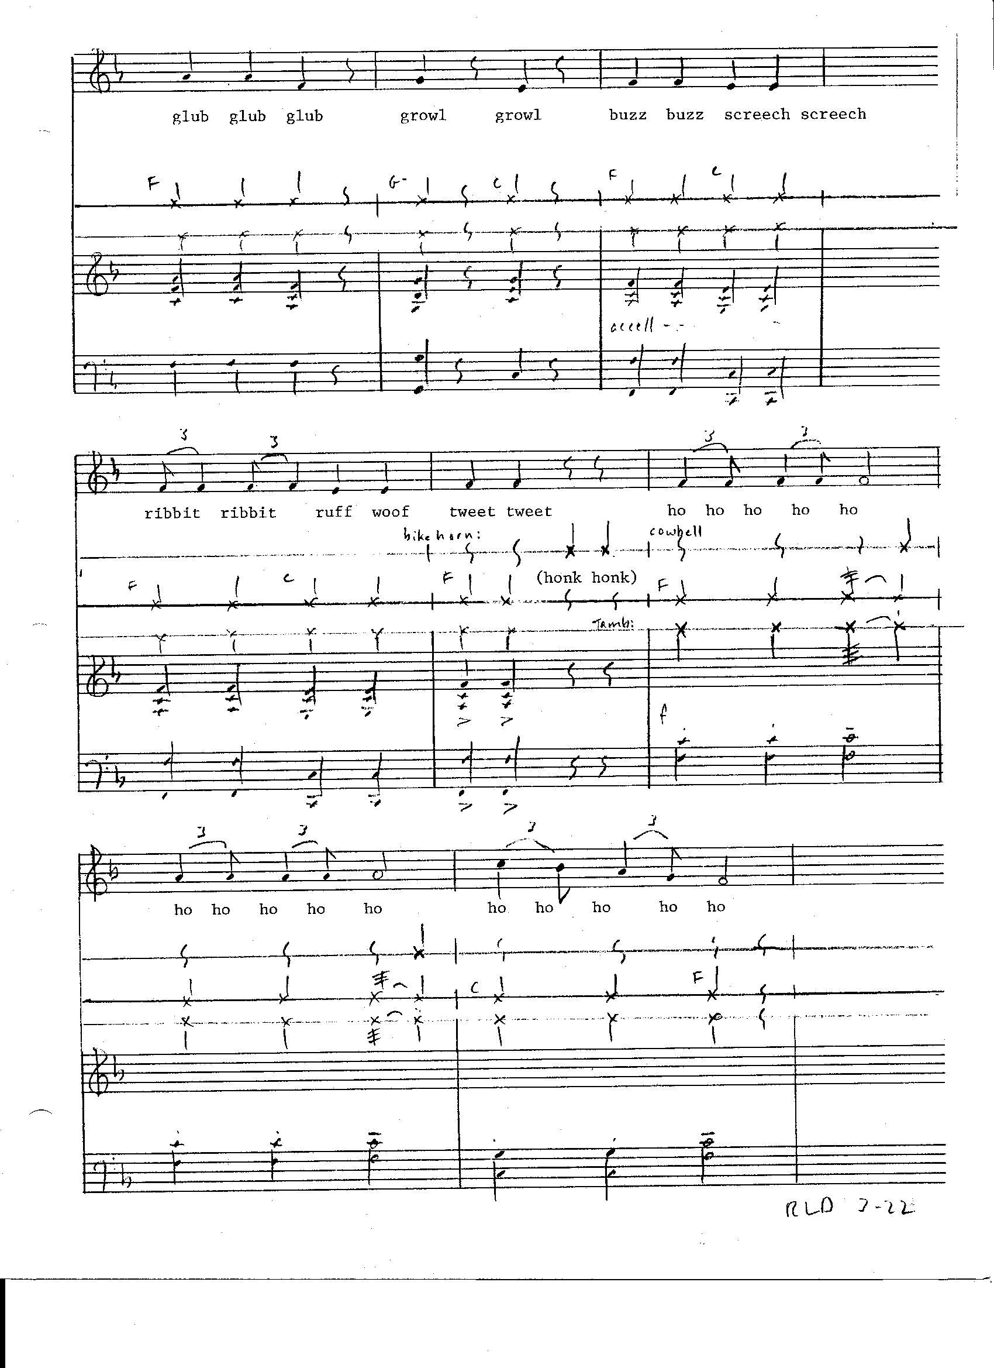
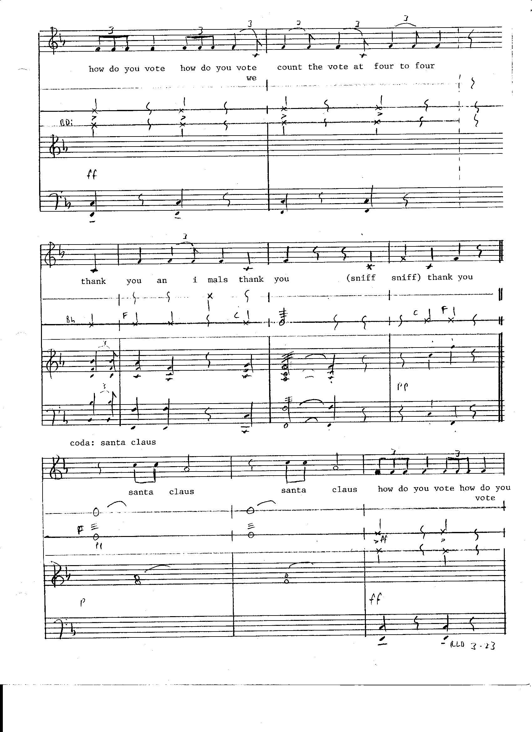
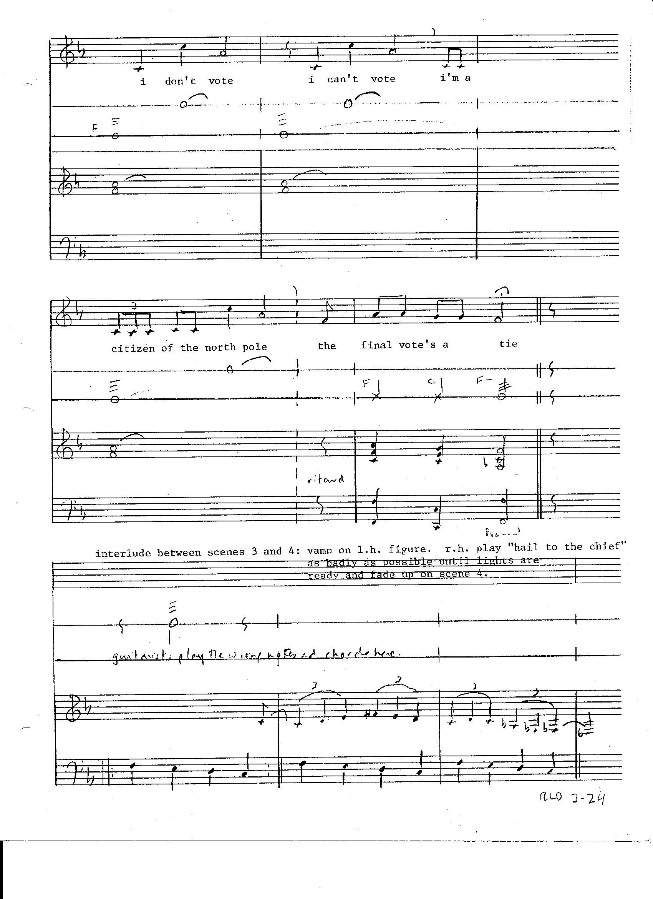
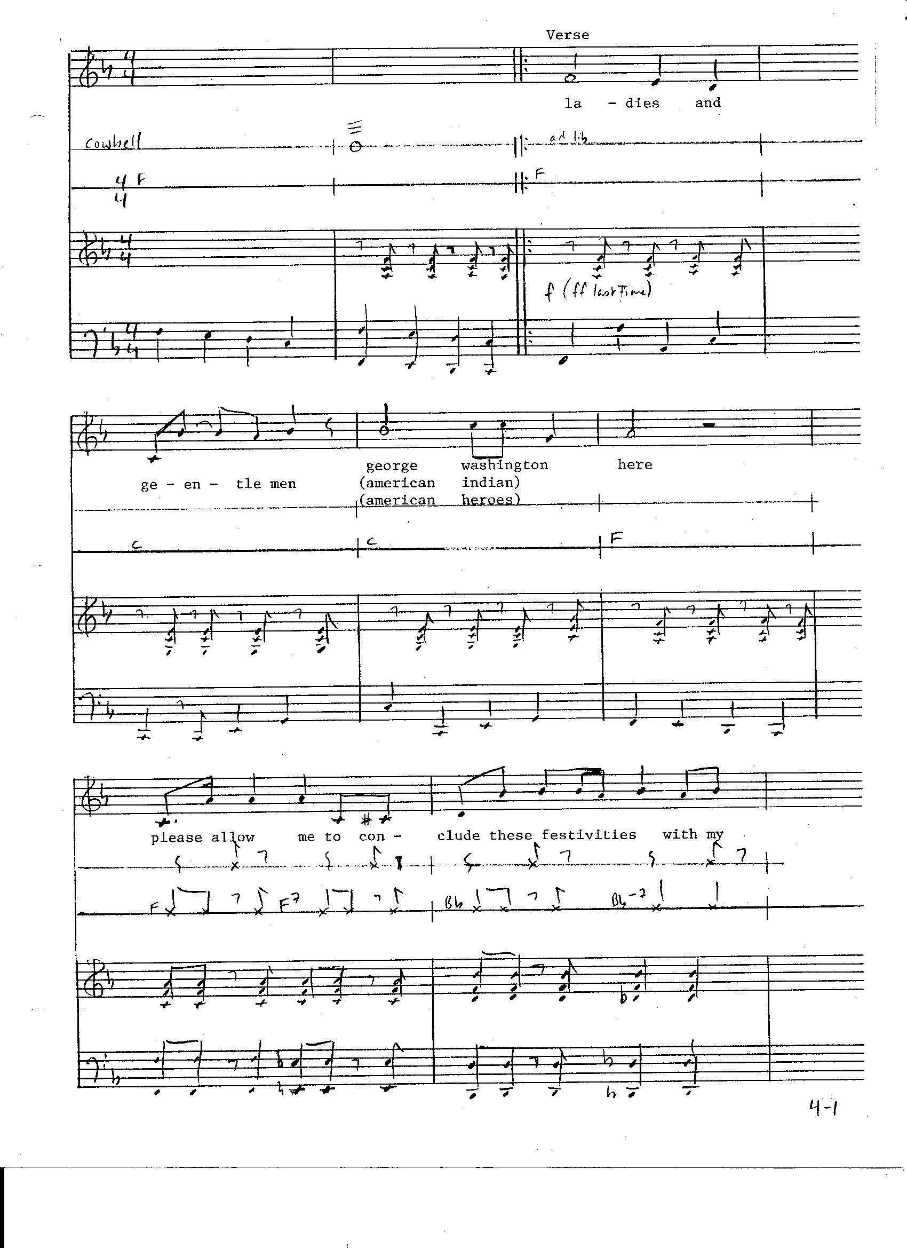
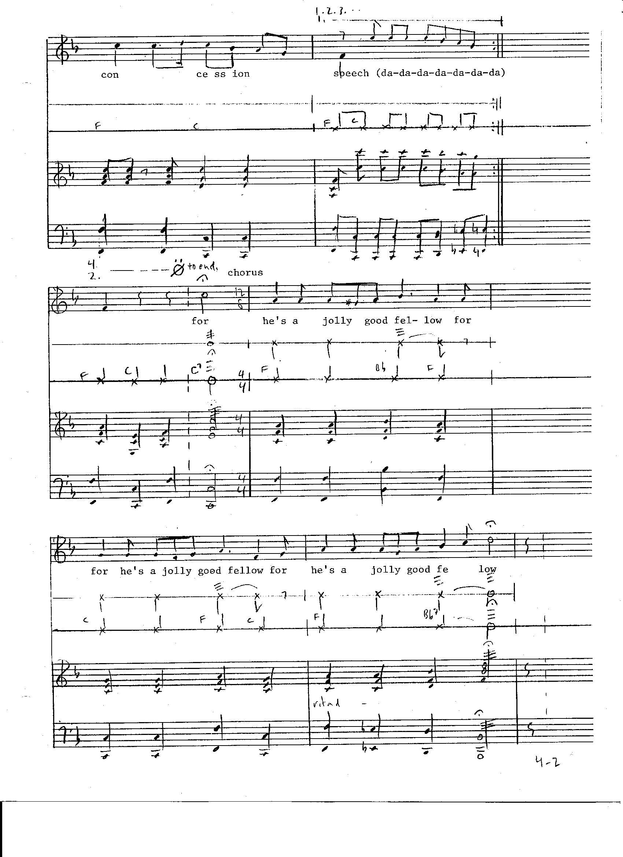
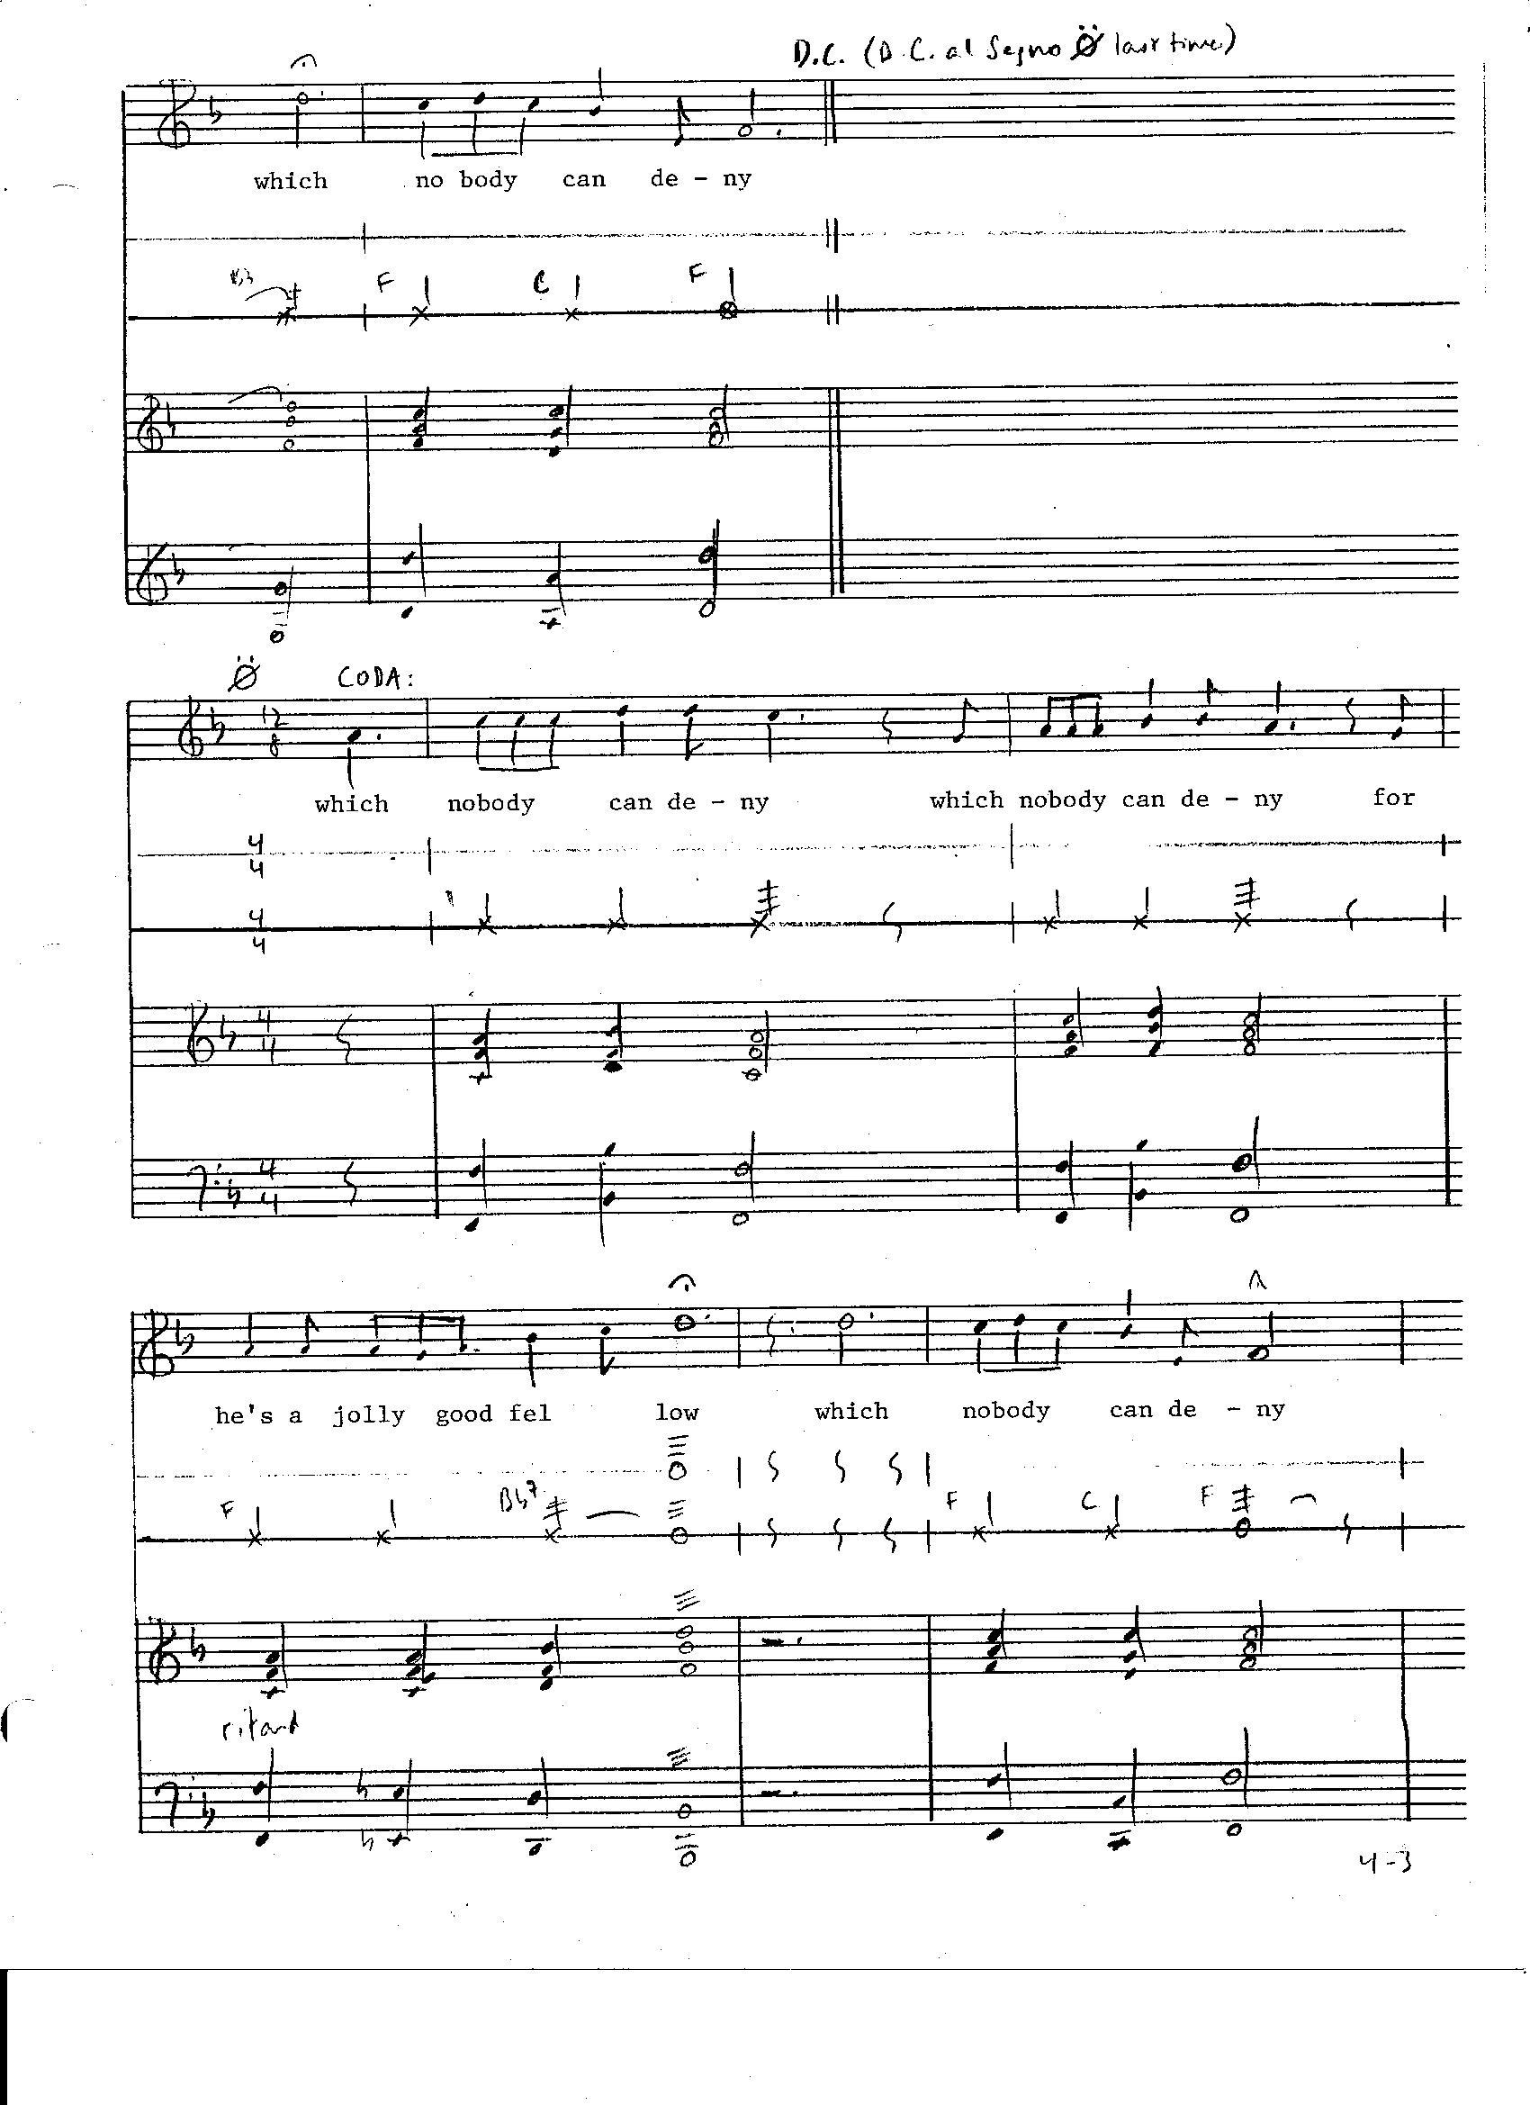
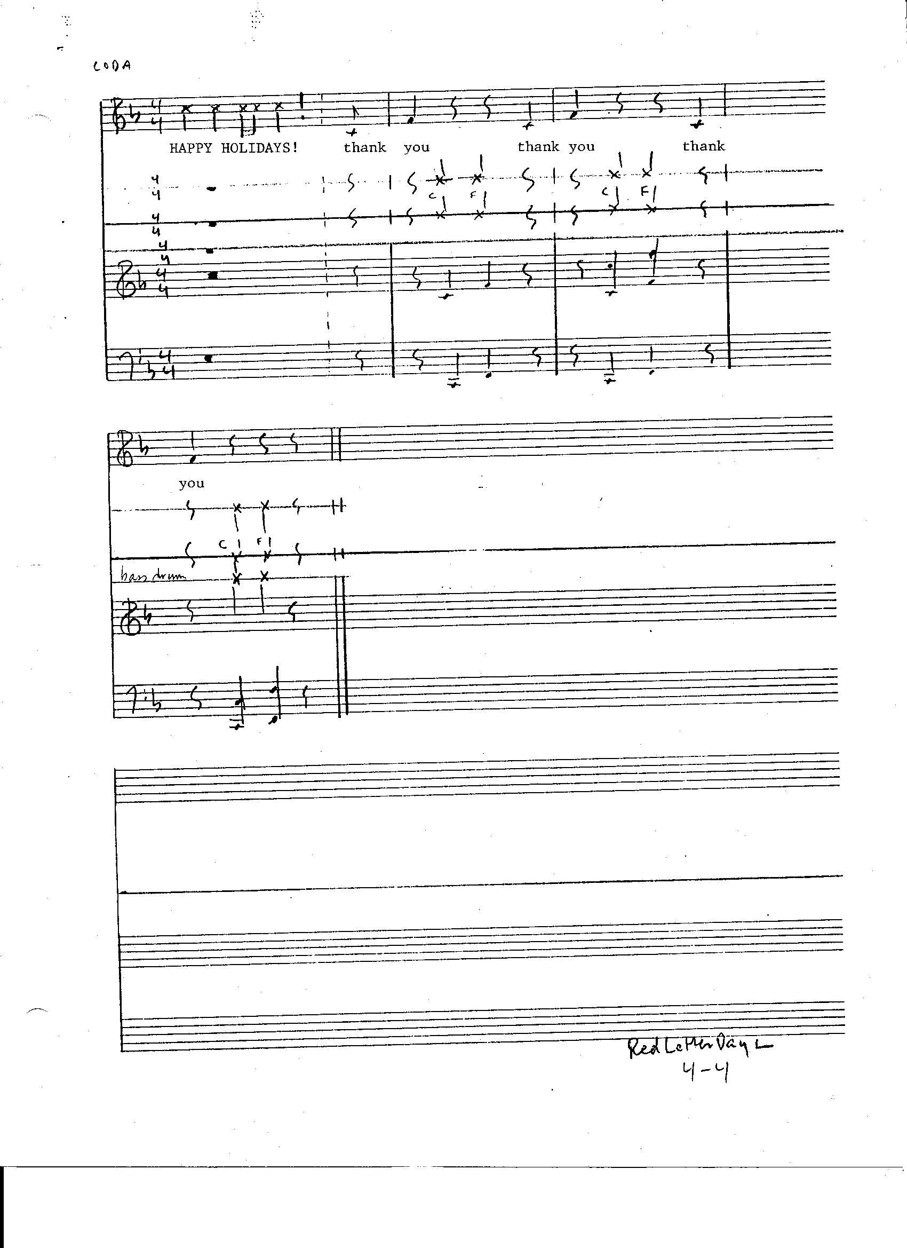
Red Letter Days: footnotes
The music for Red Letter Days is adapted in part from traditional and popular sources. Here is a listing of known musical references:

Scene l: Happy Birthday to You (Mildred and Patty Hill) (1-l)

Scene 2: Open the Door, Richard (J. McVea—D. Howell-“D" Fletcher-J. Mason-L Jordan)(2-l)
We Wish You a Merry Christmas (traditional) (2-2)
I've Been Working on the Railroad (traditional) (2-3)
Hoover Dam (traditional) - may be known by different title (2-5)

Scene 3: The Inky-Dinky Spider (traditional) (3-2)
Battle Hymn of the Republic (traditional) (3-5)
Blarney Days (traditional) (3-9)
When Moses Was in Pharaoh's Land (traditional) (3—l3)
Rock-a—Bye Baby (traditional) (3-16)
In Your Easter Bonnet (not known) (3-20)

Scene 4: John Jacob Jinglehelmer Schmidt (traditional - may be known by different title) (4-l)
For He's A Jolly Good Fellow (traditional) (4-2)

As of February ll, l987 the authorship and domain (public or private) of these tunes are not known to the author and composer(s). They will be verified for future use at a future date.

“Living in the USA” is used in The Three-Minute Manifesto for an Uncle Sam On Stilts. It was written by Chuck Berry and is published by Arc Music (BMI).

r. goldberg - 2/1l/87

54TH WEDDING ANNIVERSARY
OF THE PRACTICAL JOKERS
WHO GOT MARRIED ON
APRIL FOOL'S DAY

SCENE ONE

(Clock ticks throughout)
(Lights Up)
(OLD MAN, in nightcap, asleep in chair, at table, snoring)
(OLD WOMAN, in party hat, smoking a cigar, enters with candlestick and rouses OLD MAN)

OLD WOMAN
Have a cigar?
(She places a second cigar in his mouth and lights it by candle. The cigar explodes.)
(Blackout.)
(Cuckoo Clock strikes 1 AM)

SCENE TWO

(Clock ticks throughout)
(Lights Up)
(OLD MAN, now standing, offers the chair)

OLD MAN
Have e seat?

(OLD WOMAN sits and activates concealed whoopee cushion)
(Blackout)
(Cuckoo Clock strikes 2 AM)

SCENE THREE

(Clock ticks throughout)
(Lights Up)
(OLD WOMAN smokes two cigars)

OLD WOMAN
Another cigar?

(She places a second cigar in his mouth, strikes a match and activates a sparkler effect. OLD MAN turns his cigar around so that OLD WOMAN must light the butt end. She does. Cigar explodes)
(Blackout)
(Cuckoo Clock strikes 3 AM)

SCENE FOUR

(Clock ticks throughout)
(Lights Up)
(OLD MAN sets a cup and saucer)

OLD MAN
One lump or two?

(OLD WOMAN holds up two fingers)
(OLD MAN reveals a rubber baseball bat and whacks OLD WOMAN twice on the head)
(Blackout)
(Cuckoo Clock strikes 4 AM)

SCENE FIVE

(Clock ticks throughout)
(Lights Up)

OLD WOMAN
Shake?

(OLD MAN shakes her hand which detaches into his)
(Blackout)
(Cuckoo Clock strikes 5 AM)

SCENE SIX

(Clock ticks throughout)
(Lights Up)

OLD MAN
Shake?

(As OLD WOMAN reaches for his hand, he withdraws it and instead tosses his thumb over his shoulder)
(Blackout)
(Cuckoo Clock strikes 6 AM)

SCENE SEVEN

(Clock ticks throughout)
(Lights Up)
(OLD WOMAN licks the palm of her right hand and extends it)

` OLD WOMAN
Shake?

(Blackout)
(Cuckoo Clock strikes 7 AM)

SCENE EIGHT

(Clock ticks throughout)
(Lights Up)
(OLD MAN, in apron, holds frying pan with tin canister inside)

OLD MAN
Try some peanut brittle?

(OLD WOMAN opens canister releasing trick snake pop—outs)
(Blackout)
(Cuckoo Clock strikes 8 AM)

SCENE NINE

(Clock ticks throughout)
(Lights Up)
(OLD WOMAN, in apron, holds a pie)

OLD WOMAN
Dessert?

(She throws the pie in his face)
(Blackout)
(Cuckoo Clock strikes 9 AM)

SCENE TEN

(Clock ticks throughout)
(Lights Up)
(OLD MAN with whipped cream on his face)

OLD MAN
Kiss?

(He rubs OLD WOMAN's face in his own)
(Blackout)
(Cuckoo Clock strikes 10 AM)

SCENE ELEVEN

(Clock ticks throughout)
(Lights Up)

OLD WOMAN
Stick of gum?

(He pulls a stick from her pack and activates finger snapper)
(Blackout)
(Cuckoo Clock strikes 11 AM)

SCENE TWELVE

(Clock ticks throughout)
(Lights Up)
(OLD MAN with bottle of red wine and crystal goblet for OLD WOMAN)

OLD MAN
Time for a drink?

(She slowly downs the goblet of wine in one drink as wine dribbles from the leaking glass onto her blouse)
(Blackout)
(Cuckoo Clock strikes Noon)

SCENE THIRTEEN

(Clock ticks throughout)
(Lights Up)

OLD WOMAN
Cuban cigar?

(She places a cigar in his mouth and reveals matches. OLD MAN snatches matchbook and strikes match himself. Match explodes)
(Blackout)
(Clock strikes 1 PM)

SCENE FOURTEEN

(Clock ticks throughout)
(Lights Up)
(OLD MAN offers the chair)

OLD MAN
Take another seat?

(As OLD WOMAN sits, OLD MAN pulls the chair out from under her, resulting in her falling to the floor)
(Blackout)
(Cuckoo Clock strikes 2 PM)

SCENE FIFTEEN

(Clock ticks throughout)
(Lights Up)
(OLD WOMAN sits on floor peeling a banana)

OLD WOMAN
Banana?

(She tosses banana peel onto the floor. OLD MAN steps, slips and falls to the floor beside her.)
(Blackout)
(Cuckoo Clock strikes 3 PM)

SCENE SIXTEEN

(Clock ticks throughout)
(Lights Up)

OLD MAN
Look!

(He points in one direction as he uses his other hand to tap OLD WOMAN on the opposite shoulder, resulting in her performance of a double take.)
(Blackout)
(Cuckoo Clock strikes 4 PM)

SCENE SEVENTEEN

(Clock ticks throughout)
(Lights Up)

OLD WOMAN
Look!

(She holds up the index finger of each hand, moves them about under the eyes of the OLD MAN and then bumps her two hands together resulting in two fingers extended on one hand and none on the other)
(Blackout)
(Cuckoo Clock strikes 5 PM)

SCENE EIGHTEEN

(Clock ticks throughout)
(Lights Up)
(OLD MAN has carnation in his lapel)

OLD MAN
Take a whiff?

(As OLD WOMAN leans over to sniff flower, it squirts water into her face)
(Blackout)
(Cuckoo Clock strikes 6 PM)

SCENE NINETEEN

(Clock ticks throughout)
(Lights Up)

OLD WOMAN
Polish cigar?

(She places a large kilbasa into his mouth)
(Blackout)
(Cuckoo Clock strikes 7 PM)

SCENE TWENTY

(Clock ticks throughout)
(Lights Up)

OLD MAN
Shoelace untied?

(He pinches OLD WOMAN as she looks at her feet)
(Blackout)
(Cuckoo Clock strikes 8 PM)

SCENE TWENTY ONE

(Clock ticks throughout)
(Lights Up)

OLD WOMAN
Fly open?

(She gooses OLD MAN as he looks to his crotch)
(Blackout)
(Cuckoo Clock strikes 9 PM)

SCENE TWENTY TWO

(Clock ticks throughout)
(Lights Up)
(OLD MAN offers gift wrapped box)

OLD MAN
It's for you.

(OLD WOMAN opens box to reveal collection of cigar stubs)
(Blackout)
(Cuckoo Clock strikes 10 PM)

SCENE TWENTY THREE

(Clock ticks throughout)
(Lights Up)

OLD WOMAN
It's for you.

(She aims a gun at his head, pulls trigger and activates pop—up lighter)
(Blackout)
(Cuckoo Clock strikes 11 PM)

SCENE TWENTY FOUR

(Clock ticks throughout)
(Lights Up)
(OLD MAN and OLD WOMAN already smoking cigars)

OLD MAN
Got a match?

(They exchange cigars and smoke)
(Cuckoo Clock strikes midnight)
(They exchange cigars again)
(Blackout)

(END)

GHOST STORY WITH JACK O'LANTERN

VOICE
Ding Dong. I opened the door.

(IN THE DARK A MATCH IS STRUCK. A CANDLE
INSIDE OF A JACK O'LANTERN IS LIT. THE
PUMPKIN PROVIDES THE ONLY LIGHT ON STAGE.)

Trick or Treat. It was a ghost with an empty sack. I gave the ghost a bag of M & M's. I closed the door.
Ding Dong. I opened the door. Trick or Treat. It was the same ghost, the same sack. I gave the ghost a quarter. I closed the door.
Ding Dong. I opened the door. Trick or Treat. Same ghost. I gave the ghost a dozen Mars Bars and a couple of dollars. I closed the door.
Ding Dong. I opened the door. Trick or Treat. I gave the ghost a six pack of beer, my wristwatch, two rings and my wallet. I closed the door.
Ding Dong.
Ding Dong.
Ding Dong —- Ding Dong ·— Ding Dong -— Ding Dong -— Ding Dong.
I opened the door. Trick or Treat. I looked hard at the ghost. Same ghost. Same sack. I gave the ghost my three month old son. I closed the door.
Ding Dong. A witch opened her door. Trick or Treat. It was the ghost with the child in the sack. The witch treated the ghost to a bottle of dragon's breath in exchange for the child. The witch closed the door.
Ding Dong. The witch wasn't home. The boy opened the door. He was now five years old. Trick or Treat. It was a skeleton selling magazine subscriptions. The boy closed the door.
Ding Dong. The witch wasn't home. The lad opened the door. He was now twelve years old. Trick or Treat. It was a werewolf wanting to borrow a cup of sugar. The lad closed the door.
Ding Dong. The witch wasn't home. The young man opened the door. He was now nineteen years old. Trick or Treat. It was a voice on the wind.
The young man stepped out into the forest. He left the witch’s door open.
Ding Dong. The door opened by itself. Trick or Treat. It was my son. He smiled. He was tall. He was handsome. He had eyes like a cat. I closed the door. I locked the door. I closed the curtains. I turned off the lights.
Ding Dong. I opened the door. Those eyes. My son gave me an apple. I took a bite. I fell asleep for ten days. I dreamed about my mother and the doctor and the horses and the farm and the night and noises and sounds that you hear in the night.
I opened my eyes. My son gave me a blanket. It was snowing. The door was open. My son gave me another blanket. It snowed harder. My son gave me a third blanket. It snowed like a blizzard. He went out into the forest for firewood. I closed the door.
Ding Dong.
Ding Dong —— Ding Dong.
I stay in bed dreaming about my mother and the farm and the sounds that you hear in the night.
Ding Dong.
I stay in bed under the blankets. I won't open the door.
Ding Dong.
I won't open the door.

(THE CANDLE IS BLOWN OUT IN THE DARK)

MUSIC FOR
GHOST STORY WITH JACK O'LANTERN

Score by Rick Russo
Text by Dick D. Zigun
Text (c) Copyright 1986 by Dick D. Zigun
Score (c) Copyright 1987 by Rick Russo
Magnetic Tape (c) Copyright 1986 by Rick Russo
MUSIC FOR ‘GHOST STORY WITH JACK O'LANTERN'
Score by Rick Russo — Text by Dick D. Zigun

1  2  3  4  5  6  7  8  9  10  11  12  13  14  15  16  17  18  19  20  21  22  23  24  25  26  27  28  29  30  31  32  33  34  35  36  37  38  39  40  41  42  43  44  45  46  47  48  49  50  51  52  53  54  55  56  57  58  59  60  61 | VOICE  Ding Dong. I opened the door.  Trick or Treat. It was a ghost with an empty sack.  I gave the ghost a bag of M & M's. I closed the door.  Ding Dong. I opened the door. Trick or Treat. It was the same ghost, the same sack. I gave the ghost a quarter. I closed the door.  Ding Dong. I opened the door. Trick or Treat. Same ghost. I gave the ghost a dozen Mars Bars and a couple of dollars. I closed the door.  Ding Dong. I opened the door. Trick or Treat. I gave the ghost a six pack of beer, my wristwatch, two rings and my wallet. I closed the door.  Ding Dong.  Ding Dong.  Ding Dong-Ding Dong—Ding Dong—Ding Dong–Ding Dong.  I opened the door.  Trick or Treat. I looked hard at the ghost. Same ghost. Same sack. I gave the ghost my three month old son. I closed the door.  Ding Dong. A witch opened her door.  Trick or Treat. It was the ghost with the child in the sack. The witch treated the ghost to a bottle of dragon's breath in exchange for the child. The witch closed the door.  Ding Dong. The witch wasn't home. The boy opened the door. He was now five years old.  Trick or Treat. It was a skeleton selling magazine subscriptions. The boy closed the door.  Ding Dong. The witch wasn't home.  The lad opened the door. He was now twelve years old. Trick or Treat. It was a werewolf wanting to borrow a cup of sugar. The lad closed the door.  Ding Dong. The witch wasn't home.  The young man opened the door.  He was now nineteen years old.  Trick or Treat. It was a voice on the wind.  The young man stepped out into the forest.  He left the witch’s door open.  Ding Dong. The door opened by itself.  Trick or Treat. It was my son.  He smiled. He was tall. He was handsome.  He had eyes like a cat.  I closed the door. I locked the door. I closed the curtains. I turned off the lights.  Ding Dong. I opened the door.  Those eyes. My son gave me an apple. I took a bite. I fell asleep for ten days. I dreamed about my mother and the doctor and the horses and the farm and the night and noises and sounds that you hear in the night.  I opened my eyes. My son gave me a blanket. It was snowing. The door was open. My son gave me another blanket. It snowed harder. My son gave me a third blanket. It snowed like a blizzard. He went out into the forest for firewood. I closed the door.  Ding Dong. Ding Dong —— Ding Dong.  I stay in bed dreaming about my mother and the farm and the sounds that you hear in the night.  Ding Dong. I stay in bed under the blankets. I won't open the door.  Ding Dong.  I won't open the door. | LIVE SOUND  Cup 1  |  |  Cup 2  |  |  |  Cup 3  |  |  Cup 1  |  |  Cup 2  |  Crinkle cellophane  Cup 3  |  |  (accelerate)  |  |  Scrape toothpicks  |  |  |  Crinkle cellophane  |  Scrape toothpicks | TAPED SOUND  5 heartbeats  Distant Scream  Thunderstorm  |  |  |  |  |  |  |  |  Rain and Wind  |  |  |  Cathedral bell  |  Crickets  |  |  Creaking sounds  |  |  Slamming door shut  |  Harbor sounds  |  Clanking sounds  |  Howling wolves  |  Synthetic sounds  |  |  |  Tunnel effects  |  |  |  Altered effects  |  Electronic sound  |  |  |  Single piano note  |  |  |  |  |  Piano note cluster  |  |  Insane asylum  |  Garbled verbal animal language  |  (fade)

REGARDING THE SCORE
A solo player uses amplified 'cupaphones' and magnetic tape.
Duration is approximately fifteen minutes.
A single microphone should be used, in association with available amplification.
Preferably, the magnetic tape is in cassette format.
Live instruments required: 3 cupaphones (see How to Make & Use Cupaphones)
Cellophane wrapping from a package of cigarettes
The output level of both microphone and tape playback should not exceed that of the actor's recitation level.
The tape shall run continuously (at a fixed level) for the duration of the performance.
The tape could be that of the one provided by the playwright, or a new version may be prepared. (If the latter is employed, see How to Prepare a New Magnetic tape).
The numbers in the left margin are index numbers for the text.
The text has been laid out on the pages in order to show the correlation between text and sound.
The prelude (5 heartbeats followed by a distant scream) shall be heard after the lighting of the pumpkin's candle. The scream shall stop before the beginning of Line l, and the thunderstorm sequence shall begin after the recitation of Line l.
Use 'disciplined improvisation' in using the cupaphones during their indicated sequences.
As the piece is performed in the near-dark, adequate lighting shall be used by the sound—artist (not visible to the audience).

HOW TO MAKE & USE 'CUPAPHONES'
A Cupaphone is an experimental sound producer.
It consists of a plastic, cone—shaped cup which normally is inserted in a cupholder for the purpose of drinking hot (or cold) beverages. The preferable type of cup to be used in making the Cupaphone is the Solo (company) brand. The instrument also consists of a round toothpick. A Cupaphone is made by simply inserting the toothpick through the center of the top of the cup, half way into the cup. This is best done by lighting a tip of the toothpick with a match or other small flame, until the tip is on fire for a few seconds. The flame is then blown out and the toothpick is inserted through the plastic while its tip is still glowing.
The instrument is played by stroking the toothpick in various ways. A performer should experiment with the instrument to discover how various sounds may be produced.
For the purpose of their use in the GHOST STORY, three Cupaphones should be used, with associated amplification.
It should be noted that when 'Scrape Toothpicks' is referred to in the score, a performer is to scrape the toothpicks of two Cupaphones, which produces a certain kind of resonance.
A completed Cupaphone will look something like this:
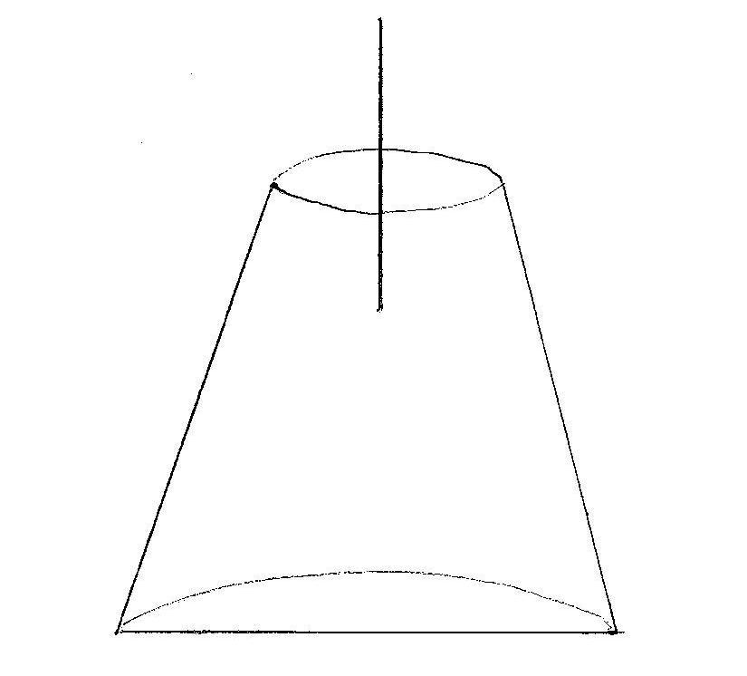

THE THREE MINUTE MANIFESTO FOR AN UNCLE SAM ON STILTS

UNCLE SAM
(ENTERS ON STILTS WEARING TRADITIONAL
COSTUME AND SUNGLASSES)
Vote for me.
Vote for me.
Vote for me and everybody's gonna find a boyfriend or girlfriend.
Vote for me and I said everybody find a boyfriend or girlfriend.
Vote for me and join the party.

(SEVERAL AMERICANS ENTER. PLAY “BACK IN
THE USA” BY CHUCK BERRY. THEY DANCE.)

Vote for me and spend more time at the beach.
Vote for me and your city will learn how to party like New Orleans during Mardi Gras week.
Vote for me and find out the truth about UFOs and about Lee Harvey Oswald.
Vote for me and Lucky Strikes no longer cause cancer.
Vote for me and place bets on your favorite tattoo parlor, pool parlor or beauty parlor being picked the daily instant national landmark.
Vote for me and every pizza parlor gets coal ovens and a Wurlitzer jukebox two plays for two bits.
Vote for me and bring back tomatoes.
Vote for me and get fireworks every Tuesday night at eleven.
Vote for me and we can put a new paint job on a late 40‘s pick-up truck, gas it up, rob a bank and put a cool million dollars in the glove compartment and drive to Coney Island and see Slim of Slim's Shootin’ Gallery, the last live ammo shootin’ gallery left in the east. Now Slim owns some 300 guns and I can get us a spare parts rifle for sixty bucks with no registration and no way to be traced...you may not want to do this at all...but
Vote for me because I have good connections.
Vote for me and the National Enquirer becomes a full-color glossy.
Vote for me and it's okay to joyride again...as long as you buckle your seatbelt.
Vote for me and make them stop screwin’ with the weather.
Vote for me and always have hot water.
Vote for me if you want guarantees Alaska stays the coolest state in the union.
Vote for me and Nevada will once more be known as a state of mind by virtue of vice rather than geography.
Vote for me and New York becomes the capital of the world while Los Angeles remains the capital of America.

(PAUSE. “BACK IN THE USA” FADES.)

Vote for me and we'll change the National Anthem every once and a while.

(THE AMERICANS JOIN HANDS, SWAY BACK AND
FORTH, AND SOFTLY HUM THE CHUCK BERRY SONG)

Vote for me and "Life, Liberty and The Pursuit of Happiness“ becomes the new Pledge of Allegiance.
Vote for me and anything you want they got it right here in the USA.
Vote for me and anything you want they got it right here in the USA.
Vote for me and anything you want they got it right here in the USA.
Vote for me.
Vote for me.
Vote for me.

INTERMISSION

UNTIMELY DEATH WITH DOGS IN DETAIL

The Murder Mystery That Asks
The Question: Who Died?

ACT ONE/Scene One

[Very dim light]

STAGE MANAGER
Act One. Scene One. Friday the 13th. The Condo:

[SOUND CUES: Breaking glass. Cat. Gun shot.]

AN ACTOR
Drip - Drip - Drip — Drip...
[Continues]
ANOTHER ACTOR
Ring — Ring ———-—- Ring - Ring

ANOTHER ACTOR
Knock - Knock

SECOND ACTOR
Ring — Ring -—---— Ring — Ring

FIRST ACTOR
Drip - Drip — Drip — Drip...
[Fade out](BETWEEN ALL SCENES THE ACTORS CHANT SUPERSTITIONS SUCH AS: "Don't walk under ladders", "Step on a crack, break your mother‘s back", "Break a mirror, seven years bad luck", etc.)

ACT ONE/Scene Two

STAGE MANAGER
Scene Two. 13 days later. Scharfstein‘s Funeral Parlor:

CRYING ACTOR
The 13 month husband.

ANOTHER CRYING ACTOR
The wealthy ex-husband.

ANOTHER CRYING ACTOR
The better looking ex-husband.

ANOTHER CRYING ACTOR
The hair stylist with the cocaine habit.

ANOTHER CRYING ACTOR
The bouncer at the latest after hours club.

MANY CRYING ACTRESSES
The past and current Mah Jongg players among her Aunt’s best friends who her since she was so high.

[Blackout]

ACT ONE/Scene Three

STAGE MANAGER
Scene Three. Later that evening. 13th Street:

CRIMINAL
Bang! Bang! Bang! Bang!

COP
Bang! Bang! Click!

CRIMINAL
Bang! Bang! Click! Click! Pow! Socko!

COP
Pow! Pow! Kick! Thud! Krunch! Pow! Crash!

CRIMINAL
Buckle! Puke! Blood! Ugh! Uncle!

COP
Read him his right, O’Reiley! Up against the wall! Spread your legs!

O’REILEY
You have the right to remain-

COP
Kick!

CRIMINAL
Yiiiiiii!

[Blackout]

FIRST INTERMISSION

STAGE MANAGER
House lights. Intermission. Push. Smoke. Phonecall. Drink. Pee. Smoke. Push. Lobby lights: on/off/on/off. Excuse me. Excuse me. Curtain up.

ACT TWO/Scene One

STAGE MANAGER
Act Two. Scene One. 13 years later. Court of Appeals:

[CRIMINAL plays Chopsticks on the piano]

JURY FOREMAN
The juro findso defend not guilto by reasoning of insanitary confinement.

ACT TWO/Scene Two

STAGE MANAGER
Scene Two. 13x3: 39 years earlier. South Philadelphia Maternity Ward:

FATHER
Push! Push!

MOTHER
Ughhh! Ughhh!

INFANT CRIMINAL
Waaaa! Waaaa!

[FATHER slaps INFANT CRIMINAL. MOTHER slaps FATHER. ALL slap each other excessively.]

ACT TWO/Scene Three

STAGE MANAGER
Scene Three. 13 years after the 13th trial. Parole board hearing:

SHRINK
The patient manifests a dogphobia not unlike that attributed to Son of Sam Sequel in my exclusive National Star study, Volume 13, Number 3. We have talked at length in my office about the various merits of Dalmations vs Irish Setters as Seeing Eye Dogs, as well as theoretical ease in decapitating either species. The patient does wish to address the board.

PAROLE BOARD
Speak! Speak! Speak! Speak!

CRIMINAL
Everybody, hurt the dogs!
[He howls an ultra high pitched scream. Blackout.]

SECOND INTERMISSION

STAGE MANAGER
House lights. Intermission. Push. Smoke. Pee. Wanna leave? Whataya think? Drink. Drink. Coffee. Stiffer drink. On/off/on/off. Excuse me. Excuse me. Curtain up.

ACT THREE/Scene ONE

STAGE MANAGER
Act Three. Scene One. The 13th dimension. Inside the minds of each character:

SPINNING ACTRESS
The dead woman: ooooooooooooooo…
[Continues]

SPINNING ACTOR
The 13 month husband: woe, oh, woe, oh, woe…
[Continues]

ANOTHER SPINNING ACTOR
The wealthy ex:
[Jingles change in his pocket and continues]

ANOTHER SPINNING ACTOR
The better looking ex: fuck me- fuck me- fuck me- fuck me-
[Continues]

ANOTHER SPINNING ACTOR
The hair stylist:
[Sniffs and continues]

ANOTHER SPINNING ACTOR
The after hours bouncer:
[Punches fist into hand, bounces and continues]

MANY SPINNING ACTRESSES
The Mah Jongg players: yadda-yadda—yadda—yadda...
[Continue]

SPINNING COP
The cop: Bang! Bang! Bang! Bang!...
[Continues]

SPINNING CRIMINAL
The criminal: Everybody, hurt the dogs!
[High pitch scream and continues]

TWO SPINNING PARENTS
The parents:
[Slap each other and continue]

SPINNING SHRINK
The shrink: Another Jew -- Another book, Another Jew —— Another book...
[Continues]

SPINNING STAGE MANAGER
The stage manager: Equity—Equity—Equity-Equity...
[Continues. Blackout.]

ACT THREE/Scene Two

STAGE MANAGER
Scene Two. Thirteen seconds before the Act One, Scene One Full—Moon Friday murder. Pre—Mah Jongg game chatter:

ACTRESS
Did you try the Devil's Food Cake?

ANOTHER ACTRESS
I'm on a diet.

(THEY TOSS SALT OVER THEIR SHOULDERS.)

FIRST ACTRESS
It's the Sweet and Low recipe.

THIRD ACTRESS
Who else can we call for a Fourth?

SECOND ACTRESS
How’s your snotty little niece, Shirley?

SHIRLEY (First Actress)
Alright, so let me call... Ring — Ring ---—-- Ring — Ring...

SECOND ACTRESS
Isn't TWILIGHT ZONE on TV tonight?

THIRD ACTRESS
Life's too short for TWILIGHT ZONE reruns.

SHIRLEY
Ring — Ring ————-— Ring - Ring...

[Blackout]

DUAL ENCORE

STAGE MANAGER
Curtain call. Encore. Curtain down. Who broke the dressing room mirror? Curtain up. Second Encore.
[In the dark]

Excuse me. Sorry! I said excuse me, get off my foot! On/off/on/off/ow! I hope your limo runs over a black cat on your way home from the theatre tonight! Taxi! Taxi...

[SOUND CUES: Car horn honks. Car crash. Cat.]
[END]

LOVER'S LEAP

CAST OF CHARACTERS
SARA ..... A woman in a bathrobe.
MOE ...... A man in a hat and tie.

TIME…
February 14, 1930

PLACE
An American city.
A realistic look into two floors of an urban American apartment building. The exterior wall is removed. The audience sees two separate studio apartments, one stacked on top of the other. Two kitchens. Two bedrooms. Two baths. Identical layouts. Similar appliances. Sara's apartment contains a radio — Moe's, a Victrola. The personal furnishings of the two apartments, of course, should be different. A staircase connecting the two floors is also exposed.

(SARA sits in the lower apartment listening to a romantic radio soap opera. She wears a bathrobe and has curlers in her hair. She drinks a cup of coffee and reads a "Wonder Woman" comic)  (SARA hears the doorbell, opens her apartment door and finds a box of long stemmed roses, one mum, a heart shaped box of chocolate and a large red envelope. She looks about but there is no sign of her suitor. She enters her apartment, closes the door, picks up  the envelope and reads)  SARA  "For Sara"  (SARA tears open the red envelope)  (SARA reads the enclosed valentine)  SARA  "To My Love On Valentine's  (She opens the card)  "There's someone who loves you  I thought you should know.  I've been meaning to tell you  About your shy beau.  The secret comes out now.  Oh, who can he be?  Your valentine suitor's  None other than ME!"  "Happy Valentine's Day. Love,  Guess Who. P.S.- See letter  enc1osed."  (SARA finds a very lengthy letter enclosed with the valentine)  (SARA reads the letter aloud)  "My Dear, Dear, Lovely Miss Sara,  I don't think that you know me, but we've many times passed each other in the lobby. I'm one of your nameless neighbors, I rent 13—B, the top floor?  It's a friendly building. I've noticed you smile. Yes, for years you have had a secret admirer. I bet you never noticed. I've been subtle. I CAN keep a secret ...but only so long.  I told the birds when I thought I could not keep it in. I told the flowers and mum was the word. I talked to myself, I yelled to the mountains. I screamed to the stars. I tried to get my toaster to play Twenty Questions. Thousands of inanimate objects know of my affection, but not you, dear, lovely Miss Sara.  I think it's now time for me to uncover myself. I can no longer contain it. My cup runneth over. I love you sweet Sara! So there! There you are!  Did anyone ever tell you that your hair looks as soft as a box full of downy white feathers? Perhaps you've been told that a lot. Still, I mean it sincerely. It's not just a line. I've studied your features. I dream of your face. Your eyes, your nose, that mouth, your teeth.  The cheeks, that chin, those ears (cute little ears). Do you believe in love at first sight? I think you are a vision.  (She eats chocolates)  I'll love you until I go blind. You'll forgive my postulation, but I can't help but think that you're Swedish. Oh, I know you don't look Swedish, but it's a strong impression I get from the way that you dress. Am I right? I couldn't help noticing the way you seem to wear sweaters so often. They make your figure look good and believe me, that's GOOD! You've got a nice shape, a nice turn of the ankles. Your legs are the longest. Your bosom the fullest —·— I hope I'm not getting too personal.  Sara, it's clear you've got style. Not too heavy on make-up. There's real red in your cheeks. The way you walk, the way you sit, the way you scratch your head. But it's not just a physical infatuation. I love you for lots of other things besides.  (SARA sniffs her rose)  I mean, after all, what's important when it all comes down to it, is compatibility. Could we two get along? Be two peas in a pod? Share a Coke and two straws? Take a tea-time for two? Me and you? Hmmm?  Sexual attraction is enough to stir lust, but in order to call an emotion "love", don't you think there has to be an equal arousal on a more ethereal plane? Believe me, I would not call you "angel" if all my feelings were base. No, there's more, much, much more to praise in you, Sara. I've studied you well.  (SARA begins to pull petals off the rose)  I've followed you, Sara. I've walked right behind you. I've seen you give money to Salvation Army Santa Clauses during Christmas time. Not just once, and not just small change. I've seen you give bills. I've seen you give twice on one block.  You're a good woman. My mother and father used to tell me to keep my eyes on the look-out for an old fashioned girl. I think you're right up to date. Thoroughly modern, Sara...but you've got the essence of that quality the folks meant. I bet you're a Pisces. I'm a Taurus. I think you get my meaning.  You might think me bold for saying it, but I was watching you through your window one night and happened to notice you entertaining some guests. You're a natural hostess, Sara, love. You won't have any trouble wrapping me around your precious finger...and, of course, it was sure obvious that you're some cook!  I'm not what you might call one of those peeping toms (don't worry about that) so I didn't get to see your desserts, but if there's any truth in the saying: "Sweets from the sweet", I'm sure that everyone went home happy and full of cavities.  You know what, Sara, sweet-heart? I had a dream about you the other night.  (SARA shaves her legs, getting somewhat  stimulated in the process)  I dreamed we went to an amusement park which, by the way, is not a bad place to go on a first date. It breaks the awkward ice, the way the rides and roller coaster go so fast you press up against each other and have to hold on to each other...you were in my dream and I was in my dream and we were all laughs and holding hands at this amusement park.  And I won you a teddy bear and you got cotton candy messed all over your face and I had to lick it off and then we rode through the Tunnel of Love five times...oh, yes... it was a nice dream.  The tunnel was dark and small waves rocked the boat and then I took your hands and you didn't resist. And then we paid two more tickets. And then I messed your hair and you didn't complain. So we paid two more tickets. And then I kissed you full on the lips and you didn't mind my tongue, so I threw the man two more tickets. And then I pulled you over to me and then you squeezed in even more.  More tickets? You bet! And then: umm-umm—umm—ohh—boy! We gave him all the tickets we had left. It was a swell dream, you bet!  I can't get you off of my mind, Sara. Not that I'd want to, but even if, for some reason I did, it just could not be. The radio, for instance, has lately been playing nothing but songs meant for you:  You are my Sunshine,  My only Sunshine  ...and...  Picture you  Upon my knee  ...and...  I dream of Sara  With the Swedish hair...  (SARA combs out her hair)  I've even felt inspired to compose a love song about you myself. Here it goes. I call it:  SARA: OH—OH-OH.  S is for a silly little letter  A is where the alphabet begins  R we ever gonna get together?  A thru Z we got lots in comm—in.  Sara, oh-oh-oh  Oh, Sara, oh—oh-oh  My, Sara, oh-oh—oh  That day is finally here.  Well, what do you think? No, don't tell me. I want to see it in your face next time I see you. There's so much we must talk about, Sara.  Do you like to ice skate, roller skate, dance, miniature golf, swim or go bowling? Are you a Republican or Democrat? What's your religion? Do you think that two can, indeed, live as cheap as one? How long is your lease?  Maybe I should tell you some things about myself. I don't own a car, but I like to take walks...I could never sew my way out of a paper bag, but I've been called a twinkle-toed dancer...I'm not the best dressed man about town, but I know some of the best out—of— the—way places...I can't claim that I was well bred, but I'm becoming well read...I don't like green salads, but I like sappy, mushy matinee movies. I have a sense of humor, but I get carried away sometimes... you don't think that I run at the mouth, do you? I like baseball and beer and hotdogs and pretzels and putting money in a jukebox and rowing boats and Mary Pickford. I don't like black jelly beans. I don't like the Mayor...right now, anyway. I don't like steam heat, or our landlord... or missing the high notes in The Star Spangled Banner. I'm just an average guy.  I like Valentine's Day...a whole lot. That's not so unusual, is it? I mean, I don't do anything weird to celebrate it, but it's just my favorite holiday of the year...this year, anyway. That's not hard to understand, is it, Sara?  I'm just an average guy with a normal heart that Cupid's shot. That's what seems so extraordinary. That's what's so bold: I'm an average guy made special by love.  Looks? Don't be afraid to ask. I've got no warts, no ugly surprises. I'm an average guy. I don't look Swedish, I'm not tall, blonde and muscular but I'm no cross—eyed, sour-pussed, tongue—tied Thomas either. I'm average and that's not great, I admit, but it's also not bad. I mean, there's something more here than just a nice personality. My eyes, for instance, made special by love. They've got a gleam, you've added a sparkle. For you I'll look handsome,  sweetheart, but please, don't judge me just by my cover. I didn't with you. Looks are not everything and beauty's only skin deep. Please, Sara, also try to love me for the way I'm like inside.  I grew up just outside of Hershey, Pennsylvania. Have you ever been to Hershey? I hope not, I'd hate to think we could have met long ago and wasted all this time. Maybe you don't know anything about Hershey at all. Boy, can I tell you stories! Hershey's where they make the chocolate candies. You know, "Kisses". Yep, that's my hometown, Kisses, Pennsylvania; and here I am sending you Valentine sweets. Isn't that something? I hope you can appreciate the irony. Hershey's a romantic town, I think, if you look at it right. The lights on all the street lamps are meant to look like kissing, I mean the candy kisses in the foil wrappers, you know. And at night they keep the lights real low, they don't want the chocolate to melt or something. And the streets are real dark and everything looks real good and soft and it's actually very romantic.  This is my hit or miss year, Sara. I'm trying to put things together. I've had a couple of breaks. I think that the thicket is clearing. My work is getting attention. People are beginning to know who I am. The roughest part of the way seems to be over, and believe me, it's gone smooth at just the right time...I was beginning to contemplate some desperate actions back there for a while.  But that's all past now. I'm putting down roots. I want to get settled. I want all the good things in life: I want a house. I want a dog. I want a couple of goldfish. I want a lawnmower. Three square meals a day. Home delivered newspapers. I want paid vacations.  I want wine. I want song. I want sun. I want life. I want you. I want to live. I want you, Sara. I want you to bring me to life. I want to share love with you, lovely lady, Sara. Sweet, wonderful life.  S is for a silly little letter  A is where the alphabet begins  R we ever gonna get together?  A thru Z we got lots in comm—in.  Sara, oh-oh-oh  Oh, Sara, oh-oh—oh  My, Sara, oh-oh-oh  That day is finally here.  Dear, Sara, in short, I cannot live without you. I love you. I want to marry you. I want you for my wife. I'm waiting for you upstairs. Please do not reject me. I'll wait 15 minutes by the window. That gives you enough time to read this love letter. If I haven't heard from you in fifteen minutes...if you haven't knocked or called or slipped a note under my door...  (As the lights slowly fade) | (The upper apartment is dark and unoccupied)  (MOE enters and climbs the steps of the building. He pauses by the closed door of the lower apartment. He leaves a package by the door, rings the bell, knocks four times and exits up the steps)  (The door of the upper apartment opens. A man is silhouetted by the hall light. MOE turns on his lights, enters and shuts the door to his place. He wears a typical suit and tie. He carries an empty shopping bag. He folds it and puts it away.)  (MOE goes into his room, winds his alarm clock and sets the alarm)  (MOE cranks up his Victrola, puts on a record and plays instrument - all jazz music from the 1920‘s — the music we now associate with Loonie Tune soundtracks. Throughout the play he keeps playing records)  (MOE turns on the sink, takes off his shirt, lathers and shaves)  (MOE brushes his teeth)  (MOE gargles with mouthwash)  (MOE combs his hair)  (MOE cleans his ears with the tip of a washcloth. He applies a deodorant stick under his arms)  (MOE brushes under his nails. He clips and files one.)  (MOE puts on a new shirt and tie, puts on his jacket and straightens his clothes in a mirror)  (MOE switches his jacket for another and then switches again. MOE checks the time. He lights and smokes a cigarette. MOE paces. He checks the time  again)  (MOE makes and eats a sandwich and drinks a bottle of Coke)  (MOE chews gum. He spits it into a tissue and cleans his teeth with a toothpick)  (MOE blows up a balloon, rubs it on his head for the static electricity and hangs it, clinging to the wall)  (MOE makes a face in the mirror and blows a noisemaker at himself. He lies on his side, unzips his pants and masturbates)  (MOE grinds out the cigarette butts he finds in his ashtray)  (MOE checks the time. He yawns.)  (MOE feels his forehead, looks at his tongue in the mirror and puts a thermometer into his mouth)  (MOE takes aspirin)  (MOE checks the time. He pours a nip from a whiskey bottle into a shot glass and drinks it)  (MOE guzzles the bottle. MOE puts the bottle away. MOE guzzles the bottle again.)  (MOE lights another cigarette. He lights another cigarette and smokes two at once.)  (MOE checks the time. MOE paces. MOE pulls his tie so tight that he chokes. MOE sits at the table, smokes an entire pack of cigarettes and tries to arm wrestle one hand against the other)  (The alarm clock goes off in MOE's apartment. He lets it ring itself out. He gets a pen and paper, sits at the kitchen table and writes a brief note)  (MOE opens and jumps out the window of his apartment. His body falls past SARA°s window but she does not see it. She reads on)

THE RABBI'S PRAYER FOR THE COMMISSIONER OF BASEBALL

RABBI CHANTS
Dear Commissioner of Baseball:

We read from right to left
You read from left to right.

We wrote the Old Testament
You wrote the New Testament.

Our Sabbath is Saturday
Your Sabbath is Sunday.

Our New Year's is in the Fall
Your New Year's is in the Winter.

We give presents eight days on Chanukah
You give presents one day on Christmas.

Our calendar starts five thousand years ago
Your calendar starts two thousand years ago.

You eat in kosher style delis
We eat in kosher delis.

And this should suffice to explain
Why Sandy Koufax is forbidden to pitch
In the World Series on Jewish Holidays.

Amen.

THE LIFEGUARD CHOIR THEME SONG
to be sung a-capella

Summertime's Coming And I Wanna Be A Lifeguard
(But) I‘m Glad I Wasn't A Lifeguard
(Back} In Nineteen Fifty Somethin’
(When) That Famous Tropical Heatwave
(Put) The Lifeguards To The Test
(When) The Beach Was Full of Millions
(And) The Lifeguards Got No Rest

It's May Day -- First of May
May Day In The Surf Today
May Day -- Splish!
May Day -— Splash!
Two Communists Have Cramps!
Two Communists A Drowning!
Help Us! Save us!
Stroke! Stroke! -- The Dead Man's Float!
Splish! Splash!
One of Them Sank In The Icy Blue Sea
(Back) In Nineteen Fifty Somethin'
(When) That Famous Tropical Heatwave
(Put) The Lifeguards To The Test
(When) The Beach was Full of Millions
(And) The Lifeguards Got No Rest
It’s Memorial Day —- End of May
Memorial Day In The Surf Today
Memorial Day -- Splish!
Memorial Day -- Splash!
Three Unknown Sailors On Shore Leave!
Three Unknown Sailors A Drowning!
Help us! Save us!
Two Communists Have Cramps!
Stroke! Stroke! —- The Dead Man‘s Float!
Splish! Splash!
One of Each Sank In The Icy Blue Sea
(Back) In Nineteen Fifty Somethin'
(When) That Famous Tropical Heatwave
(Put) The Lifeguards To The Test
(When) The Beach Was Full of Millions
(And) The Lifeguards Got No Rest

It's Flag Day -- Midst of June
Flag Day In The Surf Today
Flag Day -- Splish!
Flag Day -- Splash!
Four Boy Scouts In A Kyack!
Four Boy Scouts A Drowning!
Help Us! Save Us!
Three Unknown Sailors On Shore Leave!
Stroke! Stroke! —- The Dead Man‘s Float!
Two Communists Have Cramps!
Splish! Splash!
One of Each Sank In The Icy Blue Sea
(Back) In Nineteen Fifty Somethin'
(When) That Famous tropical Heatwave
(Put) The Lifeguards To The Test
(When) The Beach Was Full ot Millions
(And) The Lifeguards Got No Rest
It‘s Independence Day -- Fourth of July
Independence Day in The Surf Today
Independence Day -- Splish!
Independence Day -- Splash!
Five Little League Teams In A Tug of War!
Five Little League Teams A Drowning!
Help Us! Save Us!
Four Boy Scouts In A Kyack!
Stroke! Stroke! -— The Dead Man's Float!
Three Unknown Sailors On Shore Leave!
Splish! Splash!
Two Communists Have Cramps!
One of Each Sank In The Icy Blue Sea
(Back) In Nineteen Fifty Somethin'
(When) That Famous tropical Heatwave
(Put) The Lifeguards To The Test
(When) The Beach was Full of Millions
(And} The Lifeguards Got No Rest

It‘s Dog Days -- August Afternoons
Dog Days In The Surf Today
Dog Days -— Splish!
Dog Days -— Splash!
Six English/Irish Setters with Sunstroke!
Six English/Irish Setters A Drowning!
Help Us! Save Us!
Five Little League Teams In A Tug of War!
Stroke! Stroke! -— The Dead Man's Float!
Four Boy Scouts In A Kyack!
Splish! Splash!
Three Unknown Sailors On Shore Leave!
Two Communists Have Cramps!
One of Each Sank In The Icy Blue Sea
(Back) In Nineteen Fifty Somethin'
(When) That Famous tropical Heatwave
(Put) The Lifeguards To The Test
(When) The Beach was Full of Millions
(And) The Lifeguards Got No Rest
It's Indian Summer —· September's End
Last Day of Summer In The Surf Today
Indian Summer Day -- Splish!
Indian Summer Day -- Splash!
Seven Red Skinned Last Mohicans!
Seven Last Mohicans A Drowning!
Help us! Save us!
Six English/Irish Setters with Sunstroke!
Stroke! Stroke! —- The Dead Man's Float!
Five Little League Teams In A Tug of War!
Splish! Splash!
Four Boy Scouts In A Kyack!
Three Unknown Sailors On Shore Leave!
Two Communists Have Cramps!
One of Each Sank In The Icy Blue Sea
(Back) In Nineteen Fifty Somethin'
(When) That Famous tropical Heatwave
(Put) The Lifeguards To The Test
(When) The Beach was Full of Millions
(And) The Lifeguards Got No Rest

Lifeguard Choir Theme Song: notes on performance
The Lifeguard Choir Theme Song is scored for any number of voices in any combination.
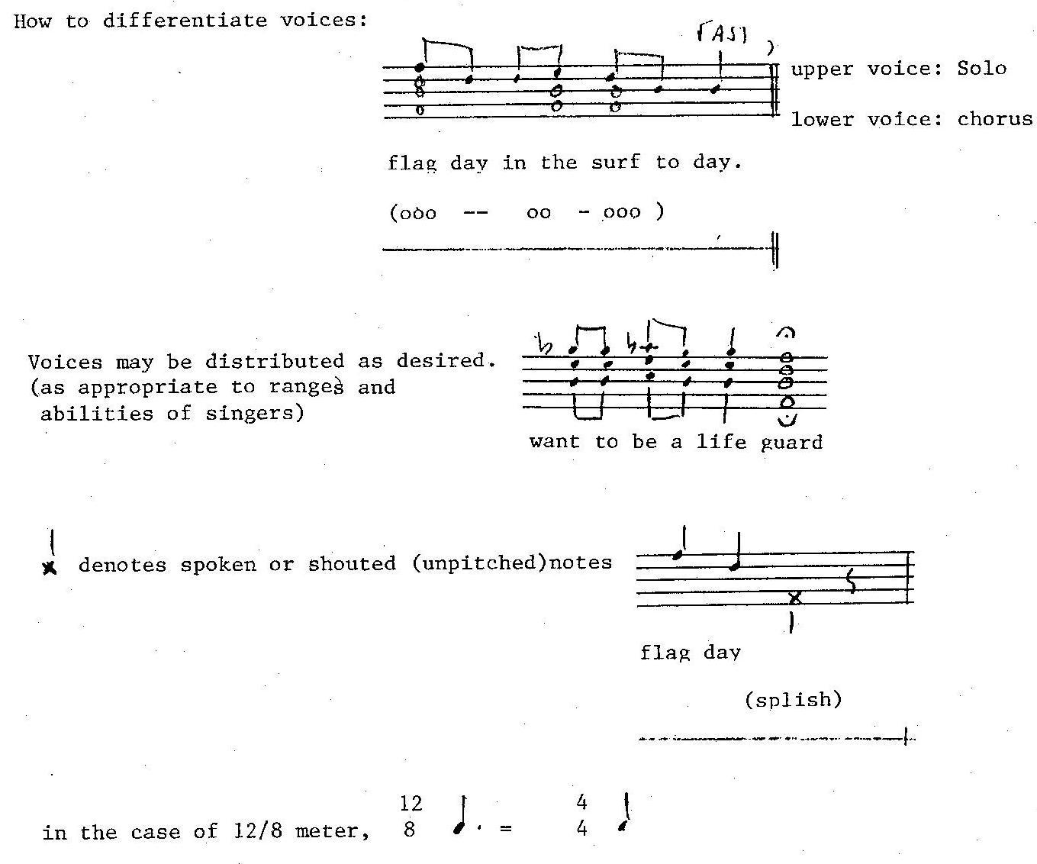

The bass drum part is optional, and may be played by either the conductor (for emphasis) or by one of the singers (the "head lifeguard")

